The Primal Diet

by Aajonus Vonderplanitz

Master Guide v0.2

Author: Rom

I have been informing people about Aajonus' Primal Diet since 2018-2019, and written many guides, articles, ... over the years.
This is the Master Guide.
You will not find a better one anywhere else.
It will receive several iterations.
History of the versions:
1. Originally from: July 19, 2020: Primal Diet 101, FAQ, and index on Facebook, Telegram
2. July 09, 2023: Primal Diet Master Guide v0.1, v0.11
3. Current version: December 3, 2024: Primal Diet Master Guide v0.2
This guide and the author aren't affiliated with the official Primal Diet trust.

Permission to reproduce. Please just do it like this:
Author: Rom. Source: https://healthfully.ai/primaldiet
so people can find updated versions of it. Thank you.
Please share to anyone who wants to get started on the diet.

You do not need to read the 200+ pages of that guide… Just Step 1, Step 2, then whatever you need.

Legal disclaimer:

The READER understands that the AUTHOR of this guide is not engaged in rendering medical advice or services. He provides this content, and the READER accepts it, with the understanding that he or she acts on it at his or her own risk.
The AUTHOR of this guide shall have neither liability nor responsibility to any person or entity with respect to any loss, damage, or injury caused, or alleged to be caused, directly or indirectly by the content contained in this document.

Content disclaimer:

Aajonus gave an instruction for people giving advice on his behalf in online groups:
« Well, then they need to put up an address up there and say: “The people who give information are not doing it from Aajonus unless they’re quoting from the books.” »
This guide is not direct quotes from Aajonus. It is paraphrasing statements made by Aajonus, but also carefully ventures in some degree of interpretation, drawing conclusions by following the logic he laid out.
Some interpretation is sometimes necessary, since Aajonus sometimes made statements that can look contradictory to the untrained eye, but require an understanding of the context as well as the broader context that is his collection of works.
Interpretation is unavoidable in practice, and since this guide aims to be practical above all, there will be statements that are made that you will not directly find stated by Aajonus in his body of available works, however, they should be in line with his system and based on an understanding of his work.

Aajonus’ 3rd book, the detoxification book, was never published, along with several other works, visit https://primal-diet.net/ to learn more about this, and help get this new data published.

“I feel like I have finally achieved and chosen heaven on Earth.”
— Aajonus

Who was Aajonus?

Aajonus Vonderplanitz was born John Richard Swigart, April 17, 1947 (Denver, Colorado, U.S.), and declared dead August 28, 2013 (aged 66), following a balcony fall in Thailand.
We won’t go into his biography here.
He created the Primal Diet.

What is the Primal Diet?

The Primal Diet was created by Aajonus Vonderplanitz and developed over 30 years.
It is an almost exclusively raw food diet, centered around eating raw meat, raw animal fat, and cold-pressed vegetable juice often made with a base of organic celery.
It is a relatively low carb diet, that promotes eating big quantities of food, especially raw animal foods, and to avoid fasting.
Other important foods include raw milk, raw eggs, raw unsalted cheese, unheated honey, raw fruits, clay, vinegar.
Not all raw foods are included, for example salt (raw rock salt), raw grains or sprouts, and whole hard-fiber whole vegetables, are excluded.
Their order of consumption and the rules by which they are combined defines the Primal Diet.
It is a synthesis of observing animals in nature, remedies Aajonus learned during his travels, and his own experimentation.
Although they are grouped under the name of a diet, Aajonus’ health protocols also strongly emphasize several other aspects such as hot bath therapies, EMF exposure, environmental toxin exposure, sunlight, sleep, some psychological awareness, etc.
Aajonus claims it can reverse almost any disease, and enable the body to gradually regenerate itself until it reaches its full potential, extending lifespan, and physical and mental abilities.
It is a diet “for life”, designed to be sustainable in the long-term, and varies over time and circumstances to adapts to the person’s state at any moment.
Still, even if not followed completely, it can function as a fix, and will bring benefits to whatever extent it is applied.
Through his diet, Aajonus offers a very different understanding of biology itself, that fits more under the paradigm of what is known as the “terrain theory”, relating to our relationship with bacteria and other organisms, and the mechanisms by which living beings function.

What is the best way to learn and do the diet?

You can learn through Aajonus’ two books, “We Want To Live”, and “The Recipe for Living Without Disease” (official website: primaldiet.net)
However, significantly important extra information has come up since those.
You can also read all the extended material, but even experts missed important information or their significance after studying all those documents.
So this is what this guide is for.
Reading the book is still recommended to get a great understanding of the diet.
The first book is We Want To Live.
However, I often recommend reading the second book first, "The Recipe for Living Without Disease", because the first book, “We Want To Live”, is half a biography, followed by hundreds of specific remedies, and only a few theorical chapters that establish the structure of the diet solidly.
Aajonus made the second book not only to present recipes but to give more in-depth explanations about the diet’s aspects, as well as plenty of scientific studies in footnotes, if you’re so inclined.
You can also watch the man himself, here are some samples:
https://www.youtube.com/watch?v=r6p2Ov-CTC8
https://www.youtube.com/watch?v=Zacl6VN32gU&list=PLA4-m0Jyxx3mHBv5fxOwmyWYton1z_4qk&index=1

Note

In this guide, I will refer to any balanced version of the diet as the “complete” diet (although there can be several of them, variations).
The term of “full” diet will be reserved for doing literally everything on the diet (which isn’t necessary and which nobody is doing). This is a very important distinction that I introduce here to solve a common misunderstanding.
Eating 100% raw, or eating fully raw, is not the same as eating “the full Primal Diet”, however it is a prerequisite to eating a “complete Primal Diet”. Once you eat all raw, there are other things to do, recipes, timings, etc. to be “completely” on the diet, and to do the “full” diet would mean every single element of it. Still a bit confusing, but keep that idea in mind.

Communities

After you read this guide, you may want to ask questions, etc.
There are FREE communities with experts and many members sharing their experience and planning things together.
The main ones are:
Facebook: https://www.facebook.com/groups/aajonus
Telegram: https://t.me/primaldiet
X/Twitter: https://x.com/i/communities/1844287828974350492

Glossary

PD = Primal Diet
RJ = Royal Jelly

Table of Contents
Step 1: Complete beginners 13
Do you need to eat 100% raw? 13
What to start with? 13
What to do when experiencing a detoxification? 16
What else to expect when starting to eat these raw foods? 17
You want to binge on 🍯 unheated honey and you are concerned that it is too much sugar 18
You get unquenchable thirst for 💧 water 18
Increased sleep time, more daytime sluggishness 19
Step 2: Going on a complete Primal Diet 20
Barebones Primal Diet 21
Regular Diet Schedules 25
Special schedule for leaky gut/Crohn’s disease 29
Special schedule for digestive problems 31
Special schedule for flus, colds 31
Weight loss diet 31
Special schedule for bodybuilders 33
Special schedule for pregnant women 33
Special schedule for performance 34
Special schedule for elderly people 34
Special schedule for diabetes 34
Special schedule for autism 35
Special schedule for terminally ill people 35
Special schedule for people without appetite 35
Diet for people who want to detoxify fast 36
The diet over the years 36
How long to completely heal? 37
Sports / Physical activity efficiency 37
What if you crave starch? 37
What if you crave cooked meat? 38
What if you’re overweight and crave so much food? 38
What if you ate cooked foods while on the Primal Diet? 38
Appetite levels 38
Red meat vs white meat: blood types 39
Ratio of fresh to fermented meat 40
Advanced diet schedules 40
Weight cycles 41
Cuts, injuries 42
Hot baths 42
EMF 43
Sun 44
Sleep 44
Bowel movements 44
Blood tests 45
Avoiding contact with external toxicity 45
Living in hot climate is preferable 45
Physical activity / Sports 45
Stretching 46
Posture 46
Meditation 46
Stress 46
Sex 47
Period 47
Pregnancy 47
Massaging 47
Psychological 48
Brushing teeth 48
What if you have dental amalgams and want to remove them? 48
Hair loss 49
Skin care 52
Eyes / Vision 53
Snorring 53
Step 3: Look up specific remedies 54
Items of the diet: Index of Ingredients and main Recipes 55
#1 🧈 Eating a lot of raw animal fat 55
#2 🥩 Eating a good amount of raw meat 55
#3 🍵 Drinking as much celery juice as needed 55
#4-A 🧀 🍯 Raw unsalted cheese with unheated honey (or moldy/blue cheese) 62
#5-A 🧀 Raw unsalted cheese (“trains”) 63
#4-B 🥛🥚🍨(🍯) Milkshake 67
#5-B 🧈🥚🍋🍯 Moisturizing-Lubrication Formula 69
#6 🥩🦠 High meat 70
#7 🍹 Hydration formula / Sports formula/drink 70
#8 🌰🍯🥚🧈 Nut formula 72
#9 🏝 Clay (non-volcanic and with milk) 73
🥒 Cucumber 73
🍅 Tomato 77
Dates 83
Aloe Vera 85
🥑 Avocado 87
🍌 Banana 90
🦴 Bone Marrow 96
🍫 Cacao 101
🥪🍚🥔 Cooked Starch 104
🥥 Coconut 108
Food Quality 113
Organic branding 114
Sourcing 115
Minimum and Maximum temperatures for each foods 115
Eggs 116
Honey 116
Oysters 117
Meat 118
Fish 118
Salmon 119
Octopus 119
Wild game 119
Water 120
Juices 120
Vegetables 121
Nuts 121
Lemon 121
Papaya 121
Pineapple 122
Watermelon 122
Cucumber 122
Apple 122
Fruits 122
Clay 122
Raw milk 123
Raw butter 123
Raw unsalted cheese 123
Dates 124
Vinegars 124
Olive oil 125
Coconut cream and oil 125
Wines, ciders, meads 125
Eating at restaurants 126
Rules of Primal Diet 127
Rule 1: Eat raw foods for health 127
Rule 2: Eat plenty of raw animal fat 127
Rule 3: Eat plenty of raw meat 128
Rule 4: Drink enough raw celery juice 129
Rule 5: Do not eat too much sugar 130
Rule 6: Do not eat rock salt 131
Rule 7: Space out raw meat and raw vegetable juice by 1h 133
Rule 8: Eat raw animal protein at least every 5 hours 134
Rule 9: Drink raw milk 135
Rule 10: Eat raw eggs without moderation 136
Rule 11: Like heals like 137
Rule 12: Do not eat frozen foods 138
Rule 13: Perspire at least every 4 days 139
Rule 14: Eat raw unsalted cheese 10 minutes before meals 140
Rule 15: Have equal amounts of raw fat when eating sugar 142
Rule 16 Eat fermented raw foods in specific amounts. 143
Rule 17: Eat small amounts of unheated honey to improve digestion 144
Rule 18: Drink raw milkshakes 146
Rule 19: Do not eat carbs/sugars for the first 6h of the day 147
Rule 20 and more: to come 147
Health themes 148
Raw vs cooked 148
Plants or meat 154
Fasting 157
Being fat 165
Semen retention 168
Carbohydrate/sugar consumption 173
Detoxification 175
Terrain theory 204
Salt 204
Supplements 205
Hydration 205
Seed oils 205
Vaccines 210
Heat/Cold 216
The biotin deficiency due to raw egg white avidin myth 216
Equipment 218
Juicer 218
Food processor 220
Blender 221
Utensils (wood, etc) 223
EMF meter 224
How to 225
Making raw cream 225
Making raw butter 225
Making raw unsalted cheese 225
Making raw fermented milk (Aajonus’ “kefir”) 230
Making sour cream 231
Making pâté 232
Making “deli” fermented pâté 244
Marinating meat 249
Making moldy berries 252
Making clay 252
Making high meat 253
Making the parasite formula 254
Juicing vegetables 255
Juicing coconut cream 256
Eating raw eggs Aajonus-style 256
Primal Diet suppositories 256
Storing your food 257
Washing food 258
Washing dishes 258
Washing clothes 258
Weight yourself 258
Make your own water filter and bath tub 259
Making the anti-EMF car pillow 260
Feeding the soil / plants 260
Growing celery 261
Animal husbandry / Animal raising 261
Chickens 261
Cats and dogs 262
Cows 262
All 262
Feeding sick animals 262
Traveling by plane 263
Environment 264
List of plants for your home 264
Types of clothes 265
Furniture 265
Computer gear 265
Phones 265
Jobs 266
Iridology 267
Documents 277
Vaccination – ACCEPTANCE OF RESPONSIBILITY FORM 277
In case of Injury, and Unconsciousness 284
« Request for Advice » form 285
Doctors’ letter 288

Step 1: Complete beginners

Do you need to eat 100% raw?

No, not right away.
It is recommended to switch to 100% raw ONLY WHEN you have all the essentials raw foods of the Primal Diet available in sufficient quantity. This will be explained in detail.
Raw foods are healthy, but powerful, and you need to get a general idea of how to balance them.
This is crucial to know. Otherwise, it can wear you down over months.

What to start with?

You’ve probably already eaten some raw foods.
Raw fruits for sure, but also raw meat, such as sushi, sashimi, steak tartare, oysters, raw cheeses, … are fairly common, and of course, if you were breastfed, raw milk.

First of all, If you haven’t done so already, you can cut tap water from your diet, and use naturally mineral water, and also cut seed oils (they are everywhere, not just in fries: in meat, in salads, in cakes, to cook foods, …), and switch to more organic quality foods, even if cooked.

You can introduce new raw foods, one at a time.
If you start eating 🥚 raw eggs for the first time, do that for around a week before adding 🥛 raw milk, for instance.
Although in theory you can jump head-on into the complete diet without transition, it requires more preparation, in general most people benefit from getting familiar with elements of it first. If you do want to jump into the complete diet right away, do read this section first, then jump to the schedule in the next section Step 2.

When introducing a new raw food, it is recommended to do it over the weekend.
“New” raw foods introduce new types of bacteria and combinations of nutrients to your body, which could give you an initial reaction of stronger detoxification.
Therefore, if you have 2 free days ahead, and start on a Friday afternoon, for example, you will not be too bothered with your work or other activities if such a reaction occurs. Such a reaction could be nausea, vomiting, diarrhea, or headaches, for instance.
Note: usually 🥚 raw eggs give more initial detoxification (in the form of stomach discomfort) to some people, so you might want to start with raw milk, or raw butter, for instance.
It is also possible that you will feel nothing from it, except more energy and well-being, but just plan for your best comfort.
Rest assured, if you feel any queasiness while or after eating those foods, it is temporary. In general, the more you will eat, the less this will occur, as the toxin stores from your body are getting cleared.
Many report feeling bliss upon eating certain raw foods for the first time.

Eat the quantity you feel comfortable with. You may binge or eat very little the first time depending on your body’s reaction. Have more as you go every day.

Here is a list of raw foods to procure and try out:
- 🍯 Unheated honey
- 🥩🐟 Raw meat: beef, chicken, fish, or other.
Regular cuts, such as sirloin, or rib, or lean parts
- 🦪 Raw oysters
- 🥛 Raw milk
- 🧈 Raw butter
- 🍨 Raw cream
- 🥚 Raw eggs
- 🍵 Cold-extracted celery juice
Do you need to eat every single of these raw foods before starting the complete diet (see section “Step 2” right after)? No, but it’s good to get used to some of them first.

On Primal Diet, it isn’t just important that the food is raw, but also that it is of organic or equivalent quality, and there are many criteria to be aware of, including some fake “raw” labelled products (especially dairy and honey), chemical spraying directly on the product or other things.
All of this Is detailed in the “Food quality” section of this guide, which gives you important tips for each type of food and help you in your sourcing.
You can do them in any order. Every week or so, add a new one, and keep eating them daily.
Example:
Week 1: 🥚 eggs eggs eggs
Week 2: 🥛 adding raw milk. Drink on its own. Then start having them the same day.
Week 3: 🧈 adding raw butter. Have on its own. Then egg or milk and the butter on same days.
You can introduce 🍯 unheated honey anytime, it is less detoxifying than other foods, so you could have 🧈 raw butter and 🍯 unheated honey together at once.
Week 4: Add some 🥩 raw meat.
Etc.
Could also start by week 1 🥩 meat, then week 2 🧈 butter, then 🍵 celery juice, then 🥚 egg, …
Note: If you start by eating two foods at once, such as a steak tartare made with 🥩 raw ground beef and a 🥚 raw egg yolk on top, it’s fine as well.
Note2: If you start with 🍵 raw celery juice, don’t wait too long before introducing a raw animal food in your diet.

There are no limits to these foods. Eat to your heart’s content. Aajonus recommends to eat big quantities of raw foods, to supply plenty of nutrients to cleanse and rebuild the body, but you are not on the complete diet yet, so you do not have set quantities at this point.
You can eat 30 🥚 raw eggs in a day if you want. Or 🦪 100 oysters. Or 500g/1lbs of 🧈raw fat.
Whenever you get a detoxification from those, it is a healthy process.
🍵 raw celery juice could have a limit, but it varies per individual. Less than 2.5L (or 1.5 quart) if you ever reach that much in the first stages shouldn’t pose a problem, although that amount varies per individual.
🍊 Raw fruits, especially high carb fruits, however, should in most circumstances be limited to a few per day, or just one.

When you start combining foods, there are certain good and bad matches, some foods are completely incompatible as they will hinder each other’s digestion:
- 🥚 Raw egg: You can eat with any other food
- 🍯 Unheated honey: You can eat with any other food.
Caution: Unheated honey together with raw eggs can trigger detoxifications in some people. If that is the case for you, and you do not wish to undergo that detoxification now, avoid that combination for the time being.
- 🧈 Raw butter: You can eat with any other food
- 🍨 Raw cream: Do not combine with 🥩 raw meat (which includes 🦪 oysters), it will prevent half of it from digesting. Can eat with any other food.
- 🥛 Raw milk: Avoid having more than a little at the same time as 🥩 raw meat. Would slow down digestion.
- 🍊 Raw fruit: you can have with anything, but avoid high-carb fruit with 🥩 raw red meat, that can give too strong detoxification.
- 💧 Water: should not be had less than 30 minutes around 🥩 raw meat, it will significantly slow down its digestion.
- 🍵 Raw celery juice: It must be 1h away from 🥩 raw meat, or will completely prevent its digestion.
Examples: Having 🧈 raw butter with 🍯 unheated honey is very good, 🧈 raw butter with 🥩 raw meat is excellent, 🥚 raw egg with 🥩 raw meat is great too, 🥚 raw egg 🧈 raw butter and 🍯 unheated honey mixed together are possible as well, 🥩 raw meat with 🍯 unheated honey is fine when starting, …
And you can have those with cooked foods while you still eat those (avoid 🍵 raw celery juice with cooked foods though).
More details on food combining and recipes later when we get to complete schedules and the breakdown of each food.

Fresh 🥛 raw milk and 🥚 raw eggs should be kept out of refrigeration to be better digested.
Other foods can be had cold or room temperature.
Store foods in glass, preferably (except 🥚 raw eggs, those can stay in their shells and in cartons).
When starting, have those foods fresh.
Fermented foods are an important part of this diet, however when starting, they can induce more detoxification.
Some slightly fermented 🥛 raw milk (as long as it’s fermented in glass, otherwise discard entirely) could be fine to have early on, it’s just recommended to wait until enough raw foods have been in your diet for a certain time.

Is 🥩 raw meat still hard to eat?
If you are still eating whole vegetables, according to Aajonus, it can make raw meat harder to digest, and give a reaction of revulsion.
However, as long as you eat cooked meat, which is overly acidic, Aajonus explains that some 🥬 raw fiber (despite them being undigestible, and unhealthy overall, creating lacerations in the intestines), helps to move it through faster, which is not required with 🥩 raw meat, and actually does the opposite.
Another possibility concerns white meat in particular: raw poultry or seafood. These can be marinated (see the instructions and photos towards the end of this guide). People who would absolutely never eat raw chicken have on their own eaten this and loved it. Marination is a fermentation method using an external agent that transforms meat and can make raw meat more similar in appearance and taste to cooked meat, and more zesty…

What to do when experiencing a detoxification?
On this diet, you will occasionally experience mild to strong detox bouts, while your overall health and baseline improves month after month.
If you are experiencing a detoxification, it may simply “go away” (reach completion) on its own fairly fast. For example, you feel nauseous, have a headache, you go to sleep, and in the morning, you’re feeling better, or have a bowel movement and then feel better. Again, that will not happen all the time, but it can happen when introducing new raw foods.
However, you can accompany it with certain raw foods, which have the advantage of making the experience smoother, faster, and with less side-effects (protecting you internally and enabling faster recovery), or you can even stop it if you feel overwhelmed.
The body isn’t going to hurt itself with those foods, especially the fatty raw animal foods, even if the detoxification feels intense.

When experiencing detoxification, eating 🥚 raw eggs, or sipping 🥛 raw milk (or 🏝 🥛 raw clay milk, the recipe is given in another section), is helpful (in case they weren’t the food causing that specific detoxification).
In addition, or if 🥚 raw egg or 🥛 milk are not appealing, making a mixture or drink made of
🍅 1-2 raw tomato or 🥒 peeled cucumber or 🍉 watermelon, or a combination of those,
🍋 2 tablespoons of lemon juice,
🍯 1-3 tablespoons unheated honey,
optionally 1-2 tablespoons of 🟢 raw lime juice,
and optionally 1 teaspoon of 🍷 raw vinegar, provides nutrients that help with the detoxification process, and to stay hydrated (better than straight 💧 water).
A variation is a raw lemonade made with similar ingredients, but swapping tomatoes/cucumber/watermelon for good quality 💧 water.
These formula help even with missing ingredients, so a single raw 🍅 tomato, slice of 🍉 raw watermelon, or just 🍅 raw tomato with 🍋 raw lemon juice, for instance, would help too.

Extremely recommended:
Buy 🟢 lime. If you experience a strong detoxification and do not wish it to let run its course, you can stop it by drinking 🟢 raw lime juice (can be added to something else, recommended is good quality 💧 water and a little bit of 🍯 unheated honey). This is to avoid panicking and doing other reckless things.
Just know you can always stop or lower a detoxification with 🟢 raw lime juice very fast.
In that case, drink 4 tablespoons of 🟢 raw lime juice.
(Do not drink more than 8 tablespoons of it, and avoid drinking for many consecutive days, that would lower your gut bacteria that is necessary for digestion, and even lower overall body function.)
Very strongly recommended:
Get 🧀 raw unsalted cheese.
This item will be properly detailed later, how to source it, or to make it.
It makes life so much easier, by trivializing most detoxifications, and thus improving overall body function and digestion; that type of cheese is able to bind to toxins very effectively and sometimes shuts down symptoms in a matter of seconds.
Have it 10 minutes before every food to facilitate digestion, and whenever you feel an issue (digestion problem, stomach cramp, headache, …).
More on that later.

What else to expect when starting to eat these raw foods?

The following effects could increase as you progressively switch to eating 100% raw, but can start with the introduction of these raw foods into your diet.

You want to binge on 🍯 unheated honey and you are concerned that it is too much sugar
It is true that according to Primal Diet, the human body is made to run better on fat than on sugar, and too much sugar can be detrimental in the long run.
However, consider that truly unheated honey will contain much less sugar than you imagine, according to Aajonus, 90% of the sugar has been converted to enzymes (beneficial nutrients), so it is different than most sugar sources.
Secondly, this is temporary. Many people experience cravings, some day eating up to a pound (!) of 🍯 unheated honey. This can last for weeks. Over time, the body stops craving that much 🍯 unheated honey, because it has fulfilled a strong deficiency in enzymes.
Drinking enough 🍵 raw celery juice provides many extra enzymes, which can help lower the need for 🍯 unheated honey (and they can be had together, although that may produce an initial increased sugar detoxification).

You get unquenchable thirst for 💧 water
On a raw food diet, the body detoxifies at a higher rate, releasing many toxins that could not be eliminated from the body in the past and thus were stored over the years (due to insufficient resources, a lack of dietary nutrients from cooked foods, combined with being subjected daily to overwhelming quantities of toxins, just not overwhelming enough to be instantly debilitating or deadly).
The body craves water because 💧 water is a solvent, and wants it to dilute concentrations of toxins. However, that isn’t the best way to deal with toxins. Eating more 🧈 raw fat, 🍵 raw celery juice, and the drink/mixture of 🍅 raw tomato, 🍋 raw lemon juice, 🍯 unheated honey, etc. will bind to the toxins much more efficiently and over time reduce thirst.
You may strongly crave water for months, 2 years, … depending on your situation. Over time, and by eating those other foods, the intense craving for water diminishes.
Aajonus recommends to avoid drinking too much 💧 water because it also “dilutes” the system internally. Definitely less than one liter / quart per day if possible when starting.
If still eating cooked foods, it is different, try to hydrate through other means first (🥛 raw milk, 🍵 raw celery juice, …) but do not limit water too much, cooked food eaters can require more 💧 water, and evaporate more of it during sleep due to detoxification.
So the solution is not to purely try to abstain, but to compensate with other more efficient methods. This is an important pattern in this diet.

Can't help but “gulp” 🥛 raw milk
Similarly, the body is looking for something. When you cannot stop drinking 🥛 raw milk constantly, or feel compelled to gulp it, it is most likely because the body is seeking more of the specific nutrients found in the 🥛 raw milk, however, since 🥛 raw milk is a very liquid food (82% 💧 water), it does not get its fix. By eating more nutrient-dense dairy products such as 🧈 raw butter, 🍨 raw cream, 🧀 raw unsalted cheese (fresh or mashed with 🍯 unheated honey, more on that in the food items/recipes section), the concentration of nutrients will be provided at once and the thirst for 🥛 raw milk will suddenly diminish.

Increased sleep time, more daytime sluggishness
When starting the diet, especially when going on the complete diet, the body undergoes an intensified initial healing period. For several weeks, you may sleep closer to 8-10h of sleep at times, and feel a bit sluggish during the day. That is completely temporary. At the same time, the more complete the version of the diet you are on, the less long these slowdowns will occur for you.

Step 2: Going on a complete Primal Diet

Going on a complete Primal Diet is not very hard. The schedules can be very simple, or more complex, to your liking.
There are only 4 to 10 (maximum) main directions to remember. That’s it.
First understand those, and you can quickly incorporate the rest.

Whether you are being “casual” or “hardcore”, you must pay attention to the balance, to elaborate your “own” version of the diet day after day, within its guidelines, for safety, which is what will be presented here.

What is the most barebones, yet complete, Primal Diet you can do, for it to be called Primal Diet and have the necessary balance?

Barebones Primal Diet

The most basic, simplified, streamlined, Primal Diet you can get, is the following:

Eat raw animal protein and fat
Wait
Drink raw celery juice
Repeat throughout the day

A very basic Primal Diet “cycle”, the essential building block of your Primal Diet schedules.

A more expanded example:
Waking up
🥩🧈 raw meat with butter
1h break
🍵 raw celery juice
2h break
🥩🧈 raw meat and butter
Around midday here
1h break
🍵 raw celery juice
2h break
🥩🧈 raw meat with butter
3h break
🥩🧈 raw meat with butter
etc.

This is a functional Primal Diet, albeit very simple, and not utilizing anywhere close to the full potential of it.

First rule: Raw animal proteins and fats are mandatory.
This is not a vegan diet, and these raw animal foods are essential for our body.

Second rule: 🍵 Raw green juice (often celery) is mandatory
It is the main “remedy” and micronutrient “supplement” in our diet. We need it to deal with the detoxification of the contamination inside our body.

These categories of foods form the backbone of the diet, and cannot be taken out from it.

Here is another example of a schedule with a great variety of foods:

Waking up
🥩🧈 raw meat + butter
1h break
🍵 raw celery juice
1h break
🥚 1 or 2 raw eggs
30 min break
🥚 1 or 2 raw eggs
1h break
🥩🥚🥚 Meat + Eggs
Around midday here
1h break
🍵 raw celery juice
1h break
🥛 raw milk
2h break
🥚 1 or 2 eggs
30 min break
🥩🧈 Meat + Butter

As you can see, some of the🥩 raw meat and 🧈 raw butter have been swapped with 🥚 raw eggs or 🥛 raw milk, both sources of raw animal protein and fats. The general structure remains, of alternating those with the 🍵 raw celery juice.

Third rule: 🥩🐟 raw meat (of any kind) is mandatory. No other raw animal protein sources (such as 🥚 raw eggs, 🥛 dairy) can fully replace it.

So make sure to be consistent in having a good amount of 🥩 raw meat daily, no matter how much 🥚 raw eggs, 🥛 milk, 🧈 butter or other foods you have.

Fourth rule: 🍵 Raw celery juice must be separated by one hour from 🥩 raw meat.
🥚 Raw eggs, 🧈 butter, 🥩 meat, can be eaten together, or close to each other.
However, 🍵 raw celery juice must be separated by around 1h from 🥩 raw meat, otherwise neither will digest.
They require completely different digestive environments, and it takes time for the body to switch from one to another.
Other raw animal foods, like 🥚 eggs or 🧈 butter, can be had closer to, or something with, 🍵 raw celery juice.

Fifth rule: Raw animal protein foods should be eaten at least every 5h (could be less for certain people).

As you have seen, the schedules presented so far involve eating frequently.
Fasting of any kind is strongly recommended against in the Primal Diet, but it goes further: raw animal protein must be eaten quite frequently, even if it is just one 🥚 raw egg.
That includes overnight, and may involve waking up to eat and going back to sleep. Seem inconvenient, but it will improve quality of sleep, and overall less hours of sleep will be required.
This constraint is in place once again because of our stored toxicity. A whole chapter on fasting is at the end of the manual.
Therefore: you never stop eating. (note: eating may feel effortless, eating a 🥚 raw egg can be done in 5 seconds and weights nothing on digestion, even copious amounts of 🥩 raw meat can feel light on digestion, almost like your stomach remained empty despite being sated).

Sixth “rule”: the ratios
🧈 Raw animal fat is the most important on this diet.
Should eat half a pound/200g+ per day.
🥩 Raw meat is the second most important, followed by other raw animal protein.
Should eat half a pound to a pound / 200-500g per day.
If eating more, then ratio of 🧈 raw fat should go up accordingly.
🍵 Raw celery juice is the third most important.
Minimum of 2 cups / 500mL per day, recommended 1 quart / 1L per day, sometimes more is required if it is difficult to eat the given quantities of 🥩 raw meat and 🧈 fat.
This will be detailed more in the section which explain each food item/recipes in detail.

As you can see, there were only a handful of “rules” to define what a complete Primal Diet can start as, and how to do it correctly.
There are other “rules”, but these ones were the most important, as the only required ones.

Now you are ready to see a more complete schedule, with precise measurements, and more commonly used items all at once, as well as introducing some key recipes (technically optional, but nonetheless extremely useful).
All the schedules presented so far were complete, and technically real Primal Diet examples, but a bit lackluster. The following one is the one you would be doing on most days. It can always be tweaked, now that you know how the system works, with what “rules” it functions.

Regular Diet Schedules

General schedule #1
From Aajonus’ book, updated with information that came out later

“This plan consists of three 🥩 raw meat [Note: added more as an option for night-time] meals daily and is better for people with slower metabolism, lethargy and glycemic problems, including diabetes.”

Waking up
🧀 🧀 3 to 4 tablespoons of raw unsalted cheese
(If you don’t have this type of cheese, skip.)
10 minutes break
🥚 🥚 3 to 5 raw eggs
20 minutes break
🧀 1 teaspoon of raw unsalted cheese
10 minutes break
🍵 2-4 cups (500mL to 1L) raw green vegetable juice
45-60 minutes break
🥩🧈 6-10 ounces (1-2 cups) raw meat with raw fat, which can be:
- 🥚 raw egg(s)
- and/or 🧈 2-5 tablespoons raw butter,
- or equal amount of 🧈 butter and 🥑 avocado.
- one or a combination of several raw fats may be eaten at a meal, such as in a sauce.
45-60 minutes break
🥛🥚🍨(🍯) Milkshake recipe
- 🥚 1-4 raw eggs,
- 🥛 3-6 ounces raw milk,
- 🍨 1-4 ounces raw cream
- 🍯 1-2 tablespoons unheated honey (optional)
1h+ break
🍵 4-12 ounces (100mL to 1/3L) raw green vegetable juice
1h+ break
🥩🧈 6-10 ounces (1-2 cups) raw meat with raw fat
1h-1h30 break
🥛🥚🍨(🍯) Milkshake recipe
OR
🍊 4-6 ounces fruit with
- 🧈 3-6 ounces of raw fat
(🍨 raw cream, coconut cream, 🧈 butter, 🥑 avocado, or combination of those)
1h+ break
🍵 4-12 ounces raw green vegetable juice
1h+ break
🥩🧈 6-10 ounces (1-2 cups) raw meat with raw fat
45-90 minutes break
🧈🥚🍋🍯 1-2 servings Moisturizing/Lubrication formula recipe
1h+ break
🍵 4-12 ounces raw green vegetable juice
1h+ break
Right before sleeping
🥩🧈 6-10 ounces (1-2 cups) raw meat with raw fat
OR
🥛🥚🍨(🍯) Milkshake recipe
OR
🧈🥚🍋🍯 1-2 servings Moisturizing/Lubrication formula recipe
Less than 5h break
During the night
🥩🧈 6-10 ounces (1-2 cups) raw meat with raw fat
OR
🥛🥚🍨(🍯) Milkshake recipe
OR
🧈🥚🍋🍯 1-2 servings Moisturizing/Lubrication formula recipe
Next day
Repeat

There are new things here: 🧀 raw unsalted cheese, 🥛🥚🍨(🍯) milkshake, and 🧈🥚🍋🍯 moisturizing/lubrication formula are the main additions. You can find explanations for each of them in the section about food items.
Just note that the 🧀 raw unsalted cheese appears throughout the day, one piece 10 minutes or more before each meal (whether solid or liquid).
I did not put it here before every other food because it would take so much space, but you see it as the beginning.
It is to bind to toxins and improve digestion, one of the most useful items in the diet. It seems to add a lot of space to this schedule, but it is just a little thing you end up doing automatically before meals after a bit of practice.

What if you cannot do everything? It’s perfectly fine. Just pick up wherever you’re at, you know how the basic “cycles” work.

Regular schedule #2

“This plan consists of two 🥩 raw meat meals daily and is better for people with high metabolism and hyperactivity.”

For simplicity’s purpose, I will not be detailing it now. You can take the previous schedule, and swap one meat meal in the afternoon for another milkshake.

Aajonus:
“If you are balanced metabolically, I suggest that you alternate those plans. The recommended daily diets above are intended to cause the weight-gain necessary to remove deep-tissue toxicity.”

Here is another one:

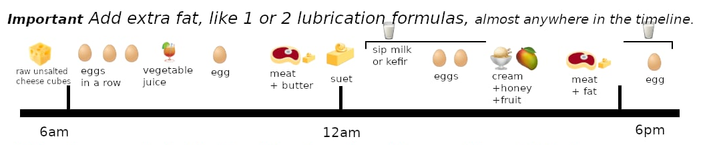

Let’s introduce some more principles so you know close to everything:
- Eat 🥩🐟 raw meat with fat (🧈 raw butter, 🥚 raw egg, …).
Raw meat without raw fat is converted to energy most of the time, and not used for rebuilding your tissues as much as it could. By eating raw fat with raw meat, the raw fat gets used for energy instead.
Eating raw fat with raw meat also helps protect from detoxification caused by the raw meat proteins, and if there are any toxins inside (no food Is perfect).
It needs to be 3 tablespoons of extra raw fat (by itself, not blended with the raw meat), even if the meat itself is already fatty (because then the fats are “bound” to the proteins in the meat marbling).
- Avoid eating 🥩 raw meat with 🥛 raw milk except blended with as a "smoothie".
Half a cup of fermented 🥛 raw milk with meat can be fine.
- The day must always start with raw proteins as soon as possible (after 🧀 raw unsalted cheese, which removes toxins). Your body will make glycogen for the body for the day by converting the protein to pyruvate (a protein sugar), the cleanest form of energy you can get.
- Do not eat sugary foods In the morning. Avoid 🍊 raw fruit, 🥛 milk, too much 🍯 unheated honey or 🥕 carrot in the juice. In the first 6 or so hours after waking up, eat mostly protein and fat. 🍵 Raw celery juice is low in sugar. What happens otherwise is that your body will use some of this sugar to make glycogen, which creates more undesirable byproducts throughout the day, and will make you more lethargic.
- Make sure to eat sugary foods (especially fruit) with fat except in very small quantities.
- No fruit with meat, except bland fruits like tomato, cucumber, bell peppers.
- Except: Any fruits can go with white meat (fish and poultry) though.
- Sip all fluids (could be 1 tablespoon every 3 minutes, or 2 tablespoons every 5 minutes, …). Drinking too fast leads from the ionically bound water to separate from the rest of nutrients, so cells are fed less properly, and that separated water will dilute you internally, and lead to more urination, and through that more loss of nutrients. In a hot bath, you can sip 2 to 3 times faster.
- No high-carb fruit juice, so lemon juice is used in the diet, but not e.g. apple juice, or mango juice. Notable exception is the Orange Julius recipe (one of the recipes for fluds/colds, explained in next section of diet schedules), but even there that is an option. Fruit juice releases sugar too fast, even if having it with raw fat, the raw fibers (that are soft, and don’t hurt the digestion) help shield from the sugar.
- Most high-carb fruits are better eaten unripe. Unripe fruits could be 10% sugar and 90% enzymes, and ripe fruits, the opposite. Enzymes help with digestion (breaking down food) and breaking down toxicity, diseased/dead tissue. Beware, unripe pineapple can eat at your tongue and make you bleed if you eat too much of it and without fat! Even if the fruit is unripe, too much of it shouldn’t be had.
Tomatoes are not to be had unripe, watermelon neither. Pineapple is best unripe. Most other fruits should have green skin, but not completely: half-green banana, half-unripe papaya, …
- If having strong cravings for too much fruit, you need more vegetable juice, and can have more honey too.
- If feeling acidic, besides having more celery juice, and the sports/hydration formula (explained in recipe section), a higher ratio of white meat (less acidic) can be had.

A general tip:
- If you don’t have anything ready, eat a few raw eggs along the day at any time and to avoid fasting. You can also sip milk, but eating more raw eggs is better.

Let’s now go through various specific cases and their modified diets.

Special schedule for leaky gut/Crohn’s disease

Leaky gut is a condition that Aajonus has a special schedule for. In that case, it is better that people do not eat certain foods that are more complex to digest, or are abrasive to a weak gut. Undigested food particles cross the blood barrier through the leaky gut, which isn’t supposed to happen, and causes a toxic reaction. Many people with arthritis have leaky gut, because these undigested food particles are stored by the body in the joints, one of the most resilient places in the body.
Aajonus put these people on a raw egg only diet. The raw egg is the most complete “fast food”, as by itself, it digests between 27 (if egg white is eating first) and 37 minutes (otherwise).
The diet can therefore simply be:
Wake up
🥚 1 egg
30 min break
🥚 1 egg
…
Until the end of the day, and repeat.

One at a time, because they will digest better that way.

It is important to eat enough raw eggs to not lose weight. Raw eggs can cause weight loss, especially when eaten one at a time. This is not the goal here, people with leaky gut are often quite skinny, and there needs to be an abundance of all those proteins, fats, minerals, vitamins, etc. to regenerate the gut as fast as possible.
For an individual, this can go up to 20-30 eggs per day. There is no limit (except not too many eggs at once, two at once every time could be fine).

This is one of the only rare cases where meat isn’t mandatory, because it simply can not be digested well enough, and so, for a few weeks, until the gut heals sufficiently, meat will not be reintroduced.

However, that diet isn’t complete.
Raw eggs are not enough to supply water, for example, and can actually lead to more thirst (because of detoxification).
So what to drink, water? Too much water is a problem in the case of leaky gut, and even for people without leaky gut, as it dilutes the mucus membranes, strips them down, this is the opposite of what we are trying to achieve.
The answer is the celery juice, as usual. So that is kept from the normal diet. In addition, eating a lot of raw eggs cause a need for the non-heme-iron found in green vegetable juice.
It’s better to avoid acidic or astringent fruits like tomatoes, lemon juice, etc. for a while as well.
So now we have a diet looking like:
Wake up
🥚🥚 1-3 raw eggs
30 min break
🍵 raw celery juice
30 min – 1h break
🥚 1-2 raw eggs
30 min break
🥚 1-2 raw eggs
…
Until the end of the day,
and repeat.

Lastly, 🧀 raw unsalted cheese could be added before each meal, as usual, as it will help clear the toxins of the gut, and digest the foods better. However, it isn’t extremely clear if Aajonus recommends to do this every time when on the leaky gut protocol. He mentions to have if you get perceptible gut detox, at the very least.

After some weeks, some more foods could be reintroduced, such as 🧈raw butter, 🥛 raw fresh warm milk, and eventually, raw milkshakes, 🥩 raw meat.
When to know to reintroduce foods? If leaky gut gives you pain, and the pain fades away, it could be an indication to reintroduce them.

Special schedule for digestive problems

If you think you have digestive problems, you may not have leaky gut. That schedule could still be useful for you as a “reset”, for one day or more (or a 1-day urine diet to recycle your finely digested nutrients, the urine being the blood serum without the red blood cells, and avoiding the first urine in the morning, the most toxic, from nightly detoxification), but you could also be wrong. Some detoxifications are not digestive difficulties per se.

Let’s say you ate lubrication formula, or drank celery juice, and got diarrhea, and digestion feels stopped. It is not because your liver cannot digest fats, most of the time, but because the food you ate pulled out a lot of toxins, which interfered with digestion. As you eat MORE (and not less) of the foods to accompany detoxification, this reaction with quickly lessen, and your body will be much healthier for it.

Special schedule for flus, colds

Add up to 3 times per day, during the duration of the cold/flu,
A 🍊 raw orange, with raw fat, especially raw animal fat.
Examples: orange with cream, orange with butter, egg, and honey, orange with milkshake.
This is one of the only cases where Aajonus can recommend more than one high-carb fruit per day, exceptionally, and temporarily.

You can also eat a higher proportion of chicken.

Weight loss diet

The weight loss is an egg lower in fat and sugar.
It avoids eating different foods at the same time, which usually can have benefits, but also can lead to weight gain.

Eat one egg at a time
🥚 1 raw egg
30 min break
🥚 1 raw egg
…
For faster weight loss.
Two at a time for slower weight loss.
Eat at least one every 5h (the rule against fasting), to avoid getting hurt internally from detoxification, especially on such a low fat diet, and avoid eating more than 10-15 a day, otherwise it may maintain your weight, depending on your size.

You can alternate with small portions of lean meat. Since the meat is lean, and protein needs fat to digest, the lean meat will seek fat In your body.

Since raw meat can be more detoxifying, and has less fat in proportion to protein than a raw egg, just one time, eat a teaspoon of butter with your lean meat.

🥚 1 raw egg
30 min break
🥚 1 raw egg
1h break
🥩🧈 Lean meat + teaspoon ? butter
1h break
🥚 1 egg
30 min break
🥩 Lean meat
Do not eat egg whites alone. This can create deficiencies and a frenzy, and is not safe enough. Only whole eggs.

You should still shed weight off very fast. If the meat is very lean, even at a pound or two a day, you will lose sizes.

For hydration, and balance, use celery juice, without honey. You can add lemon juice to it, to shed fat even faster.
It is possible to have a bit of the hydration/sports formula too (the mixture/drink with tomato, cucumber, lemon juice, etc.), one that is low in sugar/honey, and fat, in alternance with the juice.

If feeling agitated, nervous, or not calm, you can add half a cup of milk at the end of the day to soothe the nervous system. Too much milk will slow down weight loss though.

Warning: Other raw foods can force weight loss, like eating a lot of fruits, or vinegar, or certain oils, … That is not recommended. It can hurt you to abuse it, and you do not need it.

Do not force the weight loss diet too much (around 1 month maximum recommended). If you stagnate, hit a plateau, it may be that the body holds onto it and needs more nutrients at the moment, and it would be damaging to some extent to keep going.

Special schedule for bodybuilders

Aajonus said that the following schedule made a man who wanted to be “big” all his life, gain inches on his arms so fast that his gym accused him of taking steroids…

It consists of having several meat meals per day, and a lubrication formula every time, as follows: drinking 1/3 of the lubrication formula with the meat meal, and the rest 15 minutes after finishing the meat meal.
See the advanced schedule in the following pages to see all the details.

Special schedule for pregnant women

Pregnant women are often either more hungry, which is understandable, considering they are feeding a growing baby, or nauseous and with loss of appetite, or alternate between both.
An increase of celery juice may be required in case of loss of appetite. It will give back appetite, and shield the woman and her baby from the toxins circulating.
Increased quantities of meat, fat, and mineral-rich foods like raw unsalted cheese (with unheated honey) are important.
Avoiding foods that trigger strong detoxification such as moldy berries, too much raw coconut cream, etc., is important.
Do not eat papaya seeds at all costs, it can cause miscarriage.

Special schedule for performance

The regular Primal Diet calls for healing first and foremost. However, it is possible to make it more performance-oriented.
Eating smaller meals, only one or two foods at a time, makes digestion easier, which gives much more energy, but doesn’t heal as fast (eating big meals gives an important influx of nutrients to the body, which may discard some performance temporarily to go into a healing phase, which could be a nap for example).
This is similar to the weight loss diet, except you can eat bigger amounts of food over the day, but without overfeeding like regular schedules call for.
See the advanced schedule in the following pages as well.

Special schedule for elderly people

Elderly people may start off too weak to undergo the regular detoxification Primal Diet puts the body into.
Eating one cooked meal per week, which could be a lightly cooked chicken meal, for example, can lower detoxification.

Special schedule for diabetes

There are some changes to the main schedule.

First, Aajonus mentions diabetes can be misidentified. Some people have sugar level problems without it being diabetes.
“If you've got a true insulin problem, you're not metabolizing your sugars to run your brain and nervous system. You're not going to breathe. You're going to go into a coma in three days. If you don't have any of those symptoms, you are not diabetic.”

He said Hippocrates healed diabetes by putting people on fresh warm raw milk regimens.

Aajonus recommends unheated honey as well. Honey has to be truly unheated, not just raw. If the honey is from a desert area, or from the summer, it could have gotten too hot to be truly unheated even if the beekeeper doesn’t heat it otherwise.
Some people with diabetes can’t metabolize even unheated honey correctly, especially if the pancreas is damaged, but Aajonus would still recommend them half a cup of honey per day.

If honey is not tolerated well on its own, Aajonus recommends to eat it together with 5x more raw fat.

Special schedule for autism

Aajonus recorded the fastest improvement with parents who gave their severely autistic children one moldy berry a day (guide given at the end on how to make them).
Be careful with moldy berries, they remove heavy metals from the brain fast, but can be very detoxifying.
It is recommended to do the regular diet without moldy first for a few months at least, all the raw fats and raw proteins, minerals, etc. will already lead to much improvement.

Special schedule for terminally ill people

Usually, Aajonus wouldn’t recommend too much fermented or moldy foods, such as high meat, to people who just started the diet.
But, for example, for some people who are later stage 4 cancer, and cannot afford to wait, he said he gave them more moldy/fermented foods than to anybody else.
It could still lead to side-effects, so eating plenty of raw fats, some fresh raw meat, and enough celery juice, is extremely important in that case. Aajonus says in the case of cancer, raw fat could account for up to 80% of the diet. In general, this diet is high fat for everyone, but in this case, especially so.

Other time of terminally ill people may be more concerned by the one below…

Special schedule for people without appetite

People with no appetite and who are severely sick are in danger of withering away.
Some people may have been on antibiotics for weeks, and have lost much of their gut bacteria, and therefore their capacity to digest.
Raw eggs are the most easily digested food, so this food will always have the highest chance of being assimilated.
There is another recipe Aajonus made and gave to people who were in this situation, bedridden, unable to eat literally anything, on the verge of dying…
The papaya custard. Papaya contains a lot of enzymes, which are a major contributor to digestion, and this whole recipe, with the honey, also containing enzymes, etc., very palatable and tasting like a desert, enabled people with no appetite to eat it, and to eat several more meals the same day.

Diet for people who want to detoxify fast

Don’t wreck yourself with moldy berries or cilantro juice.
Eat a lot more oysters, a lot more raw unsalted cheese trains. That can clear 90% of your toxicity much faster, and safely.
Make sure to follow the main guidelines. Drinking enough celery juice according to your needs (could be (1L, 2L, …) has been noted by Aajonus to make people progress MUCH faster than the ones who didn’t.
Only introduce the harsher more detoxifying foods after 1 or 2 years on the diet, and never on a weight loss diet.
That includes a parasite/helminthic therapy.

The diet over the years

Over the years, the needs change, and so does the diet.
Every seven years, Aajonus dropped 1 cup of vegetable juice from his diet.
So over time, if doing the diet consistently, the need for celery juice becomes less and less. It is important to not underestimate the quantity of juice that you need (better a bit more than required, than less).
Other plant foods also, will become less appealing, and if not diminishing them, will have a more detrimental effect on digestion.
Same for water.

How long to completely heal?

It could take around 40 years on an excellent raw diet to completely regenerate all tissues to their healthiest state.
As for vaccine toxicity, there can be more than a lifetime of toxicity from them.
With an optimal diet, with frequent cheese trains, daily lymphatic baths, etc. it is possible to cut down the detoxification time to a fraction of what it would take otherwise, and multiply healing several-fold. Therefore it might be possible to completely detoxify and reshape our body to its optimal state in much less than the estimated 40 years.
In pristine conditions, we might have been able to live to 140 years old in good health. However, because of our toxic generational upbringing, the Primal Diet might not allow us to reach that figure, but 120 years might be possible.

Sports / Physical activity efficiency

How to get most performance out of sports, Aajonus quote:
« I tell marathon runners, even 10 minutes before running, start off with lots of raw butter and honey (8:1 ratio athletes but 6:1 for normal people and 1:1 for person in coma) to build up that fat system right away, because you’ll hit the wall later but it will be minimized. It will shrink by half the wall they hit at 7, 13 (most major wall), 18 and 20 miles. Usually marathon runners don’t start off at high speeds like sprinters. Sprinters may start off eating 20 minutes before running.
Football player can eat and go out on the field right away. They are not running constantly.
Basketball players, again, need a little bit of time. Use your sport drink to sip on all the time.
A long distance runner can eat a lot; it doesn’t matter. I’ve had 10-15-20K runners eat a lot of cream right before. If you’re a stocky runner, raw cream is not a good thing to eat too close. May be 2-3 hours prior is OK. Butter is better; it digests easily. Cream is not so easy to digest so digestion will take from your athletics. I told one very stocky, thick marathon runner to have cream with orange juice 3-4 hours before running as she already had a lot of fat on her body. She had it an hour before and puked for the first two miles before getting her momentum up. Raw butter and honey would have been better. For runner, 8:1 ratio; average person, 6:1; person in coma, 1:1 ratio. »

What if you crave starch?

You may need the nut formula (see in the foods section).
Some people still need starch, especially with certain kind of severe brain detoxifications…

What if you crave cooked meat?

You could be undereating, or specifically, undereating fat.
If you have trouble eating fat, you may need to up your juice consumption, and use a bit more honey too, for digestion.
You may also want to make marinated meat / “deli” pâté. Instructions at the end of this guide.

What if you’re overweight and crave so much food?

That isn’t surprising. On standard diets, you get many calories, but few nutrients, and the nutrients that you get are in poor condition. Your body has been deficient for years… Initially you are going to be catching up very fast by eating a lot of raw foods.
You may even lose the extra weight while overeating, that isn’t unusual. The body swaps a lot of old toxic fats with some new healthier raw fats.
In any case, you can always do a weight loss diet, extremely efficient on this diet, but don’t force it at the beginning, please, let your body fill itself on the nutrients it was deprived of for so long.

What if you ate cooked foods while on the Primal Diet?

Maybe you want to eat a cooked meal with your family or friends.
What you can do to bind to the toxins of cooked foods is to eat plenty of raw eggs before, during, and after, as well as milkshakes, and raw unsalted cheese during and after.
Cooked foods may dry you up, so you may get thirsty, celery juice will be helpful.

Appetite levels

Some people have “too much” appetite or too little appetite when on standard diets.
A standard diet is deficient in nutrients and leads some people to have too much appetite, because they do not get appropriate nutrition from their diet.
Other people have impaired digestion from their inappropriate diet, so they lose appetite.

On the Primal Diet, appetite levels can fluctuate.
Digestion is vastly improved, however, the gut is often used as a detoxification site, which can lower appetite.
When this happens, it is important to eat the easy to digest foods which will remove those toxins and restore appetite.
The blood can also get flooded by toxins when detoxifying, which makes it over-acidic, and lowers the appetite for meat, especially red meat, and fat.
Raw green juice to remove over-acidity and raw milkshakes to build protective mucus that shields the mucous membranes in the gut and elsewhere from toxins, as well as raw unsalted cheese, that attracts and binds to toxins, are the most important things to have.

In some cases, appetite might be lost even with those foods, and sports formula and raw lemonade might be craved.
Raw milkshakes are necessary but can be too thick and more you feel sluggish.
The raw lemonade or sports formula can help remove certain congestion, they might be required in some circumstances when you feel stuck, but if had too often, they will demineralize you and strip off mucus from your body, and overall weaken you and make you fatigued.

Red meat vs white meat: blood types

From We Want To Live:

“There are three basic blood types when determining what meat someone should eat regularly. These types are:
1) People who naturally have acidic blood easily produce red blood cells. They do not naturally produce enough white blood cells. Generally, this type should eat mostly white raw meat (fish, fowl, rabbit) to be balanced. If they eat red meat more than occasionally they will have a tendency to be irritable, impatient, overanxious and overaggressive.
2) People who naturally have alkaline blood easily produce white blood cells. They do not naturally produce enough red blood cells. Generally, this type should eat mostly red raw meat (beef, lamb, venison) to be balanced. If they eat white meat more than occasionally they will have a tendency to be lethargic and tired (anemic)
3) People who naturally have a balanced blood pH produce a balance of red and white blood cells. Generally, this type should eat both red and white raw meat to remain balanced. Few of this type can do fairly well as vegetarians.
Type 1 usually has a ruddier complexion, holds a tan easily, and/or has a high adrenaline level (that is, they have a lot of physical energy).
Type 2 usually has a light complexion, his or her tan fades moderately to quickly, and/or he or she is more emotionally and mentally oriented than physically oriented.
Type 3 normally has a balanced complexion, tanning cycle, and a near-even balance of physical, emotional and mental energies.
A person can change from one of these blood types to either of the other types many times throughout his or her life.”

Ratio of fresh to fermented meat

Aajonus recommends a ratio of at least 1/3 fresh meat, to up to 2/3 high meat.
Someone eating high meat very frequently, over the year, could eventually switch to only high meat, because at that point, it would stop being detoxifying, and only provide energy, but until then, fresher meat is important to balance and avoid unwanted damage from detoxification.

Advanced diet schedules

More advanced diet schedules involve precise cycles for the meat meals, and fat meals of different kinds following them shortly after.
This is useful for bodybuilding diets, obtaining faster gains, or simply to get even more energy and progress in health faster.
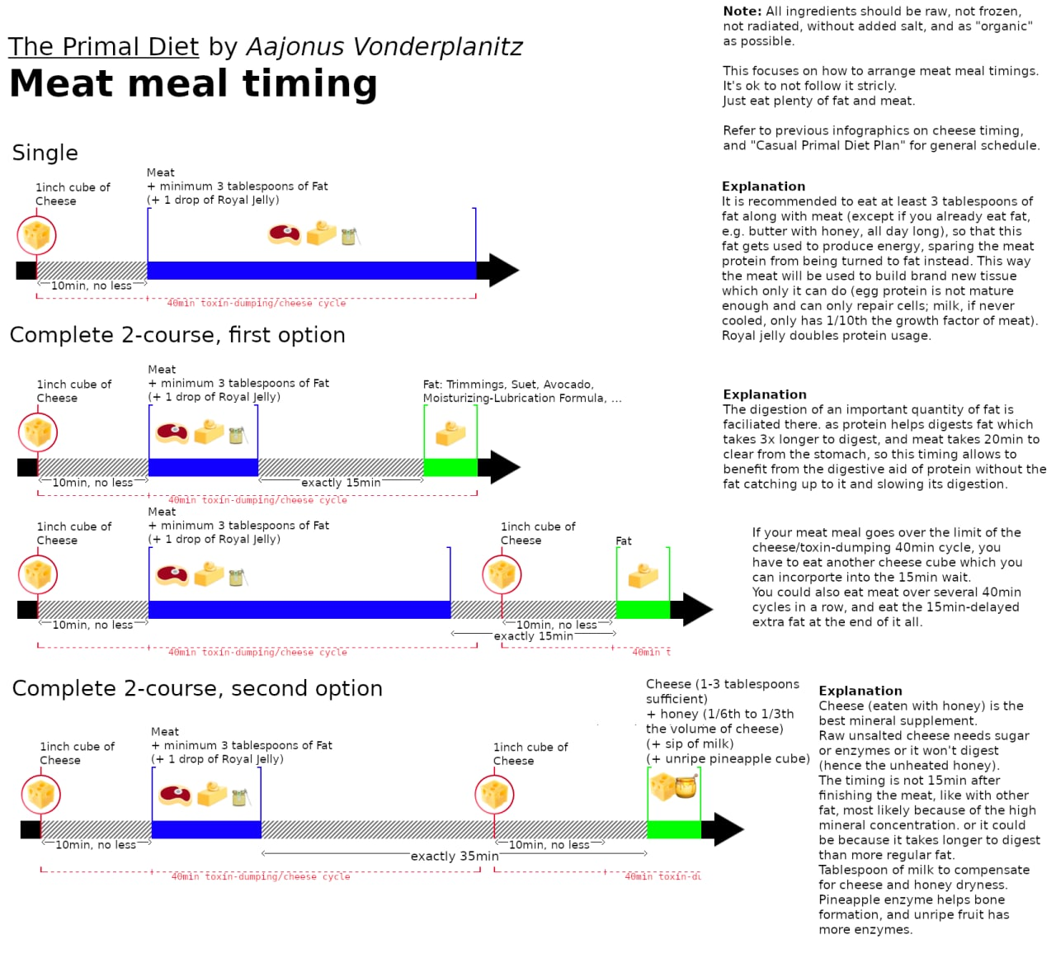
Making raw meat pâté, and fermenting that raw meat pâté into a sort of “deli” meat (or marinated), is a major game-changer. You will not need to do that many raw meat recipes after that when you get tired of the taste of average quality unseasoned raw meat on its own.
The bacteria will develop its flavors in a pleasant way most of the time, unlike high meat which is not always appealing at all times, will improve the texture of the pâté which can be bland, give it some colors of deli or cooked meat, and improve digestion, giving more energy and requiring up to 1.5 less hour of sleep per night.

Weight cycles

Keeping extra body fat (at least 15 pounds) for at least 3 months enables the body to use that extra body fat to create solvents that remove toxins within deep tissues in every area of the body.
Shedding that weight off removes the toxins from the body, at a very fast rate.
This is the weight loss cycle.
This also enables to discard “bloated” fat. Every time, the fat can look better on your body, and stack up in more “natural” places. Raw fat is compact, cooked fat can swell up to 50 times its initial volume (look at bacon frying on a pan).
That extra weight can be kept up to around 3 years however, that is the time it takes for the body to saturate its internal fat storages in toxins. After that point, when it is time to “change the oil”, the body has to discard them, so it usually puts you into several flus in a row, as a way to expel that toxic fat.
Eat the diet for flus/colds, and one of the best time to go into the weight loss programs is right after one such fat storage-induced flu has completed.

Cuts, injuries

- Lime juice over injury
- Then unheated honey
- Then raw fat (like butter)
- Then raw meat (boxers healed black eye with raw steak applied to their face)
- Then a slice of watermelon to keep it moist
- Then some plastic to keep it wrapped.
Most of these are optional, any will help.
Discard the meat before It dries.

Hot baths

One of the most important quotes from Aajonus:

"I recommend everybody – unless they’re an athlete who sweats ever day - get into a hot bath for 40 minutes. It’s important because that will stay under your skin and if it builds up year after year, it causes deterioration of connective tissue, destruction of skin, and can lead to lupus, MS, destruction of your nerves - all of your tissues internally. You’ve got to perspire those poisons out of your body."

A 45 min 39-42°C hot bath, or in general making sure to sweat every 4 days, sometimes more often for comfort, like 2 days in a row, or every other day, is strongly recommended, for anyone, whether on the diet or not. Since this diet leads to more detoxification, it can be considered as mandatory to do so, to avoid continuous damage.

More than an hour long hot baths 39-42°C are "lymphatic baths".
They are made to decongest the lymphatic system.
The lymphatic system’s function is to clean your body, however, it is jammed because of seed oils, which harden into plastic-like substances in our body, and only these baths can remove them (safely).
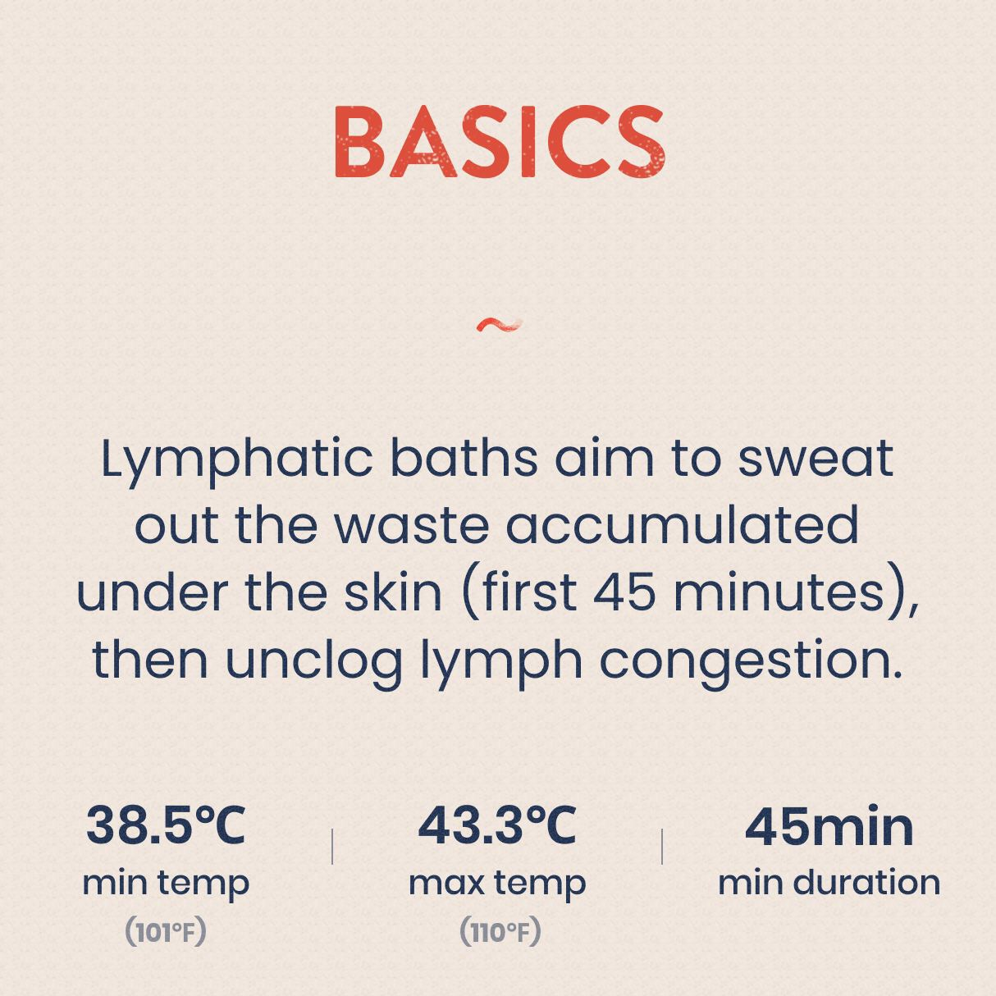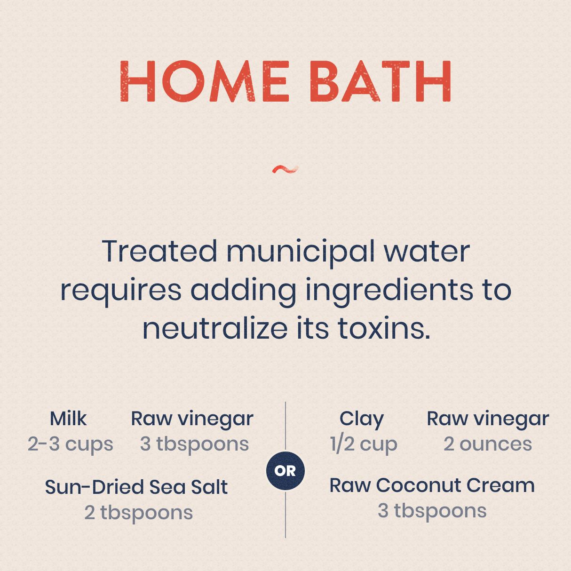

EMF

Artificial electromagnetic frequencies can be quite detrimental.
It is proven that more than 3 milligauss cause damage to animal cells.
Some machines emit so many of them that they can damage you for months.
Most are just daily appliances that add up, and end up causing a non-negligible effect on our health.
Some people, by only reducing their exposure to EMF, become much healthier. Some people have become completely EMF-sensitive and need to live in EMF-zones, without signal.
The Primal Diet will make you stronger, and more resilient to EMF, however, it is still recommended to be aware of them and avoid whenever you can.
For example, if you can replace your home Wi-Fi with ethernet connection, that will be a huge plus.
If you move your desktop computer 1 meter away from your feet, that is another significant gain.
Avoiding to sleep with your smartphone next to your head.
Etc.
Grounding is a practice which can help undo the damage caused by EMF, along with the diet. Walk in nature, bathe in rivers and hot springs, …

Sun

10 minutes to 1h of direct sun exposure daily on the two side of the body is good on this diet.

If you want to tan, only do 30 minutes of sun exposure on the first day of sunbathing, then you can do longer the next days.
If you just washed (removes the natural oils for you skin), put raw butter on your skin. Some oils such as olive oil can make you tan faster, but they can also magnify the sun too much and cause some burns.
Avoid washing yourself the same day after sunbathing because you will strip away all the oil and the Vitamin D that was obtained, before they can reabsorb.

If you sunbathe for a long time, you could get a lot of Vitamin D from your skin, which can trigger a deep bone detoxification.

Sleep

Sleeping as often as needed, taking naps.
A lot of detoxification, and healing, happens during sleep. Sometimes, headaches, etc., can be solved by going to sleep. Detoxifications may get stuck and only move after sleeping, or as the phrase says, “sleeping it off”.
90% of the nervous system detoxifies at night, so whether you sleep or not, if between 3 to 5:30am, you are awake, and feeling pressure in your head, nausea, etc., it is because of that. Have raw unsalted cheese, other foods that you can, and wait until it settles down to sleep a few more hour.

Bowel movements

The tips found online are not always accurate.
Some people think that because yellow feces that floats indicates a difficulty to digest fat, however it isn’t so simple.
Raw unsalted cheese will never be digested for example, that’s normal.
Fat digestion can work very well, but some detoxification can occur and give the impression that it is impaired, when it is not.
If you have a bowel movement every 24 hours, and it is dry, that’s a sign of got good digestion.
If you have constipation without pain, it is caused by the nervous system starving of fat. Eat more raw cream, and perhaps do fat suppositories if that is not enough.
If you have constipation with intestinal pain, it is caused by congestion.

Blood tests

Blood tests aren’t necessarily a good indication of the overall state of the body.
The presence of certain substances in the blood can be different at any time, and the body can put more or less of it depending on many factors.
Eating more raw fat could lead to less cholesterol, or more cholesterol, in the blood, at varying times.
The blood is also a detoxification pathway, so there will be high quantities of certain substances circulating through it which are not indicative of a pattern.

Avoiding contact with external toxicity

Living in polluted areas, wearing clothes made of synthetic fibers, …

Living in hot climate is preferable

Heat is good for healing, helps the body save a lot of energy.

Physical activity / Sports

Aajonus says we need around 2h of light physical activity daily (walking, moving around, etc.) daily.

And 1h of sports or 20 min heavy singing per activity ring (see the iridology section at the end).

Too much intense sports practiced regularly could be damaging, and getting in the way of healing. On this diet, the body may want to undergo deep healing phases in some body parts, it is best to let it complete that and only resume sports afterwards. Without any training, your performance will be better, with brand new tissue.
Iridology (see the section towards the end of this guide) can help tell you further which areas of your body are damaged or currently infected/healing.

Stretching

Aajonus says that not much stretching is required.
He recommends the plow as the only daily yoga pose that you could need.

Posture

Primal Diet doesn’t address posture very much.
Besides the stretching exercises, Aajonus just mentions sleeping with the head slightly lifted up.

Meditation

Meditation is not mandatory.
Here is a quote from Aajonus about it:
“When you excite the kundalini, you raise the blood, the body’s temperature. There’s no way around it. At least I never met a yogi who taught otherwise. It always increases heat. But to me, that’s a good thing because it causes more discharge. You’ll do more cleansing of protein levels, cellular levels if your body heats more.”

Stress

Stress can use up more body's resources.
(Don’t we hear often about some people compulsively eating ice cream under stress? Cream being a fat that can feed the nervous system.)

Sex

Sex or masturbation according to your current needs.
Toxins unfortunately store in your sexual glands, and the body needs to expel them, otherwise they will keep causing damage.
However, on this diet, if done properly (as this guide intended to teach), there isn’t to worry about deficiencies from ejaculating.
There is an entire section later in this guide on semen retention.
Note: women can also discharge from masturbation.

Period

Raw white/green cabbage juice (not mixed with other juice), half a cup a day, can lower excessive bleeding.
Period cramps can be caused by protein assimilation deficiencies. Eating raw mushrooms with raw meat, together or separately, can correct it. Also, consider pâtéing all your meat (see the guide towards the end of this document).

Pregnancy

During pregnancy, the body cannot use the period anymore to detoxify.
This leads to a surplus of toxins circulating.
To prevent those toxins from harming the baby, eat enough raw unsalted cheese and raw green juice to get rid of all toxins / over-acidity.

More raw white meat leads to a smarter child, while raw red meat leads to a more athletic child. Both for a balance.

Massaging

Light massages only (stronger massages cause damage to the skin, the lymph)

Psychological

Activities to express oneself and strive towards goals.
In We Want To Live, he lists not only physiological reasons, but also psychological reasons, for certain conditions, such as asthma, and agoraphobia.

Brushing teeth

Brushing teeth every 3 days at least to prevent plaque.

Brushing teeth 1x/week with formula to remove plaque.

Toothpaste recipe:
- one tablespoon of coconut cream,
- two teaspoons of terramin clay
- one half to one teaspoon of raw apple cider vinegar.
“It actually whitens teeth, as well as just rips the plaque off of the teeth – just melts it, dissolves it away - without damaging the dentin, unless you brush too often with it.
Once a day is fine. And you brush it down into the gums.
I don’t use these big toothbrushes; I don’t think are good. I think you should get one of those baby toothbrushes, very soft. And just brush - work that down in there.
And it will dissolve the plaque so you don’t have to have deep root cleanings. I have found that I haven’t had to use my water pick. Maybe every three months or something like […]
And also found that when you use this particular formula, that it helps gums reverse the receding. In the last four months I’ve also experimented with bone marrow. And applying bone marrow and rubbing it into the gums and even brushing it into the gums will bring the gums back almost a half of a millimeter over night.”
— Aajonus

What if you have dental amalgams and want to remove them?

Dental amalgams are toxic. However, removing them leads to intense detoxification. It is better to wait 2 years on the diet to remove them.

Hair loss

This is a major topic, so it deserves its own section.

Hair loss is mostly from toxins leaving through the scalp and harming the cells as they come out.

The hair follicles and other cells on the scalp can be strengthened to withstand the contact with toxins passing through better.
It's also possible to redirect part of the head/brain toxins to be removed through different pathways.

It's also possible to promote hair growth so that even if hairs fall, they will grow back and stronger.

The brain being made of a lot of fat stores important quantities of toxins, so there will be significant amount of head-related detox through the local pathways including hair.

A diet such as this one makes the body stronger but also promotes more detoxification, so it is a sort of balancing act. If the important things are considered then there should be improvement in hair (both quantity and quality), on average.

Here is a summary of guidelines from Aajonus' Primal Diet for hair loss:

The main elements from the diet (whether on 100% or not) are still the basis including for hair loss (the sections like Rules of Primal Diet cover them well):

- Having enough fat ensures your hair follicles are protected.
Plus, when detoxifying your hair can get more dry, the fats are being pulled away from it. Then it can fall. So more fat is the main way to protect.
Eating a lot of raw butter, and also some raw cream, because the raw cream feeds more the nervous system, so the brain. This is less toxins for the hair to deal with.

- Raw cold-pressed vegetable juice (mostly made with organic celery) binds to many toxins that the body releases from stores, otherwise those toxins will harm tissue everywhere including around hair.

- And raw meat strengthens and regenerates cells, creates new tissue, promotes growth, etc.
For example eating 1kg of raw meat per day (or 500g of pâté or 250g of pâté with royal jelly ...) can make hair grow very fast.

NOTE for what follows: not everything is necessary. Any of these you add will help, just add as many as you want/need to take things further.
The part above was what was really important, if you apply the things below without the things above you could get inconsistent results.

Now for slightly more specific things:

- Raw unsalted cheese
That can redirect toxins away from the hair/scalp so they can be dealt with in the gut instead. Also does the same for rest of the skin and for flus.
1. absorbs toxins from the GI tract very efficiently so that they don't get recycled with the food you eat and end up sent to various places of the body where they could create more harm before being stored again.
2. Not only that but this type of cheese also draws toxins from surrounding fluids (blood, lymphatic fluid, and nervous fluid), to itself as it goes through the gut.
(Amounts: 3 tablespoons in the morning at least, adding one piece 10 min before each meal is even better, and "cheese trains" in between meals if you are a G).

- Oysters
White meat, especially fish or shellfish, such as oysters, nourish the nervous type of tissue even more than other kinds of meat.
On top of that, they contain a lot of minerals. Minerals along with fat are the main "nutrients" that bind to toxins to neutralize them.
Minerals from animal foods, especially meat, enable a type of detoxification that is very balanced, with a lot of "buffering" to it. Aajonus says it promotes brain detoxification with the least symptoms, basically. (Therefore another thing to spare hair)

- Lubrication formula
This is a formula that makes the fat that is part of it reach the "starving" parts of your body that get less fats than other parts, such as skin and hair.

- The hydration formula
Just like celery juice, this formula binds to a whole array of toxins. It complements the celery juice well.

- Clay milk. Similar thing as the oysters. Another optional formula in the toolkit to go even further (not mandatory).

Now for the topical treatments:

- Rub butter, bone marrow, on your scalp. That strenghtens the cells, they can eat directly and so don't the body doesn't have to split that fat with the rest of its parts.
Fermented milk is good too (but leaves "curds" that dry).
The regular egg on hair is nice too but it dries off pretty quickly and not a lot of fat that gets the time to be absorbed by the cells, it's effective as a regular shampoo but you may want something stronger to really feed your hair.

- Every other day, throw raw apple cider vinegar on your scalp. It can neutralize the toxins coming out of the scalp.
(It's important to alternate so that one day is focused more on pulling the toxins out faster, the other on strengthening the cells, otherwise just putting vinegar all the time could weaken the hair cells).
The apple cider vinegar can be mixed with pre-moistened clay. Applying on the hair helps remove dead cells on the scalp/skin, exfoliates.

- Can also use raw (usually homemade) coconut cream as a shampoo, it draws toxins out from the scalp the best, especially if fermented (beware though it stings if it gets on your face, you will need milk or egg white to wash it off and stop the burning). Vinegar is very good though.

- Oil pulling (or cheese pulling with raw unsalted cheese).
Draws out toxins from the brain through the gums, this way there could be less toxins sent upwards through the scalp if the toxins are dragged down into this fat.
Swishing around 10-20 minutes some oil in the morning or packing some raw unsalted cheese on teeth.
Can even leave the cheese on at night so it continuously draws through the night (pretty good since 90% of the nervous system detoxifies at night according to Aajonus, and that can take a lot of nutrients and energy, that carries on to fatigue throughout most of the next day if not matched with enough food).

Finally, the best hair regrowth formula Aajonus tested, quote:
"I have recently been utilizing floured mixed peppercorns to grow hair and stop hair loss. (#Rogaine, the famous hair restorer, is made from peppercorns but has lots of chemical additives.)
I blend 2 Tbls each of black and white peppercorns until it is a powder. I add 3 ozs. of rain water (or distilled water not from a plastic bottle) and blend for 1 minute on medium speed. I allow it to stand in a dark cupboard for a day before I begin applying it.
I apply it on a clean scalp by dipping my fingers into the peppered water and rub it into my scalp. I leave it until I wash my hair. You may apply it every time you wash your hair as long as it does not irritate scalp. Because the pepper can be irritating, I suggest applying it only every 3rd day.
Within 3 weeks I noticed a thickening of my hair on my longtime thinned hair on the top of my head created by radiation and chemo therapies. I have only applied it once or twice a week after washing my hair.
My mixture is working with each of the 5 people experimenting with it."
— Aajonus, 2003

Skin care

Topically, applying raw butter, raw bone marrow, raw kefir, or raw coconut cream feeds the skin.
Kefir absorbs the fastest because it’s predigested, so it can be the most efficient.
Raw coconut cream is the best moisturizer.
Aajonus often recommended half raw butter half bone marrow mixtures as well.
Making Aajonus’ Primal Facial cream can also feed the skin.
For some people, an ingredient will work, while for others, another will work better.

Raw oils can help tan faster but magnify sunrays and can lead to sunburn.
When sunbathing, do not bathe before, as that would wash off the protective oils from the skin, or rub raw butter to replace them.
Only sunbathe 30 minutes the first day of sunbathing, to avoid burning.
You can sunbathe unlimited time the following days.

For moles, scars, rubbing raw unripe pineapple or raw vinegar will gradually dissolve them.
Rub gently for 20 seconds and leave on until the next time you wash.
Do not do it too frequently, only every 3-4 days.
Every other day, put raw animal fat like butter to feed the cells and strengthen them, otherwise healthy cells could also start getting damaged by the solvents that are in the pineapple and vinegar.

Eyes / Vision

The eye is connected to the rest of the body by only one nerve, so it doesn’t receive much nutrition. Topical feeding can particularly help with it.
Egg white drops feed the eyes well. Melted raw butter can also be used, however it takes 20 minutes to absorb, so better do it when in bed.
To correct vision issues, Aajonus recommends pinhole glasses. He says it’s a muscular issue.
For scar tissue in eyes, Aajonus recommends to dissolve a drop of solvent like vinegar 10 times, for example, in milk, and dropping this in the eye.

Snorring

If you snore, you might have scar tissue in your nostrils. Dilute raw vinegar in 10 times its amount of water and snort it.

Step 3: Look up specific remedies

On a day-to-day basis, you can look up in We Want To Live or one of the equivalent resources a particular condition you are encountering, and finding the remedy to apply, within your existing diet frame. Or even if you don’t follow the complete diet, remedies do work to a great extent.

Items of the diet: Index of Ingredients and main Recipes

The interactive food pyramid and other tools are available on https://healthfully.ai/primaldiet

#1 🧈 Eating a lot of raw animal fat

Fat does everything from providing energy, to both detoxifying and protecting from detoxification, to building and strengthening the body tissues, cell membranes, brain, hormones, ...
The bulk of "calories" should come from fat.
200g min, 300g average, can aim for 500g
(just to give an idea, since most people who do the diet still only stay at the "minimum" figure not realizing it would be considered a lower end although it's "a lot" by standard measures)

#2 🥩 Eating a good amount of raw meat

This is tantamount for healing. Raw meat protein can be used for growth, to build new tissues in a way that milk and eggs can't.
Eating too much lean meat will lead to energy crash, and also suffer from damage from detoxification in the absence of enough fat. A lot of extra fat is required for this reason. Some people make this mistake, even when thinking they have the proportions right.
Sometimes you'll want a lot more meat than usual for anemia or blood loss or if you want fast growth (example: longer hair).
200g minimum, 300-500g average, 1-2kg "maximum" (there is not really a maximum, only how much you can digest and how much extra fat you can keep up with).
Some people drink too much milk and not enough meat.
Note: In case of leaky gut, you replace meat by raw eggs (eaten one at a time) until able to eat raw meat again.

#3 🍵 Drinking as much celery juice as needed

Juice is necessary for many years to digest more meat and fat, and to remove certain toxins that burden the body's function and digestion a lot.
It supplies extra micro-nutrients: vitamins, minerals, enzymes.
Minimum is 2 cups (500mL) a day. That's just to deal with the toxins.
2 more cups helps replenish the micro-nutrient stores of the body.
However, it is often overlooked that the quantities depend on one's individual needs, some people will need much more, even if temporarily. It can be 2, 3L for a few days, or weeks.
Without enough juice, it can be hard to do the diet at all even after years.

Vegetable / Green juices are a main component of the Primal Diet.
They are obtained by slow masticating juicers such as Omega, Greenstar, or Angel, because fast juicers or blenders destroy many nutrients in the juice by heat or exposing them to oxygen.

They are mostly composed of celery juice, or sugar cane juice, there can be other specific vegetables in varying amounts.

Vegetables are mostly unedible.
Their fibers, made of cellulose, are too hard to digest for carnivores.
Herbivores have several stomachs and 60.000 more enzymes to digest it.
When eaten, the fibers lacerate our stomachs, and prevent digestion of other foods, like meat.
This is fixed by juicing them, which removes most of those fibers.
Vegetable juice doesn't contain a lot of sugar, unlike fruit juice.

Juice has many functions, from removing toxins, to giving appetite, correcting deficiencies, etc.
It is very important.

There is a natural equivalent in carnivores.
For example, any dog or cat
They go and chew on a few blades of grass,
swallow the juice and spit the pulp.
It is a medicine for them.
Because of our toxicity levels and deficiencies,
we need much more for many years.

Juice contains nutrient-bound water:
it is good for hydration.

Celery contains lots of sodium.
The blood is very high like the ocean in sodium,
Celery meets that almost perfectly
without causing the clumping of the sodium molecules that rock salt does.
Salt will destroy red blood cells very quickly, numbs nerves, burns them,
ages prematurely inside even without noticing it, until it hits all of a sudden.

The nutrients from the juice bind to toxins in our blood.
Alkalizes the blood so we can eat enough meat.
Without the juice, we will get so acidic
that we will be repulsed by all meats, especially red meat.
It is because toxins are very acidic, and make us over-acidic.

Fish also helps that.
Fish is still acidic but there is a high mineral balance and it will help neutralize.
The high mineral balance in the fish when you are eating it with the red meat helps neutralize some of the ill acidity that might be created when the blood is overly acidic.

It still takes the juice to alkalinize the blood by cleansing it.

Green juice is also the main (bioactive and non-toxic) "supplement" of the Primal Diet for micro-nutrients.
It has lots of vitamins, enzymes and minerals.

2-3 cups a day
are enough to take care of all the toxins,
and the missing vitamins, enzymes and minerals
in the food that we eat, which is not the freshest and has some deterioration.

1-2 extra cups a day
help revitalize and replenish and restore those leached from every time we have eaten cooked foods

When we eat cooked foods,
which are deficient in micro-nutrients,
enzymes has been destroyed, many vitamins, minerals cauterized, etc.
by the excess heat,
our pancreas has to send out hormones to every cell of the body,
giving order to every cell to leech from their own nutrient stores
to digest the cooked foods,
leading the body to getting weaker and weaker,
which in old age results in inability to digest more and more foods.

The extra vegetable juice helps restore some of what leached out through the years.
It takes many years to do so, 20-40.

Aajonus noted that on his journey to discover the Primal Diet,
when he started eating more meat,
he feared he would crave more fruits,
which he did.
But by drinking vegetable juice,
his cravings for fruits subsided.
It is because the vegetable juices supplies the enzymes, minerals, vitamins, useful to digest heavy foods like meat and fat.

Having too much fruit, because of its sugar, can lead to nerve deterioration, mineral deterioration, and manic behaviour, mood swings, depression.

Consumption
Vegetable juices require an alkaline environment to digest.
Certain bacteria and enzymes only work in acidic of alkaline environments.
They can't be had with meat, which requires an acidic environment.

Vegetable juices should always be separated by 1h from meat meals.
Except in the morning, because we are much more acidic, only 45 minutes.

They can be had with any fat, even animal fats, because those are neutral.
For example: adding raw cream, which can be helpful to deal with toxins that the juice pulls out.

An egg can sometimes be had, even though it has animal protein, as raw eggs digest the easiest of all animal foods.
A whole egg whisked (not too much to avoid oxidation) is mostly for when the juice gives a strong reaction, the protein can help bind to the toxins causing it.
Sometimes however, eggs won't digest with juice in some people, and should be avoided entirely.

Vegetables

Aajonus has tried every kind except for herbal juices which are rare and hard to get, fresh.
He tried all of the typical vegetables, spinach, celery, lettuces, all of those.

The only ones he uses consistently, because consistently they are the most healing, are
celery, and parsley.
Always, no exception.

Celery, anywhere from 60-80%, sometimes even 90%.

Parsley, anywhere 5-20% (high in carbs)
Helps with oxygen absorption.
Contains Vitamin E and chlorophyll.

If there's somebody who has a skin problem, 5-10% cucumber or zucchini.
Cucumbers are not vegetables, they are bland fruit, and cannot replace the vegetable juice.
However, they can be added to vegetable juice (preferably with the pulp which in the case of bland fruits is useful).

Carrot (30% max, high in carbs)
Can remove toxic bile especially from individuals who used to be skinny
Which can give an orange tint, from the detox of the toxic bile stored under the skin, not from the beta-carotene in carrots.
This is why some Asians have more yellow skin, they used a lot bile to bind from a lot of rice consumption, according to Aajonus.
Its sugar can fuel the brain, but in too high quantities will be damaging.

Beet (10% max, high in carbs)
Helps in production of hydrochloric acid (used for protein digestion)
If done for too long periods of time however, can lead to protein deficiencies.

Cilantro (5% max and not for all)
Removes heavy metals, mercury deep-rooted in tissue.
It triggers more detoxification and can lead to dementia, cellular damage,
if used in too high quantities.

5-10% green/white cabbage juice
is extremely useful in case of bleeding, hemorrhage, to stop it.
It helps clotting by providing Vitamin U and K that are often destroyed by toxins.
Red cabbage does the opposite, it increases bleeding, but in some cases, it can help thin the blood when needed.
Sugar cane can substitute celery.
Fennel may be able to substitute celery.

Some unheated honey, and lemon or lime juice, can also be added.

Warning
Do not juice wheat grass.
It does the opposite of what we want,
makes the blood even more acid,
and the digestive system alkaline (which prevents us from digesting animal foods).

Do not juice too much vegetables high in sugar.
Aajonus observed that his clients who did a lot of carrot juice, initially healed cancer, but it came back.

Detox of Vegetable oils
The bacteria in vegetable juices
can help remove cooked vegetable waste, tars and residues,
that create congestion in our body,
which can lead to cancer, heart, prostate issues, etc.
Fermented vegetable juice has much more bacteria, less nutrients (from oxidation), is more detoxifying, which can be too srong.

Anti-nutrients
Vegetables are often said by carnivore dieters to contain too many plant toxins.
Especially oxalates for certain green vegetables,
which are said to cause kidney stones.
However when juicing, most of the oxalates remain in the fibers,
and the remaining get neutralized by the juice's own minerals,
which bind to them, so we don't absorb them.
Certain vegetables like spinach have too many oxalates,
so they should never be juiced in high quantities (no more than 5-10% occasionally).

Non-stagnating diet
Over the course of years on the Primal Diet,
our need for juice, if taken consistently, decreases.
Aajonus dropped 1 cup of juice every 7 years, for example.
Protip: remove the leaves before juicing, they are too bitter and make a fibrous texture.
Strain through a double layer of organic cotton tissue (cheesecloth that you washed with raw whey/vinegar) to remove 50% of the remaining fibers.

#4-A 🧀 🍯 Raw unsalted cheese with unheated honey (or moldy/blue cheese)

This is essential:
The only combination that can provide a concentration of extra minerals of animal origin, which are most important as they can also be used to build the body.
(Plant minerals (e.g. celery juice) can't, they specialize in binding to toxins and other metabolic functions.)
With eating more fat, the need for eating more minerals arises, especially with a lot of butter. Otherwise that can lead to a mineral deficiency over time.
Mineral deficiency whether from toxins or from being used by digestion, means loss of bone and teeth, among other things.
PDers who don't do enough milk / cheese with honey / juice / too much fruit or vinegar can get this.
Minimum: A tablespoon per day
Recommended average: 3 times 1 tablespoon
Maximum: no limit, can be up 500g per day (very good, for weight gain as well).

#5-A 🧀 Raw unsalted cheese (“trains”)

The cheese by itself, without honey.
In this situation, it doesn't get digested. It instead is used as a "sponge" for toxins in the GI tract (and pulling from other places of the body).
By eating that before meals, the food gets digested 2x more, and intestinal discomfort diminishes by like 90%. It is not negligible. Not mandatory, but almost. It is hard to imagine doing the diet without.
Minimum: In the morning, 3.5 tablespoons.
Recommended average: Also no less than 10 minutes before every meal (even if the meal is liquid food).
Maximum: none really, cheese trains can be as often as you want. Can be every 15 minutes when not eating other foods, even more will take out toxins at an accelerated pace, it is the most painless method and cuts down detox from dozens of years to a few only.

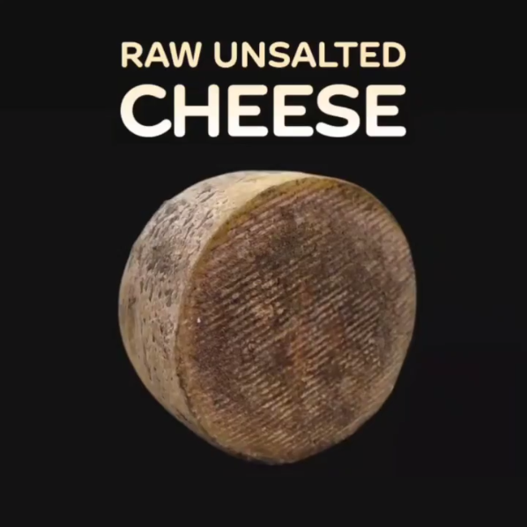

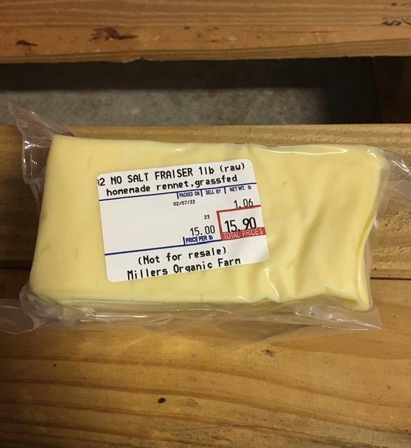

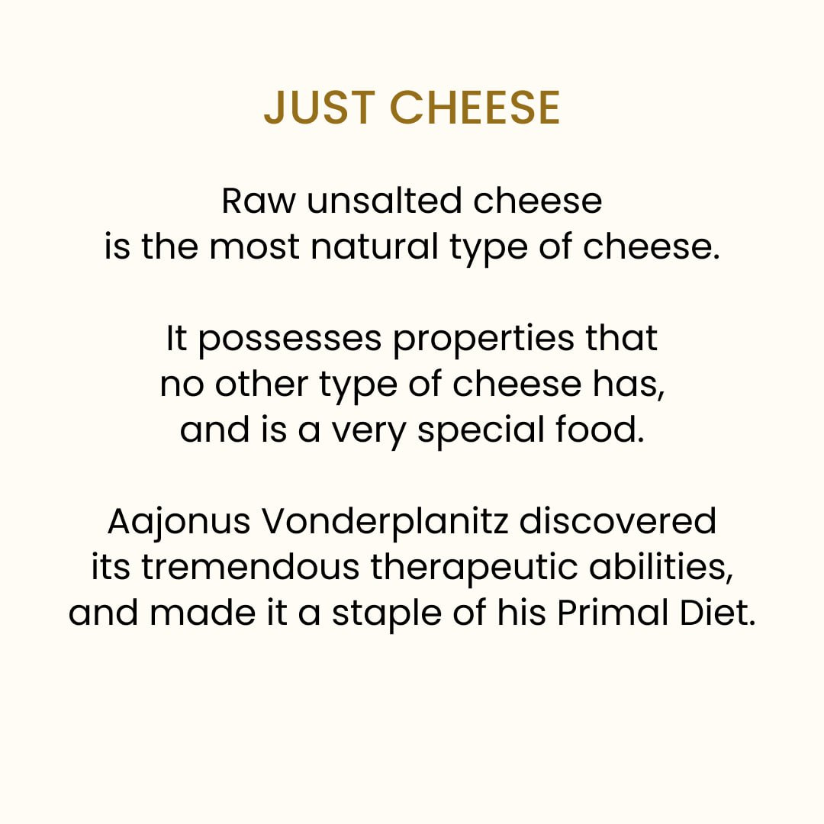
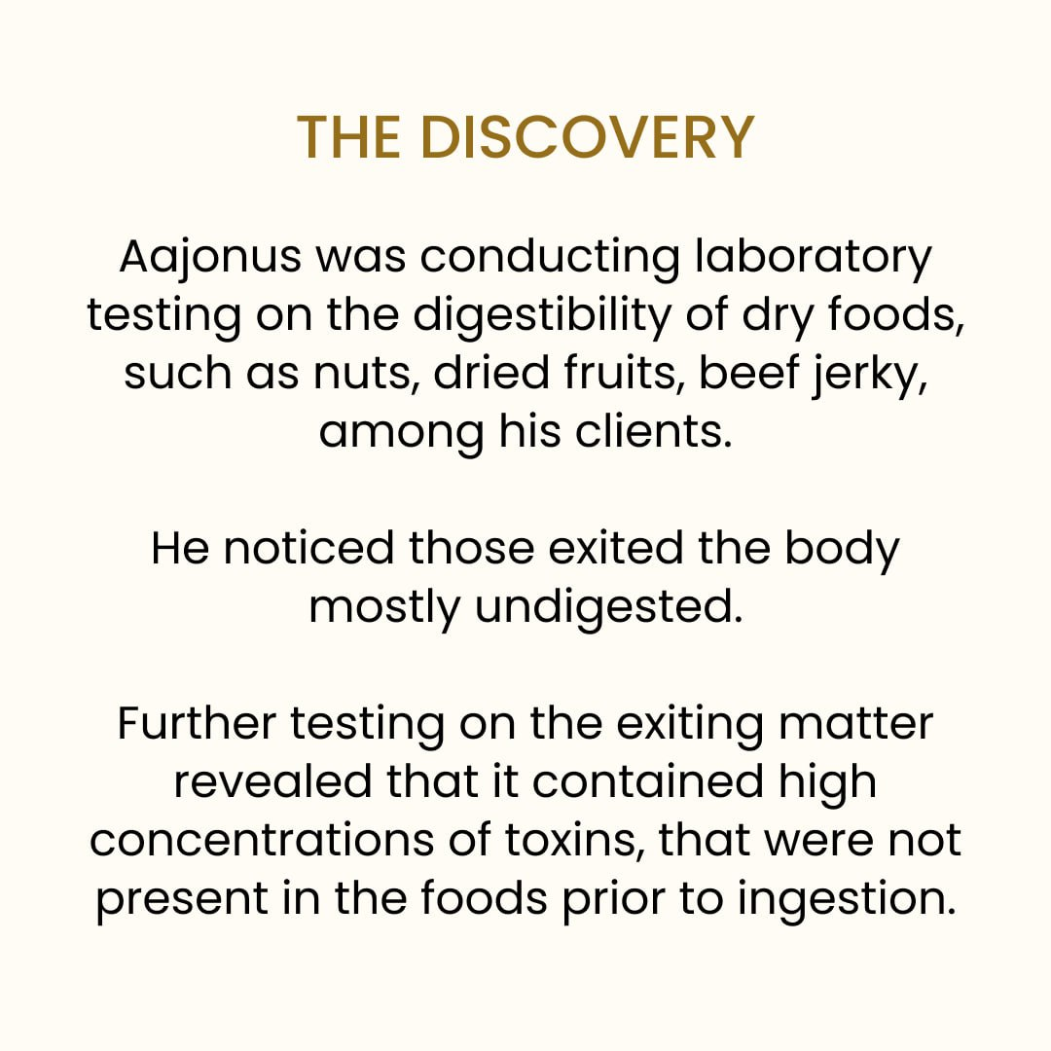
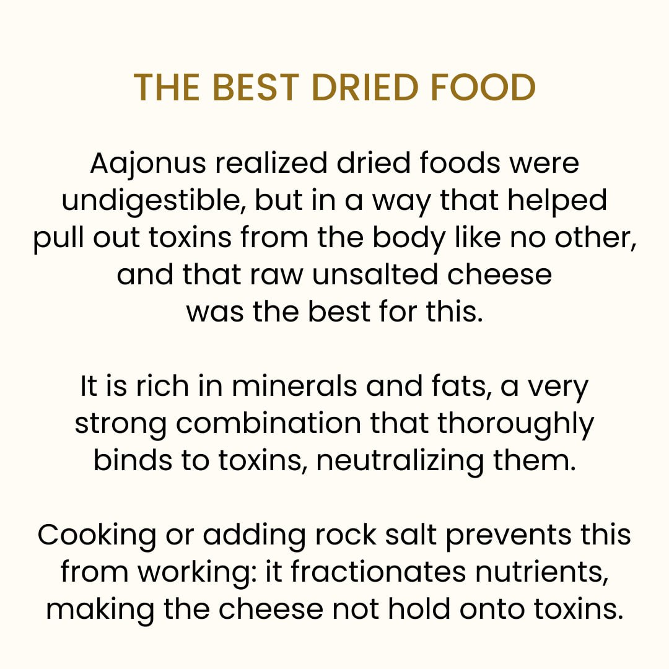
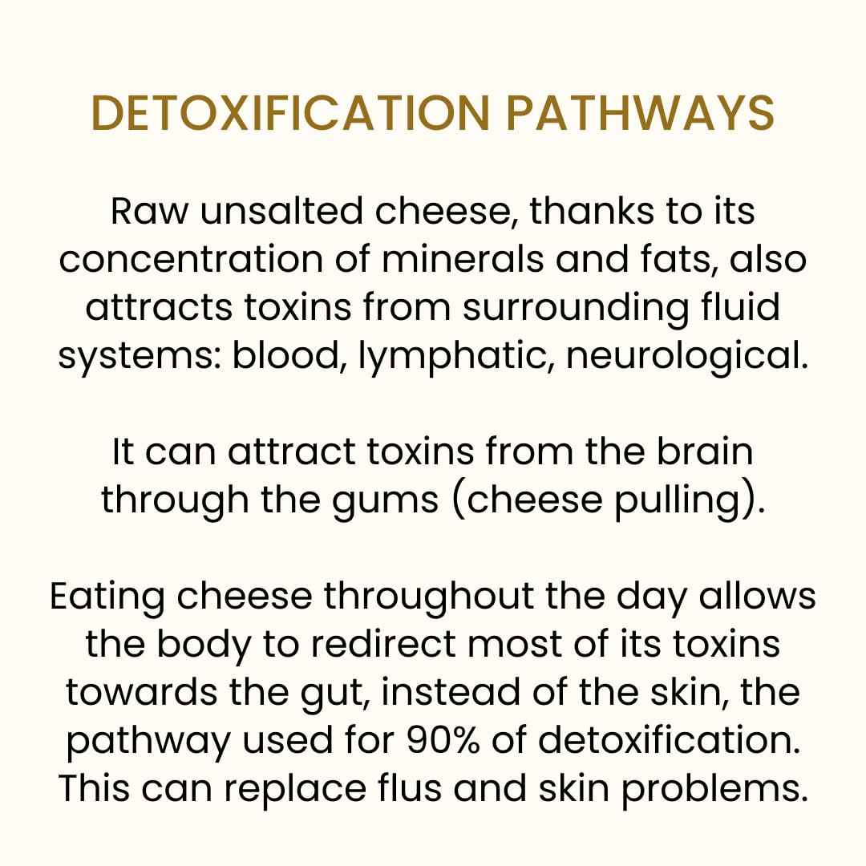
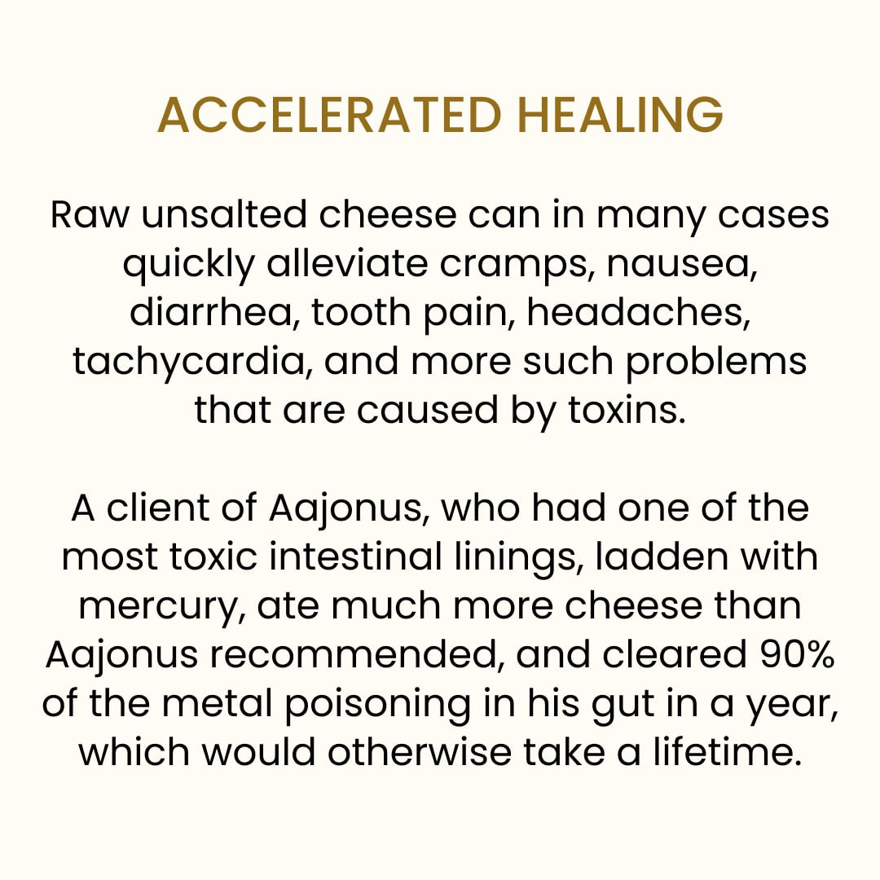
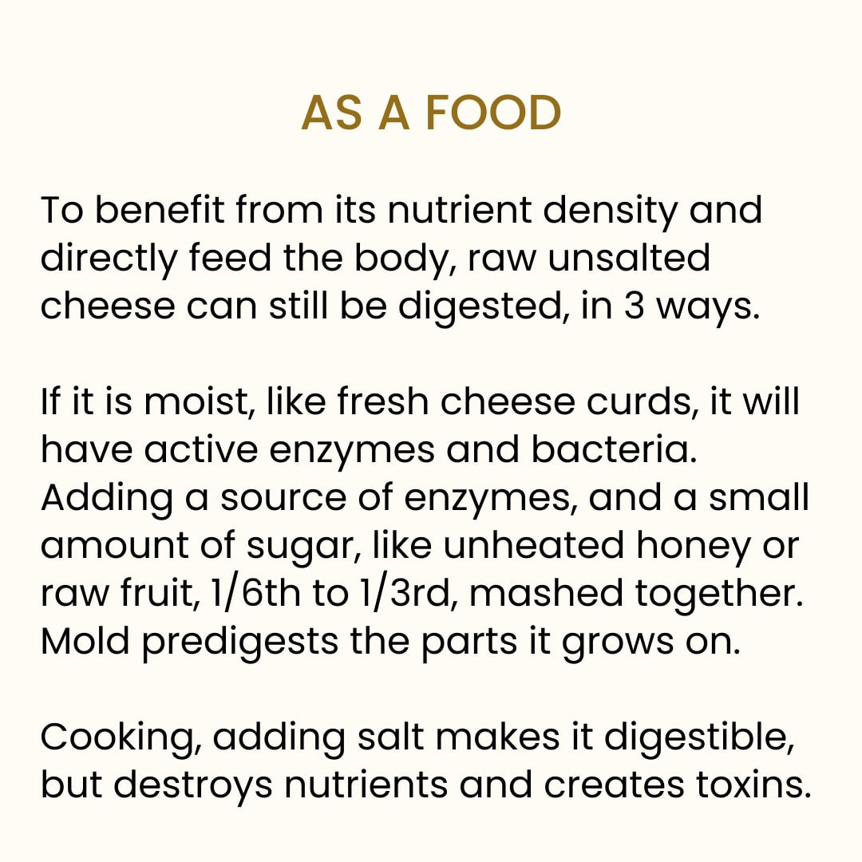

#4-B 🥛🥚🍨(🍯) Milkshake

Milkshakes, with the whole raw egg, and the extra raw cream to be effective, are the best thing to produce mucus, which protects the mucous membranes, such as in the intestines, kidneys, many places.
Without them, poisons can dump into the membranes and leak, cause damage, causing a lot of heartburn, vomiting, etc.
A few servings per day is good. Usually not too much (like liters of it) as it will be a lot of liquid and that much is not required to produce mucus, and for minerals, fats, etc. everything it has, other foods with less water and so more concentrated in those nutrients are better suited.
This is often an overlooked food.

Recipe:
- 1 egg
- 85cL milk
- 55g cream
- 20g honey
Ingredients need to be warm.
Blend well together.

Other notes:
- Good drink
- Easy whole nutrition
- Good for putting on weight
- Good for vegetarians
- The combination is particularly effective to restore mucus
(which is what protects the mucus membranes).
It takes the egg white and milk proteins, and the extra cream,
to do it the most.
The mucus is necessary for example in those case:
• Good to fix leaky gut/Crohn's disease
• For respiratory problems (flu, colds, bronchitis, ...)
• If throat burns (e.g. when eating high meat)
- Drink mostly in the afternoon as it is not low in sugar.
- Harder to digest than just milk; honey and fermentation help.
- Although the honey helps digests
in some people it's too much detox for a while.

#5-B 🧈🥚🍋🍯 Moisturizing-Lubrication Formula

This recipe has the effect of sending fats to places of the body that rarely receive any fats, like joints. Those places are very deficient in fat, not well lubricated, contain a lot of toxins and are prone to more degeneration.
On a daily basis, it's hard to eat enough fat for there to be enough left for these places, so it is useful to have some of that fat amount be consumed in the form of the moisturizing-lubrication formula.
Recommended amount: One or two a day
Maximum: Not really a maximum, can do many servings per day.
This food is often made wrong, by not getting the butter liquid enough to blend homogeneously with the other ingredients, or getting it too hot. It takes time to get the making process down.

Recipe:
- 1 egg
- 56g butter
- 1 tablespoon lemon juice
- 1 teaspoon honey
Ingredients need to be warm.
Blend well together.

It is a recipe to speed up the digestion of butter so that it reaches underfed parts of the body.
Lemon promotes fermentation,
honey contains enzymes, and egg has very easily digestible proteins which help digest fats and that the protease in honey seek out.

- Good to gain weight, eat large quantities of fat.
- Good to make butter palatable and digestible.
- Really tasty; like pastry lemon cream.
- Good for skin, hair, joint problems.
- Can give nausea/diarrhea from detox a few times.
- Good to reduce pain during some detox.
- Best taken 15min after meat meal
Can be taken by itself too.
- A full meal with protein/fat,
so good right before sleeping
- Good to get a few harmless carbs in.
- Good to help with hydration (with the other things).

#6 🥩🦠 High meat

Fresh raw food has kept all its bacteria, but sometimes more is needed for better function of digestion, and the entire body.
More than 90% of the body's function is bacterial, and we restore only 1% per year (lost in only a few days on antibiotics) on a regular PD.
Sometimes a little piece per week only is necessary.
More can be better but it can also be detoxifying, it's better to have 2/3 of the meat being fresh for several years, and keep eating a lot of fat. Milkshakes sometimes too are necessary (see below).
Fermented milk (before it's turned to alcohol) and eggs are very good as well.

#7 🍹 Hydration formula / Sports formula/drink

Contains various ingredients that will bind to remaining toxins, or will act as solvents and break down certain toxicity and dead tissue in the body (certain fruits, vinegar, coconut cream, a bit of water, etc.).
Eating fat alone does this to an extent but this formula covers the rest.
Very few people do it, even partially, and although it's not anywhere close to the most important item, it's really useful and recommended at least once in a while, can be had daily. Sometimes it will be the thing you need.
Recommended average: every day.
Maximum: Maybe 2L max, 1L on most days.

plan was merging hydration formula and most of the fruit meal together. It is used by his client athletes for sports.
Sipping it throughout the day (just not too close to meat; about 30min separation before or after) ensures thirst is dealth with and constant
(but mild) detox, supply of energy, and acidic/alkaline balance,
probably better digestion too. It will clean the blood and protect your body from much damage all around.
With the right recipe, you can unlock tremendous amounts of energy.

A hydration formula can be as simple as 2-3 ingredients.
Here are almost all the useful ones you can put in it.
The bulk of it is cucumber/tomato/watermelon purée (hydrating).
Peel the cucumber. For watermelon, don't keep from the central part from the core up to the seeds which is a bit too high in sugar.
A little dairy cream (avoids damage from detox and sugar spikes). Best if it's sour.
A little coconut cream (makes strong solvent for detox)
A little honey.
A few eggs (makes even stronger solvents and gives complete nutrients)
Possibly a little naturally sparkling water.
1 tablespoon of vinegar (strong solvent) for a quart of formula.
Possible use of whey (hydrating and minerals)
Berries, especially blueberries and raspberries. (specific amino acid that chelates to heavy metals)
Unripe pineapple (strong solvent)
2 tablespoons lime juice (1 specific amino acid that chelates to toxins) with at least 2 teaspoons lemon juice (to counter antibiotic effect of lime, lemon incitates fermentation which is why it is a good marinater).

It doesn't always look good, but it tastes good.
With tomato it can be similar to gazpacho. With fermented watermelon and vinegar it can remind of cola even for non-primal people.
Also mousse (like on cake).
Or just regular smoothie.

#8 🌰🍯🥚🧈 Nut formula

Do this once every week to every month if you have anxiety or stress that could be caused by certain toxic hormones that damage the body, and aren't the ones from activity rings (those get removed by sports / intense singing).
Or in general if you have a craving for it and it isn't from under-eating.
Maximum recommended: twice per week, not two days in a row, to avoid triggering a too strong neurological detox.

The nut formula can considered a “nut butter” with real butter.
- 57g (2oz) nuts (not sprouted or preopened-heated)
- 60g (4 tablespoons) raw butter (/dairy/coco cream)
- 1 raw egg
- 42g (2 tablespoons) unheated honey
Blend nuts into a flour, then blend other ingredients.

Better than the best pastry in France. Good to offer.
Binds to some toxic stress/anger/anxiety hormones, cuts starch cravings, satiating, reverses some nut allergies!
Unheated honey, fat disable the enzyme inhibitors from nuts (that prevent protein absorption for up to 48h), and enables to digest their hardly accessible nutrients.

Usually no more than twice a week and not two days in a row to avoid potential strong detoxification.
Can be eaten with meat, but not with lemon, which will re-enable the enzyme inhibitors!
Caution: raspberries increase its nervous system detox.
Don't sprout nuts. Removes 1 anti-nutrient but 3x more.
Use these nuts: walnuts, pine, hazel, macadamia nuts, sunflower and pumpkin seeds. Can be a combination.
Avoid those: almond (hard to digest), peanuts (toxic).
Exists as a pasta substitute in the recipe book.
Can be added to ice cream as "dough", cheesecakes, ....

#9 🏝 Clay (non-volcanic and with milk)

Another great mineral and micro-organism supplement.
It's a special life-form that can shapeshift, and in the body's environment, can generate bacteria or other micro-organisms that the body needs more at the moment.
Dosage: 1 tablespoon of pre-moistened clay dissolved in 2 cups of milk
Maximum: 3 times a day (or the clay will start adhering to the intestines and dry it out even with this preparation)

🥒 Cucumber

The following is presented as notes.

Summary:
Extremely useful for hydration, skin/collagen, and dissolving certain internal scars which cause diseases like Alzheimer's, MS, etc.

Always peel cucumber cause coated with petroleum wax
even when organic most of the time, another type of wax

Is a bland fruit
low sugar
can be eaten all day
good for hydration
can be used to make Sports Drink, with cucumbers, tomatoes, etc.

Sports drink:
when sweating a lot eg. during sports
2 – 2 ½ cups cucumber puree 1 cup tomato puree 1 tablespoon vinegar 1 tablespoon lemon juice 2 – 4 tablespoons coconut cream 2 – 4 tablespoons dairy cream about 2 ½ - 4 oz. sparkling mineral water
could use whey instead of the water in the sport drink: 2 ½ to 4 oz. of whey instead of water.
Whey can be added to the Sport Formula instead of vinegar or along with the vinegar.
Blend that all together and you sip it throughout the day. it leaches nutrients out of the body.
When doing a heavy sport for perspiring, need more cucumber than tomato

Cucumber as collagen precursor (and some other bland fruits)
for skin (instead of injections)
such as when detoxing through skin
some of A's clients who ate 0 fruit had skin issue from raw food detox
so has to be the pulp too, not just cucumber juice

For skin problem or some other kind of problem that involved a lot of silicon in tissues
cucumber, 5-10% (as minimum, can go to 40-50%) of purée with the rest of the vegetable juice,
or zucchini for somebody who has a mineral balance, especially zinc

Helps getting rid of wrinkles when applied on skin

Helps with calming certain inflammations when applied on the skin
Example:
Hives, take coconut cream and take slices of very cold refrigerated tomato, tomato slices or cucumber slices and then keep cooling those areas
because there is an active mold coming through that skin with chemicals, burning the tissue, causing scabs, swellings, etc.

Cucumber to cool and calm the body

Cucumber, especially with raw coconut cream
great for detoxing the nervous system
can dissolve hardened nerve cells
Examples:

- MULTIPLE SCLEROSIS is a disease that deteriorates the protective coating of the nerves in the brain and spinal cord, causing scars or lesions and hardening of the affected nerves.
Eating ½-1 cup cucumber with 4-6 tablespoons raw coconut cream and 1 tablespoon unheated honey helps dissolve hardened nerve cells.

- ALZHEIMER'S disease is presenile dementia usually occurring in middle age and associated with sclerosis and nerve deterioration. The hardening is in the nerves of the brain that delineate motor impulses, preventing proper association with motor commands.
frequently eating fresh raw coconut cream with cucumber dissolves the hardening of nerves that causes Alzheimer’s, effecting reversal in its early stages.

- SHINGLES is a detoxification of the skin’s nerve endings, resulting in blisters, crustiness, and pain that can last for weeks.
eating cucumber with coconut meat or raw coconut cream gradually dissolves scars

- IMPOTENCY
When not mostly psychological, hhysiological impotency occurs from deterioration in the nervous system
Eating, or blending and drinking, 4-8 tablespoons raw coconut cream with ½-1 cup peeled cucumber helps dissolve hardened nerves.

Aphrodisiac:
Drinking 2 cups of hard peeled cucumbers blended with 2-3 ounces fresh raw coconut cream and 3 ounces of unheated honey usually helps to develop and sustain erections. Adding 1 teaspoon bee pollen to the cucumber/coconut cream mixture strengthens erections for many men but not for others. Experiment and discover for yourself. For some men, raw garlic or red onion is also effective in maintaining erection; for others, garlic has the opposite effect.

Aching or burning feet: Drinking a combination of raw tomato, raw cucumber and raw carrot juices helps soothe the feet. Applying cold slices of fresh raw tomato, or cucumber or potato to the soles of your feet soothe and relax the feet. Or soaking your feet alternately for two minutes in cold and then in warm water as many times as you like stimulates circulation and relaxes the feet.

High blood pressure
Fresh raw grapefruit or fresh raw grapefruit juice lowers blood pressure. One half of a grapefruit may be adequate, but some people may need more. Eating raw cucumbers or fresh raw cucumber juice helps soothe stretched arteries, veins, capillaries and nerves. Eating fresh raw garlic helps stabilize high or low blood pressure.

BEDWETTING is the inability to control the bladder during sleep because of nutrient losses during stressful waking hours, usually when toxic blood conditions exist. Blood sugar problems are commonly causative, such as in childhood diabetes.
Drinking the combination of 3 ounces fresh raw cabbage juice, 2 ounces fresh raw cucumber juice, 2 ounces fresh raw carrot juice, 2 ounces fresh raw parsley juice and 3 tablespoons unheated honey supplies nutrients for nerves and bladder control. Drinking that juice combination once early in the day every 3rd day, and eating unsalted raw cheeses, raw eggs blended with unripe banana (or other appealing unripe fruit), raw fish and celery daily usually correct this condition within several weeks.

Dandruff
A topical remedy can be applied. Once every second or third day, massage 1½ tablespoons of cold-pressed-below-96° fermented coconut oil or stone-pressed olive oil blended with 1 teaspoon fresh cucumber into the scalp and let stand over night. Then wet hair, wash hair and scalp with a whipped raw whole egg, let egg remain for 3-5 minutes, and rinse hair and scalp thoroughly.

Menopause
Eating fresh raw peppermint leaves or fresh raw cucumber (or the fresh raw juice of both) soothes, relaxes, helps digestion, and rids her of the bloated feeling.

Fermented cucumber tastes like soda, can be energizing

Pickles recipe
Simply putting thick slices in raw whey (optionally adding raw vinegar and unheated honey, NO salt)
after 1 or 2 days of waiting
makes eating raw meat much easier

Tomatoes, zucchini, cucumbers, all of those can go with raw meat

🍅 Tomato

The following is presented as notes.

Summary
Tomatoes are a bland fruit, low in sugar, high in sodium (good source), acidic (good to eat with meat such as in many sauces), with very good toxin-binding/alkalizing properties, very soothing for the skin, and that can often be eaten with: raw fat, olive oil, cheese, lemon juice, cooked starch, other fruits.

Tomato is acidic but is one of the most alkalizing substances
It can be eaten with meat because it is acidic
but once it is digested, it has an alkalizing effect, because it binds and removes very acidic toxins

Can be eaten with any animal food in general
Even eggs in smoothies
Ok with red meat too

Remove body odor
After lemon juice
Rub raw tomato into hands.
including fecal matter smell (remedy for cancer)

Removing bodily storages of arsenic:
Combination of 1/3 cup tomato, 2 tablespoons no-salt-added raw cheese and 5-7 leaves of cilantro, or 2-3 ounces raw coconut cream, 1/2 tablespoon unsalted raw butter, 1 tablespoon raw cream (dairy cream) and 1/2-3/4 cup of organically-grown dark berries (such as blackberries, blue berries and boysenberries).

Example of sauces by Aajonus:
Good if tired of meat
There are 82 sauces in the Recipe Book.

1. A salsa, which doesn't have fat in it. Blend tomato and onion, maybe 1/4 tsp of lemon juice in that. (Even during weight loss cycles)

2. (Warning: Raises libido.)
Take about two large tomatoes and put them in the middle of a quart jar, and you take one of those whole packages or two of dill and you don’t use the stems – you use mainly the stalks on them – the fronds on it – the tentacles. And you put that in there with a… I use about a thin slice of onion – about like this and about this big around. About 1/8th of an inch thick – maybe three thirty-seventh’s of an inch thick. And then I put two cloves of garlic in.

3. This one is "so good" for a client
"It’s two and a ½ cups tomato; I put two to three eggs, depending on the size of the eggs; two cloves of garlic; one slice of onion that’s about an 1/8th or three thirty-seconds of an inch thick; one – those packages of dill – at least one"

But do not pâté the meat with the sauce.
If you blend the sauce in it it’s going to arrest because all those things are alkalising – you’re using the tomato in it – it’s got a high alkalinity, so the bacteria’s not going to grow in the meat.
Only pour the sauce at the last moment on the meat.

Can help digest more fats, such as by combining with raw butter.
But no need to eat fat with the bland fruits, because they are low sugar. So tomatoes can be eaten alone.

Eating citrus fruit or tomato with or immediately after olive oil helps digest the olive oil.

When to stop eating them?
You will know if you have eaten too many because your mouth will feel raw. Some people can eat many of them, others not.

Hydration
Tomatoes hydrate cells best.
Bland fruits in general (cucumber / watermelon except the core)
Or the sports drink is even more efficient
Good for avoid dehydration after diarrhea

Sports drink ultimate drink for hydration (and some light detoxification / energy):

In a sports drink you have three cups of at least two of four items: tomato, watermelon (peel the green and eat the rind up to the seeds – not the sweetest part), cucumber, whey.
My sport drink is 1 cup of whey, 1 cup of watermelon puree, 1 cup of tomato puree or you could do cucumber and watermelon purees, instead of tomato and watermelon. You could do tomato and cucumber instead of tomato and watermelon. They’re interchangeable. The cucumber, the tomato and the watermelon and they all can be combined too. So we had 2 tablespoons of lemon juice, 2 teaspoons of lime juice, 1 tablespoon of raw apple cider vinegar, 1-2 tablespoons of honey, 1-2 tablespoons of coconut cream and 1-2 tablespoons of dairy cream. If you’re an intense athlete like a basketball player, a runner or a tennis player, you’re going to need 2-4 tablespoons of cream. Also, you’re going to need ½ cup of sparkling mineral water and then blend it all together. And you sip on that, throughout the whole time. Now, I have champion tennis players. Last year the two high school tennis champions started on the diet at 8 and 9 years old – a male and female. They would take 1 quart of that sport drink out with them for five hours of tennis play and their opponent was guzzling down a gallon of water in 5 hours and they get weakened. So, my players are out there with that sport drink and those electrolytes and just can’t stop them. Water will stop you – slow you down because it leaches nutrients out of your body. It will wear your body down. Okay, so just add some good sport drinks to your activity – and eat more raw foods of course. Okay, yep.

Thinning the blood naturally
Beet juice and grapefruit but almost any bland fruit, cucumber, zucchini juice, tomato - any of those will thin the blood.

CANCER
Tomato contains a lot of lycopene which can shrink tumors. Eating the skin too, as it contains a lot of it.
"Tomato is the only food that almost exactly mimics the cancer cell in composition. When you cook it, it actually interferes with dissolving dead cells which cancer is the inability to dissolve dead cells so they collect into fibroids and other misshaped tumors. They're just storages for dead cells that you can't dissolve. So eating cooked tomatoes to get the lycopene out of it, that's another spin on “sure you don't digest the lycopene very well unless you cook them, unless you're eating raw diet”. Then you'll digest everything very well. Well you remember when you ate cooked foods, they sat in your stomach and your intestines and now?"

Brain congestion from plastic fats
Vinegar, pineapple and heat (hot baths). Tomatoes will also help to clear the brain.

Candida
This fungus can detoxify several things including excess hormones
When eating cooked starch and raw fat for too high adrenalin and insulin levels,
eating raw tomatoes neutralizes the condition over a period of years

Celiac disease
Avoid eating tomato (cooked or raw) with wheat or corn

Cirrhosis of the liver
If experiencing, Extreme nausea
eating plenty of raw tomatoes throughout the day as long as it takes works best
(to alternate with the cheese)

Beriberi / colitis (intestinal problems)
Eating raw tomato can help neutralize volatile substances in intestinal walls and improves intestinal environment.
can be eaten with raw butter, cheese, extra virgin olive oil.
(10 minutes after the raw unsalted cheese cube)

Aching or burning skin, feet, rash, hives
Eating or applying tomato or cucumber helps soothe the skin
Can add coconut cream

Dermatitis, Psoriasis
Inflammation of the skin
Drinking red or yellow fresh raw unripe fruit (like tomatoes, papaya or pineapple)
Eating plenty of tomatoes, by itself or in a drink (such as sports drink)

Detoxification of salt
Ripe tomatoes

Eating tomatoes reduces fever
not that this would be desired, but better than being scared and going to the hospital
When eating a predominantly raw diet, no irreversible brain damage has occured, even with fevers above 105°F

Ear infection
Tomato and citrus help neutralize toxins in the affected area

Correct many mineral imbalances
Eating tomato with raw unsalted cheese together

Example: edema can be from a mineral deficiency

Eyestrain
eating red or orange raw foods such as tomato, tuna, salmon, carrot juice, orange, watermelon, cantaloupe, can help (along with sleep, sunshine, etc)

Gout
Often uric acid from cooked meat storing in joints
Tomatoes help remove these toxins

Cluster/suicide headaches (extremeley intense and dangerous)
Mainly eating cooked starch with raw fat and raw tomatoes together help remove the adrenalin or other chemicals causing them
sometimes eaten along raw fish
raw garlic can be added as well

Hemorrhage
Besides the cabbage juice,
Drinking over 16h, a blend of 18 eggs, 2 small tomatoes, and 2-4 tbsp unheated honey prevents re-hemorrhage

Hypertension
Mainly lack of enzyme-mutations to utilize cooked fats
Eating raw fats with raw tomatoes, unheated honey

Liver problems
eating 10-15 raw tomatoes for 1-2 days weekly helps detoxify/alkalize the liver

Measles
After detoxification, eating a lot of tomatoes relaxes the membranes

Cramp
Tomato, raw fatn, unheated honey, and unsalted raw cheese quickly alleviates cramp

Syphilis
Eating for 8 days the drink of 18 tomatoes / 5tbsp lemon / 5tsp honey removes the toxins eliminating the need for the virus

Thyroid Problems
Eating plenty of tomatoes cleanses it
Warning: possible detoxification with headaches, then do not eat for more than a week

Tonsilitis
Detoxification/inflammation tonsils
Drinking 3 tomatoes / 4 tbsp lemon juice to neutralize the toxins
Once, then 4h later

Intestinal and stomach (mucous membrane) Ulcers
Avoid tomato and citrus

Dates

The following is presented as notes.

Dates are a fruit high in minerals.

They are high in sugar.
Even though they are high in niacin and high in minerals
to help bind with the sugars so they're aren't used so rapidly,
it still can create emotionality.

It is better to eat them with fat.

It isn't a problem to eat dates as long as they are eaten with an intense fat:
butter or coconut cream or avocado or whole coconut, or cheese.
The body will be satisfied.

Eating them alone, doesn't make the craving go away,
because your body is trying to make fat from the sugar
and it's not going to do it easily.
It's going to start pulling it out of the nervous system instead,
which will irritate,
and that's going to be the emotionality.

Dates when eaten with butter are helpful for depression.
It is said pectin can't be digested
but in Aajonus' lab experiments,
he has seen pectin from dates – not apples or berries –
enter the nervous system
because of the high nicotinic acid (niacin) vitamin B
and help with depression.
Cheese, dates and butter together will pull out poison even better.

Usually, when eating cheese with fruit,
it will not completely act as a toxin sponge,
and by digesting some of that cheese
may re-digest the poisons.
When the fruit is high in pectin,
it will detoxify and won't reabsorb.
This is the case of dates, figs, all berries,
and some apples and pears.

Dates must be unsteamed. They can be sun-dried.
They're the only food, besides cheese (and clay), that can be dried without issue.

Fresh fruits high in water will cause detoxification.
Sun-dried dates will not cause the same detoxification.
Dates with butter and/or cheese are very much like milk.
Dates are powerful concentrated nutrients.
Only three a day with an equal amount of butter or cheese or both are needed.
That can keep stable for many, many hours in a day.

Dates incite longevity and health.

There’s niacin heavily in dates.
It also helps butter digest.
In combination with butter,

eating three of them two days in a row, hormones are going to be increased, libido will be increased.

For thyroid problems,
eat dates, cheese and butter.

Dates cheese and butter together
will give more energy.

It's a good backpacking food.
(can take dates, lots of no-salt cheese butter and honey)
Honey and dates are the best things to use to sweeten foods.

Aloe Vera

The following is presented as notes.

Aloe Vera is a soothing and protective food which can along with other foods prevent cellular destruction and increase recovery.

Has to be raw, not commercial, taken directly from the leaf, and strained with good mineral water to the remove the substance which can be toxic for the liver for certain people.

Contact lens solution.
"A lot of them have thimerosal in them; that is liquid mercury. But they make it without it with glycerin.
You can put aloe vera juice in your eye and contacts over that. You can’t do it with butter or egg white because they create a film. I tell people to just take distilled water and put a few grains of sea salt in it. You’ll have pure, saline water. If you’re putting egg white, butter or aloe vera in your eye, you’re coating and nurturing it. You don’t need glycerin that is a chemical compound that’s not natural when they finish making it. It may have come from cellulose but by the time they chemically treat it and produce it, it’s a gelatinized chemical."

Can you put butter in your eye after surgery?
"No. You can put egg white in your eye right after surgery, aloe right after surgery but I would wait 24-36 hours before putting in butter."

Client using aloe vera on a burn
"Anyway, the burn happened on Wed. February 16th. It was initially very, very red with a big blister. I did not know the extent of the burn, so I opened your book and read about burns. I used kefir on it for relief then switched to fresh aloe vera from a plant, and then to some homemade moisturizing cream from your recipe book."

Canker sores
If severe, avoid all pressed oils for two weeks. Too hard to digest.
Take an aloe vera leaf and scoop out and eat about half a cup a day until all the sores are gone.
A tablespoon at a time throughout the day.

Drinking very fresh raw gel of aloe vera
in combination with other juices such as carrot or parsley
most often increases healing and decreases suffering

Balding
Rubbing aloe vera gel on the scalp (and raw fat) can help protect the scalp and follicles.
That is not the only thing for balding (other things to eat)

Burns
Eating avocado and aloe vera gel helps soothe burned cells and eliminate scars.

Very soothing to the intestines (such as for colitis)

During fever, it also soothes tissues, especially mucous membranes, and prevents cellular destruction.

Radiation burn
Along with other foods (coconut or olive oil, tomato, egg and clay on the radiation burn) can improve results

🥑 Avocado

The following is presented as notes.

Avocado is a fruit, that is low in sugar and high in fat.

It is a good fat, not a staple.
It has interesting uses.

Avocado can often be substituted for butter.
Especially if raw butter is not available.
It can never fully replace it.

It does not build or heal the body.
It mainly causes detoxification.

It takes animal fats to protect the body.
There is no way you the body can be protected with plant fats like coconut cream or avocado.
They are more of a water soluble fat than that.
There's very little oil soluble oil in the coconut and almost none in the avocado.

Most often avocado fat is used to bind to toxins and escort them out of the body.
It is especially helpful for cleansing and strengthening the liver.

Even with eating tremendous quantities of avocado
There can still be fat deficiency
Dry skin, etc.

Avocado is very difficult to digest.
It digests even less than cream
Most people do not have a liver that digests it properly.
Wait about 2 years on the diet to eat many avocados.
Other than that, maybe 1-3 per week at the most.
Unless no other fat available.
Half of it is just going to pass out with the feces

Avocado with meat risks changing the meat into a fuel too
Other foods like milk, eggs, butter honey, etc. do it.
Don't use your meat to fuel the body.
For healing

Eating meat and avocado together will create more energy.
Either sexual or whatever else to let off adrenaline.
Used as fuel verses regenerating cells.

Avocado and fruit go together fine.
Still having a little bit of butter or cream is good,
animal fats protect more from detox.

Can be eaten with honey.
Unheated honey provides enzymes we are deficient in to help digest these complex foods.

Example of recipes:
Guacamole
Wasabi
...

Radiation detoxification
Avocado and orange together
If you have particles of uranium stored in your body or iodine, any isotope it’s going to be radioactive for 55 thousand years. So you have to get it out of the body.
The damage done from X rays is highly bacterial. 1 X ray is like having 100 doses of antibiotic.

Aphrodisiac
Avocado and orange as well.
Avocado and watermelon.
And oysters.

Intestinal cramps
Papaya and avocado

Sometimes
Can be put on skin, like olive or coconut oil.
To go in ocean to protect the skin from the salt if it's not naturally oily
But not super good to moisturize,
if you rub avocado in your skin it just dries into a cake.

For people who consumed soft drinks and want to remove any bodily storage of benzene before it could cause cancer
Drink 1-2 cups of raw mixed vegetable juices of only 90% celery and 10% cilantro once daily around noon time for 5 consecutive days.
Eat 1 tablespoon of no salt added raw cheese and 1 tablespoon of unsalted raw butter or avocado about 20 minutes after drinking the juices.
Repeat that process every 10 days for 2-6 years, depending on how much soft drinks was consumed.

Other formulas
For stopping detox...
For alcohol cravings...
etc.

🍌 Banana

The following is presented as notes.

Banana is a high carb starchy fruit, high in potassium.
It is frequently eaten on SAD or vegan diets.
On Primal Diet, fruits are limited, and bananas even more.
They do have their particular use in remedies.

Banana is classified by Aajonus as a melon.
It has all the properties of generating hormone precursors that melons have.
In fact if to build up the skin, melons are good, and bananas is one.
Have lots of female hormones in it.
Good for the skin, good for the joints.
Biochemically that's how a banana breaks down, just like a melon does.

Bananas can be stored outside of the refrigerator, or not, like other melons.

Banana is one of the longest fruits to digest
It is a slow release as long as it’s not too ripe

Banana is a difficult food
requires complex enzymes
and white cells
for proper digestion.

Bananas are usually eaten half-unripe.
More green is preferred.
Not fully unripe, as that would be too hard to digest.

Unripe, as it isn't this hormonal reactive.
To boost hormones, eating it more ripe.

Never too ripe.
Should be half yellow half green at the most ripeness

Modern bananas now are not like the wild variety.
They don't have the seeds.

In the wild there are some big red ones and there's some different size ones.
The big yellow ones have been boosted.

They've been trying to get rid of seeds, because of Monsanto and other companies.
To make you buy seeds from them to grow things.
Aajonus' uncle made him aware of that cause he worked for Dow in their agricultural department and he went all over the world trying to teach people to cultivate bananas differently. He spent 12 years in Africa doing that. So they were intended way back. He started that in the 50s. Working with Dow to get rid of seeds all over the world.

Gorillas eat green bananas.
They don’t eat any ripe fruit, only green.
They eat the rind with it.

Most animals in nature don't eat much fruit. Except for the bats and some of the monkeys.
But those monkeys are hyperactive and crazy.
National geographic showed John Goodall's film called 'the Beginning', a full-length documentary in 1970-1971.
It was nominated for an academy award and won it.
And he showed that if you took monkeys and apes and in their natural environment they never ate ripe fruit.
They always ate it green, or there was hardly any sugar in it. Green bananas, green figs, everything was green that they ate.
When they took ripe bananas and they took 3 bunches of them and threw them in the midst of these apes, the apes normally would go up, pull a banana off, and that's it.
But they were thrown out these bananas, the apes started eating the ripe, they had never done that before. Started eating them ripe.
Within 1/2 hour, they were all fighting over them, and they couldn't stop eating them. And they were fighting each other, they were screaming, they were hitting, and they weren't like that before.
So fruit is to be careful with. Not the great carbohydrate to use.
Even in meat there's carbohydrate that can be used.

Appetite
Banana can be helpful to eat more butter or cream.
Because it is hard to digest,
Usually no more than 1/3rd to 1/2 banana a day.
In a smoothie.

If it causes sleepiness,
it can be a sign it's bad.

Pain, including excruciating
Banana is one of the few things that can reduce pain.
When not having ingredient for pain formula (lub formula, bee pollen, raw unsalted cheese)
2.5 inches of banana
with 3 tablespoons of no salt butter
(or 2 inches of banana and 2 tablespoons of butter)
Can add some honey.
The high potassium in the banana helps get rid of the bruised dead cells,
removes the soreness.
Reduces pain
Often in minutes

Soreness, Muscle Cramps
Banana is also helpful to reduce soreness and muscle cramps.
Eating unripe pineapple or banana with unheated honey (and fat) relieves soreness.

Diarrhea
To balance the effects of diarrhea,
Raw plain kefir, a little banana, no-salt-added raw cheeses, and a Nut Formula
Example:
2-3T B blended with 2-3 oz raw fermented milk
Absorbs the radical toxins

Cold and flus
Apart from milkshakes and one orange smoothie a day,
Can add a little banana, if overwhelmed.

Soy byproduct toxicity
To gradually remove from within the body,
Eting a combination of
2-3 ounces coconut cream,
1-inch cube no-salt-added raw cheese,
1 tablespoon unheated honey,
2-3-inches section of unripe raw banana and
1-3 raw eggs.
Eating enough raw meat daily helps remove body-stored soy-protein toxicity.

Polio
Five raw smoothies a day
Each smoothie consisted of 2 raw eggs blended with a whole green – unripe - banana.
Up to 10 weeks

Shingles
Some type of skin eruption with itching.
Eating banana and honey and fat are a great help.
It creates a mucosal coating on the cells to protect them as the toxins came through.
However, doing it too often will send the poisons somewhere else.
So, shingles or dry skin will appear somewhere else.
It balances out, helps detox.

Blood clumping

1 tbsp of kiwi
mash it with
2tbsp of banana, and
3 drops of lime juice.
an 1” by 1.5” cube of cheese (Monterey or Cheddar, Monterey from Amos Miller is a little bit preferable).
Creates a chemical reaction in theblood that stops the blood cells from sticking together so much.
Because they're clumping, and when they're clumping, they're not able to get to the capillaries as well.
It helps circulation.
Helps with energy,
Because the blood's not flowing properly, not utilizing oxygen well, then your energy level is always going to be low.
Could be done for 6 months for someone with this problem.
5 days a week for 2 weeks,
then 3 days a week for 1 week,
and then 2 days a week for the rest of the 6 months period.

Menopause
During menopause,
Toxins go down there in the ovaries
Hormones are being cleared,
toxins that are related to glands and not only changing over to a new way of utilizing them.
Melons are good.
Bananas with sour cream and cheese would help get through that.

Ankles Swelling
Most people will store a lot of lactic acids as they get older.
They have less and less ability because they’re not eating good food.
They don’t have much nutrients in them at all if they’re cooked, especially if they’re processed.
So, as it starts accumulating - lactic acid is a by-product of metabolism.
Because of blockages in circulation, the body has to swell, to expand.
The veins, everything will have to swell to accommodate that and people will have very large swellings because of that.

To relieve it,
Eat things like
coconut cream with pineapple,
coconut cream with banana.
Those are the best, or whey with some kind of fat.
Dairy cream isn’t very good for that, because dairy cream causes a lot of swelling
- not in a bad way, it’s good for the nerves,
but it can cause too much at one time.
So small amounts of cream,
a lot of butter is good.

With a hot bath
Eating pineapple or banana with fat, such as coconut cream
helps move the lymph system

Can help with insomnia

Can be used in some sauces like a fish sauce,
or in cheesecake crusp, for example.

🦴 Bone Marrow

The following is presented as notes.

Bone marrow is the soft red fatty tissue
located inside animal bones.

Bone marrow holds cells
that create red and white blood cells as well as platelets,
which make whole blood.

It is also a rich source of raw collagen.

Value of Bone Marrow

The bone marrow is a highly coveted food
due to its rare healing capacities.
It has active stem cells
- cells from which all other cells with specialized functions are generated.

In the medical field, stem cell therapy
is sold to patients at high costs
(10k+ per treatment, commonly!)
as they provide relief and treatment to conditions
that allopathic medicine is ineffective against.

Suzanne Somers lost a breast to cancer
and then regenerated it from stem cell therapy.
Aajonus recounts a man
who had stem cells injected into his heart
after suffering a long time following a bypass.
The man was back to working
in two months.

Utilization of Stem cells

Doctors segregate stem cells from the blood
in the desired area of treatment;
pancreatic for diabetics;
heart for heart, etc.

Aajonus himself preferred eating
raw, never frozen organic bone marrow
over these specified treatments,
as from his observations
the stem cells go immediately
to the parts of the body they’re needed in;
raw bone marrow cell
can become any cell in the body.
And at 1/100th of the cost!

Consumption for maximum ROI

Never frozen bone marrow is the only place
you're going to get a high amount
of concentrated stem cells;
it is unlike other animal fats for this reason.
80% of the value is lost
if the bones were ever frozen.

Eating honey with the marrow
will alter a portion of the stem cell effect.
Cooking denatures majorly as well.
Flash freezing, if one must,
would do the least amount of damage.

It is truly vital to consume it
in its unadulterated state
to reap the benefits of the stem cells.

Consuming marrow
along with ¼ teaspoon of never frozen royal jelly
will also increase utilization
and add another source of active stem cells.

Bone marrow for remedies

Bone marrow applied topically
also proves valuable,
adding stem cells to the skin.

One example was from a client of Aajonus
who had troubles with wrinkles and dryness in the face;
she applied fresh bone marrow 3x weekly
and saw almost all the dryness disappear,
along with an 85% reduction in wrinkles.

It rejuvenates the skin so well
because the cells can reproduce faster.
and you slough off dead cells at the same time.
It’s an exfoliator and rejuvenator in one.
Many women also noted
accelerated hair and nail growth,
from the very radical growth stem cells present.

Marrow is also effective
when applied onto the gums
in cases of gum recession.
Dental decay occurs
when toxic metals leave the brain,
exiting through the gums.
The body uses calcium, phosphorus, magnesium and potassium
to collate with those toxic metals,
to try to alkalinize
in order to prevent dental damage.
When bone marrow is applied topically
it allows the gum line to seal itself
because it has all the stem cells in it,
allowing all the minerals previously mentioned
that are present already
to be utilized and begin regenerating the area.

An effective cream for rashes and eczema
is comprised of
2 oz. of bone marrow,
2 oz butter and
1 tablespoon of pineapple,
blended together
and applied once a day.
That’ll protect the area,
so when poison come through the skin
it won’t irritate as much.
Marrow is useful in skin issues
to soothe and protect,
and aids in dissolving old scar tissues.

A combination of half butter and half bone marrow
applied to the scalp
1-2x weekly
helps regenerate hair follicles.

Sourcing & Quality
Because animals store most toxins
in glands and fats,
it is crucial when sourcing bone marrow
to ensure the health of the animal.
Organically grown, no medications or injections.

Storage
To prevent "spoilage"
(it is actually just a beneficial fermentation,
but some people may not like the taste)
of bone marrow,
removing it from the bone
and placing it in an air-tight jar
helps preserve it longer.

🍫 Cacao

The following is presented as notes.

Chocolate is a fermented food made from cocoa beans.
It is mainly made of fat with 20% of sugar (sometimes more).

Chocolate cravings:
The body is actually craving the fats, and the 20% sugar and enzymes (from unheated honey) to help digest this fat.

Tremendous fat deficiency with an inability to digest fats.
Eating raw butter and unheated honey together is usually enough to fix it.
Take ½-1 tsp every hour.

Cooked and processed chocolates are not digested well, and tend to store in the body without being properly utilized.

Cocoa beans contain theobromine which is of the same family as caffeine and a nerve irritant, and theophylline.

When cooked and/or processed, that neural irritant is a free radical.
It often stimulates hormones such as adrenaline, testosterone and estrogen, making people think their new energy is healthful.

Caffeine carries heavy metals with it; so does theobromine.
That's why they cause nerve damage.
That's why it has an affinity to the neurological systems, the brain.
When they are cooked, those heavy metals - the mercury, the lead, all those trace heavy metals - become free radicals.
Then the caffeine is bound magnetically with these heavy metals.
Which causes that stimulation.
It pumps up adrenaline, cortisone, neurological hormones.

Can be addictive to cooked foods eaters.

Strokes
A person is much more likely to have a stroke while taking medication or eating chocolate.
The 3 people Aajonus knew who had strokes while partially following the Primal Diet were heavy consumers of regular brand chocolates.
That is not the case with raw chocolate.

Processed chocolate, also has hydrogenated vegetable oils.
It’s not butter or cream like it used to be.

Whole raw cocoa beans used to make raw chocolate recipes are not intrinsically problematic when eaten in moderation.
It is not as addictive.

Too much can overstimulate the system depending upon the individual because of the theobromine, caffeine, etc.,
may cause hunger or nausea, demineralization that sometimes results in loosened teeth and pain in jaw and around teeth, acidic and sore tongue, headaches, hyperactivity, lack of focus and clarity plus insomnia.

Aajonus has only seen those symptoms when people ate 1/2 cup or more daily for several days of the chocolate mixture, undiluted in milk, cheesecake or other recipe.
Some people who over-ate raw chocolate became immune to those side effects and continued to overeat it, asymptomatically.

Some should only have it once a month, some can have more.
Most people on a raw diet could consume safely
about 2 tablespoons of pure cocoa beans weekly
blenderized with raw egg, 6 tablespoons of raw fat and some unheated honey without any harm.
Eating it only occasionally, they might benefit with increased energy, mental activity and creativity
as well as the physical benefits mentioned earlier.

If raw cacao doesn’t make you wired or irritable, it’s fine.
It affects nervous system – not adrenals. It stimulates neurological and brain activity.

Eating is as a raw ice cream can be a good way to not have a problem with it if it is upsetting to the body.

Using raw carob powder is a good alternative for cacao.
Carob does not have the toxic and addictive chemicals in it that cocoa does.

Or making some raw chocolate from the cacao beans.

The only truly raw cocoa bean retains it moist skin and must be hand peeled.
Most "raw cacao" bought in shops is not raw.
In small amounts it may be briefly ground in a coffee-bean grinder or blender without reaching high temperatures to retain its rawness and nutrition.

Consuming chocolate can create a terrain favorable to fungus growth, like athlete's foot.
Coffee and caffeine and theobromines from chocolates cause molds because there is a high amount of metal toxicity associated with them.
The fungus detoxifies those.

Some tribal people, Kuna Indians of Panama consume about 3 cups of cocoa brew daily.
It is not healthy, but not deadly unhealthy.

Other foods can have a chocolate taste.
Fermented cheese
High liver
Terramin clay in milk
...

🥪🍚🥔 Cooked Starch

The following is presented as notes.

Eating starch is important for some people with excess hormones or toxicity,
which cause anxiety, depression, stress, extreme anger, suicide headaches, etc.

Sources of starch

Starch is present in raw meat and vegetable juices.

When this isn't sufficient,
Nut formula is the starch of choice, it is raw.

Cooked starch is for when nut formula fails.
The starch may not be assimilated in nut formula even with the added unheated honey and fat.
Cooking releases starch and gluten that some individuals cannot obtain from any other source.

Quantities

Eating too much cooked starch
causes the accumulation of acrylamides and advanced glycation end products,
creating obesity and/or cellulite, and diseases.
Generally, an individual should not eat as much cooked starch as she or he may crave.

Eating small quantities of it when necessary
reduces anxiety, depression, anger, symptoms of detoxification, etc.

Plenty of raw fats must be eaten with every cooked starch to help prevent more toxicity,
cellulite- and acrylamide-storage, and constipation.
If constipation ensues, not enough raw fat (equal amount) was eaten with cooked starch.

Cooking

When cooking, it is healthier to cook ingredients
in oven-safe glass or pottery.

Cooking at low/normal recipe temperatures is better
and produces less toxins
like acrylamides (the higher the temperature, the more acrylamides are made from carbs).

When the raw fat is added to the cooked starch,
it shouldn't be too hot,
as to not cook the fat (only the starch source is supposed to be cooked).
This can be verified by sticking a finger deep into the hot food
after steam no longer rises from it.

Food Quality

Be careful about irradiated or GMO foods,
non-organic foods,
and foods enriched in supplements.

Potatoes
Approved.
However,
People lacking enzyme-mutations
for eating cooked red fruits and vegetables
should not eat yams or red or purple potatoes.
If anyone has an ailment that relates to a lack of enzyme-mutations
for eating cooked yellow food,
he or she usually yellow potatoes easily or properly.
Baked, steamed, or boiled (with good mineral water).
Discard the skin, it contains too many anti-nutrients.
Cooking potato skins often creates toxic resins and concentrated residue.

Rice
Approved.
Avoid the wild kind.
Has too many toxins.
"Refined" white rice is better.
Some rice contains arsenic.
Rice cakes are approved.

Bread or Pasta
Approved.
Only unbleached flour,
that is not fortified
Flours are often enriched in supplements,
best to avoid those.
Other allowed ingredients:
yeast and water.
(A little salt in the baking is acceptable
because gluten will not easily release salt into the body;
however, breads made without salt are best for health)
Refined flours are best.
The fiber from whole grains is not desired.
If anyone has an ailment that relates to a lack of enzyme-mutations
for eating cooked yellow food,
he or she usually yellow whole grains easily or properly.

Soy, Millet
Too toxic.

Corn
A fruit.
Ai-popped corn is an option.
If anyone has an ailment that relates to a lack of enzyme-mutations
for eating cooked yellow food,
he or she usually yellow cooked corn easily or properly.

Banana / Plantain, Pumpkin/squash
A fruit.
No mention about their usage as raw or cooked starches.

🥥 Coconut

The following is presented as notes.

Coconut is mostly used for coconut cream.

Coconut Water / Coconut Milk

Coconut milk, also called coconut water is water.
Little bit of extra minerals and nutrients in it,
little higher in calcium but It's basically water.

It shouldn't be consumed in large quantities.

In Asia women will not drink but maybe a half a cup of it a day
because it causes swelling, causes water retention.

It can be blended with richer foods.

Coconut Meat

The fibers are not digestible.
Grated coconut meat is used in remedies for hernia or prolapse.

Young Coconuts

In those young green coconuts, the hard fibers and fats are not well-developped yet.
Eating their meat increases fat digestion.

Coconut Oil

Coconut cream is better than coconut oil,
because it also contains the water-soluble fats.
Oils are very detoxifying,
and the presence of the water-soluble fat is protective.

Coconut oil, if truly raw (most raw coconut oils in store are cooked above 40°C),
can be used for oil pulling (10-20 minutes, draws toxins out from the gums, then spitting it out).

Coconut Cream

Coconut cream like dairy cream has mainly water soluble fats.

Nobody ever talks about water soluble fats because they are so fragile.
At 105 degrees, they're all destroyed.
A lot of them are destroyed or are altered as it goes to 96 degrees.
Most raw store-bought coconut cream are pressed above 96 degrees.

Most of the vitamin A and concentrated vitamins are in the water soluble fats.
Only 7% of anything is oil, 7% of vegetable juice is oil, 7% of coconut cream is coconut oil.
Coconut is 80% fat, and only 7% of that fat is oil.
The remaining 93% is water soluble fats.

The body uses coconut cream the same as it does
olive and flax oils but without drying the body because
coconut cream contains those water-soluble fats
which can lubricate and soothe.
Coconut cream is better.

Coconut is mainly 60 to 70 % solvent reactive;
pressed oils are 60 to 90 % solvent reactive.
Animal fat, the body can use it 100% to protect and lubricate or it can use it to dissolve and burn.
Its entirely up to the body what it does with it.
Whereas those plant fats are more solvent reactive.

However, the tribe that Aajonus visited who ate only raw fish, raw banana or mango, and raw coconut,
ate coconut as its fat-enriched food, and not animal fats.
Since we are so toxic, coconut pulp is most often indigestible
and the juices and fats detoxifying rather than building.
From 1980-1982, Aajonus observed 16 people whose diet were mainly raw meats and coconut.
They suffered frequently and were relatively malnourished.
In our toxic world, Aajonus found that we get well better with less pain when we eat raw animal fats.

Coconut cream has both water soluble and oil soluble vitamins and minerals and enzymes.
Coconut oil only has oil soluble vitamins and minerals. It doesn't have any protein.
Coconut cream has everything in it. It's a complete food.

The body uses 80% fat, 15% protein and 5% either alcohol or vitamin C,
to utilize fat as energy.
This is the 'Citric acid cycle'.
Coconut cream matches those proportions.

It's an excellent fuel for energy, endurance, strength, athletes.

Coconut cream is also a very strong solvent.

The most aggressive fatty nutrients
to dissolve and envelop free-radical metallic minerals
are obtained in raw coconut cream.
An animal fat, such as butter and/or cheese,
usually should be eaten with coconut cream
to insure that enough lipids are available
to escort the toxins out of our bodies.

Coconut cream is the only fat that Aajonus knows that can do what the butter does,
getting deep into the tissues, the lymph system, the joints, the bones.

Pineapple and coconut cream are the best way to dissolve congestion, such as lymphatic congestion (along with hot baths).
Coconut cream or olive oil and pineapple are also useful for dead cells collecting in the lymph system (resulting in lymphoma).
Berries with coconut cream or any fat except meat fat are good
if there are toxic metals involved with dead cells collecting.

It is a very good soap and shampoo.
When it is fermented, it is more potent.
However, it can also burn if applied on the delicate skin of the face.

Coconuts cream can be used to clean wounds
after a layer of lime juice and honey.

Coconut cream is one of the best skin moisturizers
to apply directly on the skin.

On hair, it won’t protect the follicles.
It’ll help detoxify more poisons through the scalp and out of the scalp
but it won’t really protect it from hair loss.
Butter and bone marrow will protect.

If having hives,
coconut cream and slices of very cold refrigerated tomato or cucumber slices or cucumber slices
will keep cooling those areas
where there is an active mold coming through the skin,
detoxifying chemicals,
which is going to burn the tissue,
and eventually cause scabs and swelling.

Eating plenty of raw fats - such as coconut (especially coconut cream),
eggs, dairy cream, butter, butter and honey mixture, and avocados -
will help neutralize the heavy wastes that occur during heavy detoxifications.

Food Quality

The set of raw foods used on Primal Diet will always be more healthy eaten raw than cooked.
Cooking is not a way to “sanitize” dubious quality food, all it will do is kill the bacteria, which is what people are concerned about. But in terms of the actual toxins already present inside, cooking will RELEASE them by breaking the eventual raw fats or other nutrients that may bind to some of them, so cooking leads to worse toxin exposure in low quality foods.

Here are a list of general tips to check for food quality, followed by specific question for a variety of specific foods.

Food should not be frozen, bar a few exceptions, which will be explicitly noted.
According to Aajonus’ experiments, freezing destroys 80% of the nutrients in meat, butter, and turns some proteins toxic, and the bacteria that will grow from it, mutate, and lead to more radical detoxification.

You need to look carefully at the labels.
Not just the title, check there are no other ingredients.
You may buy “meat”, but it contains meat, as well as sugar, oil, or some other stuff.
At the same time, labels are not entirely to be trusted. They can be very treacherous. Some “raw” butter, cheese, or honey, are not raw at all. You can look at the laws of your country to find out what is accepted to be called “raw”, but mostly, you need to always double, triple-check, by calling, emailing, or asking in person.
If it’s a brand, find the website. Learn more about it. Find if they have Facebook groups, or Youtube channels, where they may post videos of their processes.

You need to ask a lot of question.
And you need to ask open questions.

If you ask a closed question, like “Is it raw?”, the person may feel pressured to answer “yes”.
Ask “What is the maximum temperature reached during the process?”.
Acting a bit interested can help make the person comfortable.

Don’t ask if they give the animal vaccines or antibiotics, ask WHAT vaccines, antibiotics, dewormers, and other drugs they give to the animals.
Ask one at a time, or they will not reply to all.

Ask what the animals eat.
When they tell you grains, ask what the mix of grains consists of, where it’s from, how organic it is.
Ask if there is anything else.

You can ask how far the animals or foods are from roads, and other sources of pollution, if you are not directly at the farm.

Some farms which are organic now, may have been conventional only a year ago. You can ask since when.

You may think you are being annoying by asking all these questions, or appear as a snob, or a geek. But if you don’t have your checklist, and ask every chance you get, and several times, you may eat non raw food while thinking it’s raw, and pesticides while thinking you don’t, spending your money for months on food that is not slowing down your health progress.

Don’t panic over it either, do what you can, you are already eating significantly better than you used to. Just be on the look-out.

Buy glass containers, and once you get to know your butcher/farmer/etc. (they may like you more if you order often from them), then ask them if they can keep the glass jars in advance and store the food items in them when they receive it. You may avoid your butter/cheese/meat/fish being on paper or plastic for hours or days.

Avoid any food stored in saran wrap, such as meat, and even coconuts. According to Aajonus, this type of plastic has chemicals that go deep in the food.

Organic branding

Whole foods is a scam, according to Aajonus. It is worse than non-organic food (somehow), except for a select few items, like the grass-fed meat.
“They have GMO in 90% of the products they carry and are labeled Organic.”
Even by going at farmers’ markets, you may not get the quality you are looking for.
Best is if you know get to know the producer.

Sourcing

Go on online maps, search organic stores, farms, other specialty shops (like dairy shops), find websites that ship to your place.
Sometimes you may find good sparkling water in wine shops, keep searching.
is a great website that helps find raw milk.
(for the USA) helps connect customers to farms. Similar services can exist in other countries.
Be creative. You can find unlisted farms by going on WWOOFing websites for example.
is a map for all kinds of raw foods, with Primal Diet criteria in mind, that we are growing, with the help of the community.
You can also ask on the various Primal Diet or carnivore, or raw food groups on many social media.

Minimum and Maximum temperatures for each foods

From the Recipe book.
These are the recommended minimum and maximum ideal temperatures.
If your dairy products goes over 36°C for instance, it doesn’t mean it’s not longer raw, it is still raw until 41°C or so, it just means it will have started losing some nutrients, even if to a minor degree.

Honey, bee pollen and royal jelly should not be
artificially heated above 93°F (33°C),
nor stored below 45° F (7° C).
Fats should not be
artificially heated above 96° F (35° C),
nor stored below 38° F (2° C),
except olive oil,
which should not be stored below 50° F (10° C).
Milk and milk products should not be
artificially heated above 98° F (36.6° C)
nor stored below 45° F (7° C).
Meats should not be
artificially heated above 98° F (37° C)
nor stored below 38° F (2° C).
Eggs should not be
artificially heated above 98° F (37° C)
nor stored below 68° F (20° C).
Eggs lose many nutrients when refrigerated. Eggs should not be refrigerated except when a recipe calls for it. Recipes that contain egg should not be refrigerated after being prepared. Most recipes will last for 24 hours outside of refrigeration.
Other foods should not be
artificially heated above 104° F (39° C)
nor stored below 45° F (7° C).

Eggs

Maximum 15% of soy in the feed.
Make sure they are free-range, this way they will eat insects and grass.
They can be pasteurized even if still in their shell, in the USA at least, so be careful.

Honey

Honey is one of those foods which must not only be raw, but unheated. When only is “heated”, it can still be raw (which is a chemical state), but some of the raw enzymes will have been “lost”, turned back into “raw” sugar, so still raw, but with significant loss.
Honey that has not gone beyond 33°C (91.4°F) is truly unheated, it remains raw until 39°C (102.2°F), however, the more it gets heated, the more nutrient loss it sustains.

Ask what is the maximum temperature reached by the honey.
In the beehive.
In the process that follow.
If they use a centrifugal machine (that can heat too much without the beekeeper even knowing it does).
Ask how they extract the honey, how they cut the honeycomb (because there are some HEATING knives that just ruin it).

Definitely never get honey from faraway places (for example China to Europe/USA). Many of these have been proven to be plastic, or oils. Even if organic, the organic controls in other countries may be worse than in yours.

Ask if the beehive is in the shade.
Summer honey could be too hot, if the ambient temperature is too hot. Bees fan the beehive which cools it down (partially to dry it so it doesn’t ferment into alcohol), but that may not be enough.
If you live in a place like Dubai, North Africa, … It may be too hot for most honey. It may be raw but always partially heated.

Ask what he bees are fed.
Often, some processed sugar is given to them. Ask what quantity. The less often, the better.

Ask how the beekeeper performs pest control. Do they use anti-mites?

Truly perfect quality may not be found, and a compromise can be satisfying.

Are there tests to know if honey is truly unheated? It is unsure.
For example, if a honey crystallized, it could be raw or not.
If it doesn’t dissolve in water, it’s not an indication either. Some honey are more dry but still unheated and don’t dissolve easily in water.

Oysters

Avoid oysters from the Gulf of Mexico, according to Aajonus, it is a dumping ground for the military…
In general, oysters will be healthier, they can store their toxins in their shells, which other shellfish don’t do as well.
Sometimes, oysters are put in a tank filled with tap water. Make sure that is not the case.
Beware, buffets will sell you infinite oysters, that is not a good idea: they are almost certainly frozen.
Oysters can be UV treated, which is probably not ideal, but might be fine for consumption.
Non-organic oysters can be triploids, it is unsure how bad this is for consumption.

Meat

In the USA, by law, it seems that the meat has to be sprayed with citric acid (GMO) or frozen.
Amos Miller for example won a court case against that in 2021, however check with your farm what their stance is on that.
Private food clubs should be able to circumvent that, but do make sure still.

Aajonus said lean meat from the store can be fine, because most toxins store in organs, glands, and fat. However, consider really low-quality meat literally get injected with water or other things, so be cautious. Some livestock is now “jabbed” with mRNA.
For pig, eat only organic, that you know is truly organic.
Don’t eat organs from non-organic sources. Better if completely unvaccinated.

Avoid ground meat. Meat that is grinded only once can be fine, but twice grounded “homogenizes” it too much and makes it harder to digest, it starts the decomposition process and the body will only be able to use it as fuel rather than building blocks.
In addition, some meat grinders leech metals into the meat.
Prefer pâté that you make with a food processor, superior in every way, and can be made to have chunky texture as well (see the guides for pâté and deli pâté / marinated pâté towards the end of this guide).

Some meat that is labeled organic can still be sprayed with chemicals; as mentioned before about labels, they cannot always be trusted, and it is a good idea to investigate more.

Tough cuts are best to build strong tissue. If they are hard to chew, pâtéing solves this (see the pâté-making guide towards the end of this document).

Fish

The seas and oceans are getting more and more polluted.
Eat deep sea fish. The bigger the fish, the complex it can isolate its toxins, by binding it within many layers of complex fat molecules.
If it’s a fish that can be alive after thawing, it can be eaten frozen.
Even in high-end fish shops, the fish is most likely cleaned with tap water when it is cut. If you can, ask for that not to be the case.
It is also often put on aluminum foil, which isn’t great.
Try to make arrangements with the shop owner.

Salmon

Everyone knows farmed salmon is very toxic. So always avoid it.
Aajonus stopped eating all salmon, even wild.
According to him, years before, Monsanto released GMO salmon in the wild, and thus all wild salmon in the ocean is now hybrid GMO.
The only acceptable salmon you could get, is from secluded rivers, and even then, after making sure some lobbyists wouldn’t have paid off the locals to introduce their GMO salmon there.

Octopus

Octopus “sashimi” is often not raw, unlike other sushi/sashimi. It is chewy so they cook it.

Wild game

Be careful with wild game, in some places they get vaccine airdrops! (edible vaccines)
Some wild animals will go and eat in non-organic fields sprayed with pesticides, or people’s trash, so beware as well.
So avoid organs if you don’t know that the entire forest/area is safe.

Don't eat bruised parts from roadkill.

Water

Water should be naturally mineral. There are mineral water which are non-natural, which means they add mineral supplements, electrolytes, etc.

It should be bottled in glass, not plastic.

For sparkling water, it should also be naturally sparkling. Which means using natural gas from the spring, and not added artificial CO2.
Be careful: “Sparkling natural mineral water” could be unnaturally sparkling, here the natural refers to “mineral”.
Naturally sparkling water “reinforced with gas from its own spring” or “with added gas from natural origin” should be fine, it just refers to them adding more gas from the spring itself to make it more sparkling.

Water can also be treated.
Avoid water that was “ozonated”, or processed to “remove iron”.

Some waters have high levels of fluoride, even naturally. That may not be a concern, since we do not drink much of it. Aajonus found plastic bottling and its phtalates to be worse than some slightly higher fluoride levels that the body can deal with.

In terms of brands, in some countries, some brands are fine, and in other countries, the same brands can contain different water. For example, San Pellegrino is not naturally sparkling in all countries. Perrier is no longer sparkling in most places for a few years now. Gerolsteiner should still be fine.

Juices

There are many juice bars, and they can be a good way to get vegetable juice. It is less expensive to make your own, however, it can be helpful while moving for example.
Ask how they extract the juice from the vegetable. What kind of machine it is. Is it centrifugal? Then that’s not great, it will lose many nutrients and heat to some extent.
Ask if the vegetables are organic.
If they have complex juices on the menu, like ginger, apple, celery, whatever, you could try and ask them to remove some of it (you may not want apple or ginger, which can give stronger detoxification).
Warning: most likely, they wash the vegetables in tap water before juicing them.

Vegetables

If you can’t find good vegetables, from stores or farmers, you could ask to buy in bulk from juice bars. They may have suppliers you don’t have.
If they do you this service, please be considerate. Avoid canceling orders etc., they might not want to help other people.

Avoid non-organic celery, it is one of the most sprayed vegetables. Some countries might be spared by this (non-organic being closer to organic quality).

Nuts

Some pre-opened nuts are lasered.
So better take those with their shells still on and buy a nut cracker.

Lemon

Lemon is sometimes treated to be yellow. Naturally, not all lemons are always yellow, even if ripe, and can be green.

Papaya

Be careful that it is not irradiated. Even organic papayas can be irradiated.
If it looks burned on a side, it’s most likely been irradiated.
Sometimes, it can be very hard to find non-irradiated papaya, such as in the UK.

Pineapple

Definitely do not eat non-organic pineapple. They are heavily sprayed, with potent chemicals to prevent field raids.

Watermelon

Avoid the seedless modified kind.

Cucumber

Cucumbers, even organic, can have petroleum wax on their skin. This is one of the reasons to never eat/juice the skin, except if you know for sure that it is grown without.
In general, we always go with peeled cucumber.

Apple

If the skin of apples is shiny, it could be because of artificial chemicals sprayed on them.

Fruits

If they don’t spoil fast, it can be a bad sign.
Fruits are the only foods that can be frozen (with exception of 24h ice cream and some fish).

Clay

It must not be from volcanic activity.
It must be sun-dried. No oven must be involved in the process.
Terramin and “French green clay” are the main clays Aajonus recommended.

Raw milk

Just has to be unpasteurized, raw.
If you can get It never chilled, it will have retained some growth properties (still 1/10th that of raw meat), and will ferment very nicely and consistently.
Avoid the “cold pasteurized” or “micro-filtered” milks, even if raw, It kills the bacteria, and bacteria are extremely important for digestion.

Raw butter

Do not just trust the labels.
An “unpasteurized” butter could still be cooked. It could be “thermised” (just some lower temperature cooking) without it having to be written on the package, for instance.
Do not trust everything that comes from France.

Raw unsalted cheese

There is a trap to be aware of.
Some cheeses are made “from raw milk”, but are themselves cooked.
This is called the “cooked paste cheese”.
This is legal because it is only cooked once a cheese paste has been formed.
So beware of “raw milk cheeses”, your Gouda, your Emmentäler, your Parmigiano Reggiano, your Mozzarella di Bufala, your CHEDDAR, Gruyère, Comté, Pecorino, Ricotta… all cooked paste.

Similarly, some “no salt” cheeses are still salted.

Ask your farmer who already makes raw cheese if they can make their cheese without salt.
If they are concerned and about to refuse, you could say you will take the cheese young, you don’t need it aged (so they don’t have to worry about how it turns out, bacteria outbreak etc.).
You can also say it is not that much different from making salted cheese in the initial stages, as some cheesemakers think it’s impossible or never heard of it, but be careful with the wording, they might get offended.

Once they accept making without salt, make sure they do it with 0% added salt.
Ask if they plan to make an initial wash/bath, ask them if it’s possible without, that you would prefer dry-washed (growing mold hairs, aka mycelium, gets removed fine with just a cloth), and if they still want to do it, ask that they don’t put any salt in the water used to make the wash, even If it’s just for the cheese surface, and not for a brine.

Ask what else is added to the milk.
Usually that would be rennet, and cultures. That is fine.
You can ask what kind of rennet it is. If it is from an animal, that would be best.
Vegetable/GMO rennet is preferable to avoid.
Ask if they add anything else, such as supplements, especially calcium supplements (it increases yield). That, you definitely do not want.

Ask the maximum temperature reached at any stage of all the processes (for example, the curdling process).
Not just the temperature, but the maximum temperature.
When the milk is heated (to separate faster), a temperature is set on the machine, but it could in some cases go 2 degrees above for example. Make sure to have a comfortable margin.
Preferably, ask for less than 36.6°C (98°F).

Dates

They must be sun-dried, and not steamed.

Vinegars

They must be “unpasteurized”.
It would be better if they are not contained, or especially aged, in metal containers (even stainless steel): the acetic acid of vinegar is a potent solvent that will leech metals into the food.

Olive oil

Extra virgin olive oil (or EVOO), these should be raw.
But be extremely careful, a lot of olive oils are fake, and contain other oils in their mix.
Also, some olive oils are mixes of olive oils from different countries, and some countries might scam.

Olive oil should be made from mature, dark olives.
Otherwise, they may need to add a chemical to it, to disable a certain compound naturally found in unripe olive oil.

It would be better if they are not contained, or especially aged, in metal containers (even stainless steel): the oil is a potent solvent that will leech metals into the food.

Coconut cream and oil

You will almost never find truly raw coconut cream or oil in stores. They will heat at a minimum of 45°C (113°F).

Avoid metal storing, such as cans. Especially if the coconut cream/oil is truly raw, it will LEECH huge quantities of metals from the container (that is a property of coconut fat more than any other raw food).

Whole coconuts are one of the only foods which can be had non-organic. According to Aajonus, because of the thick shell, toxins are undetectable in non-organic whole coconuts (that you will open and juice yourself).

Avoid coconuts from Thailand and China.
They are putting some contaminant in the fields (Q&A August 17 2003).

Wines, ciders, meads

If you are to drink these foods, make sure there are without sulfites.
It would be better if they are not contained, or especially aged, in metal containers (even stainless steel): the alcohol is a potent solvent that will leech metals into the food.

Eating at restaurants

Sushi places might use MSG even if they say they don’t.
They might also freeze fish even if they say they don’t.
Carpaccio is often frozen to be made easy to cut into thin slices.
Steal tartares can have many added ingredients, some not raw, even in high-end restaurants.
If you want it to be healthy only, request it to be only raw meat and egg with absolutely nothing else, no salt, no gelatin, no oil, no spices. Request as well the full raw egg and not just the egg yolk, either the egg white can be added to the meat, or brought separately in a small cup.
You can bring your own raw unsalted cheese and raw butter without having to sneak it if you present it nicely. Aajonus brought butter in nice-looking containers.

Rules of Primal Diet

All the rules of the Primal Diet that have been created from an extensive knowledge of Aajonus' material and experience of it will be put in this thread, from most important, to least.
Follow the rules in order to learn.
There is some repetition with the foods and recipes category, however that helps emphasizing the most important information.
The rules are not always strictly in order, they are also ordered in a content-friendly way to make them readable in a row.

Rule 1: Eat raw foods for health

Raw foods, whether from plants or animals, are the most health-giving.

Cooking destroys nutrients and generates toxins.

Aajonus Vonderplanitz created the most advanced diet, based on raw foods (it is neither "raw vegan" nor "raw carnivore"), the Primal Diet.
Even if you do not eat 100% raw, you will benefit from adding any amount of raw food to your diet.

Certain foods are more bio-available when cooked, but they are the exception, and still contain toxins generated by cooking.

Rule 2: Eat plenty of raw animal fat

Fat serves 3 functions:
- fuel: provides energy
- building block: builds tissue (cells, hormones, ...)
- solvent: cleanses the body of toxins and waste

Fat, not sugar, is our main source of energy.
The liver and gallbladder are designed to digest large amounts of fat.

Raw animal fats include:
Raw egg, raw butter, raw cream, raw fat trimmings/suet, raw bone marrow, ...

As a general idea, a baseline of 200g of raw fat foods per day is good. More is even better.

Aajonus' #1 recommendation is to eat as much raw animal fat as possible.

Do carnivores naturally eat that much fat?
No, but there is a major difference between us and the rest of carnivores or human tribes living in nature in pristine environments, not in our nature, but in our situation.

We have been exposed to considerable contamination, and accumulated this contamination all around our tissues, the body unable to discard all of it continuously. This toxicity causes a significant increase in disease and degeneration, and shortening our lifespan.

Fat is the main thing to dissolve, surround, bind to, and enable the expelling of those toxins.
A single molecule of mercury could require 50 to 200 fat cells to eliminate from the body.

So we do not need that much fat to provide energy, however, since most of the raw fat we eat goes to handle toxins, we need that much more of it daily.

Eating too little raw fat, most of it would be distributed to handle toxins, and we would be left with little to no energy.

Aajonus pushes us to eat as much raw animal fat as possible, even beyond our appetite levels. This is key to healing and reaching peak states of well-being and performance.

Rule 3: Eat plenty of raw meat

Raw meat is the only food that will regenerate your tissues, and provide growth.

Raw animal protein of any sort enables you to maintain, get energy, and repair to a certain extent, but only raw meat will truly provide growth.

Aajonus found that the proteins in raw eggs are very good to repair, but not "mature" enough to generate new tissues and provide growth overall.

Raw milk, if never chilled, also provides growth, however it is still only 1/10th of what raw meat can provide.

On average, aim roughly for a pound a day of raw meat.

Note:
Eating more is even better, and there are ways to multiply the benefits of the raw meat you are keeping while keeping the same account, other rules will explain those.

Rule 4: Drink enough raw celery juice

Only celery juice can protect your body from certain toxins that will otherwise continuously damage you: it is the irreplaceable main remedy.

The Primal Diet emphasizes the consumption of celery juice and that is the main thing that separates it from so-called "raw carnivore" diets.

Aajonus agrees that we are a predominantly carnivore species and are meant to eat mostly raw flesh as our diet.

However he notes that from his observations of carnivores, they occasionally chew on some leaves.

Why is that? He states it is not a coincidence or mistake, but done with a purpose: it acts as a remedy to them.

There are some compounds only found in plant juice that will help the body remove certain toxins.

Carnivores only need a few drops to balance themselves.

In our case, since we have accumulated much more toxicity from our environment, the amount of such plant remedy we need is significantly higher.

Otherwise, many of those toxins will remain in our body and continuously damage it.

Aajonus recommends an average of 4 cups a day (2 cups would be the bare minimum). The required amount can vary importantly per individual, it could be more.

Note: Celery MUST be organic, celery can be one of the most sprayed vegetables, non-organic celery juice could cause more damage than it helps you.

The only known replacements for celery juice are sugar cane juice and unripe (green, hard) papaya juice, if you cannot find celery.

Rule 5: Do not eat too much sugar

Too much sugar/carbohydrates, even if raw, is toxic for our body.

It poses two important issues: glycemic imbalance which leads to energy crashes, and accumulation of toxins like AGEs, that cause 1/3 of diseases.

The body only has around 4g of sugar (glucose) circulating through the blood at a time.
Some of it is also stored as glycogen in muscles and in the liver.
It only converts other macros like fat or protein into sugar on-demand. This is different from plants which store their energy as sugar.

Eating more a few carbohydrates drops the blood-fat level, and raises blood-sugar level, making the pancreas overwork through speedy secretion of insulin to get rid of those excess carbs in the blood.

This first creates a sugar spike that can lead to manic behavior and hyperactivity.
Then it is by followed by an energy crash, leaving us mentally and emotionally fatigued, irritable, sleepy, and/or depressed. Monkeys that live on fruits are overly emotional.

Carb digestion also creates AGEs (Advanced Glycation End-Products, a glycotoxin).

Columbia University's Department of Medicine found that those store in a healthy body at a rate of 70%, and in an unhealthy body at a rate of 90%.

AGE is a corrosive substance, like an acid, that accumulates and eventually melts tissues, creating sagging skin, muscles.

It predisposes the body to cancer and many other diseases.

After modern civilization brought native people processed and cooked breads, sugar and alcohol, natives developed all of the diseases that "civilized" mankind suffers, including cavities, diabetes, osteoporosis, and cancer.

Some food that contain sugar can be beneficial and even required in some instances, for the other nutrients that they contain.

Parts of this text contain quotes from Aajonus.

Rule 6: Do not eat rock salt

Salt is a rock, and our body cannot process rocks.

It has a toxic effect, different from the sodium found as a nutrient in plant or animal foods.

Water dissolves rocks, and plants eat rocks, then animals eat plants, and we eat the plants or animals.
This for us is food, the minerals are made into nutrients, becoming bio-available.

Rock salt is very different from the sodium found in food.

According to Aajonus, rock salt is an explosive.

Rock salt is a mineral formed from sodium chloride (NaCl).
When eating rock salt, during digestion, the sodium is separated from the chloride, so the sodium ion becomes isolated.
Isolated sodium is more volatile than nitroglycerin, this is when it becomes an explosive.
So during digestion and after, this isolated sodium creates micro-explosions in the blood, destroying other nutrients and killing cells.

Additionally, when the isolated sodium doesn't explode right away, it can draw other isolated sodium ions to itself, creating sodium clusters, and the magnetism of them can rip off the guts of cells.

This makes using rock salt the second worst thing next to cooking in standard diet practices.
One million red blood cells are destroyed by one little grain of salt.

When part of raw foods, even during digestion, sodium is always bound to other nutrients, they are always connected on a chemical level, it doesn't get isolated and therefore doesn't have this damaging effect.

The body detoxifies the unusable, isolated, form of sodium by sweating it out when possible.
Salt detoxification is major cause of headaches.

What about salt licks?
First of all, herbivores do this, not carnivores.

What about sodium needs, and salt cravings?
Needs are not the same with raw and cooked foods, but in either case, you get enough sodium from eating raw foods, there is plenty in raw milk, raw celery juice, raw tomatoes, and raw oysters.

Rule 7: Space out raw meat and raw vegetable juice by 1h

They require opposite digestive environments, respectively acidic and alkaline, and would cancel each other's digestion if consumed too close to each other.

Our body is by default in an acidic state.

"You’ve got 2300 varieties of bacteria in the mouth and they’re all acid." — Aajonus

It's the proper environment to digest animal products like meat.

When we drink raw vegetable juice, such as raw celery juice, it alkalizes the digestive environment, and it takes a certain amount of time for it to revert back to acidic.

This is why raw meat and raw vegetable juice have to be spaced out by 1h, before and after, otherwise neither will digest.

There is a small "exception":
In the morning, the body is much more acidic than usual from the detoxification that it undergoes during the night.
So if having raw vegetable juice before raw meat in the morning, it is only necessary to wait 45 minutes to have raw meat afterwards, instead of a full hour. That only applies once in the morning.

Raw milk and raw eggs are usually not concerned by this rule, even though they are animal products:
They can sometimes be eaten at the same time as celery juice, because they are less acidic than meat; Aajonus recommended those together sometimes.
But raw meat and raw vegetable juice are never compatible.

Rule 8: Eat raw animal protein at least every 5 hours

Aajonus recommends eating raw animal protein (and accompanying raw fat) at least every 5h, that can be: raw eggs, raw meat, raw milk, or a combination (e.g. raw milkshake).
That is to prevent being in a state of autophagy.

When you eat foods, the digested nutrients end up in the blood, available for the body to use.

They do not circulate infinitely in the blood.

After as little as 5h, or even 4, 3, 2 hours, depending on the person, all those proteins in the blood are gone.

This is caused by our toxicity, and what Aajonus called mutant antibodies.
The toxins damage the protein nutrients in our blood stream.
The mutant antibodies are created in reaction to vaccines, and behave abnormally: they break down healthy protein, wasting it.

This is why healthy specimens that have lived in very good environments (such as non-polluted nature) are not affected by this, they can fast, they will not be protein-deficient after only a few hours.

What happens for us is that when our body runs out of protein because of toxicity, it has to cannibalize its own red blood cells to generate protein, which both weakens our body and makes it consume its own toxicity, since our bodies are at all times discarding stored toxicity, so eating our own tissues exposes us to more damage from our toxicity.

Aajonus recommends to wake up at night to eat raw animal protein within less than 5 hours since the last time raw animal protein was eaten, even if that involves using an alarm clock!
This may seem forced, but it gives much better quality sleep, as the body gets plenty of nutrients to heal, grow, remove its toxicity with less side-effects, etc.
It actually is the best way to solve morning fatigue, and the body gets used to it and wakes up on its own eventually. It is better to not wait to be too tired to sleep, otherwise waking up to eat could be harder.

Rule 9: Drink raw milk

Raw milk is one of the main foods that provides extra minerals.

Every food has minerals, but raw milk contains significantly more.

Minerals are extremely important:
They are building blocks for the body.
They are essential in detoxification: the minerals bind to toxins, so they remove toxins and protect the body from them.
They help in body function.

Drinking raw celery juice provides extra minerals, however they are from a plant food, so they will not directly rebuild the body: they will bind to toxins and assist in body function (2 out of the 3 things described above).

Minerals from animal foods like milk (or oysters) can also rebuild the body: they do all 3 things.

For example, healing any degree of osteoporosis with only raw meat and raw celery juice would be a slow process, but with the introduction of foods like raw milk, that process is much faster.

Raw milk is also a liquid food, which makes it digest faster than some more solid foods like raw meat.
It has animal proteins and fats so it is a rather complete food.
But it isn't as complete as raw meat, so it cannot replace it (rule #3 explained how eating enough raw meat is necessary).

So drink raw milk to supplement bio-available minerals from animal origin, and for hydration.

It could be from 0.5 to 2 liters/quarts daily on average.
Full-fat raw milk is much preferred.

Important: Do not drink cold raw milk if it's fresh, because it will not digest properly, and cause some allergic reactions: it should be at room temperature (except if it's already fermented, then it can be had cold since bacteria have pre-digested it).

Rule 10: Eat raw eggs without moderation

A raw egg is the fastest digesting complete food and an instant source of energy.

Raw egg is a complete food, with animal protein and fat, and plenty of micronutrients.

Just like raw milk, it is a liquid food.
But it digests even faster.

A raw egg eaten on its own, without any other food, will digest in only 37 minutes, and in only 27 minutes if the egg white is drank first.

This makes it a perfect food to get energy quickly, good energy from fat and protein.
You do not need fast-digesting sugar to get "instant" energy (for both mental and physical activity).

Raw eggs have many benefits. Their fast digestive times and other compounds make them a very good food for healing and recovery.

Methods include:
- pouring the egg in a glass
- drinking it directly from the shell (you can poke holes with your teeth on the lower side first, then cover it with your finger, then on the upper side, that will make it easy to drink the egg white first).

Raw eggs are so easy to digest that they can be combined with almost any other food: raw meat, celery juice, ...

You can eat several eggs at the same time, but they will digest more slowly.

Do not eat the egg yolk only, Aajonus said it creates imbalances: you need the whole raw egg.

There is a myth about raw egg white, with a concern that the avidin in it creates biotin deficiencies.
Aajonus proved it is not true. He ate up to whole raw 60 eggs a day, did lab measurements, did not have any biotin deficiencies.
There is plenty of biotin in egg yolk so even if avidin took part of it away, it would leave a surplus, but what actually happens is that avidin and biotin create a compound together that helps the body detoxify leftover carbon by-products from macronutrient digestion, so it is actually a good thing.

So eat them without moderation, even dozens per day, it's healthy.

Rule 11: Like heals like

Eating raw meat can repair the similar specific tissues in the body.

Eating raw foods detoxifies the toxic by-products of cooked foods that were eaten in the past.

For example, in case of liver damage, eating raw liver can speed up healing.

For anyone that ate cooked dairy products in the past, eating raw dairy will help pull out the toxins from those that ended up stored in bodily tissues.

Each food has specific bacteria, and when an organism dies, its own bacteria consumes it, which helps recycle it.

Therefore it will allow the same to happen in the body: debris from cooked foods will be removed efficiently by a similar or identical raw food. The bacteria will seek it out and has the proper design to process it.

The nutrients from raw foods give the body ammo to detoxify their processed, toxic counterparts.
Raw iron binds to toxic iron which allows the body to neutralize it and escort it out.
Raw calcium removes the cauterized calcium from pasteurized dairy, etc.

This works even with raw versions of foods that are not exactly the same, but more or less related.
For example, eating muscle meat will heal muscles faster even if the cut of meat being eaten isn't exactly the equivalent of the muscle that needs repair.
Drinking raw celery juice can detoxify past cooked greens (among other things), including cooked plants other than celery that were eaten.

This is a general rule, there can be other rules that are more important to heal a given body tissue:
Sometimes the best remedies are not just "to eat the same thing but raw".

Taking the liver damage example from before, Aajonus would recommend first and foremost to eat a lot of raw animal fat. Eating raw liver can also help, but in this case it is not the main thing.

Another example: If one ate plenty of cooked sugar, which is made in general from either sugar cane or from beets, then it is not necessarily raw sugar from those foods that are best to detoxify it: Aajonus would mainly recommend raw celery juice and unheated honey for those.

Rule 12: Do not eat frozen foods

Freezing foods, even if they are raw, destroys most of their nutritional value for most of them, and for some even generates toxins.

Exceptions include: fruits, fish that would survive thawing, raw ice cream for up to 24h.

In Aajonus' experiments, a group of dogs fed frozen raw butter developed diseases such as mange, while the group fed never-frozen raw butter remained healthy.
Then, the group that was eating frozen and was getting sick got placed on the never-frozen raw butter, and healed.

Aajonus concluded some foods could lose around 80% of their nutritional value from being frozen.

For certain foods, such as meat, freezing can also generate toxins from the proteins, in addition to destroying nutrients.

For these reasons, Aajonus preferred average quality fresh meat over frozen high quality meat.

Fruits are about the only foods that can be eaten frozen without issue.
Still, after they thaw, he recommends to eat them fast.

Fish that would survive freezing and thawing are another exception.
Since they would literally start moving again and resume their life after thawing, the kind of fish (such as Arctic Cod) that can endure this only loses a small amount of nutritional value, and can be eaten frozen without issue.

Finally, raw ice cream (recipes using raw cream, such as the ones Aajonus gives in his book The Recipe for Living Without Disease) can last up to 24h without losing substantial nutritional value.
It is recommended to flash freeze as that damages it the least.

If you consider using frozen meat to make high meat, thinking the nutritional value doesn't matter as much here, but only the presence of some bacteria, Aajonus also discourages this: the bacteria are changed from freezing, and they will induce more radical detoxifications.

Rule 13: Perspire at least every 4 days

Take 45-minutes-long hot baths, use hot water bottles at night, or do physical activity. (But avoid saunas.)

According to Aajonus, 90% of detoxification occurs through the skin. This means that the body sends 90% of the toxins to be eliminated through the skin.

However, they are only deposited under the skin.
It is still required to sweat for them to come out.

Leaving those toxins under the skin can create substantial discomfort and damage over time.

Besides from his main diet advice, this is one of the most important quotes from Aajonus:

I recommend everybody – unless they’re an athlete who sweats ever day - get into a hot bath for 40 minutes. It’s important because that will stay under your skin and if it builds up year after year, it causes deterioration of connective tissue, destruction of skin, and can lead to lupus, MS, destruction of your nerves - all of your tissues internally. You’ve got to perspire those poisons out of your body.

Therefore, whether through sports, hot baths, or using hot water bottles (that you can sleep with at night for example), it is necessary to sweat often.

Not only is it necessary to avoid potentially severe damage being caused long-term, but it immediately can remove feelings of lethargy, irritability, unease, makes one feel lighter, clear-headed, can help with appetite issues, sleep, healing, and body function overall.

Notes:

Saunas must however be avoided because their temperature are too hot and damage the skin and mucous membranes. (Besides, air doesn't offer as good heat transfer as water does, so hot baths are superior although they are at lower temperatures).

The temperature the body is exposed to should not be above 43.3°C (110°F) maximum or it will cause damage.

When taking hot bath, if the water is not natural water (from hot springs or heated by your own system), but municipal, treated, water, add ingredients to neutralize the toxins in the water:
2-3 cups of raw milk, 3 tablespoons of raw vinegar, 2 tablespoons of salt (for example Epsom or sea salt).

If using hot water bottles. use rubber ones, and put them out in the sun for an entire day before using them.

Rule 14: Eat raw unsalted cheese 10 minutes before meals

You will benefit from an eating window of up to 30 minutes without toxins dumping into the gut.

Raw unsalted cheese very efficiently absorbs the many toxins that the body deposits in the gut, which enables painless detoxification, and to improve digestion significantly.

Aajonus discovered that raw unsalted cheese doesn't digest, but instead absorbs toxins very efficiently.

For almost everyone, many toxins store in the gut.

Since the stomach is very resilient and contains digestive acids, the body deposits toxins there, where the acids can neutralize them.

This also gives a chance for the toxins to get eliminated from the body by being carried away with the food going through.

However, most foods end up getting damaged and contaminated by the toxins that the body dumps in the gut, and many of those toxins end up being "recycled", stored back into the body.

When eating raw unsalted cheese, the cheese, if truly raw and with no added salt, draws the toxins to itself and neutralizes them with its concentrated minerals and fats.

Therefore, eat a piece of cheese (around half a teaspoon to a teaspoon) 10 minutes before you eat any other foods (whether solid or liquid, even water).

When you first eat a piece of cheese, it will go and collect the toxins, clearing the way for the food that you want to eat next. This improves digestion significantly (making it around twice better), and appetite.

Wait at least 10 minutes after eating that piece of cheese, no more toxins will be dumped in the body for up to 30 minutes, so you can eat without your food encountering toxins, and get improved digestion.

If you eat before the 10 minutes have passed since eating the piece of cheese, the body will deposit more toxins in the gut, but it will still be less than if you didn't eat any cheese at all before.

The total duration of this "toxin-dumping" cycle that is reset by the cheese is of 40 minutes (similar to the duration of REM sleep cycles).

Rule 15: Have equal amounts of raw fat when eating sugar

When eating sugar (raw fruit, unheated honey, raw carrot juice, or even cooked starch ...), Aajonus recommends to eat about an equal amount of raw fat.

This will slow down the sugar's digestion and trickle release it into the bloodstream, preventing bigger sugar crashes.

Eating a source of raw protein can also help, but it is not sufficient on its own, raw fat is what is needed the most.

If the amount of sugar is very little, for example, a raw lemonade using a little bit of lemon juice and unheated honey, then adding some fat might not be as necessary.

Other example: if eating a tomato, which is low carb, or just one small blueberry, fat might not be needed either.

Anything more than this (such as: several strawberries, half an orange, ...), Aajonus strongly recommends to add raw fat along with it.

Raw fats could be raw animal fats like butter, cream, cheese, egg, etc.
Plant fats can also be a choice, such as avocado.

For a whole high-carb fruit, the amount of fat required should be of at least two raw eggs.

To be effective, the raw fat should be eaten before or with the sugar-containing food, not after, otherwise it might not help to slow down the sugar digestion and prevent sugar spikes.

Rule 16 Eat fermented raw foods in specific amounts.

Fermenting raw foods raises their bio-availability, as the bacteria or molds pre-digest them.

The proliferating micro-organisms will perform more detoxification, especially from plant foods, so limit fermented plant foods.

Each food, just like other living organisms, naturally contains bacteria, many specific to itself.
They are essential for a living organism's function, and when that organism dies, its own bacteria start recycling it.

Our digestive process is 90% a bacterial process, according to Aajonus, so the body relies in great part on bacteria to break down a food into nutrients.

Fermenting raw foods, that is, letting their own (or added) bacteria break them down, facilitates digestion, since that process is externalized.

For example, fresh raw milk can take 10h to digest, while fermented raw milk takes 6h (almost half).
This is a significant gain.

You do not just benefit from this pre-digestion, the bacteria that multiplied on the food are themselves beneficial as well: they will assist in detoxifying the body.

Just like it was mentioned in the Like Heals Like rule, eating a raw version of a food enables to detoxify the stored toxic residues of similar foods that were eaten cooked, fermenting multiplies this process significantly.

Since bacteria is what breaks down a food to recycle it, it will seek and remove those stored toxic residues from the body as well.

There are many stages of fermentation, with different bacteria taking over as time gies, so it is good to eat foods at those different stages to benefit from the wide range of those bacteria.

The amount of fermented foods that is recommended by Aajonus varies.

Fermented and moldy plant foods should be limited, because they bring out much more detoxification, which can be too fast. This can end up using all available resources, and causing some damage.

Fermented animal foods are much more balanced, they will trigger additional detoxification, but less, and less harshly, because they also feed, which balances it.
For example, almost all raw milk can be had fermented.
High meat can be had often.

Fermenting foods can also bring out more taste in them.
Cooking breaks down foods, which is in part what gives it a specific taste, and fermenting has a similar effect: it breaks down foods, without the problems of cooking (which are the destruction of nutrients, altering the structure of food, and generating significant quantities of toxins).

Rule 17: Eat small amounts of unheated honey to improve digestion

Honey, if truly unheated, contains 90% enzymes, and only 10% sugar, making it a great digestive aid.

It can help with sugar cravings while being a relatively low-sugar food.

Honey is flower nectar that was predigested then dried by bees.

When bees process the flower nectar, they transform 90% of the sugar into enzymes.

Enzymes break down food and can significantly improve digestion.

Additionally, bees add several beneficial compounds which will lower the main issues with sugar: sugar spikes and even AGE generation. (They are lowered but not completely cancelled.)

This makes honey one of the best sources of sugar: for the same amount, the sugar will be less harmful.

It is also one of the best sweeteners, tasting more sweet more the average sugary food while containing less of it.

Honey will help digest complex foods, such as raw cream.

Honey assists in healing.

Honey is one of the foods that should not only be raw but also unheated.
This means that, while remaining raw, at lower temperatures, honey will start losing its main benefit.
It is a fragile food.
Between 33°C and 39°C (92°F and 102.2°F),the enzymes will progressively revert back into sugar, and just become a raw sugar food with some added nutrients.

(Beware of raw labels, they might not even be raw... It's almost necessary to ask the beekeepers how they process the honey and what is the maximum temperature reached by the honey during every step of the process, if they use a heating knife, etc.)

The body is deficient in enzymes from years of eating cooked foods, because the body had to leach enzymes from its own cells to digest those cooked foods. Unheated honey is one of the foods that fixes this.

Therefore, when eating unheated honey, the body could have strong cravings for it.
This is usual: it is because the body is catching up with severe deficiencies.

Over time the cravings for honey will lower and there won't be as much of a need to binge on it, as long as the other main rules are followed.
It is not recommended to binge on honey for too long because it can create protein deficiencies.

Honey can be eaten in small amounts on its own or in bigger amounts with other foods.

Rule 18: Drink raw milkshakes

The raw milkshake is a recipe and one of the most important items on the Primal Diet.

It reinforces the body, in particular the mucous linings, which are essential to protect bodily tissues from toxin damage.

It strengthens parts of the body that other foods cannot, most of the time, as it is the best combination of foods to help the body restore mucus.

Mucus protects the mucous membranes in the intestines, kidney, etc.
Contrary to certain beliefs, mucus is not toxic. It is part of the body and remains internally.
When mucus is expelled, is during detoxification, as a vessel that contains the toxins, but it is not a toxin itself, it protects from them.

Toxins can deplete the mucus lining in the body, exposing tissues and organs to damage.

This manifests in heartburn, being constantly drained, and other ways.

So it is important to reconstitute the mucus layers that buffer those toxins, with milkshakes.

Eating raw meat, raw fat, etc., should in theory give everything the body needs to make anything it needs. However, for most people, because of limitations induced by toxicity and long-term deficiencies, it often takes the combination of foods in raw milkshakes to let the body generate the appropriate amounts of mucus.

It takes a whole raw egg, raw milk, and extra raw cream (that extra fat is necessary), with a bit of unheated honey to facilitate the digestion of this complex mix. Blend them together.

Milkshake recipe with measurements:
https://healthfully.ai/recipe/milkshake

Rule 19: Do not eat carbs/sugars for the first 6h of the day

According to Aajonus, the body makes its glycogen for the whole day in the first 6 hours from the moment you wake up.

Protein is the best material for the body to make glycogen from, making glycogen from sugar however will generate toxicity throughout the day and affect body function negatively.

Glycogen is a type of sugar that fuels the brain and nervous system.
However, despite it being sugar, the best way to produce it is not from eating sugar, but from eating protein.

The body will convert some of the protein to pyruvate to make good quality glycogen.

However, if eating too much sugar in the first 6 hours, the body will continue to make glycogen all day long, generating more toxic byproducts, and cause a stickiness in the neurological system in the blood serum and in the lymphatic system.

Eat raw meat or raw eggs in the morning to generate the glycogen required by the body.

Avoid sugary foods until 6 hours after you have woken up.
That includes honey, milk, milkshakes, fruits, etc.
Having a little bit of sugar in the vegetable juice is accepted.

Rule 20 and more: to come

Health themes

Many are already covered in the books, especially The Recipe for Living Without Disease.

Raw vs cooked

The following is made from a synthesis of a page from We Want To Live, Wikipedia, official websites of the people mentioned, and other research.

A century of modern research and ages of ancestral wisdom.
Recognized clinical, chemical, and anthropological research that promotes the idea that raw foods are health-promoting while cooked foods cause degeneration and states of disease.
- Alexander Ugolev's experiment on the digestion of raw vs cooked frogs
- Pottenger's Cat Study of the effect of Raw vs Cooked carnivore diets on 900 cats
- Vilhjalmur Stefansson and Weston A. Price's accounts of indigenous tribes' health and diet rich in raw animal foods
- Aajonus' compilation of stages of destruction of nutrients by heat
All of those figures used their discoveries and observations to help cure diseases using raw foods.

Digestion of raw vs cooked foods in carnivores
Alexander's Ugolev 1984 experiment

In 1984, Alexander Ugolev, a physiologist whose works are world-wide recognized, conducted an experiment:
He placed two dead frogs: one cooked and one raw, each into a carnivore’s digestive fluids.
The raw frog was completely dissolved, while the cooked frog was only superficially dissolved on its surface.

Why? Doesn't cooking facilitate digestion by separating the food and breaking it down?

The body's digestive fluids dissolve chunks of food matter.
The cells from the food have stores of enzymes, which are also digestive agents.
When the digestive fluids dissolve the cells from food, they free the enzymes contained within them, which in turn start dissolving more cells.
This mechanism of self-digestion is called autolysis.

However, cooking destroys enzymes, so this cannot happen with cooked foods, which is why they remain largely undigested.

Additional details:
Our gastric juices are essentially composed of enzymes and hydrochloric acid (HCl).
Enzymes are protein structures which can act as solvents.
Cells contain enzymes, some of which are responsible for regulating its environment. However, most of them are stored into specialized organelles surrounded by their own membrane, lysosomes, so that they do not damage the cell.
Lysosomes have an acidic interior. They digest waste in the cell and play a role in phagocytosis. First, the cell membrane surrounds the substance, trapping it in a small spherical section in the cytoplasm called the phagosome. Lysosomes then fuse to it to digest various substances, non-functioning organelles, food particles, foreign bodies, etc.
When the gastric enzymes and the hydrogen ions from the hydrochloric acid enter in contact with the cells, they pierce through the membranes, destroy the cells’ lysosomes, releasing the enzymes within, triggering autolysis.
Reference: [Induced autolysis as an important mechanism of the initial stages of ordinary digestion]
Thanks to Yuri Morgunov for having highlighted this person.

Impact on cooked and raw carnivore diets on cats over generations
Pottenger's 1932-1942 Cat Study

In 1932, and for 10 years, Francis Pottenger Jr., physician, performed a now famous experiment on more than 900 cats, spanning over several generations.
Several groups of cats were constituted; some were fed raw meat and milk, others cooked meat and milk, or a combination.
He meticulously recorded observations of each cat every day.

The cats fed entirely with raw meat and milk consistently displayed excellent health.
Their physical development was perfect: large skulls and thoraxes, broad faces with prominent malar and orbital arches, broad and well-formed dental arches, adequate nasal cavities, and large and long bodies.

The cats fed with cooked meat or milk developed many issues which worsened over generations.
Their physical development was impacted, their build was smaller and bones smaller in diameter. In some cases the bones would grow out of proportion, with the hind legs being much longer than the forelegs.
The offsprings had different skeletal patterns than their parents; there were variations of facial structure similar to those of human beings.
Sterility became so common that raw-food fed cats had to be used for breeding.
X-ray pictures showed that skulls of third generation cooked-fed animals had neutral profiles for both sexes, while the skulls of raw-fed males exhibited more dimorphic traits.
Their behaviour was more aggressive towards other cats and their feeders.

Of those animals subject to degeneration from the cooked foods group, some were placed on the raw diet.
Their health improved.
Over 4 generations, the offsprings gradually restored their natural healthy phenotype.

Pottenger proved that raw foods gave the animals excellent health while cooked foods halted and twisted their growth, impacted their behaviour negatively, lowered their reproductive capacity, and degenerated them in various other ways.

Although we are not cats, and are more adapted to cooked foods, Pottenger got excellent and well-documented results from applying elements of the raw diet remission protocol to his patients with tuberculosis and other chronic diseases.

https://price-pottenger.org/

Adventurers who visited and studied indigenous tribes
Viljhamjur Stefansson (in 1900s)
and Weston A. Price (in 1920s-1930s)

Viljhamjur Stefansson was an Arctic explorer, Harvard anthropologist, who, in the 1900s, lived with the Eskimos in Alaska and adopted their diet of raw and cooked fish, without salt.
In one of his travels, a sailor who had scurvy cured it by eating raw meat for several days. Stefansson noted that cooking the meat reduces its antiscorbutic properties.
Inuits who eat an almost exclusive all meat diet find a source of residual carbs in the glycogen present in the freshly killed raw meat (which soon after turns into lactic acid).

Read the accounts of his travels and further experiments in The Fat of the Land and Not By Bread Alone

Weston A. Price was a Doctor of Dental Surgery who, in the 1930s, documented the health of indigenous communities of homogenous and isolated ethnicity following their ancestral diet, as well as their modern counterpart, all over the world (Lötschental in Switzerland, Eskimos and other native North and South Americans, Pygmies and other tribes in Africa, Aborigenes, Polynesians, Maori, Swiss people in high Alpine valleys, ...), taking 15000 photos, examining teeth, analyzing samples of food, soil, and saliva in laboratory, in a seminal observational study.
He decided to do so when he noticed children of his patients had worse dental health than their parents, and emitted the postulate that dental health reflected overall health, which was largely related to diet, and so he sought people outside of modern societies lifestyle to compare.
He noted they were free of most diseases, had perfect dental development which reflected on facial development.
Most of them ate many animal foods raw, such as dairy, organs, fish.
He searched thoroughly for healthy vegetarian tribes, but only found them to have more diseases.
Weston A. Price researched vitamins and minerals and believed that modern processing (which cooking is a form of) stripped them away from foods, leading to disease.
He successfully reversed diseases and improved dental health/facial development in patients using dietary regimens, especially High Vitamin Butter Oil, rich in Activator X which he discovered (later re-discovered as Vitamin K2), and cold-extracted at 21℃ (70℉), combined with cod liver oil, also cold-extracted to preserve nutrients, such as vitamins A and D which have been found to be in higher levels, and omega-3 fatty acids.

Read his book Nutrition and Physical Degeneration
https://www.westonaprice.org/in-his-footsteps/

Scientific Consensus on the issue
Based of some of the research collected by Aajonus

Research throughout the world shows that heat-treatment of food alters, damages, or destroys many nutrients.
It is well-known among nutritionists, industrials, farmers, and some of the general public, that in pasteurized juices and milk, vitamin contents are much lower. This is why cold-extraction juicers exist and find a good market.
Most people would agree that food burnt to charcoal or ashes is no longer nutritious and is probably unhealthy.
A major problem is that food scientists view nutrients in only two categories, good and destroyed. However, there are many stages in-between:

Once food is heated above 40.5℃ (105℉), the bacterial activity is destroyed. All functions of any animal rely on bacteria.
By 44.4℃ (112℉), all enzymes that help digestion are incapacitated.
By 50℃ (122℉), most of the major vitamin, including vitamin A, are destroyed.
By 55.5℃ (132℉), all of those natural vitamins vitamins, enzymes and all those sub-category nutrients, are destroyed.
By 60.5℃ (141℉), the old pasteurization temperature - and for only 15 seconds - 50% of the calcium is cauterized, unusable. Cauterization is when heat or a caustic substance burns a substance to the point where it is relatively impervious and unable to exchange molecules to sustain or promote activity.
Raw minerals, just like clay, are malleable. Clay, when fired at even cone 2, becomes a hardened lifeless substance with very little absorption, and at cone 9, it is porcelain, which is unabsorbable.

Phosphorus is cauterized at only 36.6℃ (98℉).
The enzymes in unheated honey get progressively reverted back to sugar from 33.8℃ (93℉) to 39℃ (102℉) , point beyond which the sugar becomes radical.
oils that are not pressed under 35.5℃ (96℉) are compromised.

Cooking causes free-radicals. Cooking destroys the natural bonds of bio-active organic vitamins, enzymes, minerals and other nutrients that help to grow plant and animal tissues. The destruction of those bonds releases the metallic minerals as free-radicals. Free-radicals often cause severe cellular destruction, mutation, and cellular death.

Smoke from cooking contains toxins such as polycyclic aromatic hydrocarbons.

The evaporated water is no longer present as part of the nutrient matrix to accompany it into the cells. Adding water will not recreate the chemical bonds between the H2O molecules and the other nutrients.

The higher the temperature goes, all kinds of points of destruction are reached - protein, fat, and carbohydrate denaturation that causes heterocyclic amines, lipid peroxides, and acrylamides respectively, and all sorts of compounds.

Some foods are almost only assimilable cooked (such as grains).
Cooking is often used to break down the undigestible hard plant fiber (for example, vegetable soup), or destroy certain anti-nutrients (for example, raw soy is toxic even to most animals, so it is always cooked). However, many nutrients are still lost and toxins generated in the process. Other process exist to remove, inactivate or break down undesirable compounds: juicing, fermentation, enzymatic digestion, ... Sometimes, it is better to forego the food completely (except in situations of famine).

There are 32 known toxins produced from cooking (not much more research is being done on the subject).
All of those build-up in the body.

Going even more in-depth for those interested
(more paragraphs taken from The Recipe for Living Without Disease, recommended read for following the Primal Diet but also for chapters dedicated to scientific topics which are remarkable lectures)

Cooking protein-foods, including all meat, above 40℃ (104℉) produces toxins. Higher cooking temperatures create more dangerous toxins, such as heterocyclic amines (caustic compounds) that have proved to be carcinogenic in laboratory animals. Cooked protein is difficult to utilize for cellular reproduction, regeneration and healing.

Heating fat above 36℃ (96℉) causes toxic alterations, including lipid peroxides (oily oxidizing compounds) that have proved to be carcinogenic. Cooked fats cannot exchange ions or molecules properly. An example: If the body forms, from cooked fats, an improper or incomplete lubricant to protect the arteries, the fat hardens and arteries become brittle after many years, especially from heated vegetable oils.

Stockholm University in cooperation with Sweden's National Food Administration showed that cooking carbohydrate-rich foods, such as bread, cake, biscuits, crisps, donuts and French fries, produces high quantities of acrylamides. The British Food Standards Agency confirmed the Swedish findings that acrylamides cause gene mutations leading to a range of cancers in rats, including breast, uterine, adrenal and scrotum cancers.
The British study revealed levels of acrylamides 1,280 times higher than international safety limits in fried supermarket potatoes, chips and crisps.
Acrylamides increase damage to the nervous system and affect fertility.
The Swedish report showed that the average potato chip contains up to 25 times more acrylamides than the top level allowed in drinking water by the World Health Organization (WHO).

A deleterious array of effects from eating cooked and processed foods commonly occur within the body. Molecules degrade and repeatedly collide, causing divalent-bonding that results in the formation of “new chemical composites". Mucoid plaque layers often form in intestines, lymph and blood structures. A tremendous increase in white blood cells floods the digestive tract (leukocytosis) trying to harness and neutralize toxins. Up to 50% of cooked protein eaten coagulates and becomes unutilizable and cross-linked. Body-food synergism is corrupted. High levels of methionine result, promoting the creation of homocysteine that initiates atherogenic freeradicals. Extremely caustic waste products result, causing cumulative congestion that clogs the body’s circulatory systems. Putrefactive and mutagenic bacteria proliferate, producing more caustic waste and byproducts (intestinal toxemia) that disrupt normal actions of the intestinal flora, and are absorbed into blood, lymph and nerves, causing systemic toxemia. Lipofuscin accumulates in the skin and nerves, including brain. Water in food is reduced from 100% utilizable to an average 20% absorbable and 8% utilizable. Often, excessive overeating or anorexia results because nutrient-deficient food is unsatisfactory for our bodies’ requirements. Bio-electromagnetic energies within food are lost rather than conveyed cellularly.

Excessively heating food destroys many health-giving properties and produces disease-causing toxins that accelerate bodily deterioration associated with aging processes.

Plants or meat

Plants contain anti-nutrients and toxins,
and are not complete foods.

In grains, phytic acid prevents mineral absorption.
Plants deploy chemical warfare to deter predators.
Sugar itself can be an anti-nutrient that also reduces mineral absorption and is deleterious in high quantities from stored Advanced Glycation Endproducts dissolving tissue like acid over time.

Plants miss many essential nutrients (vitamin B12).
Some who are present are not bio-available.
Most are not in the configuration required, such as beta-carotene into Vitamin A, D2 to D3, etc.

We exhibit traits of carnivores, and our anatomy confirms it. Our intestines are 2½ times shorter than most herbivores. We have only one stomach, while herbivores have 2 to 4 stomachs.

Herbivores have nearly 60,000 times more enzymes than we have to disassemble cellulose (plant fiber) to obtain the fat and proteins from vegetation and grain. Vegetable fiber passes through an herbivore’s digestive system in about 48 hours.

“In our digestive tracts, vegetables complete their journey in 24 hours. Most of the cellulose and
65% of the protein and fat are undigested.”
from “The Recipe for Living Without Disease”, Aajonus Vonderplanitz

People who added a lot of animal foods to their diet have improved their health, reversed disease.

How to explain some raw vegans also achieved similar results, for cancer and crippling states? (though only to severely deteriorate long-term)
Why do some carnivore dieters still get a few problems (joints, hair loss, low energy after years)?

As carnivores, do we only need animal foods, and should we abstain from all plants? ?

We contain innumerable levels of toxins, ranging from heavy metals to pesticides, and toxic diet residues, both inherited and from exposure.
Wild carnivores and humans from primitive tribes living for generations in pristine environments on an ancestral diet do not suffer from this problem.

Meat and animal products promote regeneration, while some of their fats and minerals remove toxins, yet they are not the most efficient for all purposes of detoxification.
Plants can provide specialized antidotes; some of the claims touted by vegans about their detoxifying properties are true.

It is said that fruits are made to be eaten, to spread their seeds, so they are free of many toxins.

They contain too much sugar, especially fructose, which is taxing on the liver, and lowers protein and fats levels (e.g. demyelination which exposes nerves, leading to manic behaviour).

Still, this fructose can be skillfully handled and used, by combining the fruit with a good amount of fat.
Indeed, from 7% sugar, 13% protein, and 80% fat, the body produces energy and fabricates solvents to cleanse. This is the Krebs or citric acid cycle.

Sugar and enzymes from the fruit help digest the fat, hence why their combination is so appealing.
The fat slows down the digestion of the sugar so that it will trickle into the blood, avoiding insulin spikes then energy crashes. It also safely absorbs the byproducts of detoxification, avoiding damage, and animal fat is necessary to completely buffer it.
Fruitarians, deficient, induce too strong detoxification with no fat to harness it, so although they at first get hormonal energy, they deteriorate at a fast rate.

Nonetheless, more than one fruit a day would be excessive, which is not enough to solve all the issues that animal products alone can’t:
Over-acidity
Animal products are acid-forming. Although we are geared to digest them, with an acidic environment, the dumping of all accumulated toxins in our blood that occurs soon on a raw carnivore diet generates excess acidity that impairs body function, energy levels, appetite, etc.
Enzyme deficiency
Meat requires many enzymes to digest (even when benefiting from autolysis in its raw form). Years of eating cooked foods have made our pancreas leech enzyme stores from our cells to digest them.

Fortunately, exists another source: vegetable juices. Vegetables are unedible, require cooking to derive a semblance of nutrition from their hard fibers.
Through juicing, the minerals, vitamins, enzymes within, are extracted, and remain intact. They clean the blood through chelation, and provide extra digestive helpers for meat and fat.
⬇️ Low-oxalate vegetables such as celery are used.
Many anti-nutrients remain in fibers, and the rest is neutralized by the minerals from the juice itself.

Wrapping up

✅ Animal-based foods are our natural diet.

⚠️ But, meat, egg, and dairy are not enough to deal with all poisons and deficiencies plaguing us, so our dietary regimen needs slight variations to first reach our optimal condition, where then feeding more exclusively upon them will become adequate.

? Some plants, such as raw fruits and vegetable juices, constitute great medicine, and supplements.

?? By incorporating their cleansing properties with nutrient-dense nourishment, using the knowledge to navigate through both, an even superior diet, such as the Primal Diet, can emerge.

Fasting

Definition
There are many fasts. Water fast, dry fast, pseudo-fasts such as juice fast, ketogenic "fasting-mimicking state", egg fasts, etc. are the most common.
For Aajonus Vonderplanitz, who developped the Primal Diet™, from around the 70s to 2013, the most worrisome part about fasting is the PROTEIN FAST, which happens after only 5h of not eating protein.

The level of proteins in the blood plummets at this moment.
It doesn't matter how much lean meat you ate a few hours ago.
When that happens, autophagy starts with red blood cells eating each other.
It also doesn't matter if you eat fat all day long, or you are very fat, if you abstain from eating proteins, autophagy will start regardless.
(Autophagy can start earlier if you didn't have enough protein in the blood or if they get used up faster by some process.)

Aajonus completed many fasts of different kinds and observed the results of it on his clients.
He put forward arguments that invalidates the fasting studies because they start from a wrong premise. Many of these arguments are never taken into account or even known by fasting advocates.
Also, for those following his Primal Diet™, it is a whole cohesive system; by removing some part of the protocol, it is often no longer Primal Diet™-compatible, as it will end up contradicting other principles of it.
What did he find wrong with fasting?
An exhaustive list of arguments followed by direct quotes.

Exposure to toxicity
Fasting in our condition => eating toxic meat
Since we contain quantities of toxins, we are literally eating toxic meat through cannibalizing. Just as if you went to supermarket and ate unhealthy meat packaged with additives, because that's what we ate before and ended up begin now.
Healthy animals (often in wilderness) who fast don't suffer from this as a consequence.

Ketones
"but ketones will be made to restore protein levels?"
Yes, but those ketones will still be toxic because they are made from toxic tissues.

Hormonal rush
Higher hormonal production during fasting isn't a good sign
People actually seek the increase of growth Hormone, etc. However, they don't know where it goes to.
What is thought to be beneficial is actually an emergency reaction to an overflowing of toxicity.
What happens is that toxins are liberated from the body eating its contaminated tissues, and begin rampaging. With no dietary intake, you have few nutrients that are present to defend, so the body sends hormones to harness the toxins because they are made in great part cholesterol (fat) that can bind to it.
Still, this leads to hormonal exhaustion and doesn't protect from all the damage of the onslaught of toxins with these limited means.

Antidotes
Fasting doesn't mobilize more body resources towards healing.
If you get poisoned through a venomous insect bite, or poisonous mushroom like Aajonus did, or even if you lose a lot of blood from an injury, do you fast? Or do you ingest an antidote to neutralize the poison?
According to Aajonus, native Americans take milk in this circumstance to draw the poison to their gut and bind to it (which is half of where the raw unsalted dry cheese remedy came from).
He also commented that after eating the death Amanita which destroyed 90% of his liver, he needed 1 pound of butter daily and his healing increased twice-fold when he started eating raw meat daily instead of every few days.
Our body tissues are filled with serious pollutants which are circulating in blood at all time, from our past and permanent exposure to toxicity, so we always need nutrients to deal with them when they manifest, as well as actively go pull them out.

Material bottleneck
It takes 50 to 200 molecules of fat or minerals (calcium-potassium-magnesium-phosphorus) to bind to a single mercury atom.
Materially, you can't get rid of all of them (dozens of quadrillions if you received injections for example) with your own nutrient stores even if you deplete yourself.
On a standard majorly raw carnivore diet, following the Pottenger studies' observation of 4 generations (so 40 years for our tissues) to completely regenerate. For all the heavy metals we are contaminated with, it takes a century to clear all the mercury, aluminum, etc.
By eating a lot of fat, minerals, and using very strong advanced remedies (such as moldy berries with fermented coconut cream which use up a lot of minerals), it can take a fraction of this time.
Fasting can never achieve this, except if we find some almost miraculous mechanism that occurs beyond autophagy.

In nature
"Fasting is everywhere in nature."
Herbivores graze.
but among carnivores...
All fish fast?
All insects fast?
All birds fast?
Bears fast because they hibernate.
A snake fasts because it will eat an animal that will take it days to digest so it's not even really fasting...
Predators hunt and eat everything at once because they don't have fridges.

Tradition
They had to do it because they had no other way to help them detox; they did not have access to lots of foods, such as in the case of religious fasts. (also releveant for traditional diets, medicine, lifestyle, etc.)

Cell-ection
"Fasting eliminates weaker cells."
True, the weaker cells are eaten first. However, not only, as their number dwindle overall. It can take 2h for the spleen to let in more red blood cells into the blood.
That is why people are lethargic in the morning: anemia from the fast that occured during sleeping. Sometimes, you sleep for very long, wake up tired, and want to sleep more, but that sleep is of terrible quality while feeling weak. Eating as little as one raw egg (but more like a few in a row) can immediately stop the painful lethargy, and if you slept enough wake you up, making you realize the problem was not lack of sleep but too long abstinence from food.

Recycling
"Fasting recycles old cell parts."
These "recycled cells" which we marvel at are still only garbage "meat" our body is forced to eat for nourishment.
Who would rebuild his house by taking an old brick to replace a broken brick? Only people who can't afford new material, for a sub-optimal result that leads to collapsing long-term.

Deficiencies
We are nutritionnally deficient even with a full-blown Primal Diet™.
For example, it takes 2 quarts of vegetable juice daily to REVERSE the leeching of enzymes and vitamins from our cells that occured from years of eating cooked foods.
Our toxins require chelation from fats, minerals, and amino acids mainly. This means that many of the food we eat will be only used to harness toxins, leaving little for ourselves.
In addition, we need many more nutrients to rebuild our body correctly, which takes more resources than building it right from the get-go.
Finally, our digestive system is weak, so we won't assimilate our food well enough.
Plus, our "wild" counterparts eat much more than we do while they are already healthy (you can't eat all they do all at once because the digestive load is too hard even for them, it would take so much hydrochloric acid and bile and better-functionning organs).
In our long-term of both severely deficient and toxic condition, we need more food, not less, so much more, a constant supply of nutrients to stay protected and functionnal, clean, and rebuild, for the nutrients are both the antidotes (with much less undesirable side-effects compared to medicines), and building blocks.
Just like we need more vegetable juice than animals who just need to chew one leaf every now and then, we need to be pumped of those primal remedies.

Refeeding
If you fast, you will have to give up on your refeeding "feasts" ever catching up with the days of fasting or even half a day.
All the food eaten within a short eating window will not be digested well. It makes as much sense as having a factory do nothing 80% of the day and flood it with everything at once.
That will overburden the liver and not give it a rest as is often said...

Resting
Eating (well) doesn't require tremendous energy: it yields much more than it takes. That is the point of eating and any energy-exploiting system.
Organs are just stressed without nutrition going to them.
To give a rest to liver, do an egg fast, because egg feed almost completely while requiring minimal digestive work.

Insulin
"but the insulin"
Eating several times a day will produce several smaller insulin spikes instead of a big one.

Antibiotic
Fasting lowers bacteria levels.
Bacteria, in particular gut bacteria, are not fed, so their number dwindle. We constantly need to repopulate them since toxins kill their colonies.
With more toxins, we need more bacteria.
We have lower bacteria levels than we would even need if we didn't have toxins.
More digestive problems are to be expected.

Diseases
"Fasting cures diseases."
This is similar thinking with standard medical treatment. The disease is the cure.
Illnesses stopping such as flus vanishing are not a healthy sign.
A foundation of Primal Diet™ is its paradigm on biology and life. It considers diseases as a process of detoxification. The symptoms are not the problem but a reaction to the problem and often a solution.
Primal Diet™ will really complete the disease, offering ways to expedite it and sometimes circumvent it for an easier detox (even symptom-free/minimal, see cheese trains), while fasting will abort them as the body has to deal with a toxic outbreak and nutrient depletion.
This is the same principle as toxic medicines that "stop" an illness in its tracks, but worsen the overall condition, only to have it resurface later as worse, or never but with an earlier death from the never dealt with accumulation reaching a fatal threshold.
It happens that some conditions heal with fasting, however, it will be at a great expense. Some toxins will just be relocated elsewhere (sometimes even deeper) but still remain in the body, and some very precious body tissue will be broken down to be used as ammo against toxins, and other tissue will be damaged in the process.
To give a few examples:
"Fasting reduces inflammation"
Inflammation is the process by which the body brings more nutrient to heal an area. This is why it swells.
When you fast you lack the nutrients to do so and so it stops, but the area will not be healed as well as it could have.
"Fasting cures cancer!"
Aajonus goes against the theory of cancer being berserk mutant cells. These cells are "tumbs" created on purpose by the body to hold an overload of toxic dead cells that it can't normally discard because of a congested lymphatic system.

Detoxification
Fasting gives some kind of detox, but with damage, while preventing many important detoxes as seen above.
What usually happens apart from headaches and such, are white tongue and mucus, which are indeed a light detox.
You are stripping the minerals from your bones to produce the waste on white tongue (calcium-phosphorus-magnesium-potassium chelating to toxins).
You can have more of it on Primal Diet™ if you know how to trigger it or let the body decide, because when fasting you are forcing your body to do it even if it is causing damage.
In reality, the more you eat, the more you will detox and rebuild, because your body needs excess nutrients to perform those daunting tasks. For example, if you stay in the sun naked (preferably with your natural oil or fat added on your skin), it will produce a lot of vitamin D that will clean the bones deeply, giving you nausea/diarrhea later on. MORE nutrients did this.
You can have the most hardcore detox on Primal Diet™ while keeping it within safe limits. Vinegar and coconut cream (always with dairy cream to protect) for example. More fermented and moldy foods. If you want something more extreme: just inject moldy fermented coconut cream with shrooms spawning from it into your colon (eat backwards) and enjoy the 2 following days. Don't try to drive though or you could get into a deadly car accident.
Microbes are 20 to 100 more efficient than phagocytes (like your body's white cells) at eliminating waste. You get them by eating, not fasting which will reduce their number.

Hunger
"Eat only when hungry; it is your instincts"
Many ill people such as terminal-stage cancer victims are skinny and not hungryn and end up dying from starvation.
That is because their toxicity is giving them nausea, as well as lowering their digestive capabilities (lower bacteria levels, harmed organs, lack of enzymes and vitamins, ...).
If you supply yourself with enzymes and clean your gut of toxins you can eat all the time. Then you will feed the same euphoria when eating than after 5 days fasting when you are raring to jump onto your food.
The goal is to fix the digestion so that we can eat more with ease, and that takes further eating.
Just like the animals in the wild.
When Aajonus are the poisonous mushroom that destroyed most of his liver, he forced himself to eat 1 pound of butter daily.
He had an old lady, bedridden, who was about to die, after 10 years of unsuccessful medical treatments, brecover in 2 days from eating 33 raw eggs a day (and it was not a giant omelette oui oui).
There is always something to eat, even during a detox, especially during a detox. Regular feeding is the key to provide the nutrients needed to deal with toxins and protect the body and expedite the process much faster.
Often, it is something easy to digest such as a raw egg, or some simple drink recipe, that are very helpful to protect and assist, and easy to get down in these circumstances.

Impossibility
Fasting obviously can't be practiced in many situations.
Fasting in hot springs where you stay for hours in 39-40°C water...
Fasting when you are doing a lot of activity...
Animals who hunt in fasted state are not sitting on their bed with a headache. That should already be an indication that it is acting differently on them.

Spirituality
It may have a spiritual purpose, but as it is damaging to the body, first healing must happen with great feeding in quantity and quality.
Fasting experiments should be done on natives that were raised on a majorly raw carnivore diet in a healthy environment all their life. We would find out their reaction to it is most likely very different as their "machine" is already clean and well-functioning to tolerate it, and possibly get some spiritual or other benefit from it.

Incompatibility
Fasting goes against the Primal Diet™. That is, if you attempt to practice what you think is Primal Diet™ while incorporating fasting, it will not be Primal Diet™, even a subset of it, anymore.
Primal Diet™ gives you remedies to take whenever a situation occur and at all times of the day.
If you fast, you no longer have any of the food combining laid out in the meal plans.
You are already supposed to space juice/fruit meal and meat by 1h. Then cream is too heavy to digest close to meat.
We don't drink much water (mostly a solvent and 10X less hydrating than if the H2O is part of a nutrient matrix as in food) and we don't gulp fluids (because it rushes to the kidneys, doesn't hydrate well, strip mucous membranes, etc.), so we sip milk, juice, various formulas, throughout a day, 1-2 tablespoons every 5-15min. This alone automatically makes fasting impossible on Primal Diet™.

Fasting as a healing method is therefore inefficient and damaging, and only makes sense in absence of good food, occasionally.

Being fat

“If you're not vomiting, you're eating.”
— Aajonus

Let's remind the 3 functions of fat (varieties of cholesterol made from it):
- Fuel, energy
- Lubrication/moisturizing: coats everything, strengthens cell walls, protects
- Cleaning: solvents (with 5% alcohol and 15% protein), chelation to toxins
The more of it you have everywhere in your body, the better.

You may be thinking: "I eat a lot of fat, I am fine.".
Having extra fat (15-30 pounds above "normal" weight) on you remains essential.

Appearance
With raw fat you will replace your old toxic, swollen fat particles.
Actually, get really fat so you stop being "fat" from water retention (the body will use fat instead of water as the correct thing to lubricate and dilute toxins).

Shielding
Being protected for any past or present, physical or chemical attack coming your way.
Toxins store in fat. If you don't have extra fat, they will store in the next fat-richest places of your body, your brain and bone marrow.

Solvents
Makes solvents for pulling out deep tissue toxicity.
When the body has extra fat, it can do more than just base metabolism. In a few weeks, it will use these extra fats to make solvents and remove deep tissue toxicity, so you can definitely remove these hard-to-get toxins when you shed the fat later on, and redo it all over again like an oil change.
You may think that cheese trains detox exempts you from being fat; that is partly true. However, the cheese will never reach deep tissue toxicity, because the fat needs to go there and not pull it from the distance like the cheese going through the gut.

Brain
Less constipation (stemming from E.Coli fat deficiency), less anxiety and better mood
If you do cheese trains which are the 2nd staple of this diet, so you should, you will get pseudo-constipated from it if you are not fat, and require to either do the fat enemas regularly to solve this block (E.Coli holding onto great fat attempting to digest it), or get fat.
One woman who was Aajonus' client was skinny and hyperactive, irritable. He managed to get her fat. She found a neat boyfriend who appreciated her personality (and they did have sex daily). Then she reverted back to skinny, and became irritable again, lost her boyfriend.

Skin+
Re-lipidate your skin wrinkles, and protects from hair loss
Lymph, bones, joints, connective tissue and skin receive some wonderful fats.
"but I already eat moisturizing formula for this"
Good, continue eating it until you get fat.

Hormones
The body gets to produce all the hormone it wants to (which are mostly made from fat, cholesterol).
"but I eat cream". Not enough gets to your nervous system.

Baths
Necessary to handle lymphatic baths
Lymphatic baths are extremely important. They can remove plastic oil congestion of the lymphatic system whereas the diet will not or very minimally. This allows you to have 2x more energy and heal 2x more because the lymph system cleans the body and transports nutrients (more nutrients rushed and blood carries oxygen better). Cancers occurs because of the impossibility of discarding dead cells because of this, and atherosclerosis from the polyunsaturated/trans fatty acids as well (2 leading causes of death).

Wisdom
Traditionally, fat is seen as desirable.
The kings were fat. Buddha is fat. Fat women were seen as more suitable for child-birth. In some tribes, the fattest wins the women. etc.

Professions
"but I need to stay fit: I am an actor/model/salesperson"
Then become an opera singer or wrestler. Only fats can operate there.

Nature
"But there is no flabby fatty animal in nature"
Bears, seals.
The lean animal is less secure than the fatty one. Its survival is at st(e)ake.

Summary
So your fat is not sitting there being a burden on you. It is very active cleaning and rebuilding. It is necessary to install it on yourself as a construction type so deeper changes.
"Your fat works for you like money in the bank." (and there are no bankers to lose it by playing casino in the stock market). It is a worth-while middle-term investment. Once you see that the weight comes and leaves easily, you don't even feel fat anymore, but more like a shapeshifter.

How?
Some people struggle to get fat.
To get fat quickly, eat frequently so you digest better, eat milkshakes, eat cheese+honey(+butter), among other things. Don't overdose on proteins or fruits that will make you lose fat.
Another client of Aajonus was a skinny model. She started eating half a pound of honey daily, with a pound of cheese, and put on 25pounds. Her agency didn't like it, but she was better off this way.

Misidentification
Do not confuse being fat and being voluminous.
If you are squishy, it is water. Just look at meat fat, it is solid.
Fat is misidentified. Real fattiness doesn't look as bad. Even some tribesmen pictures you can see they gulp milk to get all the girls.

Many factors produce bloat:
- toxins that need fluids to dilute them
- congested lymphatic system with waste building up under it
- water retention (oh, this one),
- gas (noticed when you do sports or take bath some may escape?)

If it is none of the above and your fat still looks big, then it is necessary in some cases because of all the deep toxicity. But eventually by getting fat for enough months, the cellulite and edemic fat and so on will be replaced by raw trim fat.

Semen retention

The dilemma
On one hand, semen retention appears as the willpower to fight a lowly urge, with the reward of more confidence, energy, and health from the sparing of nutrients (precious minerals, amino-acids, vitamins, rare marrow fluids, etc.), life force, and other vital energy.
On the other hand, there are the studies linking masturbation to lower risk of prostate cancer, and we know what to think of the limits of certain studies, but maybe the organism wants to get it out for a good reason.

The third way: a synthesis
Nobody considers that both may be right. How would they fit together then?
With explanations of the processes behind sexual arousal from Aajonus Vonderplanitz (who developed the Primal Diet™ from the 70s to 2013), we can get a better understanding and work out a verifiable viable practice that will at least solve the first half ot the problem.

Expelling toxins

Sexual urges are it seems not always exclusively sexually related.

Women's periods are important detoxification times, where sometimes even whole tumors are expelled! (not a misanthropic joke on child birth).

Similarly, semen is used as a vessel to expel the toxicity present in our bodily tissues.

Semen chemical lab analysis will reveal what those toxins are. Often, they are toxic minerals/metals, that came come from airborne pollution, store in glands, including sexual glands.

These toxins accumulate and cause further damage. When they are stored, they may not produce as much harm, however, as long as they aren't dislodged, they will prevent some proper cellular function and reproduction. This is identified as the origin of increased prostatic cancer.

So, semen may not be supposed to be designed as an evacuation site. However, it can act as one. Wherever toxicity is stored, the body will use all available closest and efficient outputs to get rid of local toxins.

(All emunctories are used are garbage sites, not only feces and urine, but skin through acne and rashes, hair, etc. With our toxicity levels, our body has to use all outputs as dumping grounds, even though they are not supposed to be (when in healthy environments including our own inner terrain). In "nature" even feces is not inherently toxic as many animals eat each other's or even some insects almost entirely subside from it.)

Until all these toxins are removed, semen retention is therefore unhealthy.

When semen retention applies: the less optimal cope, or the final stage

Semen retention does have benefits on two extremes: when on a deficient diet, or already in optimal shape.

If you are lacking animal products in sufficient quantities, you have to spare your nutrients. Semen retention helps there, but you are at a standstill, keeping your toxins.

Conversely, if you have almost 0 toxins in your body, you don't have to expel toxins that have been stored in glands.

Keep up with the "dumping"

When on a good healing, mainly raw carnivore, diet (such as the Primal Diet™ by Aajonus Vonderplanitz), a phenomenon happens that makes semen retention more detrimental than on a standard diet. It may seem paradoxal, but the explanation is simple again.

That is because this kind of diet enables to get rid of the toxicity (such as airborne heavy metal pollution) stored in glands, including sexual glands.

There is a "dumping" phenomenon, where MORE toxins are released from where they are stored, because the body is confident from the good nutrition it receives to handle it through chelation, and can afford some damage with plenty of rebuilding raw fats and proteins.

Now there is no more choice as they get lined up to be pushed out of the exit. When this takes place, the concentration of liberated toxins will increase. This is like opening the cage of the beast when you have the level. You must deal with it right there.

This usually takes months of semen retention (even with some relapses).
If they are not expelled (by ejaculation) beyond that point, you will get increasing symptoms:
Toxic retention symptoms

Acute pains in testicles.

Apparently unrelated strange symptoms, from toxic restlessness (definitely not from arousal) to debilitating fever.

"crawling" sensations in testicles (endogenously-spawned "parasites" sent in to clean by eating injured/dead tissue)
Toxic relapse symptoms

The "relapse" (oh god!) will feel awful too:
Pain in urethra (sign of toxicity, can also happen from elimination by diuresis when urinating)
Lethargy, brainfog
Articulatory pains in knees, feet, ... (there is apparently a fluid produced in knee joints that goes into semen; if it accumulated toxicity, when it starts being flushed, the toxic load moving around contribute to these painful symptoms)
Diarrhea

Despite this, a need to masturbate more, beyond capacity (limp and dry).
Terrible punishment from God for sinning?
It is rather the result of waiting too long.
Masturbating more regularly, when an urge comes in (whether arousal or pain in sexual area), will eventually show benefits that didn't occur before.
The appearance of testicular pains diminishes.
The urge to ejaculate no longer feels as a "toxic need" (toxic masculinity?).
The hand may not longer gravitate over the groin area when naked (which is quite upsetting)

No longer "draining"

It will even start giving the opposite effect: more energy, feeling of purification, less sleep, and faster ejaculation frequency.
That means that you will not only get a "high" from the ejaculation itself, followed by a "crash", but followed by a gentle wellness that radiates throughout the body instead, in the same vein as the soothing effect of some foods (often fat, milk, vegetable juices) or sports.

(similar phenomenon as when an important bowel movement removes all tiredness, sluggishness, and incomfort; it just disappears along with it instantly)

Facilitating it

Eating plenty of oysters, enough fat, meat, milk, in general, help keep up with the increased production.

Working along with it instead of trying to prevent it is the key (just like microbial/viral infections). Don't try to suppress it with medicines or other processes, just eat and eat, because something big is happening.

Note: to reach the level of detoxification women achieve through periods, would require ejaculating 7 times daily, which requires tremendous and quality eating to keep up.
Though men can barely emulate it, the benefits of are tremendous and can be felt instantly!

Some irregularity

The heavy dumping of toxins may not occur immediately. It may be decided by some biological cycle, environmental condition, food recipes used (oysters, oranges + avocados/watermelon), taking lymphatic baths, etc.

You may get occasional pain in my urethra when urinating or ejaculating again or even more than ever before. That is the sign of the presence of toxins attacking the tissues.
"But am I not just jacking it off too much?" one may then ask oneself.
And that will be very easily disproved. For example, one might have 2 ejaculations with this sensation in the urethra as the semen passes through (sometimes a little before as well, and of course afterwards for a few seconds), and a third one without pain. So it isn't "overuse" (like overtraining in sports which leads to sustaining injuries, since the pain is absent the 3rd time).

Another comparison

A similar experience can be had when on a weight loss diet with only a few raw eggs per day. There won't be any bowel movement for weeks, because there is almost no waste. But there also won't be excess nutrients, especially fats, that can bring on more detox by making solvents and chelating. Never having a bowel movement is neat, but it is wiser to trigger more elimination through the bowels instead, even though it may not be as fancy!

Summary

If abstaining from ejaculating, on may end up losing more nutrients dealing with the contained toxicity and the high concentrations of it may even damage to the point of prostate cancer. This is the explanation for these studies and why doctors recommend it and for once are not completely wrong (even though they may not understand why). However, it feels wrong because you have to realize it is supposed to be temporary (years?) when dealt with with the right remedies.
Aajonus is in line with this.
He says you may start dumping at any time on Primal Diet™, especially if it smells like bleach or molten iron, or rotten oysters.

With the Primal Diet™, you can follow most cravings within the guidelines.
On standard diet if you eat carbs you will rarely get out of the cravings for your life.
However for instance with nut formula, or even cooked starch with raw fat for extreme cases, honey with fat and protein, etc you may consume big quantities and one day the cravings subside: you have just corrected a huge deficiency with efficiency.
Same goes for semen renewal.
The quality of sperm will improve and make for healthier children too.

Carbohydrate/sugar consumption

Carb digestion creates AGEs (Advanced Glycation End-Products, a glycotoxin).

Columbia University's Department of Medicine found that those store in a healthy body at a rate of 70%, and in an unhealthy body at a rate of 90%.

They predispose the body to cancer, molds (candida, yeast infections), and parasites.

People living on grains like in some parts of countries receiving "aid", have much more parasites.

AGE is a corrosive substance, like an acid, that accumulates and eventually melts tissues, creating sagging skin, muscles.

If the carbohydrate is cooked, it is misidentified as already having been converted to glycogen, resulting in more AGEs.

Eating too much carbohydrate drops the blood-fat level, elevates the blood-sugar level, making the pancreas overwork to regulate it. This can cause manic behavior and hyperactivity. Then that energy drops, leaving us mentally and emotionally fatigued, irritable, sleepy, and/or depressed. Monkeys that live on fruits are overly emotional.

After white man brought native people processed and cooked breads, sugar and alcohol, natives developed all of the diseases that "civilized" mankind suffers, including cavities, diabetes, osteoporosis, and cancer.

Aajonus claims native tribes are among the tallest, and strongest people. Some African tribe (perhaps the Fulani) eat rotten meat with maggots and run 30-35miles an hour, catching a horse with their bare hands. That's better than most athletes.

Glycogen can be made from protein with pyruvate.

Eating too many carbs in the morning cause sticky blood and flattens nervous signal, and continuous production of AGEs.

Carbohydrate is predominantly stored as glycogen in both the liver (approximately 100 g) and muscle (approximately 400 g) with 5 g also circulating in the blood stream as glucose.

So eating freshly killed meat doesn't provide with this high an high amount of carbs.

Eating excess carbohydrates, in particular all at once, will raise glycemic level, insulin will be secreted very fast to get rid of those excess carbs in the blood.

That's why almost any carb should be had with fat.

Grains as a source of carbs contain phytic acid, which is demineralizing.

Nuts contain enzyme inhibitors that shoiuld be neutralized by blending it with honey.

Detoxification

Toxins are the main cause of disease.
Cancer, heart disease, autism? You name it.

Aajonus was the uncontested master of detoxification.
A disease is a detoxification.

Learn how Aajonus' Primal Diet is the perfect tool to detoxify the body
and heal disease to reach optimal health.

---

Detoxification is the process by which the body rids itself of toxins.

It is a normal process, occurring at all time.

---

The word has been usurped by marketing.

Real detoxification, on an advanced level like Aajonus teaches, has such a unique logic that it can be considered a whole new paradigm of biology, a fully developed version of what is now called terrain theory.

---

The biological activity of the body, including processes like producing energy and digestion, generates byproducts, toxins, waste, that have to be cleaned out of the body.

This is just basal metabolism.
Under regular circumstances, it is trivial and not noticeable.

---

The body uses the liver, the lymphatic system, etc. to process toxins, which then end up expelled through sweat, urine, or excrements.

---

The body also uses bacteria heavily to remove toxins and waste.

When your skin replaces skin cells, what recycles them, preventing piles of shredded skin from accumulating? Bacteria.

A bacteria can eat 20 times its weight, shrinking waste significantly.

---

The amount of toxins the body produces is extremely low.

Those are only the body's natural toxins.

They do not cause much hindrance because the body is a well made, efficient machine.

---

Problems within the body arise because of modern, man-made toxicity.

Industrial toxins, pollutants, poisons.

Heavy metals, plastics.
Factories and chemtrails polluting the air, soil and water.
Vaccines.
Synthetic clothes.
More than 60000 chemicals are being used in food alone.

---

Exposure to industrial toxins is rampant.

Since before we are born, we inherit some of our mother's toxins in the womb and through the umbelical cord.

This can lead to birth defects.

---

Improper diets which lead to the direct ingestion of toxins from eating the wrong foods, prepared the wrong way, are another major source of toxicity.

These improper diet are also deficient, weakening the body further, affecting its development and ability to fight off toxicity.

---

In our modern world, the number of toxins the body is exposed to from diet and environment is so high that it starts to go beyond the body's ability to eliminate all of them, which affects it.

---

It is no longer an option to "just sweat" and let the liver handle toxins.

The "regular" methods of the body show their limits there.

Some toxins are bound to stay within the body, causing damage.

---

In response, the body, which is extremely adaptative, starts opening new detoxification pathways.

It has plan Bs, plan Cs, plan Ds.

However, this is when the body's sole ability to cleanse itself "on its own" is spent, and health protocols are necessary to assist it.

---

The lymphatic system is responsible for removing all waste in the body.

It is its main system of detoxification throughout the body.

It functions using fats, which it uses to dissolve and neutralize toxins.

Fats are solvents. This is what soaps are made of.

---

For a single atom of mercury, it takes 50 to 200 molecules of fat to harness it.

Therefore, by eating more fat, the lymphatic system has more resources to deal with an increased amount of toxins.

---

However, in most people, the lymphatic system is disabled.

This is because of seed oils.

They are a unique kind of poison because they harden and completely jam the lymphatic system, with disastrous consequences for health.

https://x.com/primal_diet/status/1859360133039493490

---

How can the body cope without the lymphatic system?

Every other part of the body now has to work harder.

Even parts of the body which are not primarily made for detoxification will be repurposed by the body to be new detox pathways.

---

Detoxification falls back into the blood.

Without the lymphatic system available, the blood is used to transport more toxins in its place, with negative consequences.

These toxins are damaging blood cells, other nutrients in the blood, and just hinder its good function overall.

---

What is tachychardia, fast heartbeat?

When there are high concentrations of toxins in the blood, and those toxins are going through the heart, the body pumps the blood faster so that those toxins don't settle in the heart area.

---

90% of toxins leave through the skin.

Skin is the main emunctory by default.

This is the cause of most skin issues.
Eczema, rashes, acne, ...

Toxins are passing through the skin and irritate the skin cells, causing redness.
Itching and bleeding can ensue.

---

If there are fungi or bacteria "infecting" the skin, they are only eating the cells that are damaged by the toxins passing through.

They do not cause it in the first place, they just help recycle the waste.

It is the same for cavities.
They are toxins coming out from inside.

---

When toxins enter the body, and the body cannot efficiently dispose of them, the body tries to relocate them wherever it can.

---

As seen above, fat is the main substance that the body uses to neutralize toxins.

If there isn't enough body fat for the body to put toxins in, they will go in vital tissue, especially the brain, and bone marrow, which are mostly made of fat.

---

This is indicated by the following figure.

Muscle meat always contains the least amounts of toxins, because incoming toxins are sent to fat or to certain organs.

https://x.com/primal_diet/status/1852894651650314565

---

This is why having body fat can save the brain and other tissues from severe contamination.

Skinny people can suffer from worse long-term health for this reason.

Their toxins will store intra-cellularly, instead of extra-cellularly.

https://x.com/primal_diet/status/1848783739775524918

---

Other places the body is likely to store toxins are in the gut lining, and in joints.

Most people store a lot of toxicity throughout their G.I. tract.

This impairs digestion and therefore whole body function.

---

The body then dumps toxins in the stomach because the hydrochloric acid is able to neutralize them, and stomach walls are extremely resilient, able to resist the stomach acid.

Joints are also extremely resilient, so toxins get stored there, but over time they cause arthritis.

---

The body uses the closest pathways available to detoxify.

The brain is unfortunately one of the most toxic parts of the body, because of it being made of fat and toxins storing in that fat.

---

Brain detoxification can occur through the scalp (hair loss), the eyes, the nose (boogers, sinusitis), the gums (cavities), the ears (otitis), and so on.

The fat in the skin of the face is ripped off by the brain's toxins, which is why wrinkles appear first in the face.

---

All these examples show that when the body has to cope with massive amounts of toxicity, anything becomes a detox pathway.

https://x.com/primal_diet/status/1708251620385997225

---

This is why semen retention can have negative effects.

When sexual glands are contaminated, semen becomes a detox pathway, and retaining it also retains the toxins, which keep damaging the testicles.

https://x.com/primal_diet/status/1849147555231498246

---

Before sending out toxicity through detox pathways, the body first has to neutralize it.

Microbes eat diseased tissue and shrink waste significantly.
Bacteria and molds reduce it 20x.
Parasites (worms) do it 100x, 5 times more than bacteria.

---

That's what they do.

Aajonus called them our janitors.
They do not eat healthy tissue.

Microbes are symbiotic, and some are even endogenous.

The human body is over 99% bacteria, genetically.
In terms of mass, there are more microbial cells than human cells in the body.

---

When the concentrations of toxicity are too high, the bacteria, molds, and parasites, which are alive, cannot feed on it because they cannot survive in such high toxicity.

The body then has to use viruses, which are not alive, and can operate in these environments.

---

According to Aajonus, viruses are just enzyme structures, proteins.

Enzymes are catabolic and break down things.

Viruses are manufactured by the body as solvents and sent to cleanse diseased tissue in certain locations.

---

The trade off is that viruses are not as efficient as bacteria.

Virus only dissolve toxicity and do not reduce it, it stays 1:1, while bacteria reduce it 1:20.

This creates much more symptoms because there is more toxicity floating around the body to be disposed of.

---

What happens when none of this works, when there is too much toxicity for the body to process?

Cancer.

Cancer is the last ditch action of the body to quarantine dead cells that it doesn't manage to dispose of.

https://x.com/primal_diet/status/1856128142517150147

---

Tumors protect the body from the dead toxic cells that are put in them, and do nothing but hold them until the body becomes able to get rid of them.

It becomes essential to fix bacterial deficiency to enable shrinking of this waste, and to free other detoxification pathways.

---

The body has to be assisted in removing toxins.

That is first done by not adding new toxins, as to let the body deal with the toxicity already stored within itself.

---

In terms of diet, that requires limiting or cutting off cooked foods.

Cooking foods generates known carcinogens, and toxins.

https://x.com/primal_diet/status/1858206412494471277

---

Raw foods are necessary to detoxify.

They contain all their enzymes, vitamins, which are destroyed by cooking.

They are fully bio-available, their chemical bonds haven't been severed by cooking, so the body can use them to bind to toxins.

https://x.com/primal_diet/status/1712227996294135958

---

The body uses 50 to 200 molecules of fat or minerals, especially calcium, phosphorus, magnesium and potassium to bind to toxins.

However, when minerals are cooked, they are cauterized, they become unable to exchange ions, and they are dead weight to the body.

---

The body uses nutrients from raw foods, which have their chemistry intact, to remove toxic substances from the body, which have a wrong chemistry, either because they are not natural, or because they do not belong in the human body.

---

Some nutrients are good chelating agents, that can bind to toxins.

Such as fats and minerals.

Fats both of animal and plant origin, like butter, coconut cream.

Minerals are found in raw milk, raw green juice (usually celery juice), raw clay, oysters, to cite a few major ones.

---

Other nutrients are good solvents, that can break down toxicity into small less toxic compounds.

Fats can also do this, especially oils, the type of fat that does it the most.

Certain foods contain potent solvents, like pineapple and its bromelain enzyme, and vinegar.

---

Raw foods can help remove the toxins from similar cooked foods that are stored in the body.

Like seeks like.

Calcium in raw milk will help pull out calcium from pasteurized milk that is stored within the tissues.
Same with milk protein.

---

When a living organism dies, its own bacteria consume it to recycle it.

Similarly, bacteria that grows on one type of food can be used to recycle and the remove the dead nutrients from cooked foods that have stored in the body.

Raw food provides all bacteria that cooking kills.

---

Fermenting raw foods achieves this faster.

Getting all types of bacteria is a way to thoroughly cleanse the body over time.

Each food has 17 stages of fermentation, and many different possible detoxification paths.

Fermenting or molding plants gives stronger detox, so beware.

---

An important example:

Mercury is a nutrient when raw.
Cooked, it becomes a heavy metal.

They are not the same.

Mercury is the deadliest neurotoxin.
It vaporizes neurons from close proximity.

However mercury is also a nutrient, that fish naturally possess, regardless of pollution.

Aajonus details it as follows:

« Plankton is very good at utilizing mercury and making it useful to living creatures. So the other creatures that feed on plankton, and the animals that feed on the plankton, get high levels of organic mercury. It makes them very buoyant, they can do much more in the ocean than they could without the mercury. Once you take that mercury, and once you take that meat from the creatures who have that mercury, and you cook it, you completely fractionate all the life. [...] Basically, all of the ability to maintain a life form is gone. You've eliminated everything that causes that interaction to make this whole system full and mobile and active. So then, those little trace amounts of mercury then are poison. And if you come into contact with them or eat them, then they are poison in the system. They are free radicals, like I talked about the proton being separated from the neutron. It will bombard and split and slice. That's what mercury does when it's not organically bioactive. »

---

Quantity matters the most.

The body needs an abundance of nutrients to protect itself and to remove the dozens of quadrillions of molecules of toxins present in the body.

Hence, fasting is not indicated, it leads to detoxification with damage sustained:

https://x.com/primal_diet/status/1849552893973758461

---

For this reason, eating a lot of the right foods can trigger a detoxification, because the body suddenly has enough material to start it.

Conversely, some detoxifications happen even if the body is deficient and not ready, when some toxins are causing too much impairment.

---

During any detoxification, the body doesn't only need the proper amount of nutrients from raw foods.

Frequent sweating is required, best with hot baths.

90% of toxins are dumped under the skin for elimination, but without sweating, they remain and cause severe damage over time.

---

This is one of Aajonus' most important quotes in regards to health that everybody needs to read:

« I recommend everybody – unless they’re an athlete who sweats ever day - get into a hot bath for 40 minutes. It’s important because that will stay under your skin and if it builds up year after year, it causes deterioration of connective tissue, destruction of skin, and can lead to lupus, MS, destruction of your nerves - all of your tissues internally. You’ve got to perspire those poisons out of your body. »

---

On a non-toxic raw diet, the body's rate of detoxification increases.

So although the body gets more nutrition from raw foods, because of all the micro-nutrients and chemistry being preserved, that extra nutrition almost all goes toward dealing with the added detoxification.

---

It might seem wasteful that the body uses the extra energy from raw foods towards detox, but it gets healthier much sooner this way.

Removing toxins is as important for regrowing strong healthy tissue as getting nutrients, since toxins in tissue hinder growth and function.

---

Overall, there is still more net energy obtained from raw foods, but it requires higher quantities to match the detoxification the body wants to undergo.

A compromise is to not eat exclusively raw foods, and add some cooked foods.

It depends on how fast one wants to progress.

---

Although detoxification occurs all the time, and is highly increased when eating raw foods, it is buffered by the intake of the richer raw foods.

Episodes of intense detoxifications exist but are more rare.

They could occur one or more times per year on their own.

---

Intense detoxifications can tend to happen more towards the beginning, as introducing any new raw food can result in important quantities of toxins accumulated over the years resurfacing at once.

---

If you ever had a disease, a detoxification, that you interrupted, by taking drugs, or because you lacked nutrients to properly complete it, it will occur again.

After such a detoxification is over, important benefits are reaped. The body regains much functionality.

---

Detoxification can be tricky to grasp.

If you eat a raw food, and get a reaction from it, are you intoxicating yourself, and is it a sign the body is rejecting the raw food?

Or is the raw food providing nutrients that the body immediately uses to detoxify its own stores?

---

Detoxifications get easier over time.

The first time eating a raw food, it goes in areas that are not cleaned, and where high quantities of toxins have accumulated.

The more that raw food is eaten, the less toxins there are to remove at once, and the less there is a reaction.

---

Not confusing detoxification with intoxication, which despite being opposites, can appear similar.

Learning these intricacies is necessary to understand what is going on, otherwise it is possible to think you are getting better when you are actually getting worse or vice-versa.

---

For example, you might see people saying they take colloidal silver, and that stops their tooth infection.

It indeed does, but although they think it heals them, it does the opposite and poisons them.

Colloidal silver is liquid metal.
It kills bacteria in the mouth.

---

As seen before, the bacteria are not the cause of the issue.

The body is throwing off toxins through the gums, and bacteria are merely cleaning up damaged tissue.

Colloidal silver kills them, which doesn't fix the problem, kills cells from the body, and adds metal poisoning.

---

This is a very important principle:

Adding a toxin can stop symptoms.

But it doesn't heal the body, it just halts the detoxification, which is the true healing process.

It makes the body to stagnate and rot in its own toxicity.

https://x.com/primal_diet/status/1852457256370970669

---

Adding toxins just discourages the body from working on its current detoxification by flooding it with even more toxicity, which results in even more toxicity overall.

It will be harder, and more painful, to detoxify the current and the added toxicity in the future.

A catch 22.

---

What are symptoms of detoxification?

The irritation and damage that toxins cause to the cells are the cause of most symptoms.

The body doesn't attack itself, but the action of moving toxins out is not without side-effects.

---

What are vomiting and diarrhea?

Vomiting is when the body has released such a high concentration of toxins at once into the gut, that it becomes dangerous to keep them.

This creates nausea.

Stomach fluids are released to neutralize them and expel them at once.

---

Aajonus measured the body detoxified several times the LETHAL dose of thallium through vomit in one of his clients, the police even had to intervene!

« I measured the vomit in a few people who could not stop vomiting, who had cancer, and one of the tests came back with 3 thousand times the lethal dose of thallium. Thallium is a rat rodent poison. That’s what the women who poison their husbands that you hear about use. So whenever thallium in that measurement turns up, or even in a small 3 or 4 times normal, the laboratory has to report it to the police. So they called the police and they called me. Somebody’s poisoning your patients. Probably the spouse. And it wasn’t. These two had just been married five years and they adored each other, I mean adored each other. There was no rodent poisoning found in the house or anything. So where did it come from? She was a metallurgist. She designed toxic silver jewelry. Toxic silver jewelry. She did it over a Bunsen burner without ever wearing a mask for all those years. What’s high in silver? Mercury and thallium. Like 50% mercury in silver, thallium is 25-50%. So she inhaled that. She was diagnosed with breast cancer. She was vomiting it because the breast was melting. And she couldn't throw it out through her skin anymore, so she was excreting it through her stomach and vomiting in. In 4 oz of vomit, she had 3 thousand times the lethal dose of thallium. So vomit is a wonderful thing. But if you can curb it by eating cheese, and pass it through without being absorbed, then that’s ideal. »

---

Diarrhea is similar.

Dangerous concentrations of toxins that disturb the colonies of E.Coli in the colon, making the body flush them out rapidly.

These are the two most efficient detoxification pathways, because they get rid of more toxins at once than any other method.

---

This brings up an important topic.

Detoxification doesn't have to be painful, or tedious.

It is possible to achieve the same levels of detoxification with less symptoms.

The Primal Diet teaches that.

---

It is possible to replace a detox with a better one.

Aajonus discovered that raw unsalted cheese could redirect the 90% of detox that goes through the skin to the gut instead, without symptoms.

And even replace flus and colds completely.

Incredible!

https://x.com/primal_diet/status/1700689149429493898

---

Other symptoms of detoxification include headaches - toxins moving out of the brain - , muscle cramps - toxins causing a tense reaction -, the list is very long.

These can be alleviated by the raw unsalted cheese, hot baths, and other formulas Aajonus devised like pain formula.

---

Hormonal rushes can also be reactions to toxins.

Hormones are made of fat, cholesterol, and in absence of enough fat in the blood to harness toxins, the body will send hormones which can be mobilized quickly instead.

This leads to hormone depletion and isn't healthy energy.

---

Sleeping is a major part of detoxification.

90% of the nervous system's detoxification, and of healing, occurs during sleep.

Eating raw foods provides the body with materials to detoxify, however some detox processes will not move until the body is asleep.

---

The environment can affect detoxification, based on temperature, humidity, etc.

Certain detoxifications take place more often during winter for this reason.

---

In general, hot, tropical climates are favored for faster healing.
The body doesn't have to expend energy on heat and nutrients circulate better.

For this reason, Aajonus also recommends hot bath therapies, and when hot baths are not available, hot water bottles.

---

Detoxification is not always good, when on the wrong diet.

The body's own detoxifications are usually to be trusted, however, if the body is severely toxic and deficient, damage could occur during detox.

This is why old people can die from flus.

---

In a healthy body, the ingestion of a toxin can lead to an immediate reaction of the body rejecting the toxins.

In less healhy bodies, the body just accepts the toxins, stores them.

Someone on a predominantly raw food diet will react to eating cooked foods or salt with a detox.

---

It is often possible to stop detoxifications if the needs arise, with protocols given by Aajonus.

Raw tomatoes can lower flower, lime and beet juice can lower bacteria detox.

However, if the conditions are good enough, it is best to allow the detoxification to run its course.

---

What makes Aajonus' Primal Diet superior is that it has the perfect balance of catabolic and anabolic, of detoxification and regeneration.

Aajonus knew what food contains which compound to best deal with a certain type of toxin.

https://x.com/primal_diet/status/1845917283991891983

---

Aajonus discovered this empirically through decades of experimentation, with thousands of clients, and by spending over a million dollars in lab testing.

How did he find out what food helped with detoxification?

It's very simple.

---

You measure the amount of toxins in the food.
then you measure the amount of toxins in urine, feces, etc.

It is very expensive and can take several days to find out, and you don't always know in advance where the toxins will come out, but this is the gist of his method.

---

The main guidelines from Aajonus are the following to most people:

- high amounts of raw animal fat
- medium-high amounts of raw meat
- around a quart of raw green juice daily depending on needs
- raw unsalted cheese
- raw milkshakes
- and a couple others.

---

To discover in detail what Primal Diet is and how it works for detoxification, you can start with this post, which will take you to all resources necessary.

https://x.com/primal_diet/status/1719521954204406002

---

It is possible to follow the Primal Diet's general schedules, which should be balanced enough to deal with everyone's toxicity universally.

However, it it also possible to assess unique toxicity in each individual and fine-tune the protocols based on that.

---

How to track toxicity?

The amount of toxins in blood, urine, anywhere, doesn't represent the toxic load of the entire body.

Depending on which pathways the body is using, and how many toxins it is discarding through them, it could go from 0 to high figures at different times.

---

Aajonus' main analysis method for assessing toxicity is iridology.

There are nerves everywhere in the body, connecting every part of it to the eye, and the iris represents the toxicity and constitution of each area of the body, like a monitor.

https://x.com/primal_diet/status/1712637064909377788

---

Forcing detoxification can be dangerous.

A raw food diet like the Primal Diet doesn't force detoxification, it gives the body the resources it needs to run detox processes at its own discretion.

However, some foods force detox, especially plant foods, and have to be balanced.

---

Too much raw oil, fruit, juice of certain plants like cilantro, as well as fermented and moldy plant foods, will force more detoxification at once, regardless of how much detoxification is already happening or if the body can withstand it.

---

It shoudn't be done without knowing what you are doing. Most people shouldn't do it, at least until a couple years on the diet.

For example, drinking too much cilantro juice will pull out a lot of deep-rooted mercury at once and cause damage, and possibly dementia.

---

Meanwhile, raw animal foods are usually balanced, and their detoxification is self-contained.

When eating high quantities of raw animal fat, or of oysters, or of milk, any detoxification that might occur will not go beyond the body's means.

---

Even regular amounts of detoxification can be too high.

The Primal Diet is calculated so that the body gets enough of the nutrients it needs, like raw fats and minerals, to deal with the high pace of detoxification the body gets into when on a non-toxic, raw diet.

---

Straying away from the main principles given by Primal Diet can lead to chronic detoxification states, which slowly grind down at the body, and do more harm than good.

---

How long does it take to get fully healthy?

According to Howell's and Pottenger's works, quoted by Aajonus, it can take 5 generations to reach an optimal state.

Bones take the longer to renew, 7 years, so that makes around 35 years in human time, on an excellent raw diet.

---

It is a gradual process, and improvements happen every day.

Not adding toxins like most people do, and removing them while becoming stronger, can give impressive results way before the theorical 40 years estimate end goal.

---

Aajonus optimized Primal Diet so much he started estimating full detoxification and regrowth could be done in only a fraction of that 40 year time.
Possibly 1/6th of it.

It mostly involves following the cheese trains and lymphatic baths protocols extensively to multiply healing.

---

there are dozens of examples from aajonus' work,
but here are two examples of cheese.

---

This whole thread is not medical advice.
It is a presentation of Aajonus' works.

---

After his last book, the recipe book, Aajonus was writing a new book on detoxification.

He said it would contain precise information on how to deal with specific chemicals, the combinations of all fruits and what they do, how to induce extra intense detoxification safely.

The book was never published.

Terrain theory

To be added in the next version.

Salt

One of Aajonus’ quote:

A: Salt is an explosive. Salt is more volatile than nitroglycerin. When you isolate sodium, it is an explosive. The NSA - National Security Agency - and the military department paid General Electric 2 billion over a 10 year period to make sodium into a weapon. My father was one of those scientists on it. It was so volatile that it would ignite with a degree and a half temperature change and they had to isolate it. One football-size of pure sodium could take out New York City ...all of the buildings. So they wanted that as a weapon, badly. They couldn't control it. Sodium, when it isolates in your body, becomes an explosive in your blood. So, when your cells normally eat and your body forms food in the blood to feed the blood cells, whether it is red or white, you have a smorgasbord of nutrients - anywhere from 93 to 117 nutrients. So, each cell when it opens gets the whole smorgasbord. - a whole balanced complete diet. When salt goes in there, it starts exploding and fractionating these smorgasbords so a cell would get maybe 23 nutrients or 50 nutrients, but it never gets the 103 or 117 it is supposed to get to be balanced.
So every cell has been malnourished. ...eating disorders, eating and eating and eating or anxiety disorders. And that is what they want. They want everybody to eat, to get huge.
Q: You shouldn't salt anything at all.
A: You shouldn't put salt... Salt should not enter your body. It is rock. You don't eat salt. Plants eat rock. But if you give that to that lawn out there, what happens to it? It will burn the roots, it will destroy them, it will just dissolve it. There are only certain plants that can live in salt. Those are the plants in the ocean. And in salt water beds. Salton Sea .... In all of your salt beds that are land based, there is nothing alive in those salt beds. It has to be in the ocean because the salt beds get too concentrated in sodium. It just kills everything. Salt should not be near our food nor near our body except in the bathtub; it will pull poisons out.
Q: Isn't salt an electrolyte? Doesn't the body need electrolytes?
A: Only when it is in food.
Q: ...in its organic form, coupled with a couple carbon atoms...
A: Yes, when it is all linked in with food. But isolated...

Supplements

To be added in the next version.

Hydration

To be added in the next version.

From "The Fat of the Land" by Vilhjalmur Stefansson:
"It was when I was getting the highest percentage of my calories from fat that I drank least. It is this which makes me suggest that a high-fat pemmican, Type A or fatter, would likely prove an excellent life-raft or desert survival ration."

So eating a lot of fat reduces thirst too.
Can seem counterintuitive because fat seems "heavy".

That is in part because fat is hydrating in a biological sense.
If you put water on dry lips they get more dry.
Putting fat "hydrates" them.

And the body craves water as a way to dilutes toxins. However fat is much better to bind to toxins for the most part.

So it goes back to the point that a lot of raw fat is the #1 thing on this diet

Seed oils

Seed oils are obtained by pressing seeds to extract the oil from them.
Very strong pressure is required to extract it.
Olive oil is different. It comes from the fruit, not its seed.

Seed oils are different than other fats.

- They are mostly composed of polyunsaturated fats (PUFAs).
- Olive oils, avocado fat, are mostly monounsaturated fats.
- Animal fats (and coconut fat) are mostly saturated fats.

This is the chemical difference:
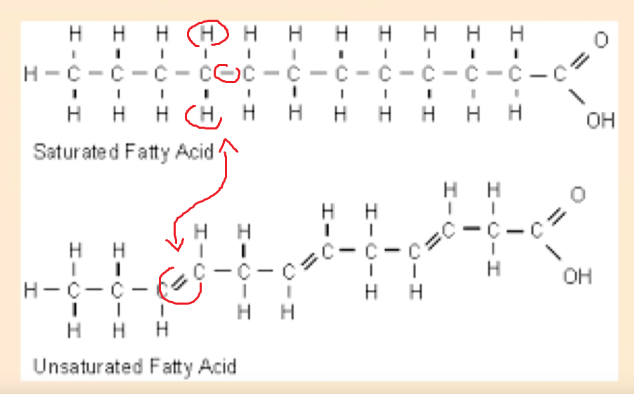
Saturated refers to each carbon having 2 hydrogen atoms around them, and not just one (which is unsaturated).
This creates a straight chain.

Unsaturated fats have these flex points, which makes them runny (oils).
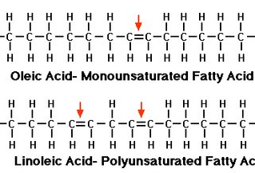
Monounsaturated has just one unsaturated carbon,
polyunsaturated has several unsaturated carbons.

This is an important difference,
as monosaturated fats are healthy,
and polyunsaturated fats are not.

How did polyunsaturated fats become popular?
In the beginning of the 20th century
There was a shortage of butter in the US
There was also waste from cotton farming in the US
It was used to make vegetable oil for low costs
Making replacement fake butters, margarine
Resulting in great profit

These industrials promote their product as healthy,
and the saturated fats (butter, animal products) as unhealthy.
They blame it for heart disease (second cause of death behind cancer).
Pay doctors, make biased studies, veganism, etc.

In reality, seed oils are the cause of heart disease.
When butter consumption decreased, and seed oil consumption increased, heart disease increased too.
The seed oils create congestion in arteries, creating heart disease.

Seed oils are everywhere, in sauces, cakes, used to cook, …

There is a process which makes them even more unhealthy, hydrogenization:
It aims to transform an unsaturated fat into a saturated fat.
By adding hydrogen to saturate the carbon in hydrogen.
It can transform oils into a spread like margarine.

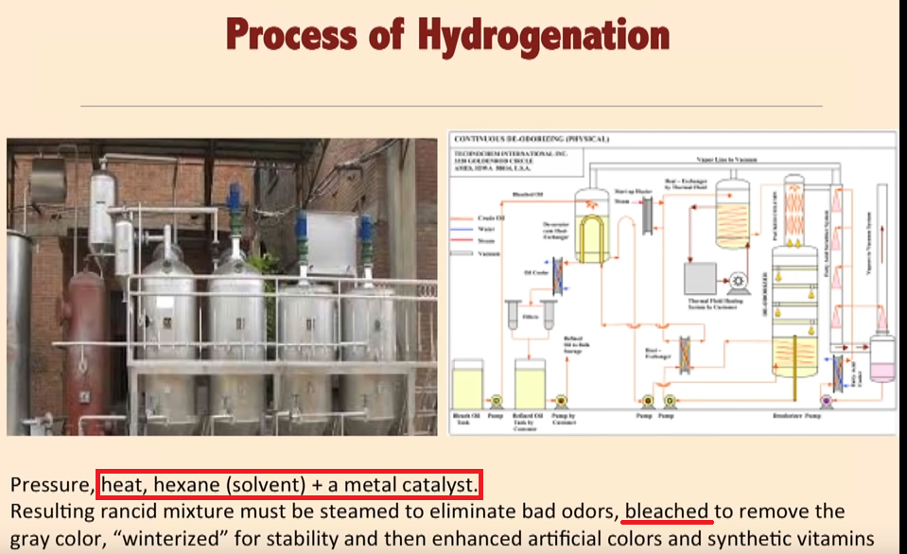

Apart from all those chemicals being used,
it actually creates a new type of fat called trans fatty acid,
and not always the expected saturated fat.
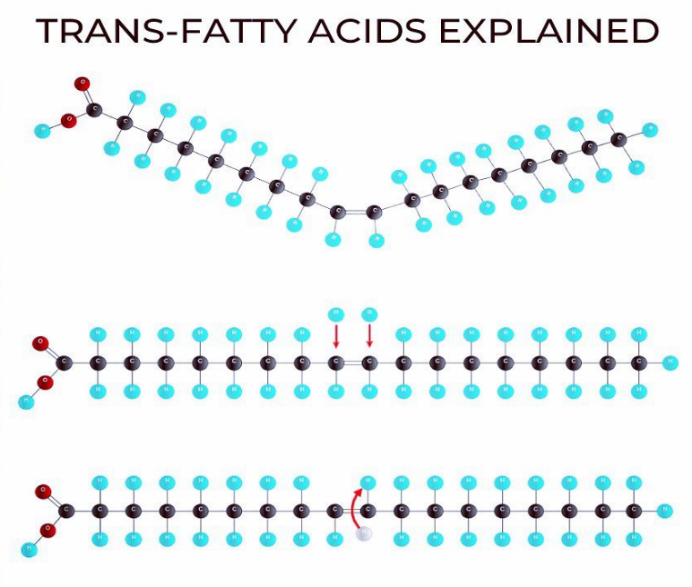

To make a saturated fat from a polyunsaturated fat, the goal is to attach more hydrogen (in blue) atoms to the carbon (in black) atoms that are not saturated.

In theory, this is the goal, but the process is not perfect, and not all carbons manage to get saturated in hydrogen, and something else happens.
In some cases, the joint gets twisted around and one of the hydrogen atoms transitions to the other side.

Then the new structure behaves in a different way.
When our body incorporates the defective trans fatty acid into the cell membranes, it leads to unhealthy results, malfunction in the cells of the brain, nervous system, and heart. https://www.ncbi.nlm.nih.gov/pubmed/27215959

Carnivore dieters and Ray Peat dieters are strong advocates against seed oils.
Seed oils have been impopular in all health circles for a long time.
Many vegans too consider them very unhealthy, while others promote them.

To detoxify them, there are different claims.

Ray Peat followers, such as Matt Blackburn, claim Vitamin E can detoxify vegetable oils, and they take it as a supplement in high doses.

Aajonus Vonderplanitz has a different view. According to him, only certain hot baths can get rid of all these stored vegetable oils.
He says that in our body, seed oils harden into crystals, that are almost the same composition as plastic.
He says that was how plastic was discovered.
They need a temperature above 38.5°C for more than one hour to be melted, so that the body can get rid of them, or they stay hardened.
Here is a conversation from an email where someone asks Aajonus about Ray Peat’s views on PUFAs: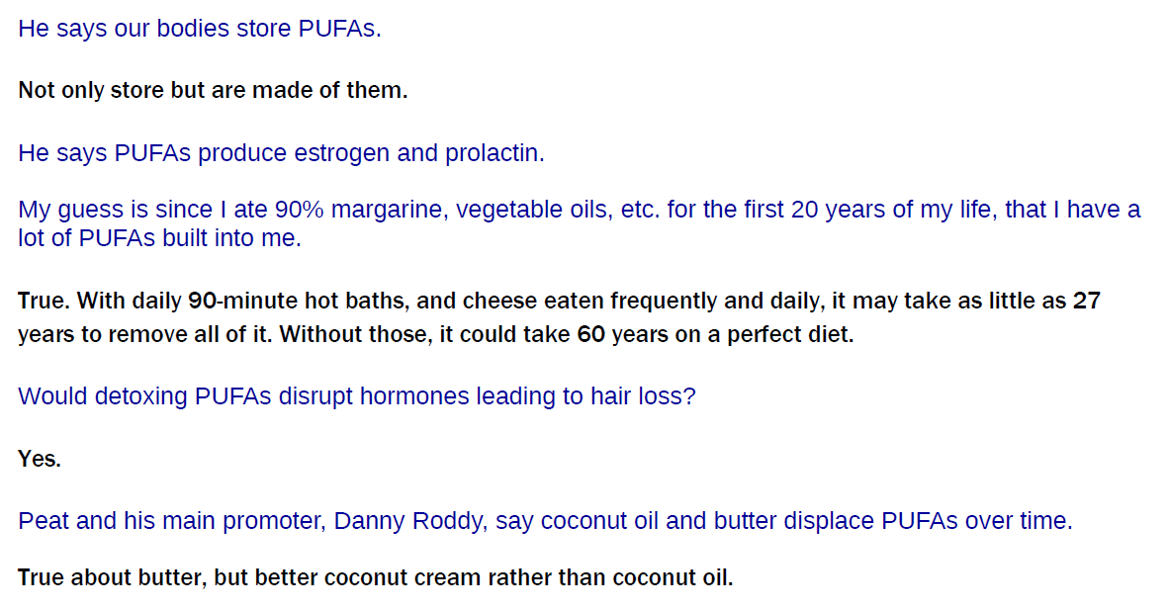

Vaccines

Note: this is about “traditional” vaccines, not “mRNA”.

Toxic ingredients

Vaccines contain ingredients which are considered toxic on their own.
They are an important source of metalic contamination.
80% of vaccines contain mercury (sometimes called thimerosal for liquid mercury, or other names):
50-76 quadrillion molecules of mercury in us from each vaccine, even many of those that now
claim to be mercury-free.
(Since pharmaceuticals have reduced mercury in vaccines from 76 quadrillion molecules to 50-56
quadrillion molecules per vaccine, the FDA allows them to call their vaccines mercury-free.)
One vaccine will give forty years of the contamination from eating cooked fish.
Being injected directly in the blood is much worse than ingesting such a toxin.

They also contain aluminum, various solvents, detergents, …
Taking each ingredient individually will reveal the extent of its toxicity. For example, on
formaldehyde, the CDC writes: « Exposure to formaldehyde can irritate the skin, throat, lungs, and
eyes. Repeated exposure to formaldehyde can possibly lead to cancer. ».
Here is an exhaustive list below:

In addition to the viral and bacterial RNA or DNA that is part of the vaccines, below are some of the
fillers considered inert but which have harmful side effects:
aluminum hydroxide (directly linked to Alzheimer's Disease)
aluminum phosphate (directly linked to Alzheimer's Disease)
thimerosal (mercury; a neurotoxin linked to psychological, neurological & immunological
problems. Nervous system damage, kidney disease, birth defects, dental problems, mood swings,
mental changes, hallucinations, memory loss, nerve damage and inability to concentrate can occur.
Symptoms also include tremors, loss of dermal sensitivity, slurred speech and, in rare cases, even
death and paralysis. This additive alone was the catalyst for another recent Class Action Lawsuit
organized by mothers of children born with Autism & the many related behavioral disorders
associated with it. Autism is now occurring at levels never seen before in history, 1 in 67. The
average used to be 1 in 20,000.)
ammonium sulfate (an inorganic chemical compound used a fertilizer and "protein purifier"; known
to cause kidney & liver damage, gastrointestinal dysfunctions)
amphotericin B (an "antifungal disinfectant” that damages the urinary tract, bowels, heart functions)
animal tissues: pig blood, horse blood, rabbit brain, dog kidney, monkey kidney, chick embryo,
chicken egg, duck egg, and calf (bovine) serum, fetal bovine serum VERO cells, a continuous line
of monkey kidney cells, and washed sheep’s red blood cells. Those build foundation for
neurological diseases)
betapropiolactone (disinfectant)
Ethylene glycol (antifreeze, proven to have extreme neurotoxic side effects)
formaldehyde (used as a preservative, embalming fluid, and disinfectant, known to cause cancer,
chronic bronchitis, eye irritation and numerous other diseases)
formalin (used as a disinfectant or anti-bacterial, containing 37% formaldehyde)
gelatin (causes allergic reactions and anaphylaxis usually associated with sensitivity to processed
egg or gelatin)
Gentamycin (antibiotic: destroys digestion and impairs healing)
Glycerol (A syrupy, sweet, colorless or yellowish liquid, C3H8O3, obtained from fats and oils as a
byproduct of saponification and used as a solvent, an antifreeze, a plasticizer, and a sweetener and
in the manufacture of dynamite, cosmetics, liquid soaps, inks, and lubricants)
MF-59 (oil-based and composed of squalene, Tween 80 and Span85. All oil adjuvants injected into
rats were found to be toxic, caused disease similar to multiple sclerosis which left them crippled and
dragging their paralyzed hindquarters)
human diploid cells (from aborted fetal tissue)
hydrolyzed gelatin (obtained by chemical extraction from the skin, white connective tissue and
bones of animals, such as cowhide splits, bones (ossein), pork skin, and fish skin) monosodium
glutamate (MSG; causes cancer in humans, also linked to obesity)
neomycin (antibiotic: destroys digestion and impairs healing) neomycin sulfate (antibiotic: destroys
digestion and impairs healing) nonoxynol (toxic chemotherapy used to treat venereal diseases)
octoxinol 9 (toxic chemical used in vagina to kill sperm)
phenol red indicator (a highly toxic carolic acid disinfectant dye, attributed to liver, kidney, heart
and respiratory damage)
phenoxyethanol (antifreeze, proven to have extreme neurotoxic side effects)
potassium diphosphate (destroys libido and motivation)
potassium monophosphate (destroys libido and motivation)
polymyxin B (antibiotic: destroys digestion, damages liver and kidneys, and impairs healing)
polysorbate 20 (trademarked Tween 20; emulsifier that often prevents absorption of nutrients
causing malnutrition)
polysorbate 80 (trademarked Tween 80: a preservative that can cause severe allergic reactions
including anaphylaxis)
porcine (pig) pancreatic hydrolysate of casein (isolated concentration of certain proteins that cause
nutritional imbalances, allergies and often excessive hunger or the opposite anorexia)
residual MRC5 proteins (chemically isolated toxic proteins from cancerous DNA)
resin (causes allergic reactions)
sodium phosphate (solvent, dangerous, even life-threatening, toxicity may occur while using
sodium phosphate if you have kidney disease, have congestive heart failure, have an electrolyte
imbalance; or are on a sodium restricted diet)
sorbitol (sugar alcohol that dissolve intestinal villi)
Squalene (causes severe arthritis and lupus in humans at only 10-20 parts per billion)
sucrose (dissolves cellular walls and intestinal villi)
tri(n)butylphosphate (solvent and plasticizer)
Triton X100 (a strong detergent)

The synergistic toxic effects produced by combining those toxins: more severe reactions result from
combining toxins.

This list was taken from Aajonus Vonderplanitz’s document:
Vaccination – ACCEPTANCE OF RESPONSIBILITY FORM (present at the end of this document)

Vaccines do not work: the figures

It is said vaccines ended epidemics such as smallpox, poliomelitis, etc.
Yet, it has not been proven. In fact, in many instances, a spike occured right after a vaccination
campaign. Other times, the epidemic was already declining and the vaccination campaign didn’t
contribute to any change from the tendency as can be observed on charts.

Example 1: polio vaccine in the US in 1958 (from Appendix D of We Want To Live by Aajonus Vonderplanitz)
Table 1 shows the reported incidents of polio in the year 1958, before the compulsory polio vaccine
law, and the year 1959, when the law was adopted. Only four states and one city kept records. The
statistics show that the polio vaccine actually created the disease that it was purported to have
prevented.
Table 1: Number of Polio Cases Reported in 5 areas, Before and After Polio Vaccine became Compulsory
1958 1959 % Increase
Compulsory Vaccination? NO YES
Connecticut 45 123 273%
Los Angeles, CA 89 190 213%
North Carolina 78 313 401%
Ohio* 17 52 306%
Tennessee 119 386 324%
Ohio had an escape clause and many people declined inoculation. Therefore there were
fewer incidents of Polio.
Eighty-two percent of all of the people who had polio in 1959 (listed above) had been vaccinated
with one or more polio vaccines. Twenty percent had at least three polio vaccinations. Polio
vaccines create polio.

Example 2, yellow fever vaccine, US (from Appendix D of We Want To Live by Aajonus Vonderplanitz)
Former Secretary of War, Henry L. Stimsom, reported that at a military boot camp in only a six-
month period, there were 63 deaths and 25,585 cases of hepatitis "as a direct result of the yellow
fever vaccine."

Example 3, polio in Sweden (from https://pourquoi-vacciner.fr/, Pierre-Jean Arduin)

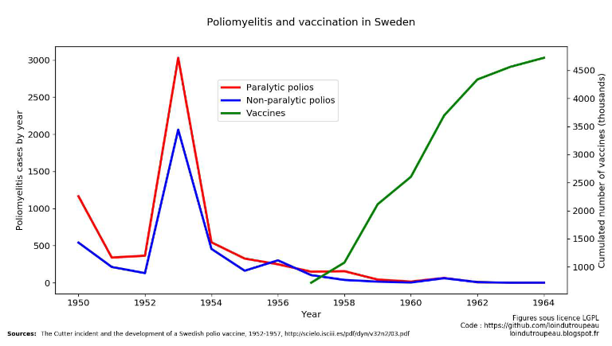

The polio spike was already mostly gone and slowly declining, and it continued to do so at the same
pace after vaccinations took place.

Example 4, tuberculosis/BCG in Europe (from https://pourquoi-vacciner.fr/, Pierre-Jean Arduin)


At really high vaccine coverage, the incidences of the disease follow at very high figures.

When vaccine harm is recognized in court

The US has a Vaccine Injury Compensation Program.
From the report from the Department of Justice, December 5, 2013, there were 139 claims settled
during this time period, with 70 of them being compensated.
42 of them were for the Influenza vaccine, the remaining including Hep B, Tetanus, HPV, DTaP,
MMR, IPV, PCV, Hib, Meningococcal, Varicella, TD vaccines.
The greatest percentage of damages compensated were for Guillain-Barré Syndrome (GBS) caused
by the flu vaccine.
Some deaths were recorded.

A European court ruled in favor of Mr. J.W., who sued Pfizer in 2006, claiming a causal link
between his vaccination for Hepatitis B in 1998, and his diagnosis a year later with multiple
sclerosis, that eventually led to his death in 2011.

Heat/Cold

Aajonus doesn’t recommend “cold therapy”.
He says living in warmer climates leads to faster healing overall.
He also recommends hot baths, with an occasional spike of cold plunge, but only under certain circumstances and if the body is resilient enough (with enough stored fat, and after long enough on the diet).
According to him, cold therapy gives energy by putting the body through stress, so the body releases hormones, so although with possible short-term, it is a process that makes the body spend a lot of resources without getting much improvement in return.

The biotin deficiency due to raw egg white avidin myth

Aajonus tested this hypothesis, ate up to 50 raw eggs per day, and did not have any biotin deficiency.
There is more biotin than avidin in an egg, so even if avidin were to “take away” biotin, there would still be some leftover.
But more importantly, according to Aajonus’ laboratory testing, the avidin in raw egg white that binds to some of the biotin in raw egg yolk creates a new compound which is actually useful, in ridding the body of biocarbons, which are leftover byproducts of digestion of macronutrients.

Equipment

Aajonus details the equipment to buy in the Recipe book.

Juicer

To find a good juice extractor, mostly for vegetable juice, but also for coconut cream, there are 4 criteria:
- most important: it must not heat the food too much
- very important too: it must keep oxidation to a minimum
- very appreciated: it must be as low EMF as possible.
- best to have as little plastic parts that are in contact with the juice as possible

Then it's just ROI, ease of use, and how much money you want to spend on a juicer.

Twin-gear masticating juicers are often the best.

The Green Star juicer, Green Life juicer, the Angel Juicer, and the Omega juicer, are good items, for different price points.

Aajonus liked Green Star juicer the most, found the Angel harder to use.
Angel is more expensive, and has a higher yield, but the Green Star is more than decent, it’s a very good juicer.
Angel is said by some to be best to make coconut cream, however.





A “hand-crank” juicer is the cheapest, it has low yield, but is better than having none and chewing, or buying a bad juicer that will destroy 50-80% of the nutrients.

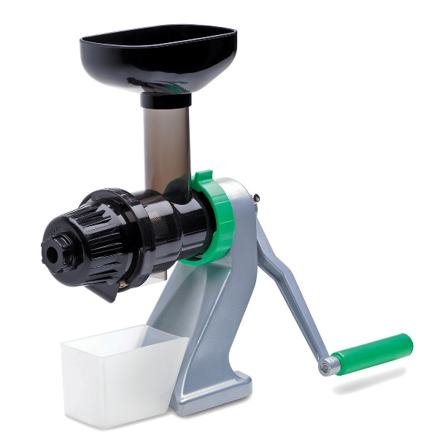

About vacuum juicers, it is not certain If Aajonus would approve them.

Do not use blenders, this is not juice extracting, they keep all the fibers.

Centrifugal juicers are not great because thy use air to press the juice from the pulp, oxidizing and damaging up to 30% of the nutrients in the juice.

Food processor

A food processor is not a blender.
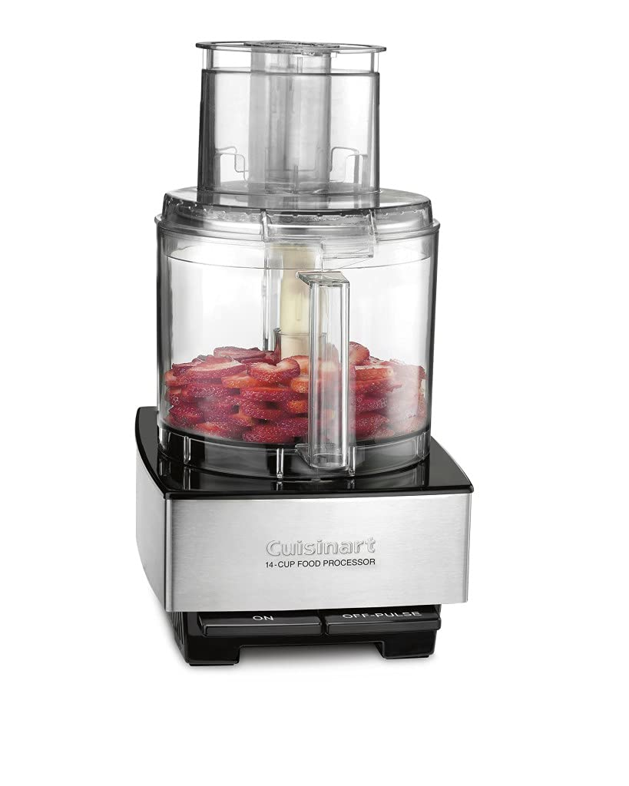

Aajonus recommended one from the “Cuisinart” brand, but others can work.

Just make sure it's powerful enough to pummel red meat without overheating (raw chicken is always easy to blend).

Some smaller glass ones with double blades can be nice, and are cheaper, although less powerful, and can not be used for longer than 2 minutes at a time (you can buy several to swap the engines to remedy that).

Blender

Aajonus used the Osterizer/Oster blender, because its size fits with the Ball glass jars.
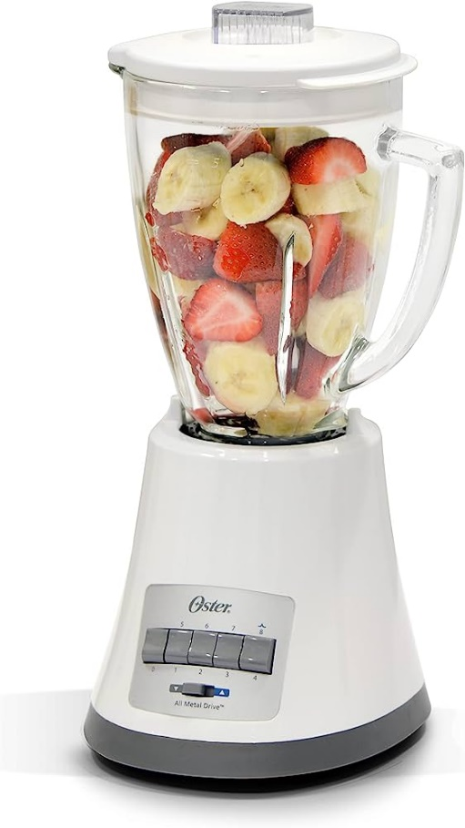
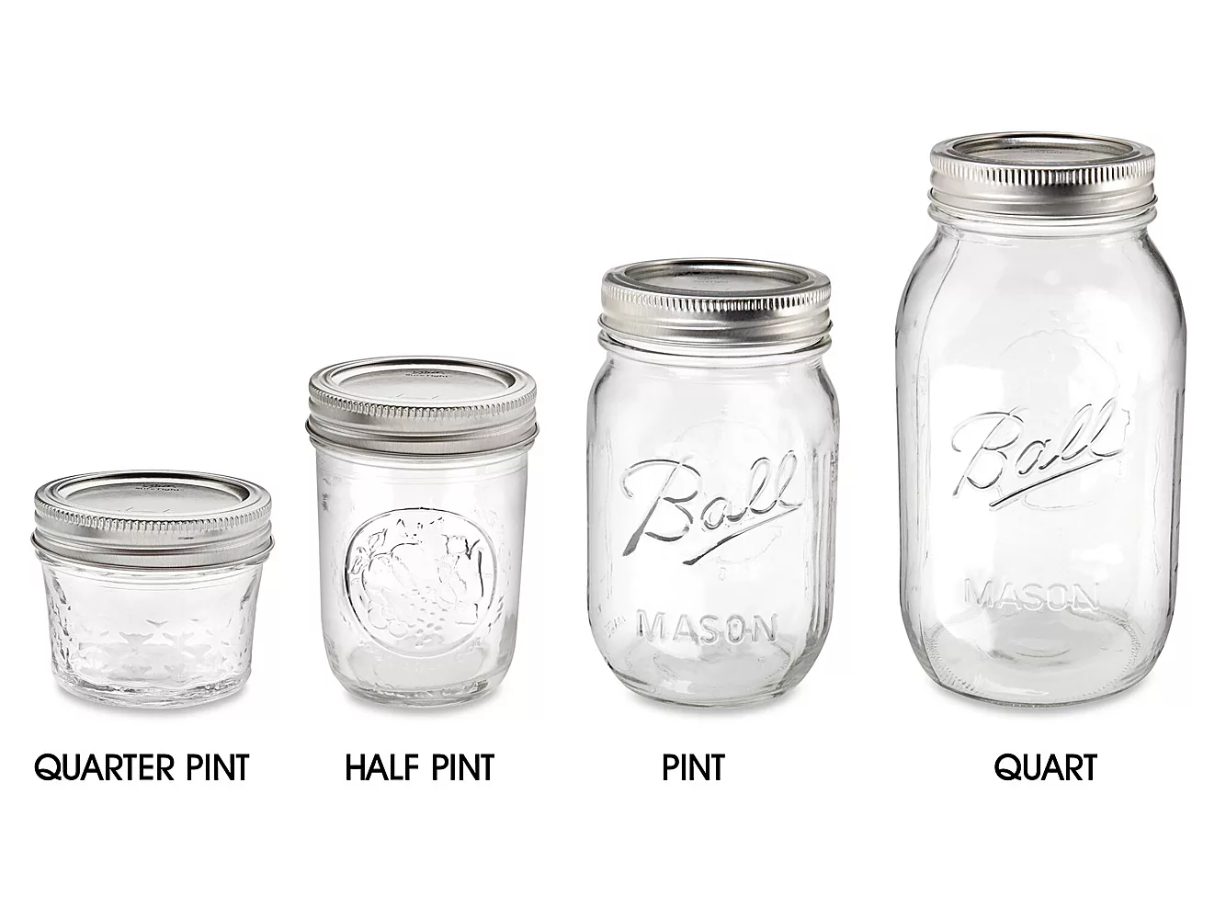

You can also get a manual immersion/plunging blender. As long as you coat the things you’re trying to blend in enough raw fat or liquid, it will limit oxidation (which leads to loss of nutrients) to an extent.



Utensils (wood, etc)

If using metal, prefer stainless steel.
Be careful, wood or bamboo can be toxic. They are often agglomerated pieces glued together with chemicals that are toxic to ingest.
Ideally, you would get an animal bone, and carve utensils from it.
Some glass or porcelain spoons exist.
And you can eat with your hands.

EMF meter

The Trifield TF2 is considered one of the best EMF meters, having a wide range it can pick up (although it seems like it cannot measure 5G).
This can be very useful to know your EMF exposure. Sometimes, you have electrical wires, etc., running through walls, and so it is truly hard to guess what areas of your place are covered in EMF, with no obvious devices in sight.



How to

Making raw cream

Cream separates from the raw milk, concentrates at the top, if you wait for around a few days.

Making raw butter

- Wait for cream to separate
- Churn cream any way you want. Avoid electrical machines to avoid EMF getting into the food.
- Butter separates.
- Press butter to remove more of the "buttermilk". The more it will be pressed, the more “dry” it will be (and harder to blend with other foods into an homogenous texture, like to make sauces), and the longer it will “last” with a fresh taste.
- Do not rinse with tap water, if you do, only use natural mineral water (non-sparkling to avoid killing bacteria).
- You can add a culture of some kind. Cultured butter is more digestible.

Making raw unsalted cheese

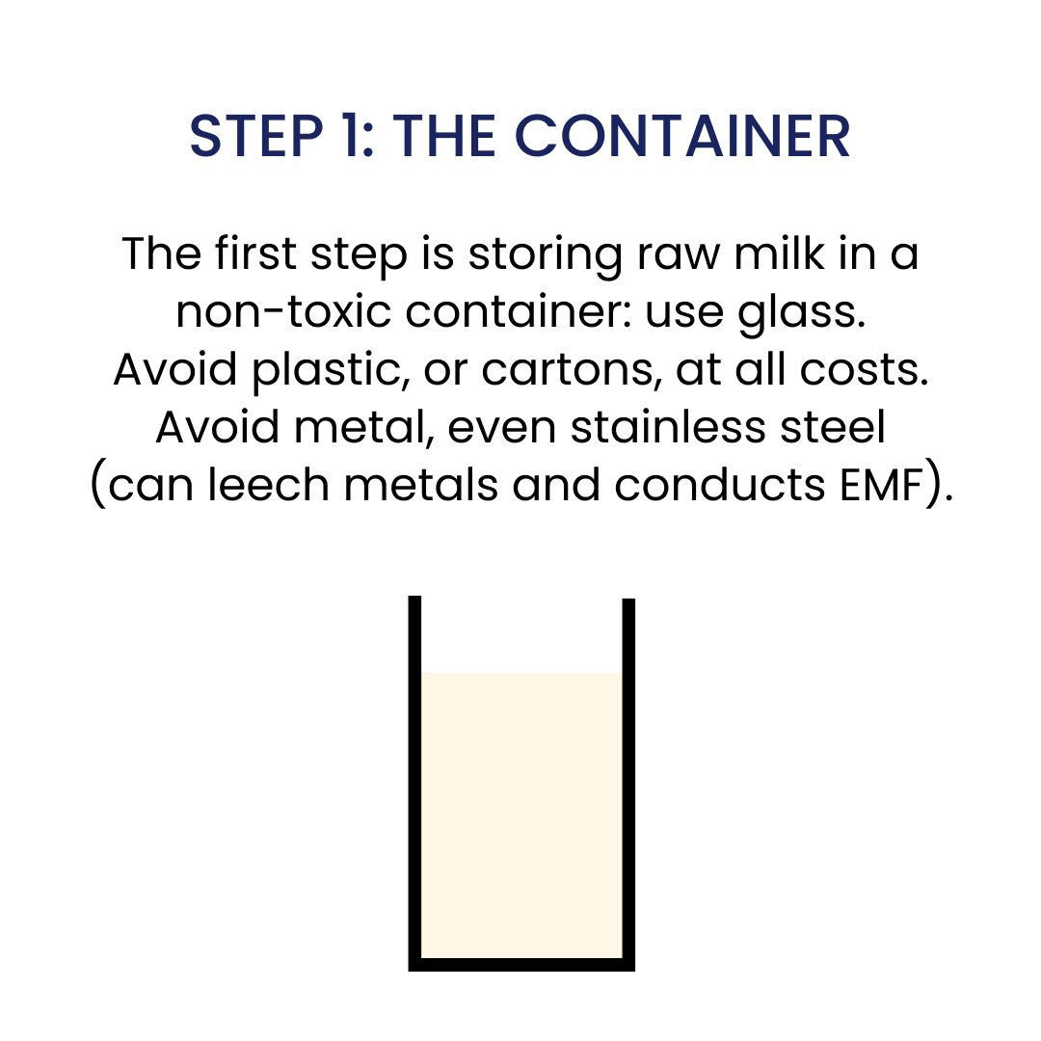
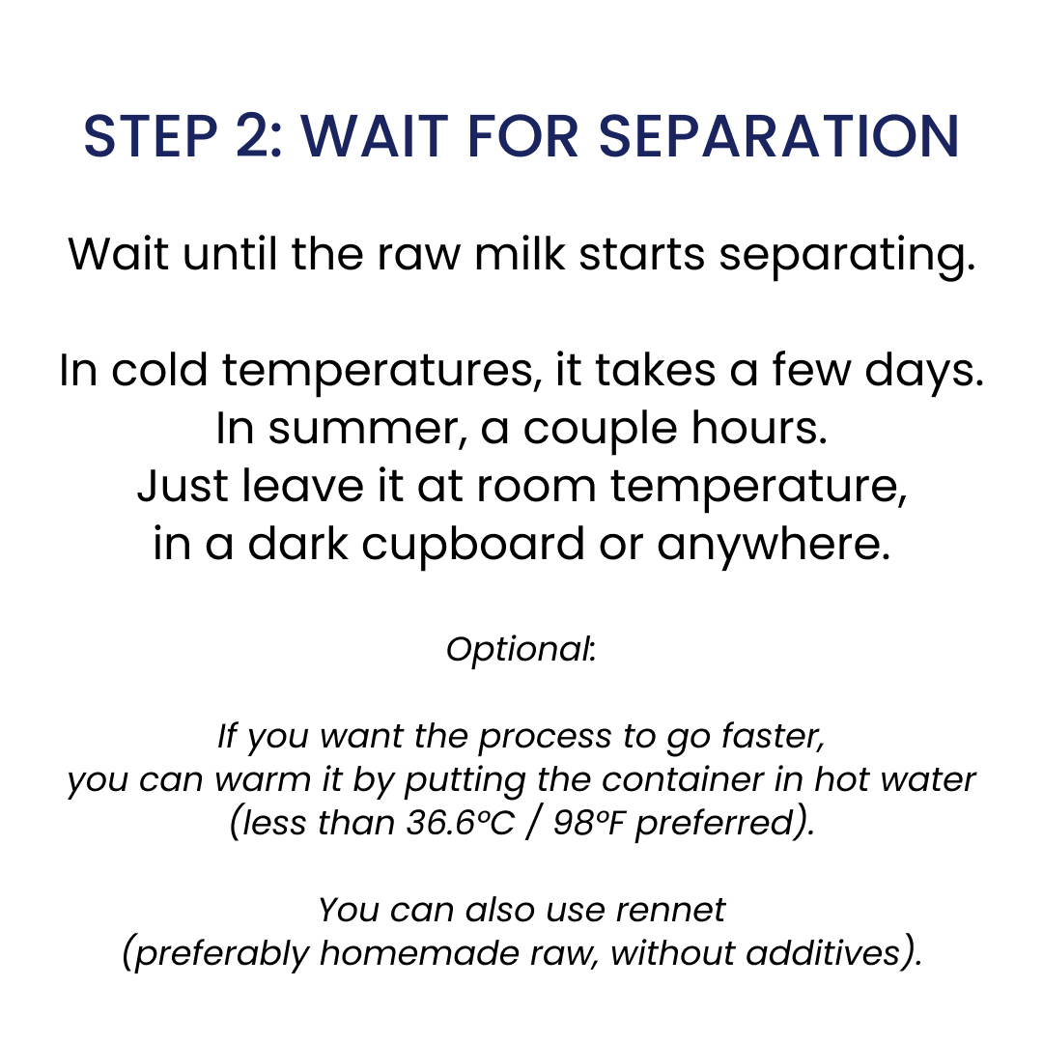
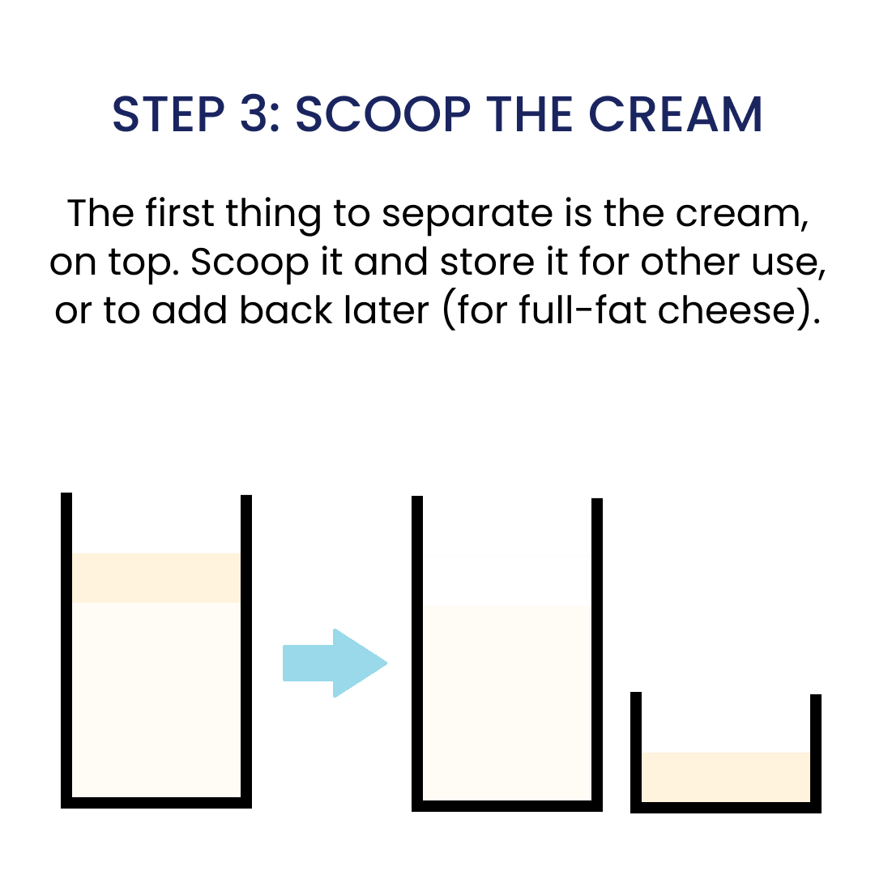
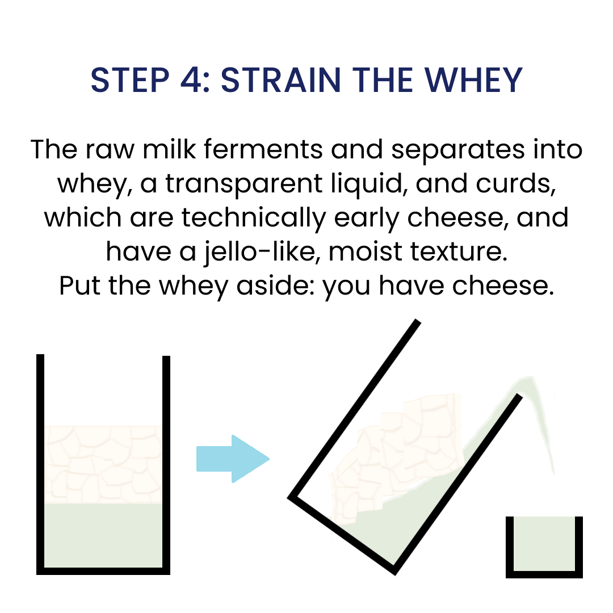
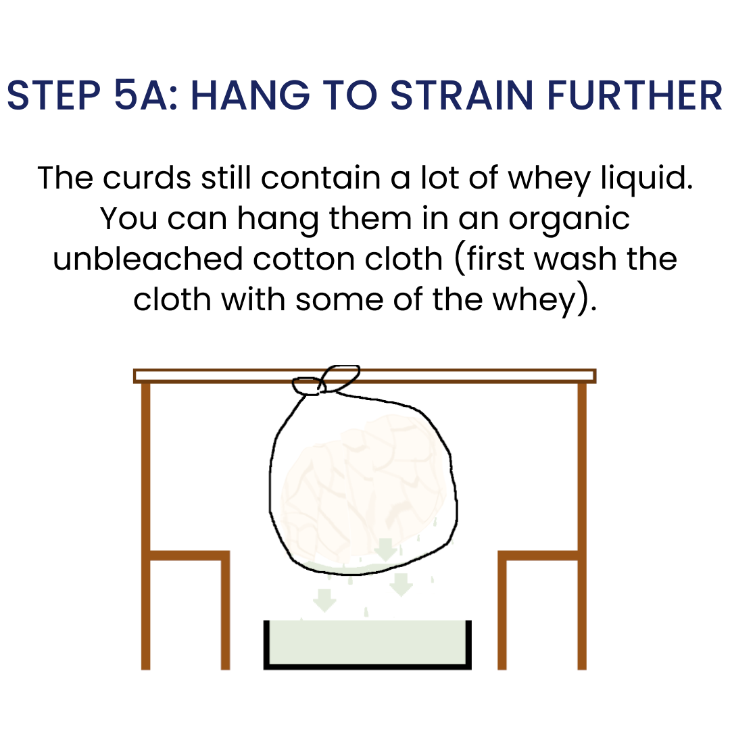
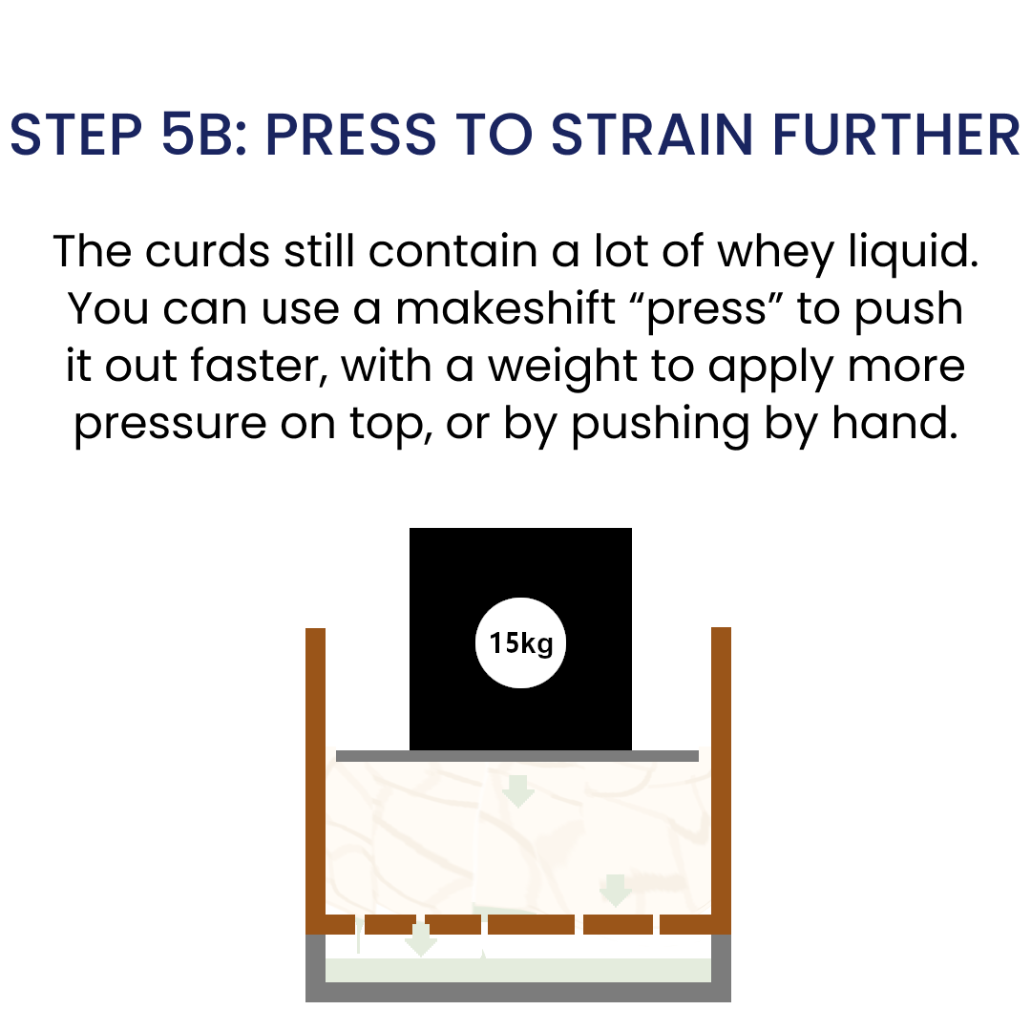
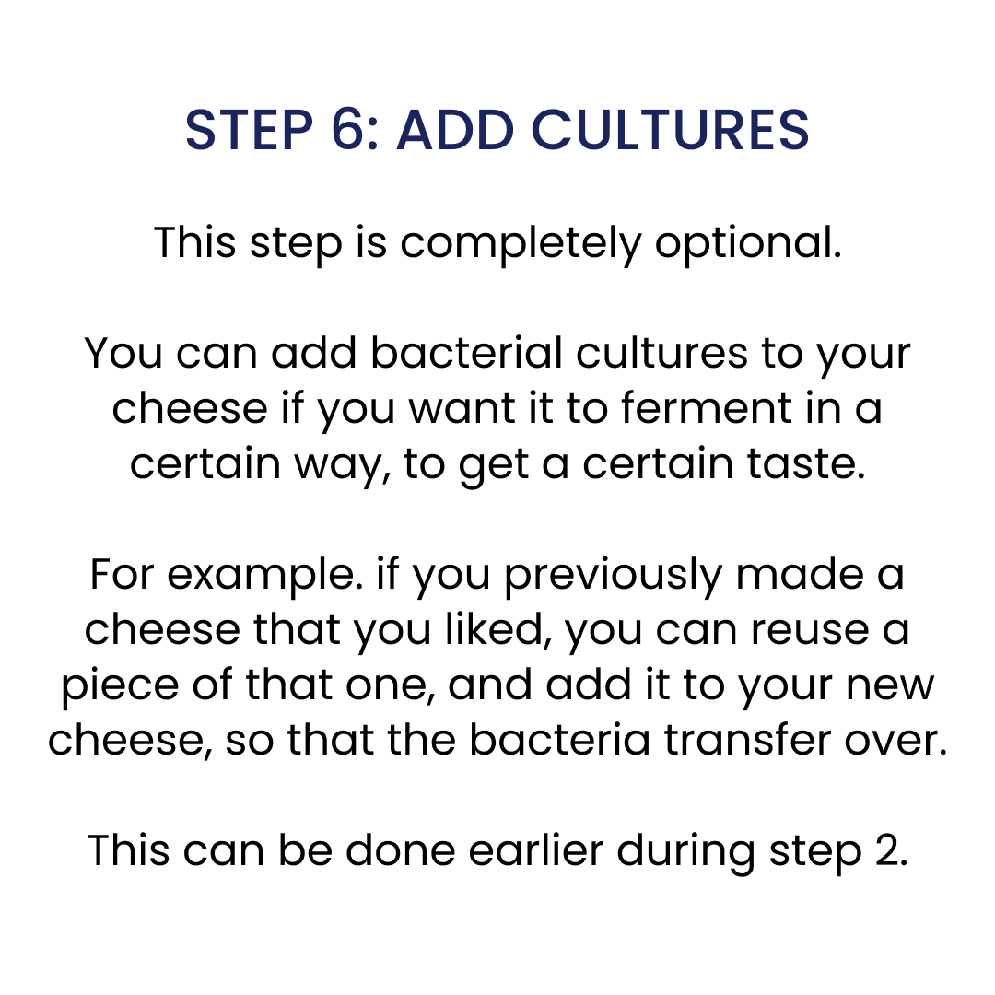
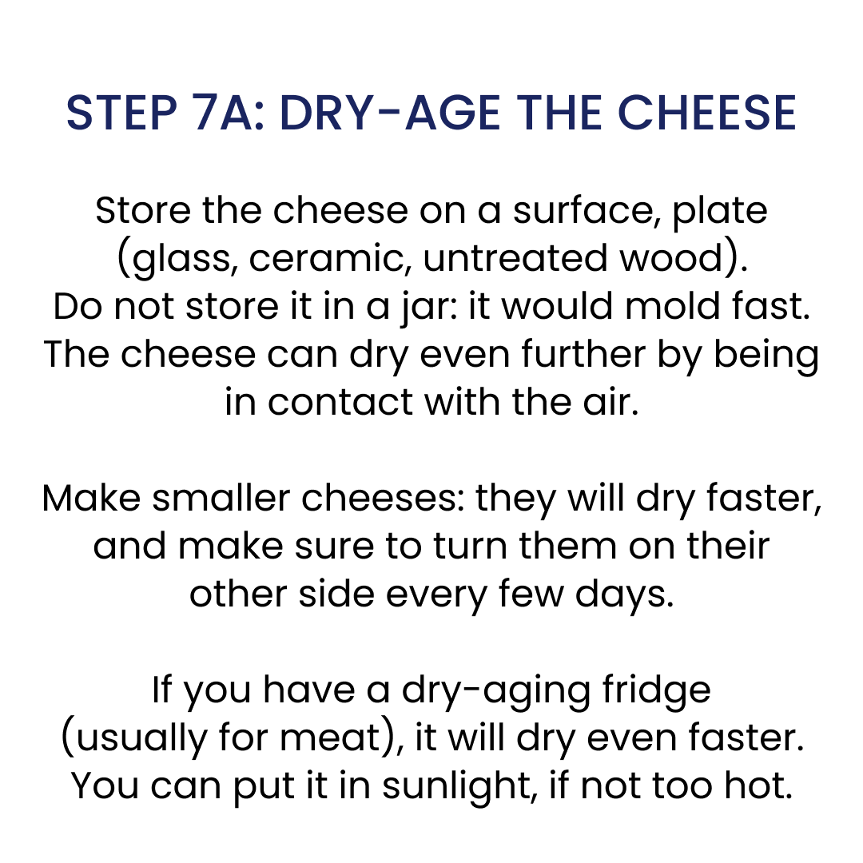
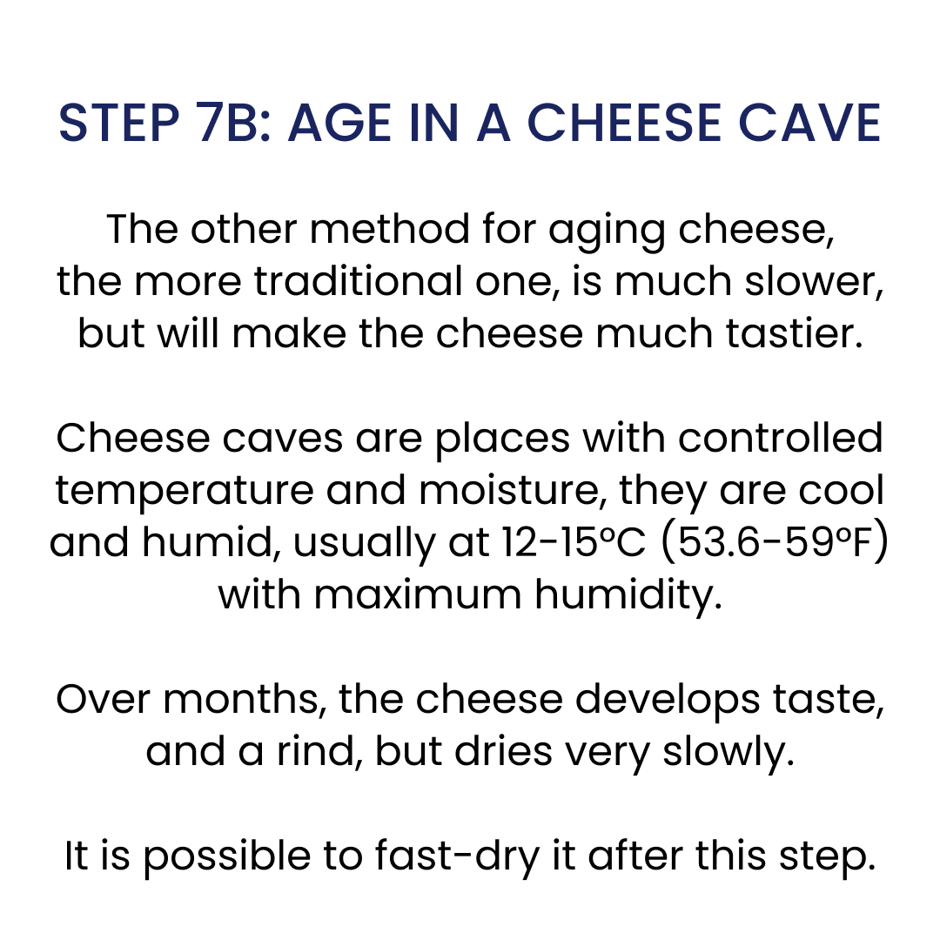

Making raw fermented milk (Aajonus’ “kefir”)

Fermented raw milk is significantly superior to fresh raw milk.

Hours to fully digest Raw milk
10 Fresh
6 Kefir

Kefir has double the digestibility.
More vitality, less heaviness and drowsiness.

Certain bacteria turn sugar into lactic acid.
↘ Less sugar: More sustained energy.
↗ More bacteria: replenishes gut biome.
↗ More lactic acid: Good for relieving soreness.

Aajonus consumed all of his milk as kefir.
It is fine to do so for many years.

The difference in energy felt can be astounding.

Kefir-making steps summary
- Fill clean glass jars to the top, with little airspace.
- Optional: Add your starting 'culture(s)'
  - Adding nothing is fine as well, as the food has its own natural bacteria.
  - Your own spit! Most recommended: will replenish your own gut bacteria.
  - If adding unheated honey, maximum of 1bsp honey per L.Honey will favor certain acidophilus bacteria which give a sweeter taste.
- Kefir can taste sweet without honey, because of the minerals fermenting.
- Kefir grains are not recommended: they are not bad, but their foreign bacteria are "competing" with ours. Also can lead to a more bitter taste.
- Store in a dark place (avoids bitterness).
- Ferment at a warm temperature, for a couple of days.
Temperature Cold 70°F (21°C) 96°F (36°C)
Time to clabber 3+ days 30h a few hours
- Too cold could lead to bitter fermentation and mold.
- Too hot could lead to strong bitter early alcohol formation.
- Check every 4h after 24h until a desired stage is reached.
- Store in the fridge (cold slows down fermentation).
- Blend for 5s if the kefir is clabbered when using.
- You do not have to blend if the milk clabbered and you like jiggly blobs.
- Note: If you add honey at the end, it can kill some bacteria in the kefir.

If you use never chilled raw milk, or more precisely milk that has never been colder than 22°C (71.6 °F), the way the raw milk will ferment will be much more consistently delicious. (Thanks Zara for this tip).

Making sour cream

Just as raw kefir is a superior version of raw milk, raw sour cream is the upgrade to raw fresh cream.
Fresh raw cream tastes very good, and its sweetness goes well with honey or berries, but it's one of the hardest fats to digest (along with avocado, and moreso than butter).
At the same time, raw cream is essential to eat daily, because it's the only raw fat (besides fat trimmings) that can feed the nervous system properly.
Whole raw milk contains cream, however not enough for our needs. Aajonus recommends to have at least 2 extra tablespoons of raw cream daily.

Making raw sour cream facilitates its digestion, and brings raw cream to a whole new level.
Sour raw cream is fermented raw cream, and tastes even better, although no longer sweet.
If done properly, it will taste consistently great, without any bitterness. It could have a cheesy taste.

Here are Aajonus' instructions which work, from his book The Recipe for Living Without Disease:
- Put raw cream in a glass jar.
- Leave only a little bit of airspace (less mold appears).
- Loosely screw/close the lid (but don't tighten it).
- Place in the fridge.
- Wait at least a month (still good after 5 months!).
- It's ready.
Very simple, but these details matter — or you could get varying results that taste too strong.

Sour raw cream can be eaten with raw meat, whereas eating fresh raw cream with raw meat causes half of the raw meat and cream to go completely undigested (meat particles come out pink and coated in pearly cream); a heavier load on digestion, and a waste.
As little as 1 tablespoon of fresh raw cream with raw meat can cause this digestion issue.

Sour cream makes amazing sauces, and some people even like to use it in sweeter recipes such as Aajonus' nut formula, or ice cream!
Aajonus really liked it with mushrooms and chives.

In 2013 Aajonus said the Amish can make sour cream in only two or three days, and he would learn how to make it from them. The method may be to add whey or some sour cream from a previous batch into a new batch of fresh cream.

Making pâté

Get raw not dried meat.
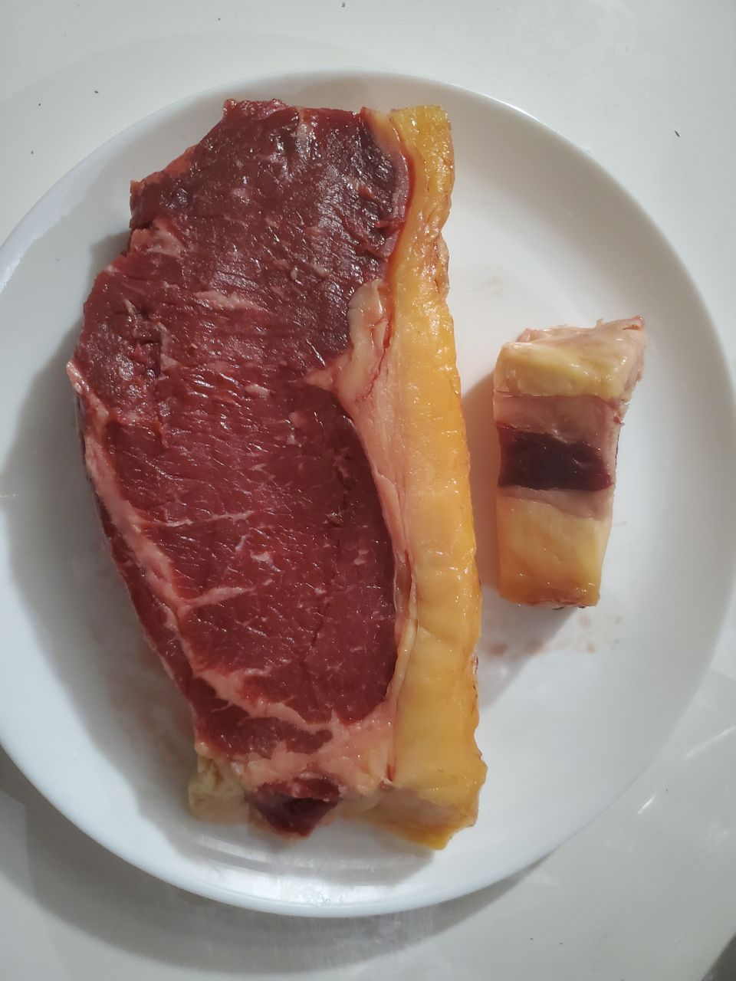

Separate most fat from the meat. You can leave a bit of fat with the meat, but avoid leaving meat on the fat (see later why).
Cut in short pieces so that it will blend well.

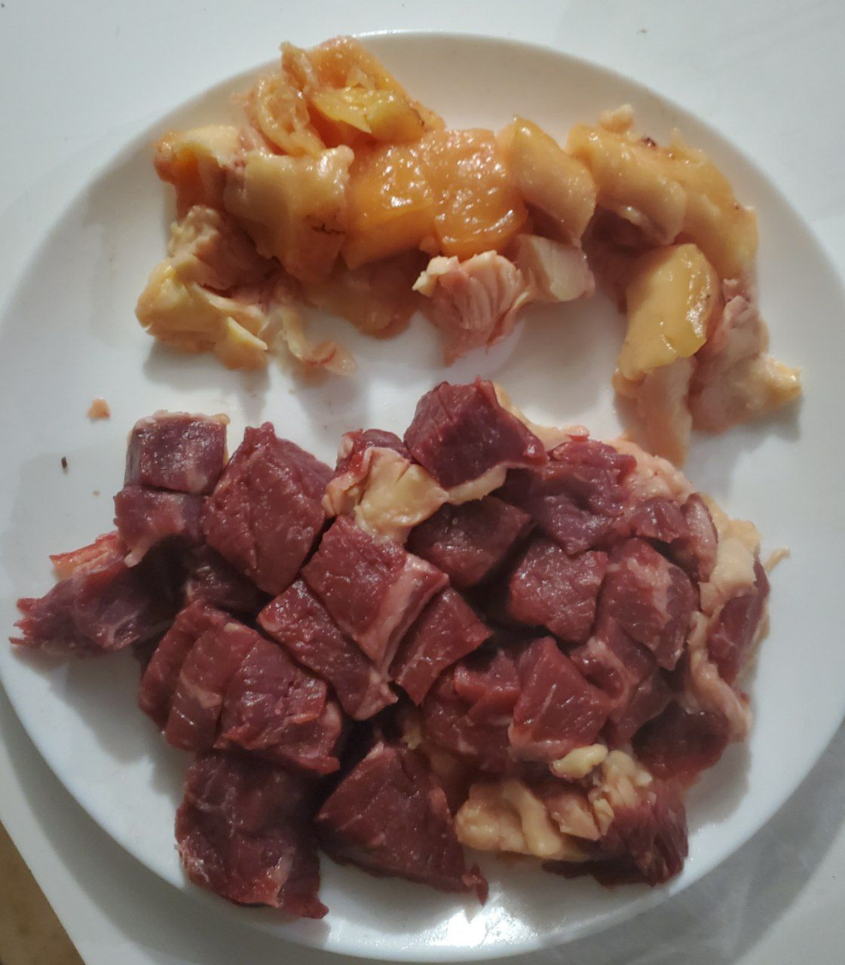

Blend fat first. If it's good quality (grass-fed, older animal for richer content, ...) it usually blends easily. This one took only 5 seconds...
Fat trimmings that are white and tough, chewy, and often tasteless are of lower quality.
Blending fat just like blending meat allows for better digestion of it: the body spares a lot of digestive fluids not having to break it down completely by itself.

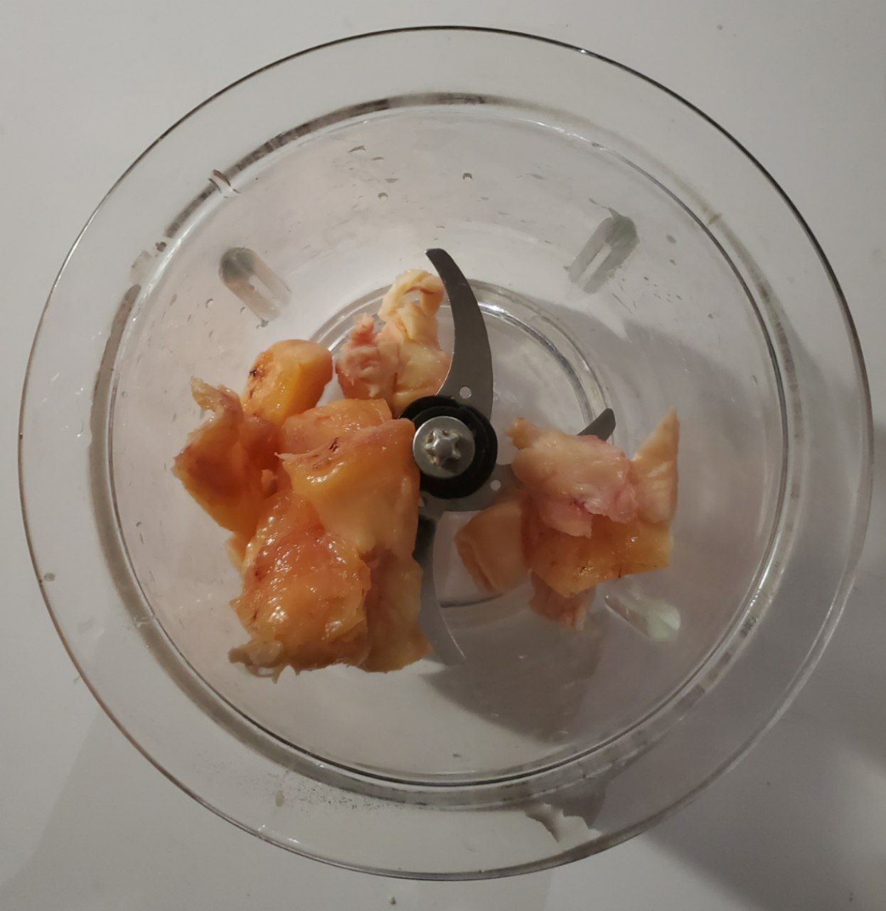
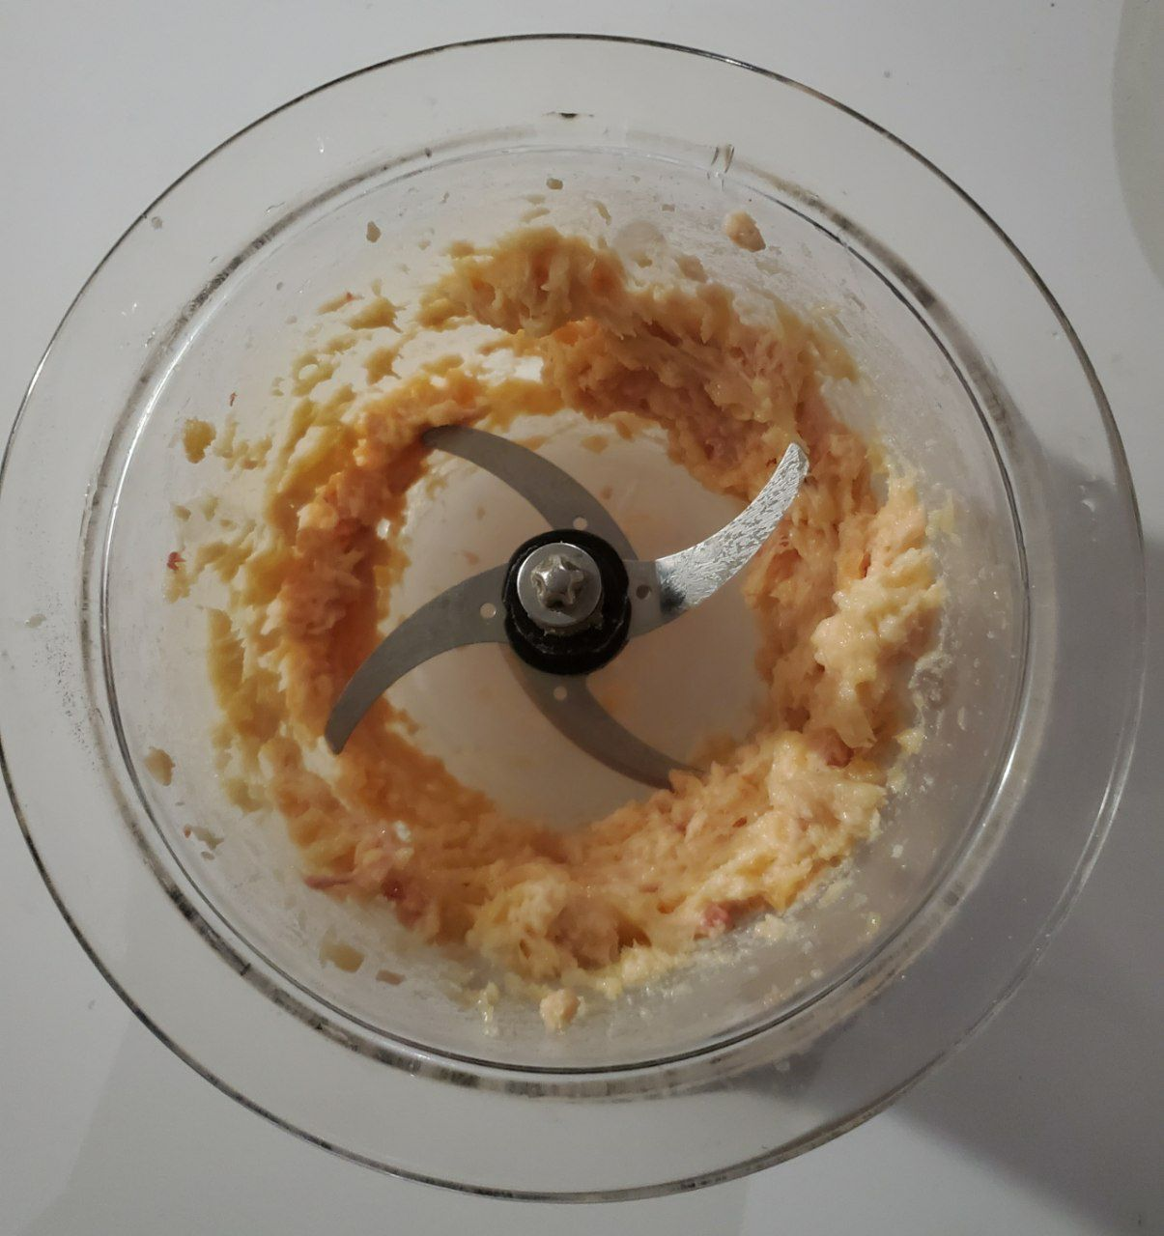

Remove blended fat and set aside. Put meat and blend (there may be a bit of fat leftovers which is ok, adds some flavor without being too heavy).
Depending on cut it could take 30 seconds to 3 minutes. Your food processor may need a break. You may need to open one or two times to move stuck pieces which didn't blend well. Make sure it doesn't overheat while blending if you blend for long or if you have a weak blender.
Only use a food processor and not a blender for this reason.
Blend until the consistency is extremely fine and can almost "dissolve" under your fingers.
Different cuts of meat may take longer.
Tough cuts of meat are very good to blend because they become as easy to chew as other cuts without cooking. Tough cuts of meat are said by Aajonus to be even better protein, he said native Americans told him they only give soft cuts of meat to elders or dogs.

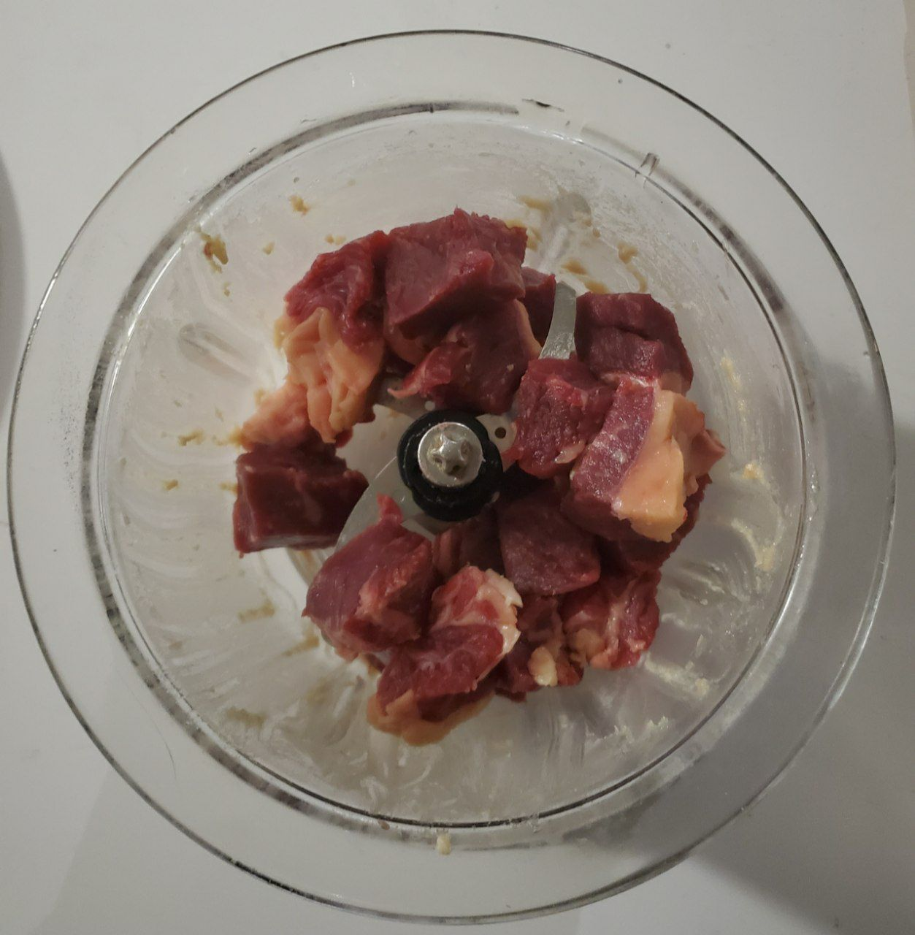
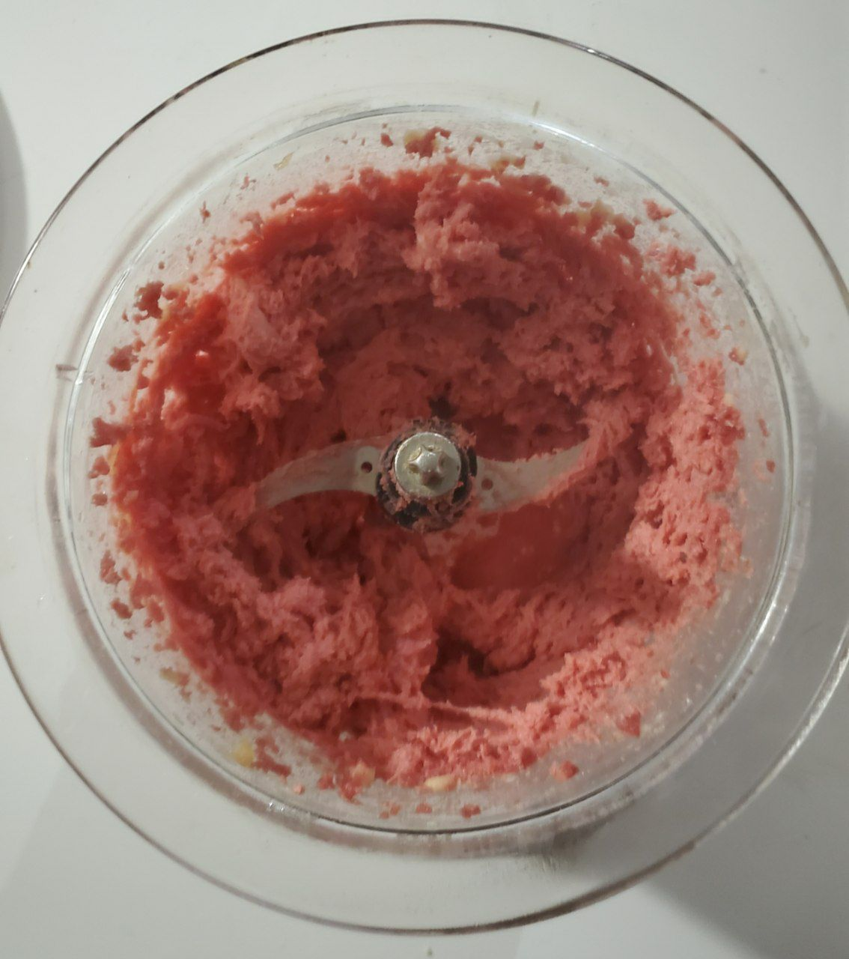
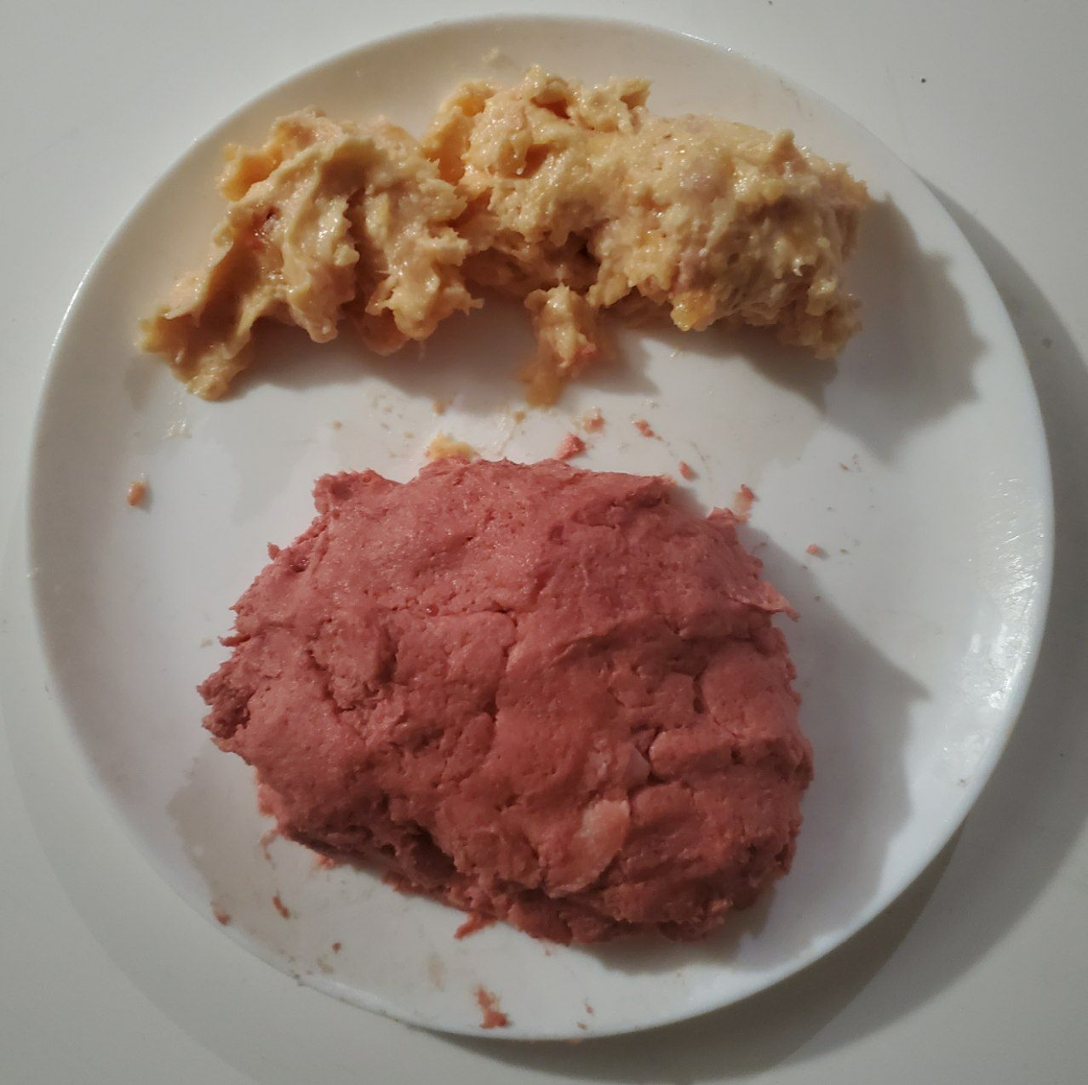

Now you have one or two doughs. And unless you have high quality herb-tasting grass-finished meat, the texture and taste are also like dough...
Not super appetizing.
If you blend 3 oysters with the meat (Aajonus often recommended to eat 3 oysters per meat meal to detox a lot of heavy metals), however, you have something that tastes immediately great, like tartare with Worcestshire sauce (which uses anchovy so that must be why).
You can also do all kinds of blends of red meat and white meat (chicken, fish, ...). Aajonus often recommended specific percentage of meat individual to his clients during consults, just like for the vegetable juices. For example 10% fish, 30% chicken, 60% beef, all in the same meal.

However there is one more step that can truly bring it to the next level no matter what meat is used.

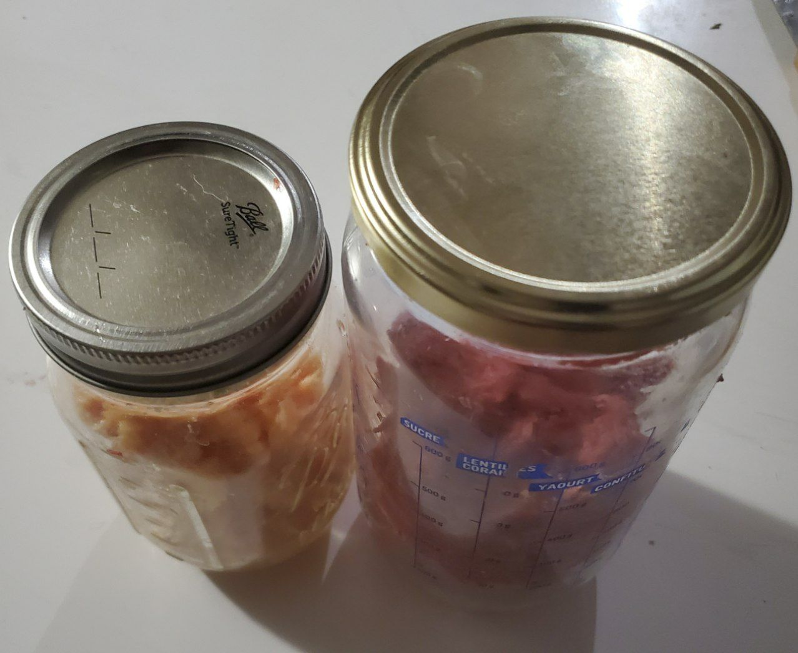

Put the meat in closed jars. The jar must be closed so that the meat doesn't dry.
Dry meat is much less digestible because it loses in a chain reaction water, killing bacteria, which inactivates enzymes.

Leave it out at room temperature for at least a few hours (overnight is good), for up to 3 days. In warmer times it is more like 1 or 2 days max.
In the fridge it takes much longer, like a whole week.

This lets the meat pâté start to ferment, and as you know, pâté ferments much faster all around and inside, because it is already broken down and bacteria have more surface to develop.

Fermenting only a few hours up to 3 days will not make it into high meat. Not the smelly high meat at least.
It will start to smell and taste like deli meat.
And for reason. Deli meat like salami is actually a fermented food... Commercially they add cultures to it.
This makes the smell and taste of it excellent, rich in flavors. Even the texture is improved greatly from the initial dough. There are various outcomes, most great.

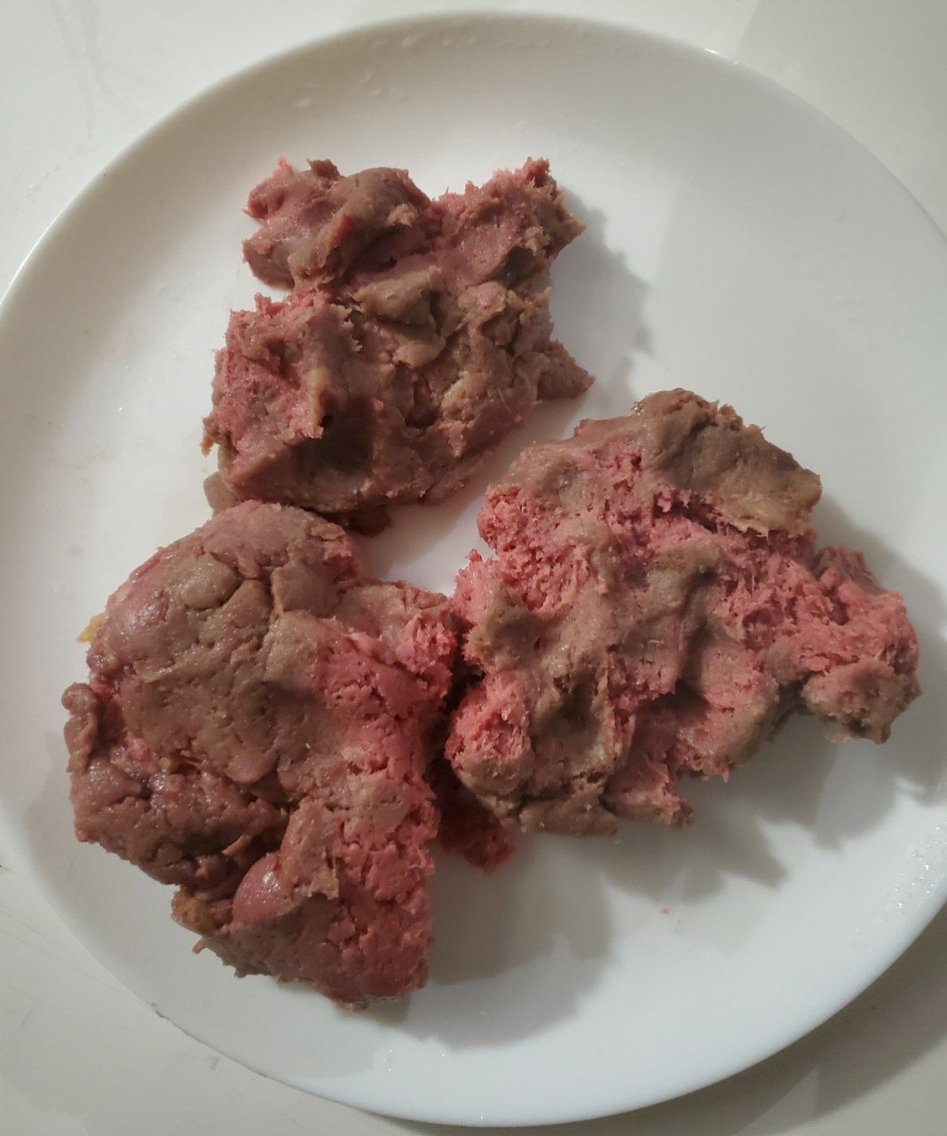

There you have it. The meat starts to change color. For example red beef will turn pink or grey or brown or all of those.
The taste can be like salami. Or a sweet wine vinegar sauce. Sometimes chocolate. But usually, nothing too strong like the high meat we are used to.

Marinades are similar, but more for white meat, as we don't mix fruits (or fruits derivatives like vinegar) with red meat, since this will have a tendency to turn the meat into fuel for energy or solvent for detox but NOT building blocks for regenerating (and meat protein is too precious to not use it this way, we should even eat royal jelly with meat when we can; fat is good enough for energy).
So in a marinade you put just lemon juices on top and mixed inside of the white meat pâté (chicken or fish) when you bottle it, and lemon incitates fermentation (unlike lime which does the opposite so avoid using lime for this), so it will transform super fast. Overnight it will become grey and chewy, people think it's cooked and want to try it.

This deli páté is of course even more digestible than regular pâté is. You're looking at x2 digestion with pâté, and probably x2 again after it's fermented.
Consider how fresh raw milk digests fully in 10h while fermented milk (like in a liquid yogurt state), ferments in only 6h (almost half of it).

People report all the time how it's so good and easy to digest, they eat huge quantities of it, even when they didn't crave much meat, and soon want to eat again like endless pits... (this is a good opportunity to eat more fat which is the number 1 goal on this diet, and it also takes care of satiation, so it all fits well).

It's one of the game changers for the diet. It is not mentioned anywhere in the books but only through reading Q&As carefully you can see it's very important, or extremely useful at the very least. And as such, slowly it is becoming the new meta...

It may seem like a lot of steps but it's because there is a lot of description in there... In practice it's not that long.
And the benefit of sleeping 1.5h less per night as well as running high on energy more than offsets that.
Pâté can be prepared for one or even two weeks.
In the fridge it will turn deli slower so by 1 week or 2 it could not be high meat yet. Only need to take it the one you're going to eat a night or so before at the start, while keeping the rest to ferment slower in the fridge.

Making “deli” fermented pâté

Recipe for "deli pâté" in accordance to the Primal Diet by Aajonus Vonderplanitz
(not his name choice, gathered from his work)

First of all, the feedback of 2 persons:
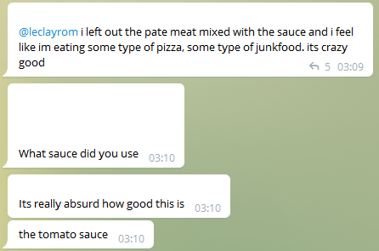
A man

A woman

The quick theory behind it:
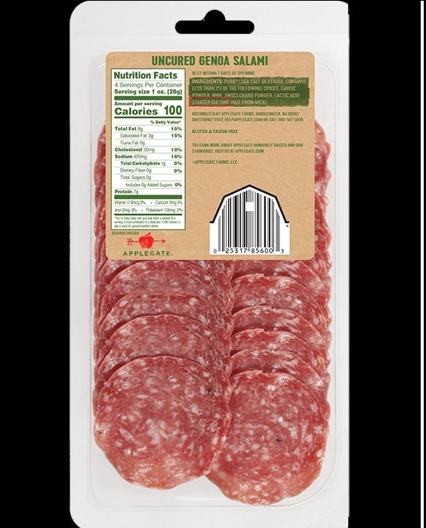
Standart deli meat is made with a "starter culture" (it's written on the ingredient list). It's even traditionally raw. We can reproduce this ourselves and get consistent results with only raw natural foods, no salt or additives, and it increases both taste and digestibility.

It won't always be strictly the exact same because we don't have a starting culture, just letting it ferment by itself, but most of the times I tried, it's always good. It becomes grey, pink, or a bit brown, and it can taste like salami, like sweet wine vinegar sauce (crazy good), or even like pasta!(one time when I made it with ground sirloin).

RECIPE #1 Red meat, no other ingredients needed

Take beef muscle, any cut (can be lean like sirloin or fat like ribs), and blend into pâté preferably (so that it ferments evenly).

Then put it in a glass jar as if you were making high meat, and put it either in the fridge, or in a dark cupboard.
I suggest doing both to see the difference.

At first wait only around 1 day. Starts tasting see if it's ready.
If not let ferment half a day or another day.
Try again.

Usually you will get the cue when the beef starts slightly changing color.
Of course in hot temperatures it ferments faster. In general 3 days is the maximum outside of a fridge, beyond that it starts to mold or becoming "slimy", basically beyond this stage like proper high meat.

This deli pâté is fermented meat but it's really not like high meat, it's more like acidulated kefir compared to milk.

The taste is full of... "umami" I think it's called.
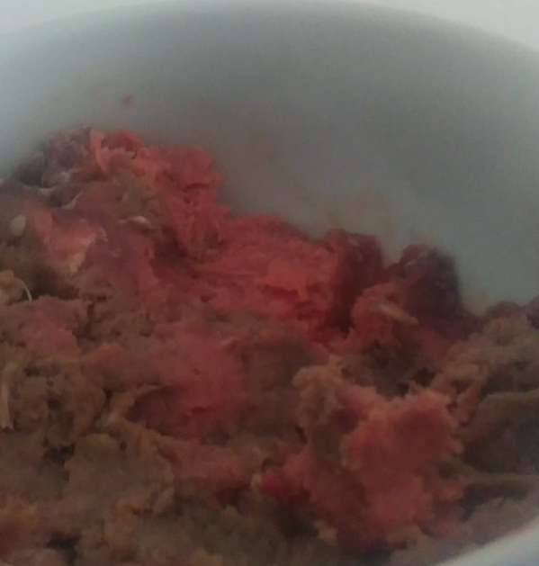

RECIPE #2 White Meat - Marination

Take white meat (tried with raw chicken, should also work on fish).

Pâté Chicken breast pâté is really bland, it's like dough.

Next, make a sauce in a separate container: bell peppers, a bit of spicy pepper, tomato, a bit of lemon juice, very little vinegar and honey, can add a few mushrooms and garlic, a little bit of onions too. Blend it in some cream.

Now pour some of this sauce onto the chicken pâté so that it mostly covers it well, push it through inside so it really infiltrates everywhere in the surface.

Do this in a bowl or a jar and cover this with a lid, place it somewhere to rest, and wait overnight for marination.

Illustration: This was delicious. I didn't have green juice and much appetite for meat yet I ate a lot, and it gave me substantial energy


There is a slight variation to it. When you make this sauce, you can keep it in the fridge for a few days inside a glass jar. Make a bit batch of it!
When you open it, it will smell just like chorizo.
So when you make the chicken pâté with fresh meat, you can use already pre-made fermented "Chorizo" sauce on top of it.
You can also make a much simpler sauce of just lemon juice for example, however you will have to strain all this juice before eating the meat afterwards, because it's too much lemon.

This is when I was making huge amounts of lemon juice-marinated chicken breast, as you can see on the edges the color turned grey. I ate easily 2kg in a day. Someone else who isn't primal and would never touch raw chicken tried it thinking it was some kind of cheese before I could even answer what it was (which really surprised me) and didn't dislike it.
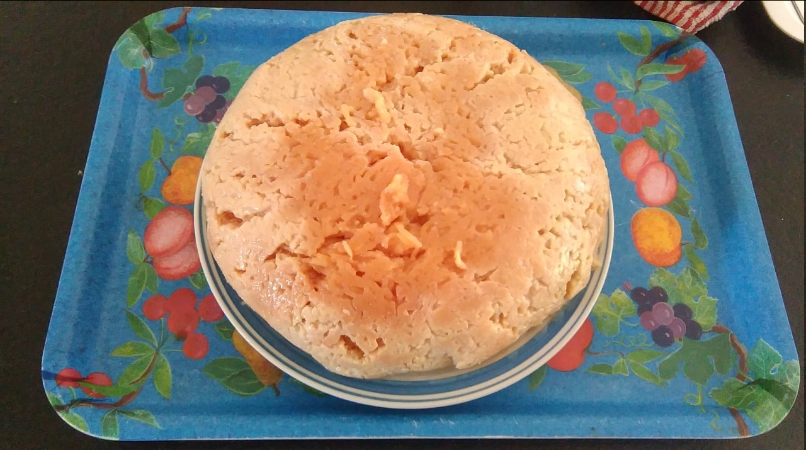

hence why people mistake marination for some kind of cooking... it even can taste like cooked meat, someone told me this about marinated salmon.
White meat doesn't ferment into a nice smell and taste, it becomes immediately high meat, so that's why marination is used for this type of deli pâté.
For red meat it would also work but as you can fruits and other things will turn red meat into fuel or solvent, and fortunately it already ferments nicely on its own as it had some great sauce put on it, but there is none, it's just itself.

Aajonus provided many other recipes in his book that would also work.
The key here it just to both pâté and ferment the meat inside of them for maximum taste and digestion.
Eat that with the usual tablespoons of fat and 1/8th teaspoon of royal jelly if you have, followed by more fat 15min later, the usual green juice/hydration formula, raw eggs, and raw unsalted cheese cubes in between, and you're set.

Marinating meat

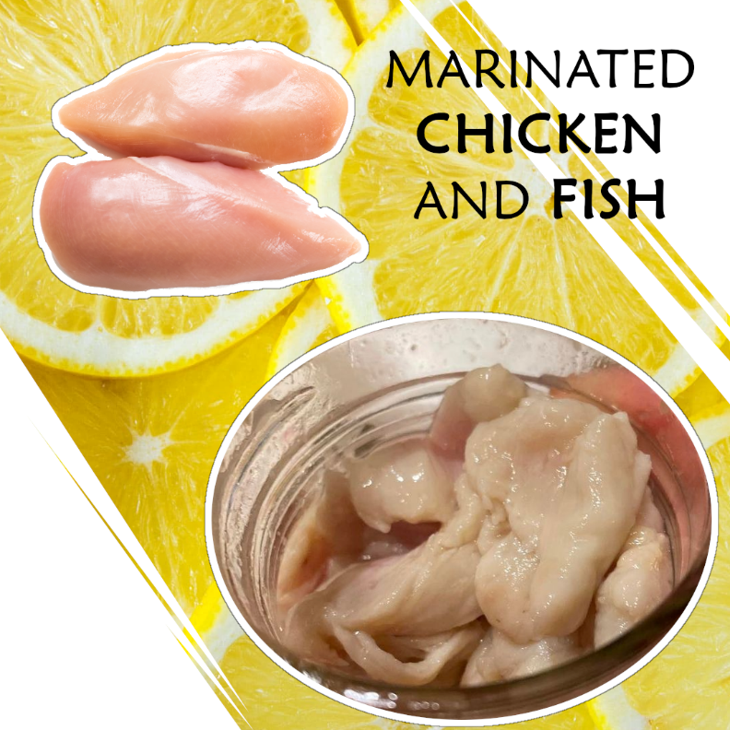
(slight overlap with the previous post)

Marinated meat looks and tastes just like cooked meat.
As you can see in the image above, raw chicken to marinated chicken.
Even raw shrimp can go from grey to white and red, similarly to when it’s cooked.

“Marinating is the process of soaking foods in a seasoned, often acidic, liquid.” — Wikipedia
Not only can it enhance the taste and texture of raw meat — it predigests it, making its assimilation by the body easier, and thus more invigorating.
From a pink-ish color, the meat will turn more grey, taste a bit more chewy... Bland doughy chicken breast is completely transformed.
People who would never eat raw chicken are not afraid to try it and often love it.

The simplest, most solid way to make it is as follows:
Just cut up some meat, soak in lemon juice, cover, leave at room temperature and wait a couple hours.
In many cooking videos, they make use of marination, but only as an intermediary step. It is not used so much by raw food eaters and its effects go mostly unnoticed and unexplored.
Some people call marination a type of cooking, however although both break down food, they are very different: cooking denatures the food through high heat reactions, which lead to nutrient loss and toxin-formation.

Ceviche is a famous example of marinated dish.
“Ceviche is a Latin American dish typically made from fresh raw fish cured in fresh citrus juices, most commonly lime or lemon. It is also spiced with ají, chili peppers or other seasonings, and julienned red onions, salt, and cilantro are also added.” — Wikipedia
Chicken Ceviche is a variation of the traditional Peruvian fish ceviche.

Aajonus recommends limiting the usage of marination to raw white meat, which he classifies as seafood and poultry.
According to him, mixing raw red meat with honey or fruits such as high-carb fruits, lemon juice, vinegar, tends to force it to turn into fuel (for energy) or solvent (for detoxification), instead of building blocks for regenerating and creating new tissue, which is a sub-par use of the meat protein.
Other fats are more suitable for these uses and less costly to digest and convert.
This doesn't happen when paired with raw white meat, though, because of the higher mineral content of white meat.

Marination often involves fermentation and other catabolic processes, on top of infusing the meat with the flavors of the marinating agents.
Lemon juice in particular promotes the proliferation of bacteria, certain strains of bacteria (while inhibiting other strains of bacteria), so the meat ferments much faster than it would on its own, and in a controlled, consistent way.
The acidity and enzymes in the lemon juice also break down the fibers of the meat and tenderize it in their own regard.
Other choices of agents include grapefruit juice.
Lime juice, although part of classic ceviche, is an exception and should be avoided — no more than once per week according to Aajonus — as it hinders fermentation and makes digestion more difficult.

Detailed instructions
- Cut in small pieces (or even better, make pâté with a food processor)
The more surface area the faster it will be transformed on the inside.
- Pour enough lemon juice to cover the meat, or another agent, but avoid lime. Or put a little lime and more lemon.
- Add anything you want (optional).
Herbs, garlic, onion, tomato, peppers, honey, cream, mushrooms, etc.
In general they can be added last as part of a sauce or garnish.
- Cover.
Recommended to avoid drying, although the juice alone could keep the meat sufficiently moist.
- Store at room temperature.
Storing in cold such as in the fridge will make the process much slower.
- Wait overnight. Anywhere between around 2h and a day or two.
Avoid waiting much longer if you do not want some type of high meat.
- Strain the juice.
Squeeze the meat.
Or it could still taste too lemony.
- Store in fridge.
It will keep a few days without changing too much.

Making moldy berries

- Wet the “berries” with naturally mineral water (non sparkling).
- Make sure they are whole if possible (otherwise the juice will leak and make more alcohol than mold, mold will only appear on surface).
- Put them in a glass jar.
- Put the jar in the fridge (mold develops more than bacteria in cold).
- Air every 4 days to 1 week.
- Eat one or two per day (only if on the diet for several months at least, wait 2 years, and if consistent on the diet and not experiencing too much detoxification already).

Making clay

- You have dried clay.
- Add good naturally mineral water (not sparkling, the bubbles would kill the clay bacteria) to clay, until obtaining a plaster of Paris consistency.
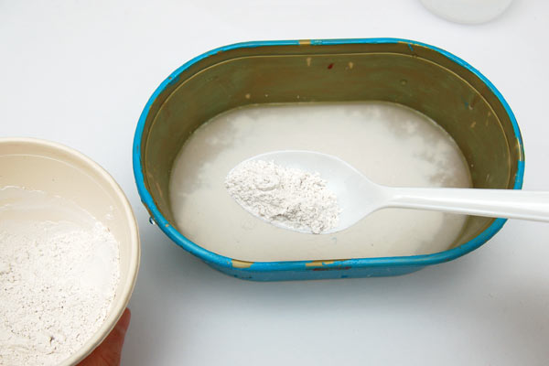
Photo: real plaster of Paris (from FirstPalette.com)
- If you put extra water, it will separate later, you can remove it then.
- You can use it right away, but the clay gets more potent and alive day after day, and after 3-5 days, it is fully ready.
- Make sure to always consume it in raw milk or raw vegetable juice (the latter is not recommended for skinny people), otherwise you will ingest some metal toxicity.
- Do not store it forever, after a while, it can start to free up more metals.

Making high meat

- Pâté meat (it will ferment faster).
- Put in a glass jar, leave 2/3 airspace ideally.
- Make sure it is in a closed container, otherwise it will dry.
- You can store in the fridge (easiest), or outside of the fridge (will be faster).
- You can wrap a towel around the jar to limit the smell from spreading.
- If the jar is stored outside, flies will try to lay eggs. Maggot high meat is not bad, but it has a different use (feeds glands more than the nervous system). If the jar is not completely airtight, the fly will lay its larvae at the entrance and the micro maggots will crawl in. You can attach a cloth around the top and use a string or rubber hand and that will prevent them more from entering.
- Air the jar every week. Otherwise it will stop fermenting and the bacteria will die. You can air every 4 days and that will be even faster, however more than that will not accelerate it further.

There are 17 stages of fermentation. So new bacteria strains will take over your high meat jar every week you air them.
You want to start eating after the 3rd week of airing. Why? Because before that, the bacteria strains that are present give actually a more radical detoxification.
At the last stage, the meat is completely liquid, like a soup. It is completely predigested, and gives the most benefits.
You want the bacteria from each week because each will perform different duties in your body.
You can smear some of your own feces (yes), not much, just as a bacteria starter, to provide your own strain of E.Coli to grow faster on there.

When eating high meat, do not eat anything else 15 minutes before and after the high meat, because it could kill much of its bacteria. For example, no butter. Water (non sparkling, or that would kill a lot of bacteria) is the only thing Aajonus found that would not harm the high meat bacteria. Water is pointless to drink here, though.
So, in this case, it is better to eat the raw unsalted cheese more than 15 minutes before, and not 10.
Eating fat 15 minutes after finishing the high meat is a good idea, to handle possible detoxification.

There are several ways to eat high meat.
Simply ingesting it.
However, leaving it on to “melt” on top of your palate, enables the high meat bacteria to directly feed your nervous system. Eating the high meat will still significantly kill a great amount of its bacteria, because of the digestive acids (that will be less the case if the high meat is made from pâté, another reason to make it), so you can leave it to absorb 2 minutes like this before swallowing.

And if the smell is difficult, Aajonus recommends to simply plug your nose…
However, a comment about this. You may be lacking fats and juice, and milkshakes, for mucus lining, if high meat is very unappealing. In this case, having those foods first well in place in your diet in the amount you require, will make eating high meat much easier. That will also avoid puking it out which would be a waste.

Start with one little piece per week, and slowly increase quantities. Eventually, you will like it more and more.
Sometimes, high meat does taste good (to most people), but even the “stinky” high meat, you can grow to like, just like those Eskimos kids Aajonus talks about, because this part of taste is highly reactive to your current state.

Making the parasite formula

This is the formula Aajonus came up with to spawn parasites and detoxify his gut:
Ferment raw maca root powder in raw milk for about two to three weeks.
The quantities seem to be 5-6 tablespoons of maca powder per quart of raw milk.
Optionally, whey can also be added.
Beware, the final mixture is very alcoholic, the vapors could sting your eyes, and if you drink too much at once, or you could also get a strong skin detoxification with extremely itchy hives that even tomato and cucumber slices will have a hard time soothing.
Drink half a cup to a cup at a time.
If it doesn’t work, your body might need to detoxify more first, try again some time later.

Eating raw pork/boar intestines that were not exposed to oxygen is an almost guaranteed way of getting trichinosis.

Another method consists of injecting parasites directly into the body, by ingesting them with an alkaline formula (like green juice), or through skin patches. This is referred to as helminthic therapy, it is possible to purchase these parasite eggs online.

Clay being a shapeshifter, it could also spawn parasites, so the clay milk recipe could do it, but it will depend on many factors.

Eating raw onions can remove parasites from the body, so do not eat too much onion frequently if you don’t want to lose yours too early.

Juicing vegetables

Aajonus made a video about it.

If you do not like your vegetable juice too fibrous, when making it, make it go through one or two layers of organic unbleached cotton cloth. That will remove up to several tablespoons of fiber from a quart of juice. Make sure you the cloth is non-toxic as described, and first wash it with raw vinegar / raw whey.
If there is still too much remaining fiber for your taste, let it decant to the bottom, it will separate and most of the juice in the glass container will become a clear liquid. Some people can benefit from some extra fiber, but Aajonus recommended most people drink only the clear liquid part.

Juice can be stored for around 4 days – 1 week without losing too much nutrition or fermenting.
Fill the glass container to the top and don’t leave any airspace to prevent the juice from oxidizing and losing nutrients.
Use honey and/or lime juice to prevent fermentation.
Do not store juice with raw fat, it will make the juice react differently in the body, it will be less available to assist in detoxification which is what we mainly want it for.
Warning: fermented juice is not bad, but it can trigger strong detoxifications, which you might want to avoid until you have been on the diet for a couple of years and have extra weight.

Juicing coconut cream

Aajonus made a video about it.

Eating raw eggs Aajonus-style

You can put It in a glass “rocky-style”.
- You can also make a small hole with your teeth on the back end,
- hold with your finger to prevent it from falling during the next step,
- then make another hole with your teeth on top,
- and “slonk” it.

Primal Diet suppositories

Suppositories are a way to feed your nervous system, because the colon is where the E.Coli bacteria finish breaking down food particles to feed the nervous system.
They are not mandatary at all. However, despite the quantities of foods on the Primal Diet, and the optimization in meal timing and preparation to make them the most bio-available, the body might prioritize feeding most of the body and leave little for the nervous system, since it comes last.

A mixture can be made and injected as a suppository to give everything to the nervous system.
It can simply be some raw eggs, made into an even mixture, some clabbered milk (blended back into a liquid), a combination of fats, or even high meat.
Of course, avoid anything else than these. Certainly do not put lemon juice, and so on.

The classic formula is:
3 tablespoons of each: raw butter, cream, and coconut cream, and ¼ teaspoon unheated honey.
If you are missing the coconut cream for example, it is fine, it is to provide a little bit of detoxification, but there is not problem with not having it, and butter and cream will be more than enough to feed the nervous system.
They must be gently warmed up by putting it in a bowl of hot water (not hot enough to burn hand for 6 seconds but uncomfortable), leaving it in 4-5 minutes, until you obtain an homogenous liquid mixture.

The goal is to have this mixture makes its way to the colon, which requires several steps…

For some people, bulb syringes are too short.
Use a “douching” syringe.
You can buy that on some online store or find it in pharmacies.

Then:
- Get on all fours and bark like a dog
- Inject it as far up as possible in the sigmoid colon, past the rectal area.
(this is why you may need an extender)
- Rest your face on your hands and roll your belly like a belly dancer for 3-4 minutes. That will move it up.
- Then lie on your right side, left leg up and roll your stomach again like a belly dancer, 3-4 minutes again, moving farther into transverse and and little bit down into the ascending colon.
- Do this right before bed and hold it in and go to sleep.

This can help against depression and chronic constipation.
It can also help with mental abilities, and for instance, Aajonus reckons high meat suppositories will give athletes top-tier coordination.

Storing your food

Store your food in a non-toxic container.
In a glass container, or ceramic plate.
Do not use plastic or cartons, paper. If your foods come in those packaging, scrape them if possible and put them in a non-toxic container.

Washing food

Aajonus doesn’t usually recommend washing food.
If your organic celery or carrot has a bit of soil dirt on it, good.

Using water (even good water) on top of meat will only push chemicals further inside.
When you get meat, butter, or cheese, from a plastic or paper package, scraping it all around is recommended.

Rarely are organic foods completely organic. Let’s take fruits. It is possible to pull some of their contaminants off, by putting them in a jar containing half of raw whey, half of good drinking water, letting them inside for a few hours, and shaking a few times. If you see dark deposits come off, then it is not truly organic.

In any case, when eating fruit, or even meat, you can eat extra raw butter and/or grated raw unsalted cheese to thoroughly bind to any toxin that might be in the food. It cannot completely detoxify the food, but it will help remove low amounts.

Washing dishes

You can rinse them with lemon juice (or lime juice) before using them, that will remove traces of chemicals from the tap water that was used. Can also use sparkling water.

Washing clothes

Ideally, you would use raw whey, vinegar, or coconut oil, along with hot water.

Weight yourself

You have to consider whether you are gaining fat, muscle, bone density, or water retention.
There are scales that weight those accurately according to Aajonus.

Make your own water filter and bath tub

"Aajonus was consulted over a period of years by the author of Life Giving Hot Tub – Therapy for Natural Healing. This author was also Aajonus’s massage therapist for 6 years. (Aajonus was in Los Angeles about half of each year at that time). During that time this author – John P. Reed – learned the secrets that are in this book. John has since gone on to build hot tubs using the data from Aajonus. I could go on and on about this as I am really excited."
A lot of information is in that ebook. Some members came up with their own so with their authorization, this will be added later on.
Here is an infographic I made long before:



Making the anti-EMF car pillow

To be added

Feeding the soil / plants

Urine, not diluted in water, otherwise It could go too deep without being properly broken down first on the top layer, andb urn the roots.
Whey is also good.
Egg-shells can be recycled by the soil and enrich it in minerals.
Any other organic produce you have, you can compost.

Growing celery

This is from one of the experts, Viltar:

You need to plant celery 15cm-25cm apart. So take 20cm and calculate. If you want 100 celery then you will need. 1m X 4m. I think

If you juice 60 celery plants every month, it takes a lot of them. Like i would plant 350 of them, maybe less, maybe more. Its complicated, because i would harvest some but they would still keep growing. So you need about 3.5m X 14m. Plus, it takes like 4-5 months for them to grow to their full size. So my advice is to plant more then you need, like 500 or if you have access to celery then you can plant less as an experiment, learn, see how it grows, then next year plant more or less depending how much you need.

You need to sprout the seeds early too, in march, if i won't forget i will remind you. Celery also needs nutrient rich soil so best to give them nutrients, you can buy bone meal and buy some cow shit or chicken shit too. Compost on them grass clippings or wood chips. In general its not hard to grow you just need to know certain tricks and when to plant.

Animal husbandry / Animal raising

Chickens

Chickens are carnivores. They need to eat meat. They really love rotten meat with maggots.
They also eat plants, including grass, celery leaves, …
If not eating grains, they don’t need as much water.
They will eat milk, butter, cream… Sometimes they can eat a lot of raw fat.
If feeding them grains, grains are better sprouted in raw whey, because the raw whey can disable some of the anti-nutrients of sprouted grains (which are otherwise strong enough to kill a bird over time).

Cats and dogs

Cats and dogs are very carnivore.
Occasionally, they will do the thing where they chew on some flower stem, for instance, but won’t eat tomatoes and so on.
They can’t sweat, so they don’t like too much heat, and can’t detoxify through the skin. So to help them detoxify, raw unsalted cheese or raw clay milk are extremely important. If they don’t want it, it can be mixed in their food (like shredded cheese added to the meat).
They need bones (raw, of course) occasionally and can digest those better thanks to their concentrated hydrochloric acid.
They love liver.
A mix of red and white meat can be recommended. If only fed on white meat, they could get anemic, check the color and temperature of their lips, nose, and ears.

Cows

Cows eat grass, other plants. Can also give them organic hay. Aajonus sometimes gave grains to his cows.

All

No soy whatsoever in diets. It is so toxic when raw that it can kill animals who eat it. When cooked, it is not as toxic, but cooking creates other toxins.
No millet either. Goats will eat anything, but not even this.

Feeding sick animals

- Get a bulb syringe
- Put milk, or clay milk, or milk-meat shake, or egg, or milk with butter, or milkshake, can even blend some cheese inside.
- In some cases you might want to stop the detoxification if it goes too far, this can be done with a raw milk – cooked rice pudding.
- Feed small amounts frequently.
Has helped sick chickens and cats.

Traveling by plane

Plane engines release benzene while flying, and some of that benzene gets in the plane because of the air conditioning.
Although it is more noisy, sitting in the back exposes to less benzene.

Wearing a triple-layer of organic cotton cloth should block the benzene.

Flying at high altitude exposes to radiation, that lowers bacteria levels.
Aajonus recommends to not wear the belt whenever possible, because metal conducts these frequencies.
High meat, suppositories, etc. can be useful to restore bacteria levels, especially if flying frequently.

In airports, avoid going through scanners. Ask for manuals checks, in many countries, this is a right by law. The staff may not know, but stand your ground, and just present them the articles of law.
Getting your food through without scanning is possible too, but more difficult.

Environment

List of plants for your home

Of the few plants tested, here are the top 10 plants most effective in removing formaldehyde, benzene, and carbon monoxide from the air:

Bamboo Palm (Chamaedorea Seifritzii)
Chinese Evergreen (Aglaonema Modestum)
English Ivy (Hedera Helix)
Gerbera Daisy (Gerbera Jamesonii)
Janet Craig (Dracaena "Janet Craig")
Marginata (Dracaena Marginata)
Mass cane/Corn Plan (Dracaena Massangeana)
Mother-in-Law's Tongue (Sansevieria Laurentii )
Pot Mum (Chrysantheium Morifolium)
Peace Lily (Spathiphyllum "Mauna Loa")
Warneckii (Dracaena "Warneckii")

The most effective at removing formaldehyde were philodendron, spider plant, and golden pothos. Gerbera daisy and chrysanthemum (mum) are common flowering varieties that were most efficient at removing benzene. Peace lily and chrysanthemum were most efficient at removing trichoroethylene.

All plants produce oxygen by photosynthesis, increasing oxygen in their immediate surroundings. All plants utilize carbon while producing new growth and are effective at removing low levels of carbon monoxide, cleaning our air, including English ivy, Chinese evergreen, bamboo palm, snake plant (mother-in-law's tongue), and the Dracaena Marginata, corn plant, and Janet Craig. Generally, one large plant per 100 square feet will clean air in an average home or office. More heavily polluted environments require greater concentrations of plants.

Types of clothes

Wear clothing made with natural materials: cotton, silk, wool.
Synthetic fibers break off and get into the skin, cause toxic reactions.

Furniture

Be careful with what you buy. Some carpets can outgas toxic chemicals for days.

Computer gear

Keep the computer 1 meter away from you.
Even if using a laptop, plug an external keyboard, it will emit less EMF.
Use mechanical mouses, the ones with ball rolling under them, not laser mouses. Require a bit more cleaning, but will save your hand a lot of EMF exposure.

Phones

Phones are tricky.
Most emit a lot of EMF.
Some German Federal Office of Radiation Protection seems to keep track of them.


Jobs

If possible, avoid jobs that expose you to too much EMF or toxins.
Let’s say you work on a construction site. You may need to eat cheese trains regularly to avoid toxicity accumulating.

Iridology

Article by Viltar, one of the experts:

People keep asking me to read their irises but i do not have time to do it for FREE. So i wrote this article to teach YOU, the reader, on how to do it yourself.
Keep in mind my iridology understanding is not as good as Aajonus and he even said himself that he developed his own iridology because other iridologist would be wrong all the time. My knowledge is from reading some iridology sources and then listening to Aajonus Vonderplantiz Q&As and back tracing and confirming some of the iridology things Aajonus Vonderplantiz talked about. So keep that in mind. I will also include some snippets from the Q&A. Whatever i got from Aajonus Vonderplantiz i will mention, so you can see which parts are right and which ones can be up for interpretation.
What cool about knowing iridology is that you can install see how healthy or sick someone is based from the knowledge. Whenever i meet any people i instantly analyze their irises and know their health state.
A good book that could give a simple understanding is called: Iridology Simplified by Bernard Jensen, however AV developed its own iridology because other people where wrong. So don't take it too seriously. Its just something that helps have a general understanding.

There is few things that add up that let's you see a whole picture in iridology. First of all the amount of fibers that are in the Iris. The more of them there are, the better constitution, which means you are better overall. The less the poorer constitution, the less alive cells there are. You could hear in certain Q&As Aajonus mention how much alive cells in percentage his clients would have. He would use the fibers to say.
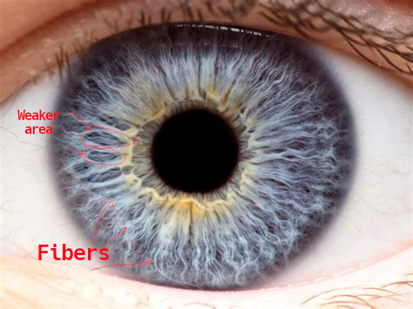This is a picture of iris with the fibers. You can see them going from the center of the eye to the sides. The more of them there are, the better you are

Sometimes in certain areas of the iris there is parts that there is no fibers or they are not as dense. That means that area is weaker, and probably has toxicity. Then you look at the iris in lower images, overlay them on your iris and you can see which part of the body is weaker.

The fibers are also layered, meaning, there is more then a few layers of them. And the higher the layer the better that area is. The more deeper holes, i will call them lesions, the worse that area is. And probably has toxicity, dead cells, ect.
Acute is the least worst lesion, degenerative is the lowest(worst lesion).

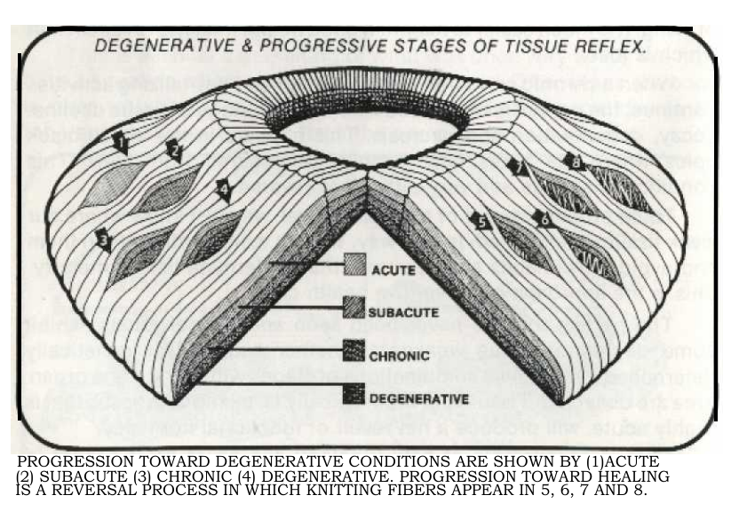From iridology simplified-Bernard-jens
Now here is a picture of the iris chart. You use it to overlay over your iris and you know which part is weaker, which is stronger, which has toxicity. Here are some areas that i confirmed from AV who are correct in this chart: skin, stomach, gut, brain. This chart is more in depth and specific one but there is more general charts as well.
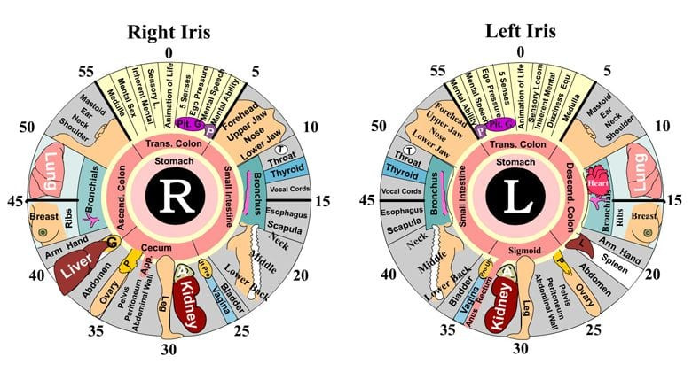

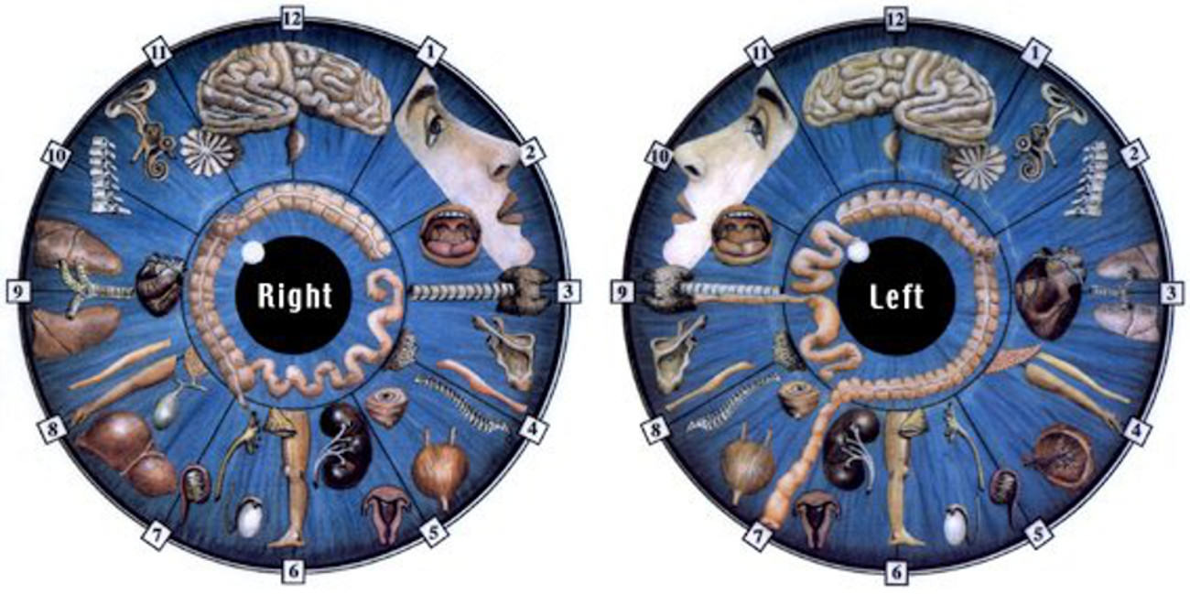A more simpler chart
Here how the chart basically works. The inner ring around the pupil is the stomach and then the gut. If stomach area has a halo ring around the iris it means that person is overacidic (heard that from AV) and needs more veg juices.
According to AV there is basically two types of real eye colors, amber and blue. Everything else and in between just means that the body is toxic and eventually with doing the diet long enough the iris would go to their natural color.
What marks that the specific area is toxic is discoloration, brown, black spots. And different discoloration means that different heavy metal or toxin is stored there. Here are some snippets from AV Q&A:
2008 04 26 CH workshop 05:18:00 "Q: What if you have blue eyes, what does discoloration mean, like a brown spot ?
A: It is toxicity stored in that particular area of your body. It could be a penicillin injection if you got a brown spot, if it is black under the brown it is vaccines or other ingestion, or where mercury is stored and your body is used oxidized iodine or iron to seal it, sometimes your body would use a lot of iron or iodine that is oxidized, they would call it rusting, to destroy penicillin molds, it is like unnatural chemo therapy. And it could cause a lot of problems, it could cause anemia, because it causes a great loss of iron in the body."
2008 04 26 CH workshop 05:16:00 " Penicillin is grown on grain mold. Penicillin is grain mold. They sterilize it, it destroys the RNI and DNI which tells the fungus to go to into hibernation, so when you are injected or given penicillin, that fungus will live in you body forever, unless you know how to get rid of it, and i have not seen one person eyes in 30 years, that did not have a sign of penicillin growing profusely in their bodies. I have seen some people with a smaller amount then others, and some people with the massive amount. And the people who had the largest amount where the people who had fibromyalgia and chronic fatigue. They usually have heavy metals all over the body or having raging penicillin growing everywhere, trough out the tissue, if you have yellow color in your eye you are full of it, if you are supposed to be blue but are green your eyes are full of penicillin. People with brown eyes are loaded with it too. Brown eyes should be amber, not dark brown or black."

Now i will list some examples to help you understand the whole concept better.
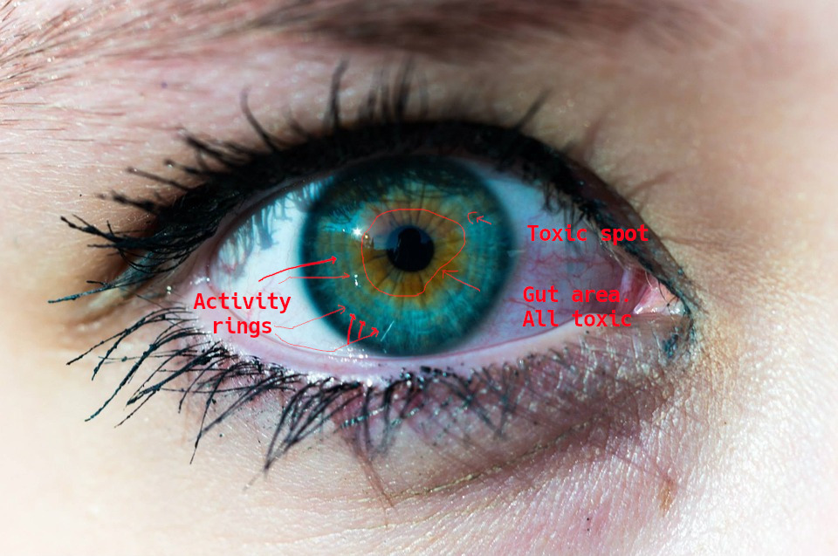An example iris. You can see the gut area is all toxic and the toxicity is spilling from the gut to the rest of the body. Irises like these are very common. It seems we all are mainly poisoning our self the most to what we put it to our mouths and eat. There is a black ring around the iris, it means there is toxicity in the skin. So hot baths
Activity rings are these rings that you can see in your iris and it basically means you are producing excess hormones and you need to use them up trough exercise or other activities. Here is some AV snipped about activity rings.
"Usually, I can gage an individual's activity level by the number of activity rings in her/his irises. The more activity rings that a person has, the more active, including exercise, s/he must be. Usually, 1 activity ring equals one hour of activity or 1/2 hour of exercise daily. Amongst iridologists, those activity rings are commonly called "stress rings". Usually, I call them "worry circles". I call them worry circles to remind people that if they are not active enough, they will utilize those hormones in anxiety, worrying about anything or everything. There are two doors from which to choose: Activity or Anxiety. Which do you choose?"
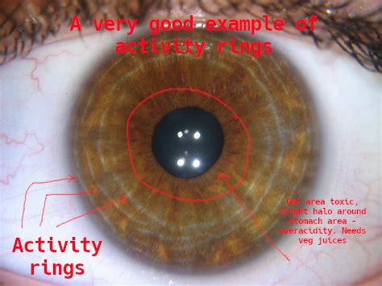Example iris of activity rings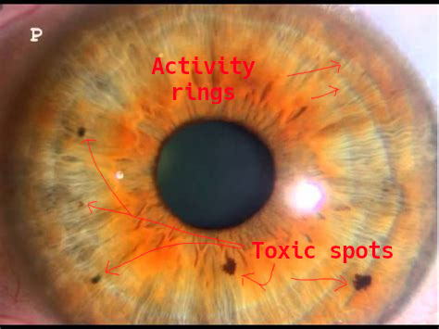

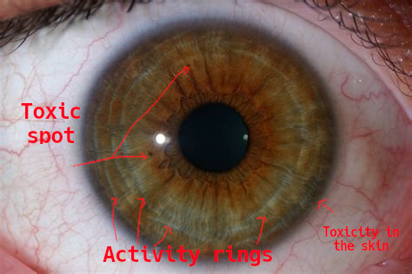This iris should naturally be blue but is brownish from all the toxicity. Limbal ring
Limbal ring means that there is toxicity stored in the skin. If person has limbal rings he should do hot baths to clear it up (info from av).

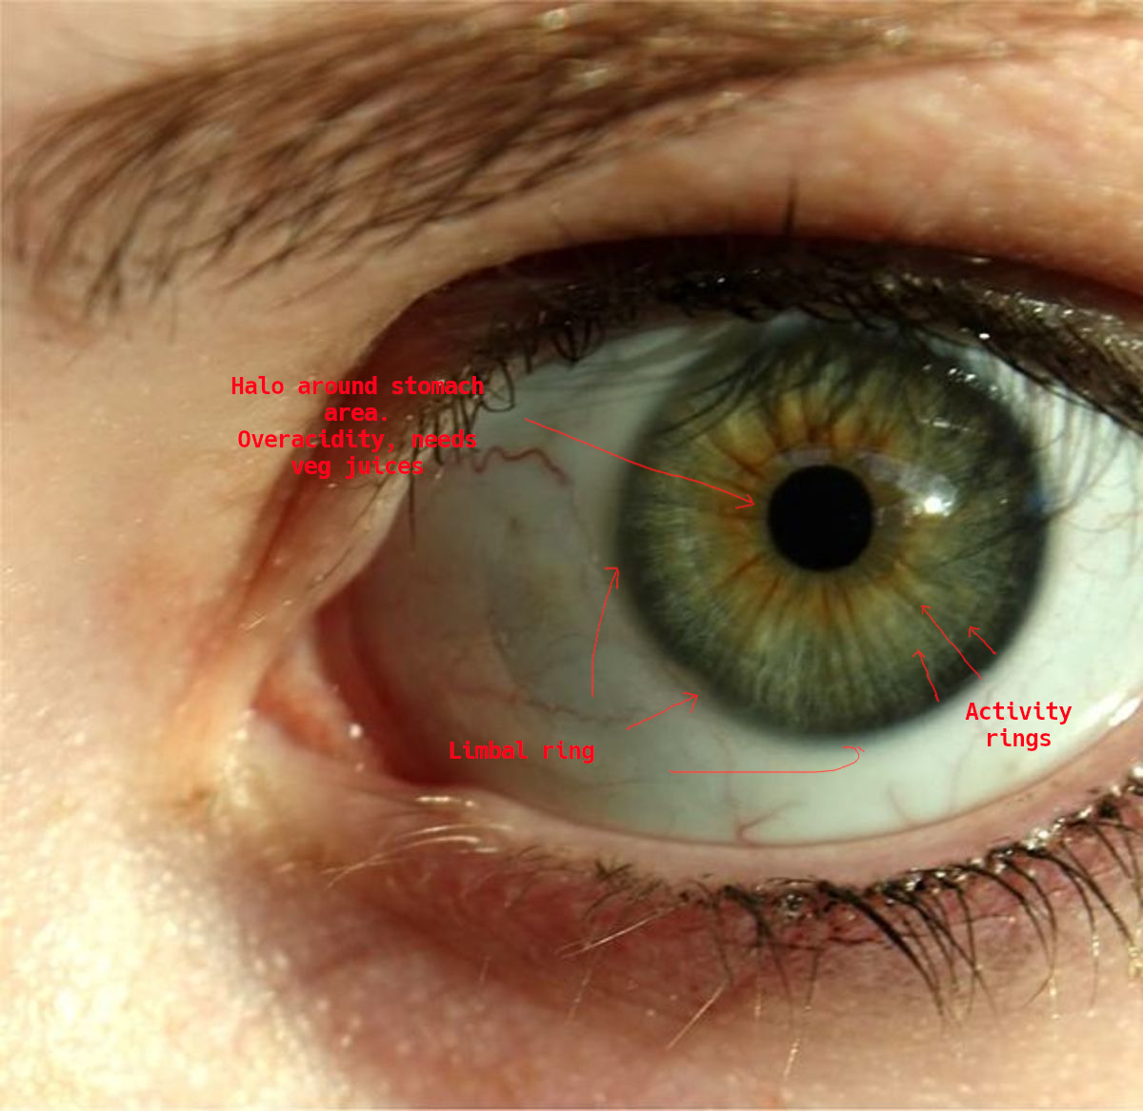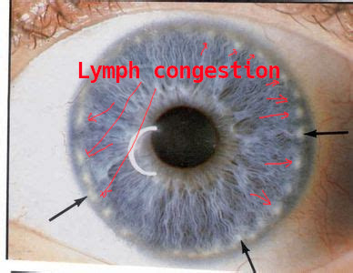
Lymphatic congestion can be seen by these small white dots around or nearby the skin area. The person needs to do Aajonus hot bath regime to fix it.

Documents

Vaccination – ACCEPTANCE OF RESPONSIBILITY FORM

DEA or HHS number is ________.
I, having assumed decision making power independently or having been appointed, to such by a government agency or corporation controlled by government, do require the following individual(s):__________________________________________ herein referenced as “receiver” or “detainee”,to receive the following vaccination(s):
_____________________________________________________________
_____________________________________________________________
I am aware that forced vaccinations are contrary to laws that provide religious and philosophical exemptions, U.S. Constitutional Amendments 4, 5 and 9, and the Nuremberg Code.
I warrant that I took an Oath to abide by and protect the laws of the U.S. Constitution. I am aware that the Covid-19 vaccines have not been properly tested and anyone who takes them is a subject of experimentation. I realize that the Nuremberg code includes principles of informed consent and absence of coercion; properly formulated scientific experimentation; and beneficence towards experiment participants. Nuremberg Code (from United States National Institutes of Health).

1. The VOLUNTARY CONSENT of human subject is absolutely ESSENTIAL. This means that the person involved has legal capacity to give consent; be so situated as to be able to exercise free power of choice, without the intervention of any element of force, fraud, deceit, duress, overreaching, or other ulterior form of constraint or coercion; and have sufficient knowledge and comprehension of the elements of the subject matter involved as to enable her/him to make an understanding and enlightened decision. This latter element requires that before the acceptance of an affirmative decision by the experimental subject there be made known to him the nature, duration, and purpose of the experiment; the method and means by which it is to be conducted; all inconveniences and hazards reasonable to be expected; and the effects upon his health or person which may possibly come from his participation in the experiment. The duty and responsibility for ascertaining the quality of the consent rests upon each individual who initiates, directs or engages in the experiment. It is a PERSONAL duty and responsibility which may NOT be delegated to another with impunity.

2. The experiment should be such as to yield fruitful results for the good of society, not procurable by other methods or means of study, and not random and unnecessary in nature.

3. The experiment should be so designed and based on the results of animal experimentation and knowledge of the natural history of the disease or other problem under study that the anticipated results will justify the performance of the experiment.

4. THE EXPERIMENT SHOULD BE SO CONDUCTED AS TO AVOID ALL PHYSICAL AND Acceptance of Responsibility for Covid-19 Vaccine Consequences - page 2 of 6 MENTAL SUFFERING AND INJURY.

5. NO EXPERIMENT SHOULD BE CONDUCTED WHERE THERE IS A PRIOR REASON TO BELIEVE THAT DEATH OR DISABLING INJURY WILL OCCUR; EXCEPT, PERHAPS, IN THOSE EXPERIMENTS WHERE THE EXPERIMENTAL PHYSICIANS SERVE AS
SUBJECTS.

6. The degree of risk to be taken should never exceed that determined by the humanitarian importance of the problem to be solved by the experiment.

7. Proper preparations should be made and adequate facilities provided TO PROTECT THE EXPERIMENTAL SUBJECT AGAINST EVEN REMOTE POSSIBILITIES OF INJURY, DISABILITY OR DEATH.

8. The experiment should be CONDUCTED ONLY BY SCIENTIFICALLY QUALIFIED
PERSONS. The highest degree of skill and care should be required through ALL STAGES of the experiment of those who conduct or engage in the experiment.

9. During the course of the experiment the human subject will be at liberty to bring the experiment to an end if he has reached the physical or mental state where continuation of the experiment seems to him to be impossible.

10. During the course of the experiment the scientist in charge must be prepared to terminate the experiment at any stage, if he has probable cause to believe, in the exercise of good faith, superior skill and careful judgment required of her/him that a continuation of the experiment IS LIKELY TO RESULT IN INJURY, DISABILITY OR DEATH TO THE EXPERIMENTAL SUBJECT.
Reprinted from Trials of War Criminals before the Nuremberg Military Tribunals under Control Council Law No. 10, Vol. 2, pp. 181-182. Washington, D.C.: U.S. Government Printing Office I agree that the stated individual(s) are in good to perfect health prior to the administration of such immunization(s). If any damage occurs to the receiver(s) stated above, I personally accept full responsibility for any and all damages resulting from such immunizations. As a result, I agree to provide compensation amounting to at least $1,000,000 to the family(s) of the person(s) I am requiring to receive the aforementioned vaccinations for each resulting vaccine related injury(s) and/or disease(s) as follows:
Shaken baby syndrome: http://www.vaclib.org/basic/sbsindex.htm
Cerebral bleeding: http://www.vaclib.org/basic/sbsrebut.htm
Cancer: http://www.sv40cancer.com/
Tumors: http://www.gulfwarvets.com/virus.htm
Asthma: http://vaccines.net/Asthma/allergie.htm
Auto-immune disease(s): http://healthresearchtoday.com/lupus/whatislupus.htm
Brain damage: http://www.vaclib.org/news/2006/pentacel.htm
Mental retardation: http://www.vaclib.org/news/2006/pentacel.htm
Crippling arthritis: http://www.vaclib.org/intro/hepbinfo.htm
Mercury poisoning: http://www.gulfwarvets.com/kids.htm
Diabetes: http://vaccines.net/diabetes.htm
Blindness: http://www.vaclib.org/email/lymefda.htm
Loss of IQ: http://www.vaclib.org/email/autismviera.htm
Seizures: http://www.vaclib.org/email/seizures.htm
Chronic fatigue syndrome: http://healthresearchtoday.com/fibromyalgia/book_104.htm
Acceptance of Responsibility for Covid-19 Vaccine Consequences - page 3 of 6
Cardiac problems, such as angina or cardiac arrest
I understand that all of those conditions/diseases that are induced by vaccination are incurable by modern medicine, but easily prevented by abstinence from vaccinations.
I have a thorough understanding of the risks and benefits of all the medications that I enforce. In the case of (detainee’s name) _____________________________, age _________ , whom I have examined, I find that certain risk factors exist that justify the recommended vaccinations. The following is a list of said risk factors and the vaccinations that will protect against them:
Risk Factor ______________________________________________________
Vaccination ______________________________________________________
Risk Factor ______________________________________________________
Vaccination ______________________________________________________
Risk Factor ______________________________________________________
Vaccination ______________________________________________________
Risk Factor ______________________________________________________ Vaccination ______________________________________________________
I am aware that in addition to the viral and bacterial RNA or DNA that is part of the vaccines, below are some of the fillers considered inert but which have harmful side effects:
aluminum hydroxide (directly linked to Alzheimer's Disease)
aluminum phosphate (directly linked to Alzheimer's Disease)
ammonium sulfate (an inorganic chemical compound used a fertilizer and "protein purifier"; known to cause kidney & liver damage, gastrointestinal dysfunctions)
amphotericin B (an "antifungal disinfectant” that damages the urinary tract, bowels, heart functions) animal tissues: pig blood, horse blood, rabbit brain, dog kidney, monkey kidney, chick embryo, chicken egg, duck egg, and calf (bovine) serum, fetal bovine serum VERO cells, a continuous line of monkey kidney cells, and washed sheep’s red blood cells. Those build foundation for neurological diseases)
betapropiolactone (disinfectant)
Ethylene glycol (antifreeze, proven to have extreme neurotoxic side effects)
formaldehyde (used as a preservative, embalming fluid, and disinfectant, known to cause cancer, chronic bronchitis, eye irritation and numerous other diseases)
formalin (used as a disinfectant or anti-bacterial, containing 37% formaldehyde)
gelatin (causes allergic reactions and anaphylaxis usually associated with sensitivity to processed egg or gelatin)
Gentamycin (antibiotic: destroys digestion and impairs healing)
Glycerol (A syrupy, sweet, colorless or yellowish liquid, C3H8O3, obtained from fats and oils as a byproduct of saponification and used as a solvent, an antifreeze, a plasticizer, and a sweetener and in the manufacture of dynamite, cosmetics, liquid soaps, inks, and lubricants)
MF-59 (oil-based and composed of squalene, Tween 80 and Span85. All oil adjuvants injected into rats were found to be toxic, caused disease similar to multiple sclerosis which left them crippled and dragging their paralyzed hindquarters)
human diploid cells (from aborted fetal tissue)
hydrolyzed gelatin (obtained by chemical extraction from the skin, white connective tissue and bones of animals, such as cowhide splits, bones (ossein), pork skin, and fish skin) monosodium glutamate (MSG; causes cancer in humans, also linked to obesity)
neomycin (antibiotic: destroys digestion and impairs healing) neomycin sulfate (antibiotic: destroys digestion and impairs healing) nonoxynol (toxic chemotherapy used to treat venereal diseases) octoxinol 9 (toxic chemical used in vagina to kill sperm)
phenol red indicator (a highly toxic carolic acid disinfectant dye, attributed to liver, kidney, heart and respiratory damage)
phenoxyethanol (antifreeze, proven to have extreme neurotoxic side effects)
potassium diphosphate (destroys libido and motivation)
potassium monophosphate (destroys libido and motivation)
polymyxin B (antibiotic: destroys digestion, damages liver and kidneys, and impairs healing)
polysorbate 20 (trademarked Tween 20; emulsifier that often prevents absorption of nutrients causing malnutrition)
polysorbate 80 (trademarked Tween 80: a preservative that can cause severe allergic reactions including anaphylaxis)
porcine (pig) pancreatic hydrolysate of casein (isolated concentration of certain proteins that cause nutritional imbalances, allergies and often excessive hunger or the opposite anorexia)
residual MRC5 proteins (chemically isolated toxic proteins from cancerous DNA)
resin (causes allergic reactions)
sodium phosphate (solvent, dangerous, even life-threatening, toxicity may occur while using sodium phosphate if you have kidney disease, have congestive heart failure, have an electrolyte imbalance; or are on a sodium restricted diet)
sorbitol (sugar alcohol that dissolve intestinal villi)
Squalene (causes severe arthritis and lupus in humans at only 10-20 parts per billion)
sucrose (dissolves cellular walls and intestinal villi)
thimerosal (mercury; a neurotoxin linked to psychological, neurological & immunological
problems. Nervous system damage, kidney disease, birth defects, dental problems, mood swings, mental changes, hallucinations, memory loss, nerve damage and inability to concentrate can occur. Symptoms also include tremors, loss of dermal sensitivity, slurred speech and, in rare cases, even death and paralysis. This additive alone was the catalyst for another recent Class Action Lawsuit organized by mothers of children born with Autism & the many related behavioral disorders associated with it. Autism is now occurring at levels never seen before in history, 1 in 67. The average used to be 1 in 20,000.)
tri(n)butylphosphate (solvent and plasticizer)
Triton X100 (a strong detergent)
Additionally, I have considered the synergistic toxic effects produced by combining those toxins. I realize that side effects compound and more severe reactions result from combining toxins.

NO PROPER TEST has been executed and released to the public. I understand that anyone who takes Covid-19 vaccines is the experiment.
I am aware that the expected harmful and possibly fatal side effects admitted by
pharmaceutical manufacturers and listed on vaccine package inserts are:
Local injection site reactions (including pain, pain limiting limb movement, redness, swelling, warmth, ecchymosis, induration). Symptoms: abdominal pain, arthralgia, asthenia, blood disorders, cardiovascular, disorders, chest pain, chills, cough, diarrhea, digestive disorders, dizziness, dyspnea, facial edema, fatigue, febrile convulsions, fever, Guillain-Barré Syndrome (often resulting in death), headache, hot flashes/flushes, hypersensitivity reactions (including throat and/or mouth edema), hypersensitivity reactions have lead to anaphylactic shock and death, immune system disorders, loss of appetite, lymphadenopathy (local), lymphatic disorders, malaise, metabolic disorders, myalgia, myasthenia, myelitis (including encephalomyelitis and transverse myelitis), maculopapular rash, nausea, nervous system disorders, neuralgia, neuropathy (including neuritis), nutritional disorders, paraesthesia, paralysis (including Bell’s Palsy), pharyngitis, pruritus, rashes (non-specific), respiratory disorders, rhinitis, shivering, Stevens-Johnson syndrome, syncope shortly after vaccination, thrombocytopenia (transient), urticaria, vasculitis (in rare cases with transient renal involvement), vesiculobulbous rash, vomit.

I am also aware that tests have proved that flu shots don’t work, such as the following:
· According to the 2006 Cochrane Database of Systematic Reviews, 51 separate studies concluded the flu vaccine worked no better than a placebo in 260,000 children ranging in age from six months to 23 months.
A study published in the October 2008 Archives of Pediatric and Adolescent Medicine found flu vaccines in young children have made no difference in the number of flu-related doctor and hospital visits.
· As reported in a 2004 publication of the Archives of Disease in Childhood, a study of 800 children with asthma concluded those receiving a flu vaccine had a significantly increased risk of asthma-related doctor and emergency room visits.
· A more recent study released at the 2009 American Thoracic Society International Conference showed children with asthma who received FluMist had a 3-fold increased risk for hospitalization.
Not only are flu vaccines ineffective in preventing flu in children, they are equally ineffective for adults, including elderly.
· According to the 2007 Cochrane Database of Systematic Reviews, studies of over 65,000 healthy adults concluded vaccinations reduced the risk of flu by only six percent, and reduced missed work days by less than a single day. Vaccinations did not reduce the number of people who sought medical help or took time off from work.
· The 2006 Cochrane Database also includes a review of 64 vaccination studies of the elderly across nearly 100 flu seasons. The studies showed flu vaccines were ineffective in preventing the flu in either nursing home patients or elderly living in the community.
· A study published in the Lancet last year found that influenza vaccination was NOT associated with a reduced risk of pneumonia in older people. This supports a study done five years ago, published in The New England Journal of Medicine.
Acceptance of Responsibility for Covid-19 Vaccine Consequences - page 6 of 6
· Research published in the American Journal of Respiratory and Critical Care Medicine also confirms that there has been no decrease in deaths from influenza and pneumonia, despite the fact that vaccination coverage among the elderly has increased from 15 percent in 1980 to 65 percent now.
“We conclude that frailty selection bias and use of non-specific endpoints such as all-cause mortality have led cohort studies to greatly exaggerate vaccine benefits. ” Lancet Infectious Diseases; 2008; Researchers at National Institute of Allergy and Infectious Diseases, and National Institutes of Health.
I hereby warrant that the vaccines I am enforcing do not contain any tissue from aborted human babies (also known as "fetuses").
In addition to the recommended vaccinations as protections against the above cited risk factors, I have recommended other non-vaccine measures to protect the health of detainee and have enumerated said non-vaccine measures on Exhibit A, attached hereto, "Non-vaccine Measures to Protect Against Risk Factors."
I issue this Government Agent’s Warranty of Vaccine Safety in my professional capacity as government agent to detainee(s). Under Nuremburg Code, regardless of the legal entity under which I act to enforce vaccinations, I issue this statement in both my business and individual capacities and hereby waive any statutory, Common Law, Constitutional, UCC, international treaty, and any other legal immunities from liability lawsuits in the instant case, according to the Nuremburg rules on injected medications.
I further warrant that I was notified that detainee’s medical care physician has deemed all vaccines are dangerous to detainee’s health and well-being because of past medical conditions.
I issue this document of my own free will after consultation with competent legal counsel whose name is _______________________, an attorney admitted to the Bar in the State of _________________________ . Name of Government agent: print):_____________________________ Position:__________________ Signature:_________________________________________Date:________
Witness: _____________________________________________Date:________
Notary Public: _________________________________________Date:________
INSTRUCTIONS FOR THE ACCEPTANCE OF RESPONSIBILITY DOCUMENT
It is quite obvious that no individual in his right mind will sign this document. Please do not expect anyone to sign it and do not be confrontational. Better that your attitude be humble, informative and calm; at times maybe even gently pleading. By getting the vaccination enforcement officer to read the document, s/he has been duly advised of your rights and her/his non-immunity liabilities and responsibilities. If s/he tries to force you to take vaccinations, this document should lose confidence in her/his authority to force vaccinations on you. Furthermore, it helps defuse authoritative intimidation when it
occurs. If the official refuses to sign document, ask the following questions:
"Why would you want me to accept vaccination when the vaccine has not been tested or proved safe and it has a lot of published side effects that include paralysis and death?”
”Why would you want me to accept vaccination when the vaccine has over 35 toxic ingredients that cause harm and even death?”
“Why would you be willing to break your oath to protect my rights under U.S. Constitution and Nuremberg Codes?”
”Since there were no laboratory-confirmed cases of Covid-19 virus causing death, there is no epidemic. Why do you think that you can force me to have vaccinations when there is no epidemic threat that warrants such deprivation of my rights without impunity?”
"Do you realize that because there is no evidence of epidemic, you will be liable for any harm to me by vaccination?”
“How much do you think your health and life are worth if the vaccinations caused you severe damage or death?”
"How do you feel about risking my life? Does it bother you that your force could cause my death or disease?”
"What does the law state that you will follow to force me to be vaccinated?"
"Who benefits financially from this program?"
He or she should get the message and probably will not force you to be vaccinated.
If you have a letter from your medical physician that states you are at high risk of side effects including death from taking vaccinations, and that you cannot receive vaccinations, present the letter to the officer. It will be a way for the officer to release you unvaccinated without worrying about his job and the consequences if he is held liable for any harm to you.

In case of Injury, and Unconsciousness

In Case of Injury or Unconsciousness, The Following Medical Procedures Apply

* Absolutely NO medications of any kind except those mentioned permissible herein can be utilized on or in my body.
* Absolutely NO antibiotics, vaccines or antiseptics are to be used, applied, administered or injected into me at any time for any reason.
* If unconscious without severe injury, NO medical procedures are to be performed on me. I am to be left alone until I recover consciousness. Once conscious, I will decide if any help is necessary.
* Alcohol (non-wood) may be used sparingly, applied to wounds only and not used internally.
* Pain relievers and narcotics may be utilized only upon my conscious request. Absolutely NO Injected or IV anesthesia. Gaseous anesthesia may be used for emergency surgery in cases listed below.
* If bones appear to be broken, only 2 x-rays may be taken and in case of bone fragmentation, the least surgical repairs may be performed but only with my conscious approval.

Type the following on the backside of the card, laminate it and keep it with you at all times:

* If dismemberment occurred, surgical procedures to reattach member may be performed excluding tetanus, antibiotics and antiseptics except non-wood alcohol used sparingly.
* Blood transfusions must be kept to minimum and at least one of the following donors’ blood only is to be used in me unless donors are unreachable in reasonable time:

______________________________________________________________________________
Name Phone number

______________________________________________________________________________
Name Phone number

I declare that it is my inherent and Constitutional right to accept or decline any and all medical
procedures.

______________________________________________________________________________
Printed name

______________________________________________________________________________
Signature Date

« Request for Advice » form

Please print a copy of this form, fill in the blanks (please print), sign and
fax to (310)589-0470:

Name___________________________________ Age: _____ Height: _____ Weight:___

Address:_________________________________________ City: ____________________

State: _________________ Zip: ____________ Phone: ________________

Email address: ____________________ Referred by: _____________________________

Individual freedom, and the recognition and development of the spiritual nature of mankind are the essence of democracy. They are the essence of life. The Ninth Amendment to the Constitution of the United States of America makes a declaration of the sovereignty and dignity of the individual clear and coherent.

Notice and Declaration of 9th Amendment Rights
The enumeration in the Constitution of certain rights shall not be construed to deny or disparage others retained by the people.

I, the undersigned, hereby declare the following natural and God-given rights as retained by the people, under the 9th Amendment to the Constitution of the United States of America and which rights I reserve to myself as follows:

I reserve the right to seek or ask advice, counsel, information, recommendations, evaluations, analyses, assessments, test and/or care, regimens, modalities or treatments from ANY person of my choice, regardless of state sanctions, for any reason or purpose I so desire.

I reserve the right to select or reject ANY individual as my personal advisor, minister, druggist, nurse, nutritionist, herbalist, naturopath, teacher, practitioner, priest, pastor, relative, friend, or anyone from the general citizenry who has, or has not, any known formal training or claimed knowledge, education, insights, qualifications or credentials.

I reserve the right of freedom of choice in matters pertaining to my spiritual, mental, emotional, and physical well-being. I reserve this right in the most liberal way. My freedom, with regard to my personal life, circumstances, well-being and the decisions I make, include the right to choose my own religion, to choose with whomever I wish to associate, obtain purchase and use any treatment technique, regimen, process, modality, herb, drug, food, diet, medicine or health product for any health condition I have whether determined by myself, a physician, therapist, layman, or by anyone of my choice. I do not relinquish these rights to others.

The enumeration, in this declaration, of these rights shall not be construed to deny or disparage others retained by me, or my right to amend this declaration at any time.

I am herewith presenting this declaration to uphold my rights. In this regard, the holder of this document is authorized to deliver copies of this declaration to anyone if such a need were to arise.

Constructive Notice: Notice is hereby given to any person or persons who receive a copy of this declaration, and who acting under color of any law, intentionally interferes with the free exercise
of my rights under the 9th Amendment, as enumerated in this document, and any I retain but not stated herein, that they may be in violation of Title 42 U.S.C. 1983 et seq. and Title 18, Section 241.

Date: _________________ Signature: ___________________________________

Doctors’ letter

Dr. Aajonus Vonderplanitz, Ph.D. Nutrition
2300/2900 South Kanan Dume Road, Malibu, CA, 90265-2740
(310 589-0589 * Fax (310) 589-0470

Allergy and Nutrition

Re: You have hereby been advised that FirstName LastName’s foods are medicine. Mr./Mrs. LastName’s date of birth is _.

To Whom It May concern:

Mr./Mrs. LastName’s foods are his medicines. He must eat every hour, I have prescribed that his food not be exposed to irradiation from any mechanical source, including airport-security scanning devices. This applies to his body as well and he must avoid body scanners. If necessary perform pat down instead. He is on a special raw-food diet and must adhere to it for his well-being, health and safety.

Mr./Mrs. LastName was exposed to dangerous environmental toxins that caused Multiple Chemical Sensitivity (MCS), and allergies. He reacts hyper-allergically from exposure to irradiation and chemicals of persons and foods. If he eats foods that have been processed or irradiated by security scanning devices, he may likely have symptoms. Mr./Mrs. LastName must carry with him items such as raw milk, vegetable juice, unsalted raw butter and cream, honey, meat and sauce, and raw eggs because airlines do not serve such raw food, and he must eat every hour. Also, it is difficult to acquire raw dairy products in most countries so he must carry enough food to last at least 24 hours.

FirstName LastName’s foods are medicine. Please hand-check his foods. Thank you.



End

